ANH 3-ĐỀ SỐ 2
PART I: LISTENING
Question 1: Listen and number (1pt)
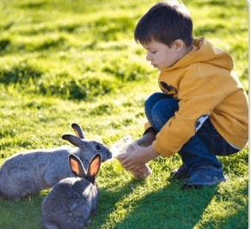 | 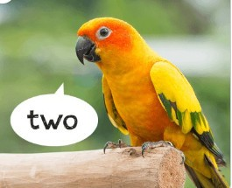 |  | 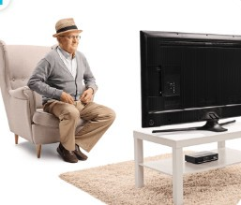
Question 2: Listen and tick (1pt)
1.a  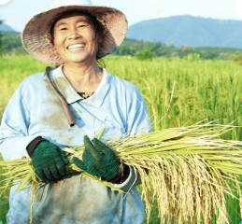 | b.   | 2.a.   | b. 
3.a.  | b.  | 4.a.  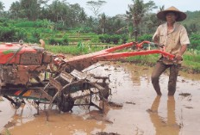 | b. 
Question 3: Listen and complete. (1pt)
1.A: (1)………… old is your brother?  B: He’s fourteen years old. | 2. A: What’s his (2)…………..?  B: He’s a driver.
3. A: Where are the (3) ………………?  B: They’re on the table. | 4.A: Would you like some (4) ………….?  B: Yes, please.
PART II: READING
Question 4: Odd one out. (1.5 pts)\
1. | a. doctor | b. driver | c. job | d. teacher
2. | a. kitchen | b. bedroom | c. bathroom | d. house
3. | a. table | b. lamps | c. chairs | d. books
4. | a. dancing | b. sing | c. reading | d. playing
5. | a. my | b. her | c. his | d. she
6. | a. doing | b. watch | c. listen | d. draw
Question 5: Choose the best answer. (1.5pts)
1………… you have any cats? – Yes, I do.
a. Are b. Do c. Is
2.A: How many …………. do you have? – I have many.
a. rabbits b. parrot c. bird
3. Look ! Nam is …………….
a. sing b. running c. play
4. …………… is she doing? – She’s skipping.
a. How b. What c. Where
5. I have many………………
a. goldfishs b. goldfish c. goldfishes
6. Do you have ……….. dogs?- No, I don’t.
a. and b. one c. any
Question 6: Read and complete. (1.5 pts)
dining drinks like rice some and

Nam and his family are at the (1) ................. table. There is a lot of food and (2)................... on the table. His father (3) .............. mother would (4) ................... some rice, beans and some water. His sister would like (5) .................... bread, meat and some milk. Nam would like some (6) ..................... , fish and some juice.
PART III: WRITING
Question 7: Look at the pictures and write the words (1. pt)
  1.A: Who’s this?  B: It’s my ………… | 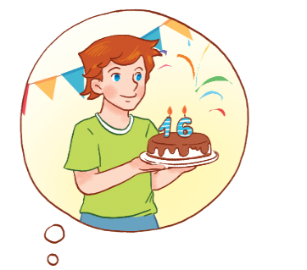  2.A: How old is he?  B: He’s ….……… years old | 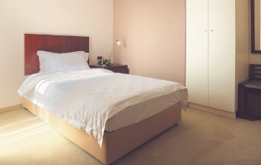  3. There’s a ………. in the bedroom. | 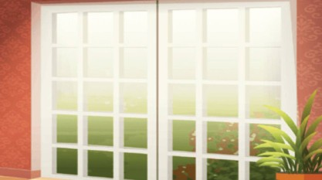  4. There’s a door in the room.  It’s ……………….

Question 8: Arrange the words to make sentences (1.5.pts)
1. to / eat / What / you / like / would / ?
…………………………………………………………………………………………?
2. some / milk, / I’d / like / please / .
…………………………………………………………………………………………
3.is / parrot / The / counting / .
…………………………………………………………………………………………
4. can / you / see / What / zoo / at / the / ?
…………………………………………………………………………………………?
5.see / a tiger / I / can / monkeys / and / some /.
…………………………………………………………………………………………
6. fish / some / you / Would / like / ?
…………………………………………………………………………………………..?

