**ĐỀ 12**

**PART I: Listening**

**Question 1: Listen and number (1pt)**

|  |  |  |  |
| --- | --- | --- | --- |
|  |  |  |  |
|  |  |  |  |

**Question 2: Listen and tick (1pt)**

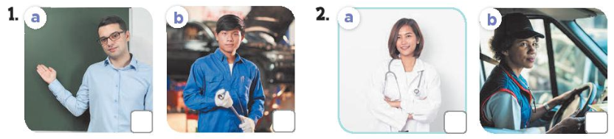 **Question 3: Listen and complete. (1pt)**

1. A: How old is your brother? B: He's……………. years old.

2. A: What's his job? B: He's a…………………...

3. A: Where are the………………..? B: They're on the table.

4. A: Would you like some……………….? B: Yes. please.  
**PART II: READING  
Question 4: Odd one out (1,5 pt)**1. A. worker B. father C. mother D. brother  
2. A. cook B. sing C. farmer D. dance  
3. A. am B. are C. my D. is  
4. A. living room B. chair C. kitchen D. bathroom  
5. A. tables B. chairs C. lamps D. book  
6. A. drawing B. singing C. write D. listening

**Question 5: Choose the best answer (1,5pt)**

1. How many ________ do you have?  
A. goldfishs B. goldfishes C. goldfish D. a goldfish  
2. A. I have ________ parrot and _________ rabbits.  
A. a-two B. a-an C. one-one D. two-one

3. Do you have any rabbits? – Yes, I _______.  
A. am B. it C. are D. do  
4. Does ________ have any parrots? – No, he doesn’t.  
A. your sister B. her mother C. your brother D. his sister  
5. What is your grandfather doing? - He is _________ badminton.  
A. cycling B. playing C. doing D. does  
6. Is her grandmother cooking? – Yes, she _____.  
A. am B. is C. are D. does

**Question 6: Read and complete (1,5pt)**

Hi, my name is Quyen. My family and I are at the dining table. There’s a lot of food and drinks on the table. My father would like some rice and juice. My mother would like some bread and milk. She doesn’t like juice. My sister would like some chicken, bread and water. I would like some fish, eggs and juice. I don’t like chicken and milk.  
1. Quyen’s family is at the ______________.  
2. Her father would like some rice and __________.  
3. Her mother doesn’t like __________.  
4. Her sister would like some ______________________.  
5. Quyen would like some fish __________ and juice.  
6. Quyen doesn’t like chicken and ___________.

**PART III: Writing**

**Question 7: Look at the pictures and write the words (1,5pt)**

|  |  |  |  |
| --- | --- | --- | --- |
|  |  |  |  |
| 1. A: Who’s this?  B: It’s my ………. | 2. A: How old is your brother?  B: He’s ………...… years old. | 3. There is a ……………….in the bedroom | 4. The …………… are old. |

**Question 8: Arrange the words to make sentences (1,5 pt)**

1. like/ you/ would/ some/ beans/ ?

.....................................................................................................................................

2. you/ drink/ What/ to/ like/ would/ ?

.....................................................................................................................................

3. can/ what/ he/ see/ ?

......................................................................................................................................

4. I/see/ can/ a/ monkey

.....................................................................................................................................

5. monkey/ a/ is/ tree/ The/ climbing

......................................................................................................................................  
6. would/ like/ some/ I/ chicken/.  
......................................................................................................................................