ĐỀ 13

**Part I: Listening**

**Question 1: Listen and number (1pt)**

**Question 2: Listen and tick (1pt)**

1. **2.**

**3. 4.**

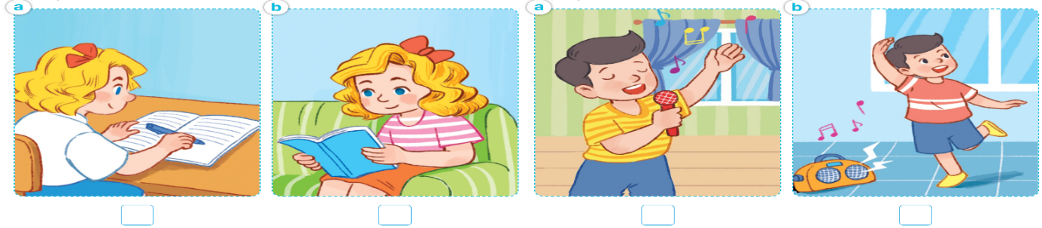

**Question 3: Listen and write one word ( 1pt)**

1.There’s a …… in my bedroom .It’s small.

2.There’s a bed in my bedroom**.** It’s ………..

3.There’re two …… in my bedroom .They‘re big.

4.There’re …… chairs in my bedroom .They’re small.

**Part II: Reading**

**Question 4: Odd one out (1.5 pts)**

1. a. singer b. doctor c. play d.teacher
2. a. am b. is c. my d. are
3. a. living room b. chair c. bedroom d. kitchen
4. a. book b**.** lampsc. tablesd. chairs
5. a. play b. dance c. writing d. listen
6. a. drawing b. singing c. write d. reading

**Question 5: Choose the best answer (1.5 pts)**

1. What is he doing? He is…….badminton
2. cycling b. playing c. doing d. does
3. My mother………cooking.
4. Are b. is c. am d. doing
5. ………….is she doing? She’s skipping.
6. Where b. Does c. What d. How
7. Where is the cat?............. is on the table.
8. It b. They c. He d. She
9. How many …….. do you have? I have many. 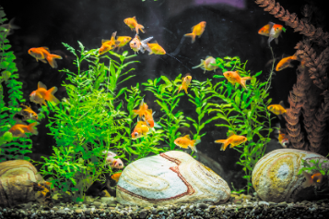
10. goldfish b. cat c. dogs d. parrots
11. I have…….parrot and………rabbits.
12. a- two b. a- an c. one- one d. two- two

**Question 6: Read and complete (1.5pts)**

|  |  |  |  |  |  |
| --- | --- | --- | --- | --- | --- |
| **nurse** | **big** | **four** | **in** | **rooms** | **bathroom** |

This is my family. These are (1)________ people in my family: my father, my mother, my sister and me. My father is a doctor. My mother is a (2)_______. Look at my house. There are five (3) ________ in my house. The living room is here. It is (4)_______. That is the kitchen and the (5)______. There are two bedrooms. There is a desk and a chair (6)_____ my bedroom. I love my family very much.

**Part III: Writing**

**Question 7: Look at the pictures and write the word (1pt)**

 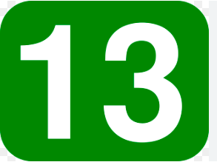

1………………………….. 2……………………………..

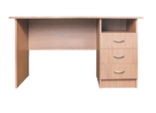   
  
3………………………….. 4 ……………………………….

**Question 8: Arrange the words to make sentences (1.5pts)**

1. see/ can/ a/ I/ monkey/ and/ elephant/ an.

……………………………………………………………………

1. monkey/ a/ is/ tree/ a/ climbing

……………………………………………………………………

1. at/zoo?/ can/ the/ What/ see/ you

……………………………………………………………………

1. do/ I/ like/ not/ milk

……………………………………………………………………

1. would/ like/ some/ I/ chicken

……………………………………………………………………

1. you/ drink/ What/ to/ like/ would ?

……………………………………………………………………