**ĐỀ 14**

**PART I: LISTENING**

**Question 1: Listen and number (1pt)**

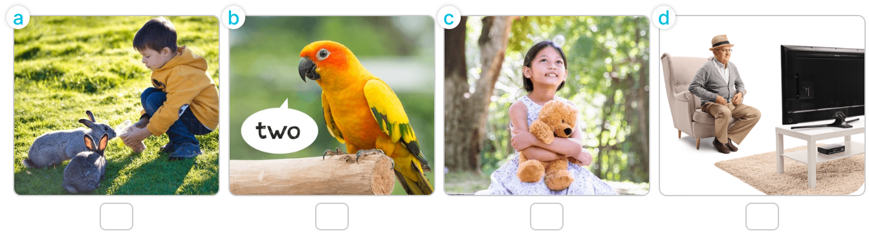

**Question 2: Listen and circle (1pt)**

1. I’m __________.

A. watching cartoons B. watching TV C. watching a video

2. I’m __________.

A. painting B. walking C. drawing

3. I’m playing __________.

A. volleyball B. basketball C. badminton

4. I’m __________.

A. listening to music B. reading books C. singing a song

**Question 3: Listen and complete (1pt)**

1. A: How old is your brother?

B: He’s ________________ years old.

2. A: What’s his job?

B: He’s a ________________.

3. A: Where are the ________________?

B: They’re on the table.

4. A: Would you like some ________________?

B: Yes, please.

**PART II: READING**

**Question 4: Odd one out (1.5pt)**

1. A. who B. how C. what D. were

2. A. chair B. lamp C. desks D. bed

3. A. dancing B. listening C. reading D. morning

4. A. living room B. window C. bathroom D. kitchen

5. A. doctor B. cooker C. worker D. teacher

6. A. he B. they C. my D. you

**Question 5: Choose the best answer (1.5pt)**

1. Do you _________ any birds?

A. have B. having C. has D. haves

2. What's Lucy doing? - _________ flying a kite.

A. Lucy B. She C. She'd D. She's

3. I have _________ rabbit.

A. an B. some C. one D. many

4. _________ is drawing a picture.

A. Linh and Ha B. Tony C. I D. They

5. How many _________ do you have?

A. parrot B. goldfish C. rabbit D. dog

6. My brother is _________ badminton.

A. play B. plays C. playing D. playes

**Question 6: Read and complete (1.5pt)**

**likes – dining – drinks – like – rice – some**

Nam and his family are at the (1) ______________ table. There is a lot of food and (2) ______________ on the table. His father and mother would (3) ______________ some rice, beans and some water. His sister would like (4) ______________ bread, meat and some milk. Nam would like some (5) ______________, fish and some juice.

**PART III: WRITING**

**Question 7: Look at the pictures and write the words (1pt)**

|  |  |
| --- | --- |
| https://img.hoclieu.vn/sgv_TA/lop_3/unit11/U11-L1-3.png | https://img.hoclieu.vn/hoclieu/SHStuhoc/SHSTA3/Unit1/U14-2_t_638085062275489646%201_t_638147321559883935.png |
| 1. This is my _________________. | 2. The _________________ are small. |
| https://img.hoclieu.vn/ktdg/english/SHS3/Unit%201/Review3_listen-n-number_H4_t_638155007889212971_t_638164765800909474.png | https://img.hoclieu.vn/sgv_TA/lop_2/jpeg-optimizer_Mask%20group%20(1).jpg |
| 3. There are _________________ lamps. | 4. He's _________________ years old. |

**Question 8: Arrange the words to make sentences (1.5pt)**

1. like / Tuan / eat / to / would / you / What / , / ?

⭢ _________________________________________________________________________________

2. to / My / like / juice / brothers / some / would / drink / .

⭢ _________________________________________________________________________________

3. can / many / zoo / the / see / animals / at / Linh / .

⭢ _________________________________________________________________________________

4. rice / some / you / like / Would / chicken / with / ?

⭢ _________________________________________________________________________________

5. tree / A / a / climbing / tiger / is / .

⭢ _________________________________________________________________________________

6. and / would / water / please / noodles / I / some / like / , / .

⭢ _________________________________________________________________________________