**ĐỀ 16**

**PART I : Listening**

**Question 1 : Listen and number**

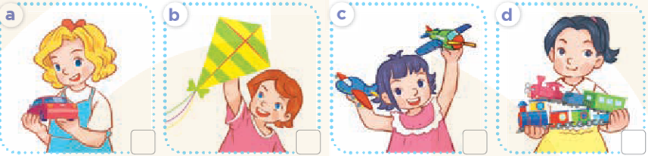

**Question 2: Listen and tick**

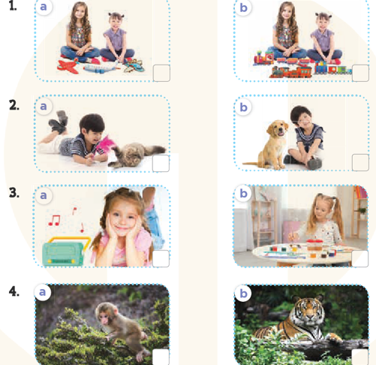

**Question 3: Listen and complete**

***1*.** What’s he doing? **3.** What’s ….…doing?

 He’s ……….  She’s cycling

**2.**What’s he doing? **4.** What’s she doing?  
    He’s flying a …..  She’s ………

**PART II : Reading**

**Question 4:Circle the odd one out** 

**1**. a. mother        b. bear            c. father d.brother

**2**. a. doctor          b. teacher          c. driver d,sister

3. a. bathroom      b. bedroom           c. house d.livingroom

**4**. a. sing         b. watching         c. listening d playing

**5**. a.doctor b teacher c job d farmer

**6**.a.table b. bedroom c.kichen d bathroom

**Question 5 Choose the best answer**

1.What’s his job? a She’s adoctor b.He’s a doctor cIt’s a doctor

2.Is your mother a teacher? a.Yes, she is b. Yes, he is c. Yes, it is

3 What’s Mai doing? a.she’s running b.he’s running c.she’s runing

4.What’s he doing? a.he’s skateing b.he’s skate c.he’s skating

5.What’s ………..job? She’s a famer. a.his b.your c.her

**Question 6: Read and complete**

|  |  |  |  |  |
| --- | --- | --- | --- | --- |
| **is** | **some** | **bedroom** | **are** | **a** |

This is my (1) _______________. It is big. There is (2) _______________ bed. There is a desk. There are two chairs. There are (3) _______________ windows. The bed (4) _______________ big. The desk is old. The chairs (5) _______________ new. The windows are small.

**PART IV:WRITING**

**Question 7: Look at the pictures and write the words .**

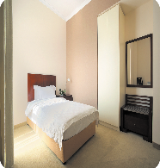**1.**There’s a ………..in the bedroom.

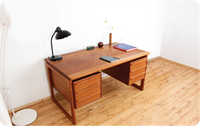**2.**There’s a…….. in the living room.

**3.**There’s a door in the room.It’s………………… .

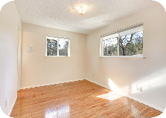**4.**There are two windows in the room. They’re……………

**Question 8: Arrange the words to make sentenmces (1,5pt)**

1. is / playing / She / badminton / .

.......................................................................................................................

2 would / drink you / / what / to / like

.......................................................................................................................

3. doing / What’s / the / monkey / ?

………………………………………………………………….

4 like / you / some/ milk/ would / ?

……………………………………………………………………………

5 .can /you /see /what /?

……………………………………………………………………………………

6 doing / the / is / what / elephant / ? /