SỐ 3 | ĐỀ THI HỌC KỲ II  MÔN TIẾNG ANH LỚP 4  NĂM HỌC 2023 - 2024  (Thời gian làm bài: 40 phút)
PART I: LISTENING
Question 1: Listen and number (1pt)
 |  |  | 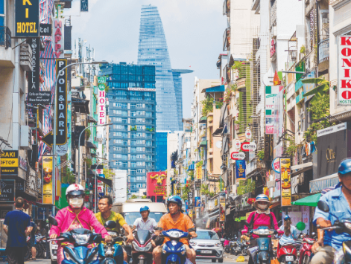

Question 2 : Listen and tick or cross( 1pt)
 |  |  | 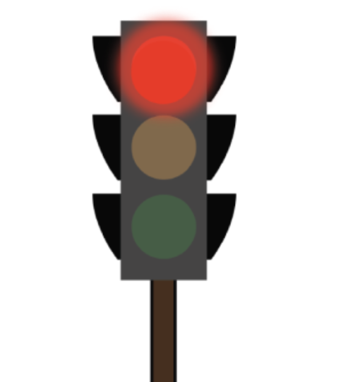

Question 3: Listen and complete (1pt)
- Hi Minh . Where………… you last weekend ?
I was in Sapa
Great ! I ................... Sapa
- What was the …………….. like in Sapa ?
It ………………sunny.
PART II: READING
Question 4: Choose the words which have stress different from the others
1. A.email B. behind C. visit
2. A. between B. bookshop C. sunny
3. A. loudly B. rainy C. behind
4.A. campsite B. between C. quickly
Question 5: Odd one out
1. A. juice B. bathroom C. meat D. noodles
2. A. juice B. meat C. lamp D. rice
3. A. paint B. run C. walk D. badminton
4.A tiger B. Zoo C. Monkey D. Peacock
5. A. Painting B. Skating C. skipping D. tiger
Question 6: Choose the best answers

1. _____does he work? He works on a farm.
A. What B. How C. Who D. Where
2. My brother is big______tall.
A. and B. so C. because D. though
3. He is a worker. He works at a ______.
A. factory B. school C. Farm D. hospital
4. What does your mother _____like? She’s slim.
A. looking B. look C. looks D. looked
5. He ______at a nursing home.
A. working B. works C. work D. worked
Question 7: Read tick True or False. ( 1pt)
Linda and her family live in a small flat . It is in a very quiet and noisy street . There are many trees in the street . At the weekend . Linda and her brother visit their grandparents . They live in a big house in a busy town . There are many shops in the town . Linda likes the town.
F
T

- Linda and her family live in a big house
- Her house is in a beautiful street
- Her grandparents live in a big house
- The town is busy
Question 8 : Look at the pictures and write and write (1pt)
 | 1. It was ………………..
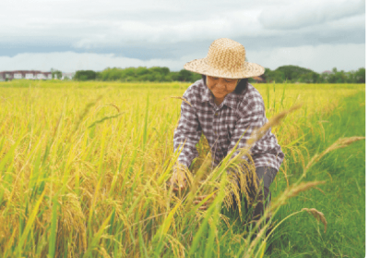 | 2. She is ………….…….
 | 3.What does he do ?  He’s ………………...
 | 4. It was .........................

Question 9. Reorder the words to make sentences. (1pt)
- does / What / look / like / she ?
………………………………………………………………………………
- They/ crocodiles / are
………………………………………………………………………………
- are / What / these animals / ?
……………………………………………………..…………………………
- My / short hair / has / brother .
.…………………………………………………………………....…………
- is / tall / My teacher / very .
………………………………………………………………………………
6. like birds / do / Why / you ?. …………………..…………………..…………………………………………

