|  |  |
| --- | --- |
| UBND HUYỆN VĨNH BẢO  **TRƯỜNG TH TÂN HƯNG**  Đề đề xuất | **ĐỀ KHẢO SÁT CHẤT LƯỢNG HỌC KỲ 1**  **MÔN TIẾNG ANH LỚP 4**  **NĂM HỌC 2023-2024**  *(Thời gian làm bài: 40 phút)* |

**Part I . Listening .**

**Question 1 : : Listen and tick.**

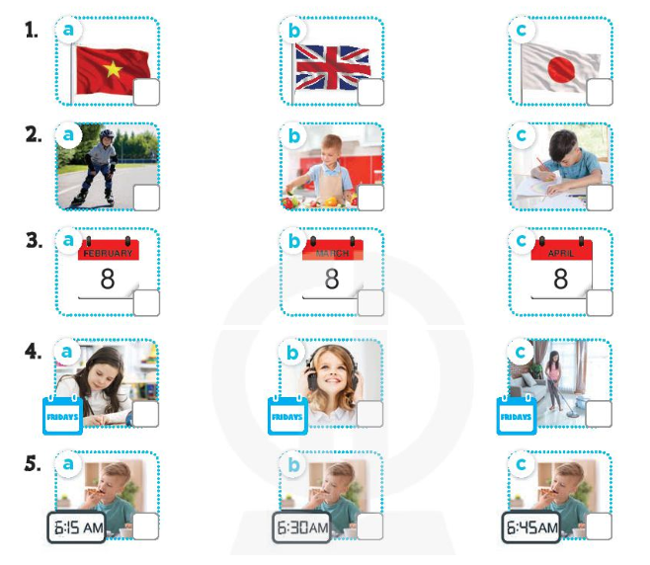

**Question 2 :Listen and number**

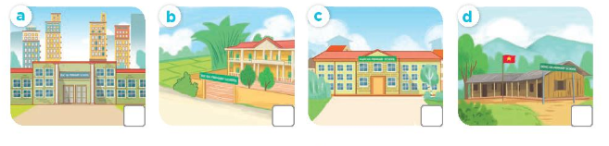

**Question 3 : Listen and complete .**

1. A: What's she doing?

B: She's……………….(1).

A: Can you ride a horse?

B: (2) ………..

2. A: Can you play the piano?

B: No,…………(3)..

A: Can you play(4)……………..?

B: Yes, I can. I can do it well!

**Part II. Pronunciation.**

**Question 4. Odd one out**

1. A.America B.Australia C.Japan D.from
2. A.six o’clock B.six –thirty C.go to school D.six –fifty
3. A.May B.chips C.jam D.juice
4. A.September B.Monday C.October D.November
5. A.beach B.campsite C.countryside D.Tokyo

**Part III. Reading**

**Question 5 *.*Circle an underlined word that has a different pronunciation**

1,A**.**dr**a**w B.pl**a**ce C.h**a**te D.d**a**te

2,A.st**u**dy B.m**u**sic C.S**u**nday D.s**u**bject

3,A.c**i**ty B.h**i**s C.v**i**llage D.sc**i**ence

4.A.**ch**ip B.tea**ch**er C.s**ch**ool D.**ch**icken

**Question 6 .Look and read: *Choose the best answer***

1,………..is it today?

A,What B,Where C.What day

2,What do you do on Mondays?>>>>I ………..at school.

A,study B,do C.have

3,Can you ride a bike?>>>>…………..,I can.

A,No B.Yes C.True

4,Can he roller skate?>>>No, ……… .He can swim.

A,He can’t B,I can’t C.He can.

5,Why do you like……………?Because I want to be an English teacher.

A,Maths B.Vietnamese C.English

**Question 7. *Read and complete***

Dear pen friend,

My name’s Bill. I’m from Britain. I’m nine years old. My birthday’s in March. It’s coming soon. I want some chips and some lemonade at my party. What about you? When’s your birthday? What do you want to eat and drink at your party?

Write to me soon.

Bill

1. Bill is from _______.

2. His birthday is in _____.

3. He wants some _____.

4. He want some ______.

**Part IV. Writing.**

**Question 8:Look at the pictures and write the words**



**1……………… 2 ……………… 3…………………… 4 ………….........**

**Question 9. Arrange the words to make sentences.**

1,from/is/She/Japan.

………………………………………………………………………………..

2,ride/you/horse/Can/a?

………………………………………………………………………………..

3.,she/ No/roller skate. /can’t,/but / can/ she/

……………………………………………………………………………….

4. your /subject? /What’s/ favourite/

……………………………………………………………………………………..

5, want/ teacher./to /I be /a /Because/Vietnamese

……………………………………………………………………………………

6 like,/I/ because /I/ a /singer /want/ music /to be/.

…………………………………………………………………………………………

**Đáp án và biểu điểm**

**Lớp 4**

Part I. Listening

Question 1 : Listen and tick. 5 câu X 0,2 = 1 đ

1-c 2-a 3-c 4-b 5-c

Question 2 :. Listen and number 4 câu x 0,25 = 1đ

1-c 2-d 3-a 4-b

Question 3. Listen and complete. 4 câu x 0,25 = 1đ

1.riding a horse 2.Yes, I can 3. I can't 4. the guitar

II. Pronunciation

Question 4. 5 câu x 0,25 = 1,25đ

1.D 2.C 3.A 4.B 5.D

Question 5. 4 câu x 0,25 = 1 đ

1-A 2-B 3-D 4-C

Question 6. 5 câu x 0,25 = 1,25 đ

1.C 2.A 3.B 4.A 5.C

Question 7. 4 câu x 0,25 = 1 đ

1. Britain. 2. March. 3. chips. 4. lemonade.

Question 8. 4câu x 0,25 = 1 đ

1.October 2,grapes 3,go to school 4,on the beach

Question 9:6 câu x 0,25 = 1,5đ

1.She is from Japan .

2.Can you ride a horse?

3.No,she can’t,but she can roller skate.

4.What’s your favourite subject?

5,Because I want to be a Vietnamese teacher.

6,I like music because I want to be a singer.