|  |  |
| --- | --- |
| **PEOPLE’S COMMITTEE OF AN LAO DISTRICT**  **AN THANG PRIMARY SCHOOL** | **THE MIDLE FIRST SEMESTER TEST**  **Subject: English 3 - Time: 35'** |

Name: ........................................................................................ Class: 3…

**Question1. Listen and number. (1 pt)**

|  |  |  |  |
| --- | --- | --- | --- |
| https://s.sachmem.vn/public/images/TA3T1SHS/U8-L1-4-2-xedxjpbynodvcjsx.jpg  A. | https://s.sachmem.vn/public/images/TA3T1SHS/R1-1-3-bxtxehiodpskwwgm.jpg  B. | https://s.sachmem.vn/public/images/TA3T1SHS/U6-L1-4-1-cmrhkymvvfepydzo.jpg  C. | https://s.sachmem.vn/public/images/TA3T1SHS/R1-1-2-jehzdqiwigfvnkkv.jpg  D. |

**Question 2. Listen and tick. (1 pt)**

|  |  |
| --- | --- |
| **1. https://s.sachmem.vn/public/images/TA3T1SHS/U2-L2-4-1-dfzaadwnlzolegmz.jpg A** | **https://s.sachmem.vn/public/images/TA3T1SHS/U2-L2-4-4-gpyhimkvqomsbjfs.jpg B** |
| **2. https://s.sachmem.vn/public/images/TA3T1SHS/U6-L2-5-3-yqvosrajkrtliinf.jpg A** | **https://s.sachmem.vn/public/images/TA3T1SHS/U6-L2-4-2-uysbuoumyfinmchv.jpg B** |
| **3. https://s.sachmem.vn/public/images/TA3T1SHS/U7-L1-4-3-owaemhjtsmwgspwu.jpg A** | **https://s.sachmem.vn/public/images/TA3T1SHS/U7-L1-4-2-aovwlkuzskfkxaak.jpg B** |
| **4. https://s.sachmem.vn/public/images/TA3T1SHS/U8-L1-4-6-tpeqkgrkhvqfeahy.jpg A** | **Kết quả hình ảnh cho pencil sharpener B** |

**Question 3. Read and match.(1pt)**

|  |  |  |
| --- | --- | --- |
| **1**. Hello, Tom. | **a**. My name’s Linda. | 1 - ............. |
| **2**. What’s your name? | **b**. Yes, it is. | 2 - ............. |
| **3**. How do you spell you name? | **c**. Hi, Tony. | 3 - ............. |
| **4**. Is this your pen? | **d**. M - A - I | 4 - ............. |

**Question 4 *: Look and complete these words, using the given letters .(1pt)***

***ss - oo - en      - ci    - in***

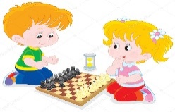

*Ví dụ*:         0. I play che_ss_

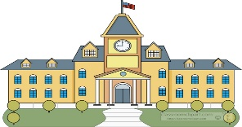



1. Op­­­__ __ y­­our book, please ! 3. My sch__ __l is big.

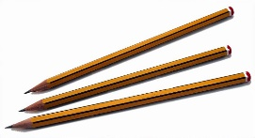   
 2. They are my pen__ __ ls. 4. I like badm__ __ton.

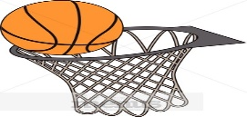**Question 5: Look and circle the best answer.(1pt)***1.* I play_________

A. basketball B. badminton C. chess

|  |  |
| --- | --- |
| 1.They are my_________________  A. notebooks  B. pencil cases  C. rulers | 2.I play ____________________   1. table tennis 2. B. football 3. C. chess |
| 3.Do you like____________?  A. hide-and-seek  B. skating  C. skipping | 4.I'm_________________ years old.  A. ten  B. eight  C. six |

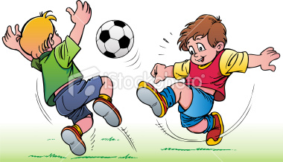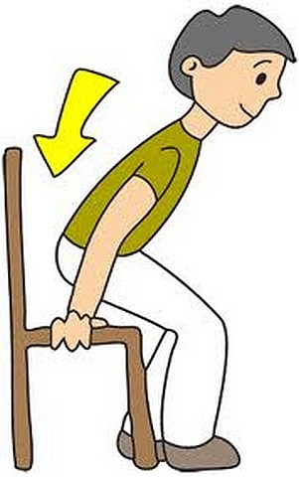

5. We play…………………………… 6. A. stand up

A. football B. sit down

B. chess C.come in

C.badminton

**Question 6*: Re-order the words to make the sentences.(2pts)***

1. your / Open / , please. / book 🖎..............................................................................
2. your / What / name ? / is 🖎.............................................................................
3. you / much. / Thank / very🖎............................................................................................

4. do / How / spell/you/ your/ name? 🖎..............................................................................

**Question 7*: Read and complete the paragraph with the suitable word.* (1pt)**

**nine - name - school - is**   
Hello. My (1)_____________ is Nga. I'm (2)______________years old. I'm in class 3A. This is my (3)__________________­­­­­_. It's big. It has ten classrooms, a gym, a library and a computer room. It (4) _____________ very beautiful.

**Speaking: ( 2pts)**

**The end.**

**KEY FOR TEST – GRADE 3**

|  |  |  |  |
| --- | --- | --- | --- |
| **Question** | **Answer** | **Point** | **Total** |
| 1 | 1.c 2.a 3.d 4.b | 0.25/ each | 1 |
| 2 | 1. A 2.B 3.B 4.A | 0.25/ each | 1 |
| 3 | 1.F 2.T 3.F 4.T | 0.5/ each | 2 |
| 4 | 1.c 2. a 3. d 4. b | 0.25/ each | 1 |
| 5 | . No 2. Yes 3. Yes 4.No | 0.25/ each | 1 |
| 6 | 1. Hello 2. school  3.book 4. sit | 0.25/ each | 1 |
| 7 | 1. school bag 2.pen  3. pencils 4.notebooks. | 0.5/ each | 2 |

**SPEAKING TEST**

1. **Getting to know each other**

***Ask 3 questions below***

1.What is your name?

2.How are you?

3.How do you spell your name?

1. **Talking about a familiar object**

***Give some school things and ask some question***

1. What is this?
2. What colour is it?
3. What are they?
4. What colour are they?
5. **Describing the picture**

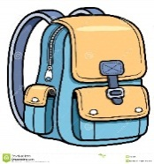

* + - 1. What’s this?
      2. Is it big?
      3. What colour is it?