PEOPLE’S COMMITTEE OF AN LAO DISTRICT  AN THANG PRIMARY SCHOOL  ------------------------- | THE MIDDLE FIRST SEMESTER TEST  Subject: English 4 - Time: 35'

Name: ........................................................................................ Class:4….
Question 1: Listen and number:(1pt)
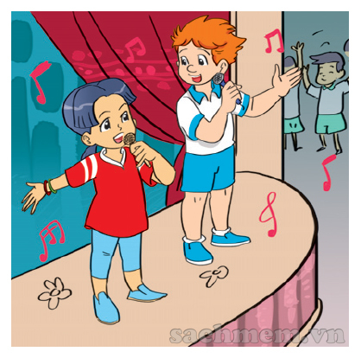 | A |  | B |  | C | 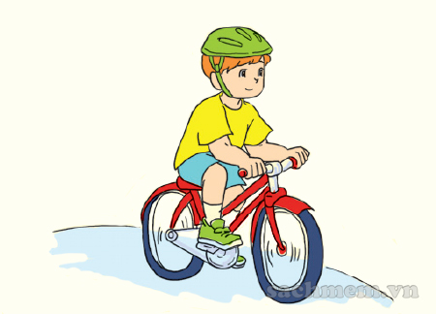 | D
Question 2: Listen and tick:( )(1pt)
1. 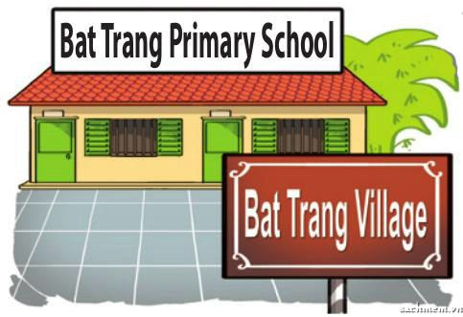 A. |  B | 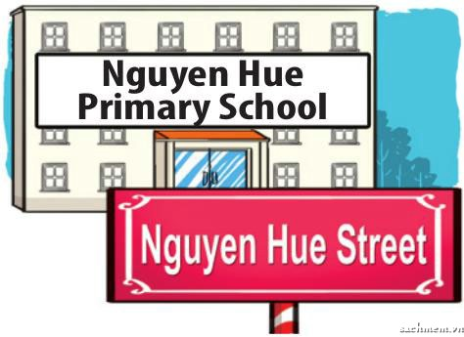 C
2. A |  B | C
3. 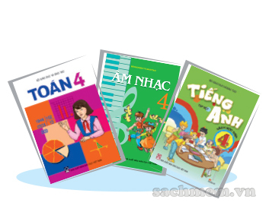 A | 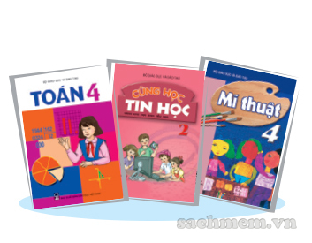 B |  C
4. 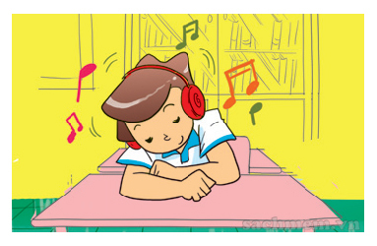 A | 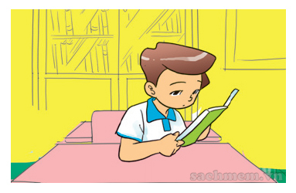 B | 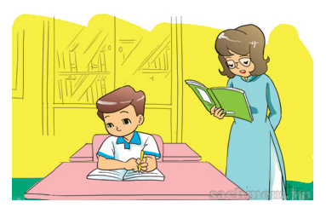 C
Question 3: Listen and complete (1pt)

A. What day is it today Tom? It’s(1)…………………..(Monday / Tuesday)
B. Do you have (2)…….……....… (English / Maths) today? Yes, I do.
C. What subjects do you have today?
I have(3)………..………..(Science / Vietnamese) , Maths and English.
D. Oh! We’re late for school. Let’s (4) ...........................(walk / run).
Question 4 : Read and write the suitable words in the gaps.(1pt)
Dear penfriend,
Hi! My name is Mai. I’m nine years old. I’m a pupil at Nguyen Du Primary School. I’m Vietnamese. I like collecting stamps. I have a lot of stamps. I don’t like playing chess. This is a photo of me. I really want a penfriend.
Please write to me: mai@english.com.vn.
0. Mai is (0) __________nine_______years old.
1.She is a pupil at Nguyen Du (1)______________ school.
2. She likes collecting (2)___________.
3 She doesn’t like playing (3)_______________
4. She wants a (4)_________________.
Question 5 : Fill in each gap with a suitable words from the box (1 pt)
Primary | sing | November | Viet Nam | name
[
Hi. My (0)___name_____ is Nam. I’m from ( 1 ) ………………………... I’m 11 years old. My birthday is on the third of (2)………………………….I study at Le Hong Phong (3)…………………………………..School. I like Music very much. In my free time, I go to Music club. I can (4)…………………………… but I can’t play the piano.
Question 6 : Look at the pictures and the letters. Write the words. (1 pt)
0. apino | 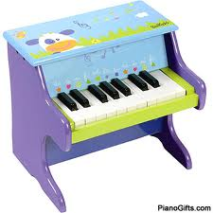 | ___________piano__________
1. aEngndl |  | _________________________
2. rtA | 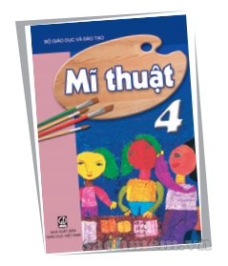 | _________________________
3. dSuany | 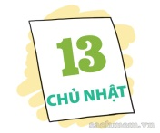 | _________________________
4. Setpebmer |  | _________________________
Question 7: Order the words to make sentences(2 pts)
1. go/to/school /I/the/ in/ morning.
…………………………………….....................................................................
2.have/on/English/I/Tuesdays/Thursdays/and/./
………………………………….......................................................................
3. can / you/ do/ What?
…………………………………………………………………………………
4. your/ birthday/ When/ is?
…………………………………………………………………………………
SPEAKING. (2pts)
The end

MA TRẬN HKI MÔN TIẾNG ANH 4

Kỹ năng | Nhiệm vụ đánh giá/kiến thức cần đánh giá | Mức/Điểm |  |  |  | Tổng số câu, số điểm, tỷ lệ %
Nghe | Nhiệm vụ đánh giá/kiến thức cần đánh giá | M1 | M2 | M3 | M4 | 12 câu  4 điểm  40%
Nghe | Listen and number | 2  0,5đ | 1  0,25đ | 1  0,25đ |  | 12 câu  4 điểm  40%
Nghe | Listen and tick | 1  0,25đ | 1  0,25đ | 1  0,25đ | 1  0,25đ | 12 câu  4 điểm  40%
Nghe | Listen and complete | 2  1,0đ | 1  0,5đ | 1  0,5đ |  | 12 câu  4 điểm  40%
Đọc | Read and write the suitable words in the gaps. | 1  0,25đ | 1  0,25đ | 1  0,25đ | 1  0,25đ | 8 câu  2 điểm  20%
Đọc | Fill in each gap with a suitable words from the box. | 1  0,25đ | 1  0,25đ | 1  0,25đ | 1  0,25đ | 8 câu  2 điểm  20%
Viết | Look at the pictures and the letters. Write the words | 2  0,5đ | 1  0,25đ | 1  0,25đ |  | 8 câu  3 điểm  30%
Viết | Order the word to make sentences | 1  0,5đ | 1  0,5đ | 1  0,5đ | 1  0,5đ | 8 câu  3 điểm  30%
Nói | Getting to know each other | 2  0,5đ | 1  0,5đ |  |  | 10 câu  1 điểm  10%
Nói | Talking about familiar object | 1  0,25đ | 3  0,75đ |  |  | 10 câu  1 điểm  10%
Nói | Describing the picture |  | 1  0,25đ | 1  0,25đ | 1  0,5đ | 10 câu  1 điểm  10%
Tổng |  | 13  34% | 12  32% | 8 21% | 5 13%

KEY FOR TEST – GRADE 4

Question | Answer | Point | Total
1 | 1. C 2. B 3. D 4. A | 0.25/ each | 1
2 | 1. A 2. B 3. A 4. C | 0.25/ each | 1
3 | 1. Monday 2.Maths 3.Vietnames 4.run | 0.5/ each | 2
4 | 1. primary 2.stamps  3. chess 4. penfrien | 0.25/ each | 1
5 | 1. Viet Nam 2. November 3.Primary 4. Sing | 0.25/ each | 1
6 | 1. England  2. Art  3.Sunday  4.September | 0.25/ each | 1
7 | - I go to school in the morning.  - I visit my grandparents in the moring.  - My birthday is on the third of December.  - I have English on Tuesdays and Thursdays | 0.5/ each | 2

SPEAKING TEST
I.Getting to know each other
Ask 3 questions below
1.What is your name?
2.How are you?
3.How do you spell your name?
II.Talking about a familiar object
Ask some questions
What day is it today?
What is the date today?
Where your birthday?
III.Describing the picture
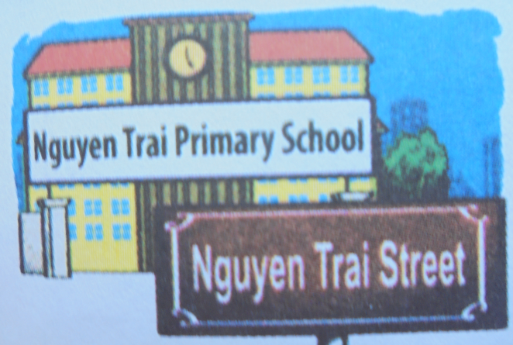
?

      - What is the name of your school?
      - Where is it?
      - Is it big?

