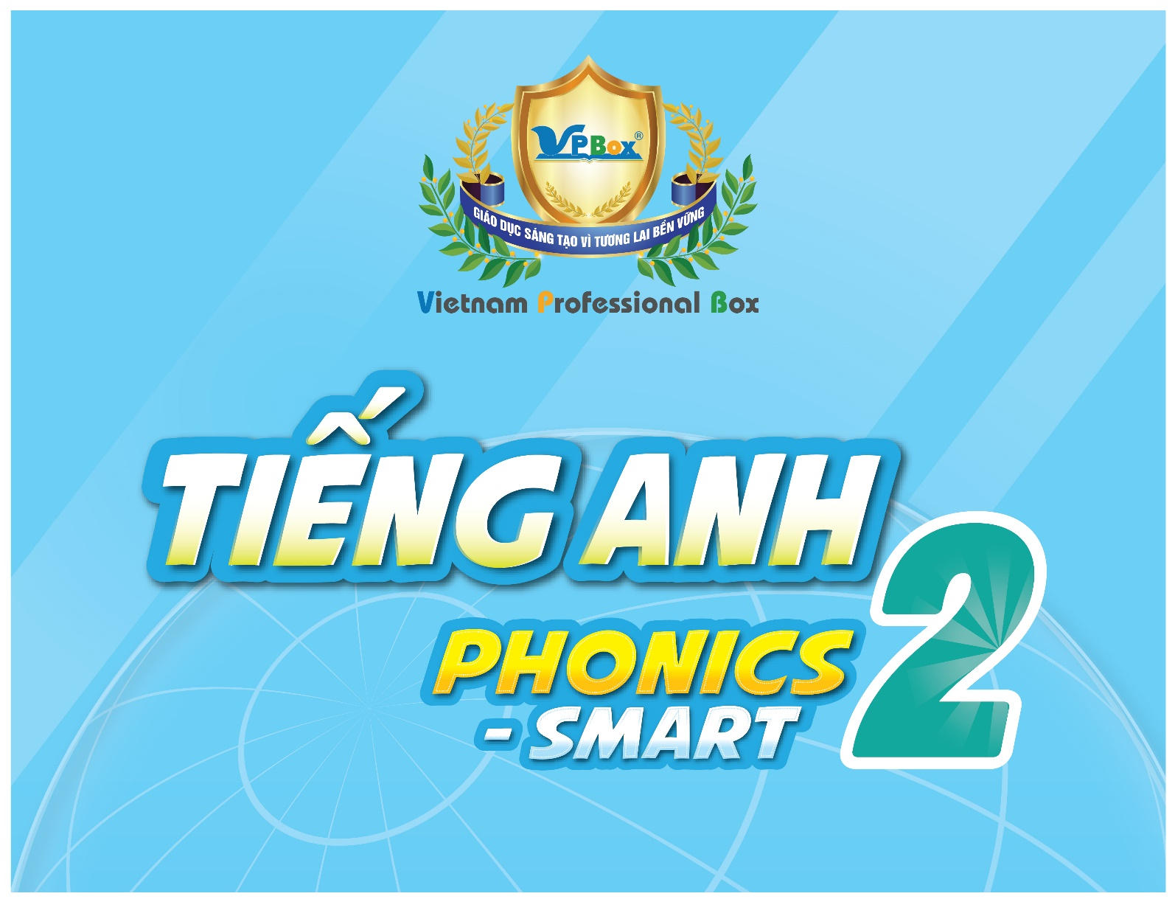

|  |  |
| --- | --- |
| **TIẾNG ANH 2 PHONICS-SMART**  **TERM 2 (2023 – 2024) – TEST** | |
| **For pupil**  **Full name: ………………………………………………**  **School: ………………………………………………**  **Class: ………………………………………………**  **Date:**  **………………………………………………** | **For examiner: Code: T2_PS2**  ***Section 1: Listening*: ………/ 2.5 pts**    ***Section 2: Reading:* ………/ 2.5 pts**    ***Section 3: Writing:* ………/ 2.5 pts**    ***Section 4: Speaking:* ………/ 2.5 pts**    **Total: *………/* 10 pts**  **For teacher (signature)** |

**SECTION 1 – LISTENING (2.5 pts)**

**Part I. Listen and number the pictures. There is one example. (1.25 pts)**

|  |  |  |  |  |  |
| --- | --- | --- | --- | --- | --- |
|  |  |  |  |  |  |
| **0** |  |  |  |  |  |

**Part II. Listen and tick (✓) the box. There is one example. (1.25 pts)**

|  |  |  |  |  |  |  |
| --- | --- | --- | --- | --- | --- | --- |
|  | **Example** | A |  | B |  | C  **✓** |
| **1.** |  | A |  | B |  | C |
| **2.** |  | A |  | B |  | C |
| **3.** |  | A |  | B |  | C |
| **4.** |  | A |  | B |  | C |
| **5.** |  | A |  | B |  | C |

**SECTION 2 – READING (2.5 pts)**

**Part I. Read and match. There is one example (1.25 pts)**

**Example**

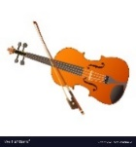I see a bag. ⚫ ⚫ A.

1. This is my grandma. ⚫ ⚫ B.



1. This is a violin. ⚫ ⚫ C.

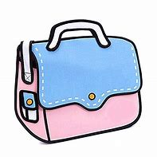

1. I’d like new shoes. ⚫ ⚫ D.

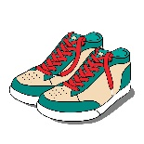

1. The cat is next to the box. ⚫ ⚫ E.

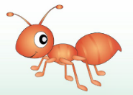

1. The ant has got six legs. ⚫ ⚫ F.

**Part II. Look and read. Put a tick (✓) or a cross (x) in the box.**

**There are two examples. (1.25 pts)**

|  |  |  |  |
| --- | --- | --- | --- |
| **Examples** |  | This is my brother. | **☑** |
| Image result for a pink dress cartoon | There is a blue dress. | **⮽** |
| 1. |  | There is a window. | 🞎 |
| 2. | Image result for a chair cartoon | This is a sofa. | 🞎 |
| 3. | Free Dog Clipart - Clip Art Pictures - Graphics - Illustrations | The dog has got a ball. | 🞎 |
| 4. |  | There are eleven robots. | 🞎 |
| 5. |  | This is a green yo-yo. | 🞎 |

**SECTION 3 – WRITING (2.5 pts)**

**Part I. Look at the pictures. Look at the letters. Write the words.**

**There is one example. (1.25 pts)**

**x**

**o**

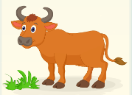**Example**

_ _

**o**

**xan**

**l**

**w**

**l**

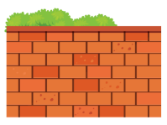

**a**

1. **__ __ __ __**

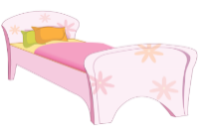

**b**

**e**

**d**

**a**

**w**

**d**

**r**

1.  **__ __ __**

 3.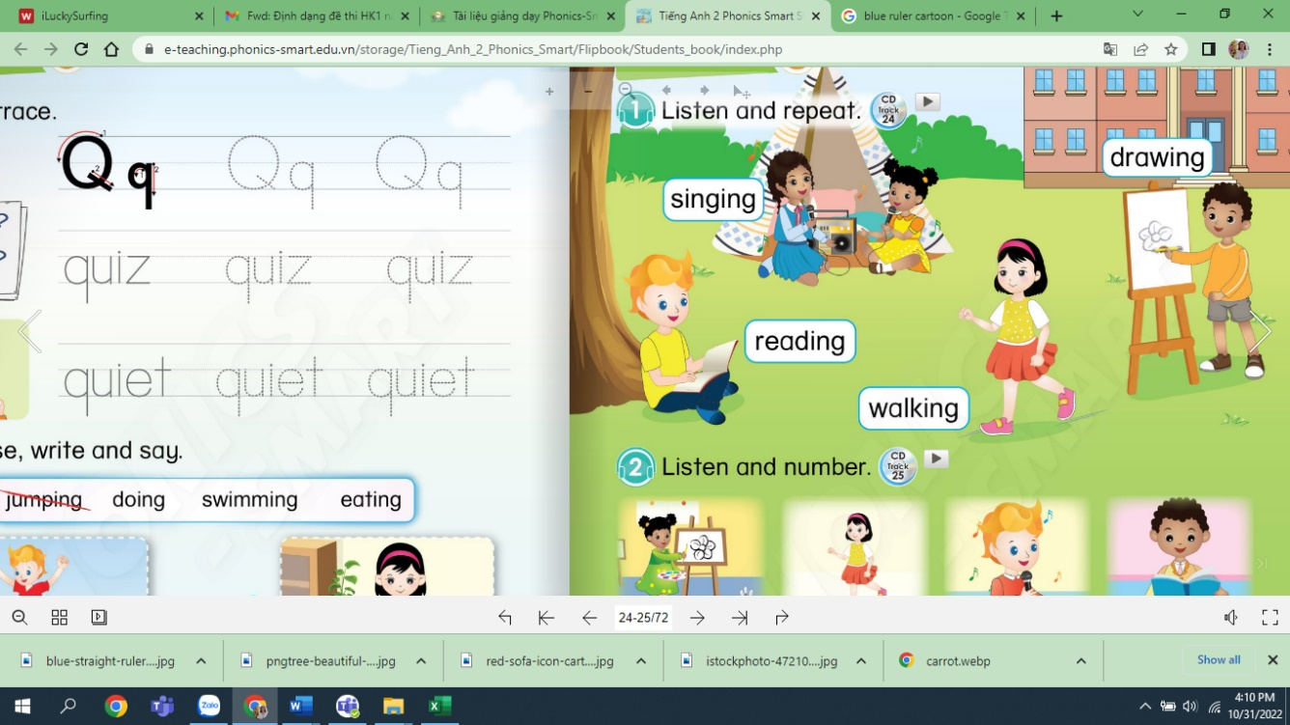 **__ __ __ __**

**t**

**e**

**s**

**v**

**t**

**br**

**o**



**ar**

 4. **__ __ __ __**

**c**

**h**

**a**

**y**

5. **__ __ __** **__ __**

**t**

**Part II.** **Fill in the blanks with the correct words.**

**There is one example. (1.25 pts)**

**chair guitar robots twelve fox uncle**



**Example** 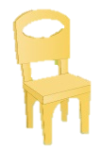 This is my **uncle**.

1. I see a __________.

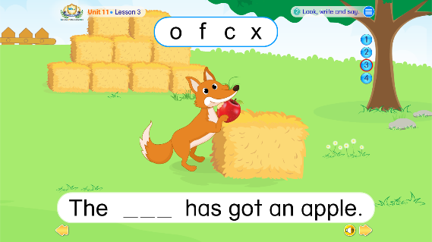

1. The __________ has got an apple.

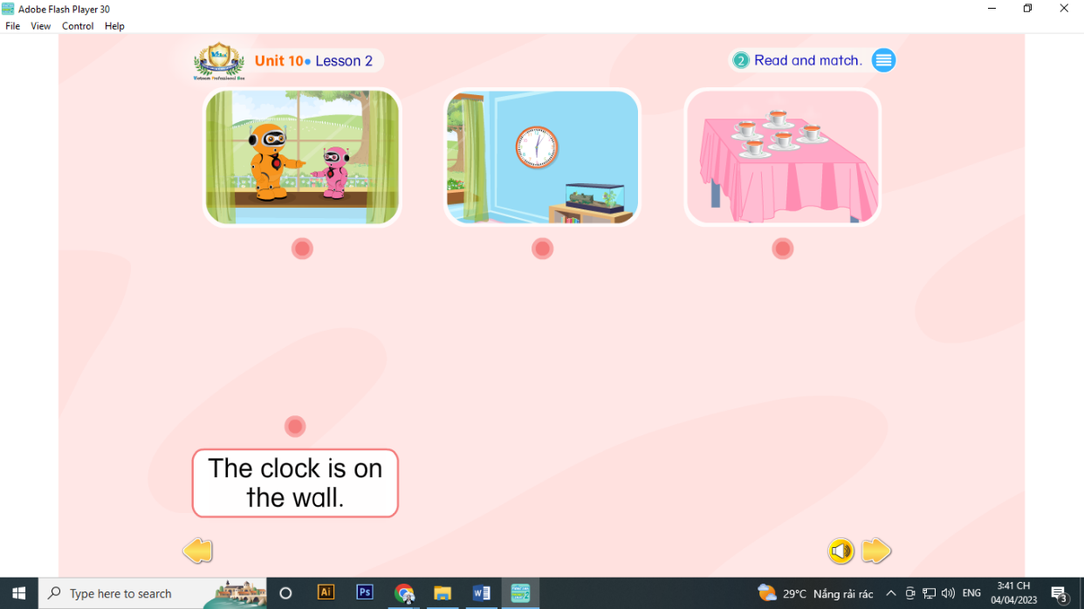

1. The __________are at the window.



1. I’d like a new __________.

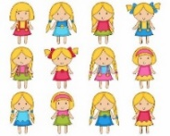

1. There are __________ dolls.