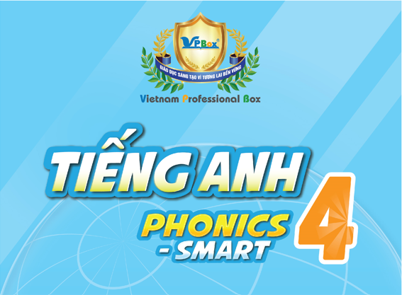

TIẾNG ANH 4 PHONICS-SMART
TERM 2 (2023 – 2024) – TEST
For pupil  Full name: ………………………………………………  School: ………………………………………………  Class: ………………………………………………  Date:  ……………………………………………… | For examiner: Code: T2_TADA_PS4  Section 1: Listening: ………/ 2.5 pts  Part I ………/ 1.25 pts  Part II………/ 1.25 pts  Section 2: Reading: ………/ 3 pts  Part I ………/ 1 pt  Part II………/ 1 pt  Part III……/ 1 pt  Section 3: Writing: ………/ 2 pts  Part I ………/ 1 pt  Part II………/ 1 pt  Section 4: Speaking: ………/ 2.5 pts  Total: ………/ 10 pts  For teacher (signature)

SECTION 1 – LISTENING (2.5 pts)

Part I. Listen and tick (✓) the correct picture. There is one example. (1.25 pts)

0. What does Tommy do on Monday evening?
 |   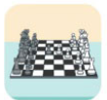   |  |  |  |  | 



1. When is Lucy’s birthday?
 |  |  |  |  |  | 
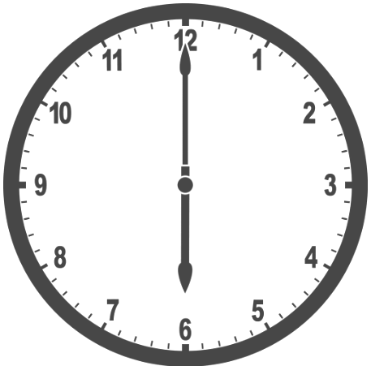
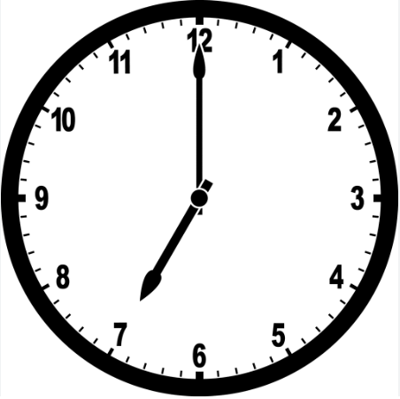
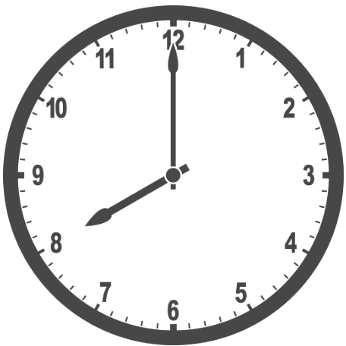
2. What time does Rita’s sister get up?
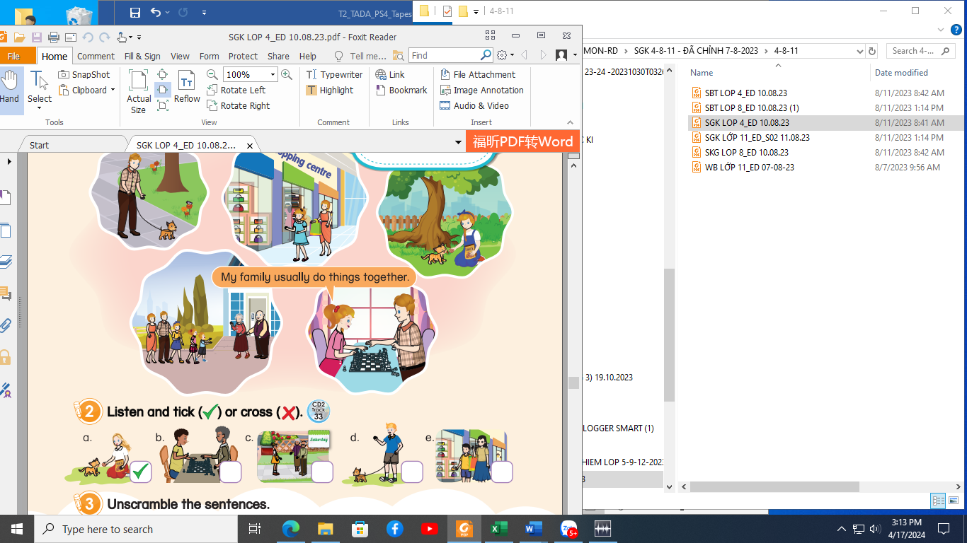
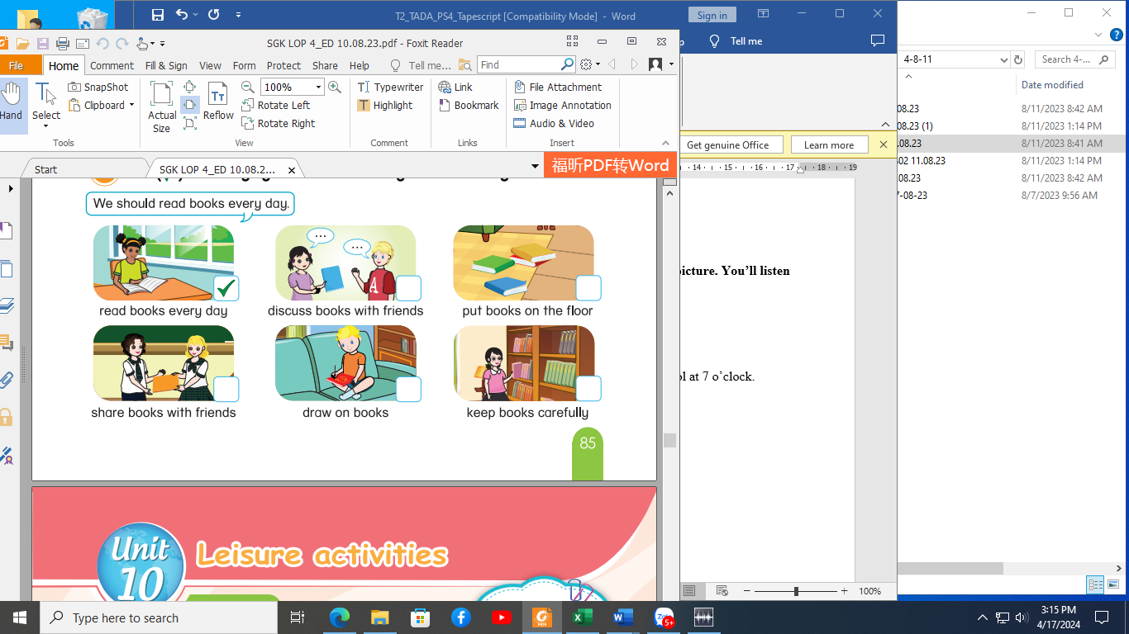
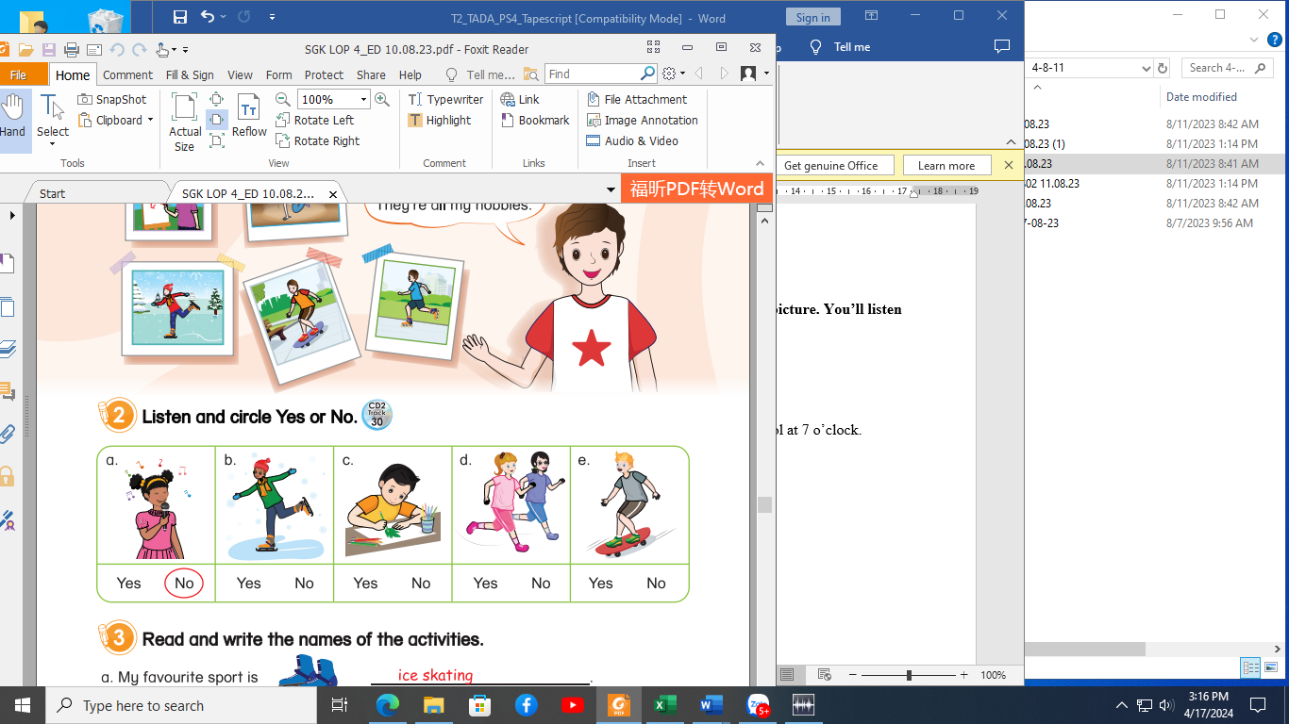
3. What does Sam usually do at weekends?
4. What’s the matter with Pat?
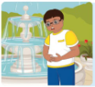
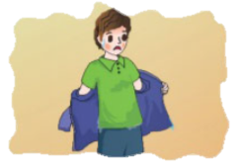
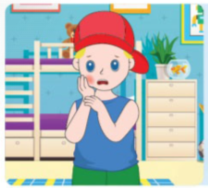

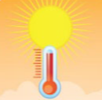

5. What was the weather like yesterday?
Part II. Listen and write a word or a number. There are two examples.(1.25 pts)
Tuesday
 | Examples When does Tim have an English class?  What’s the day today? | on ………………………  6/sixth  ………………… of August
 | - Whose birthday is in April? | ………………………
 | - What’s the date of Rita’s birthday? | ………………………of April
 | 3. What does Rita usually do at weekends? | play the ………………………
 | 4. What’s the matter with Tommy?  - Why does Ben like the elephants? | ………………………  very …………………
SECTION 2 – READING (3.0 pts)
Part I. Read and put a tick (✓) or a cross (✗). There are two examples. (1 pt)


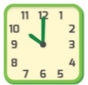
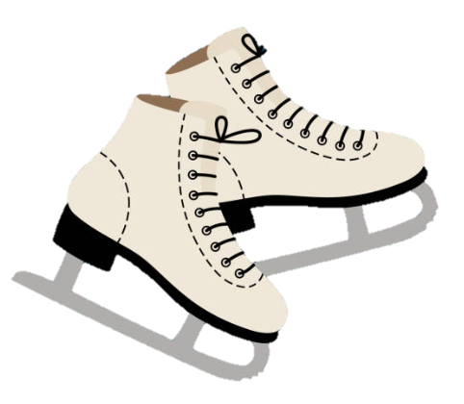

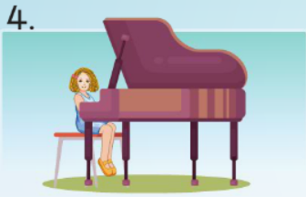
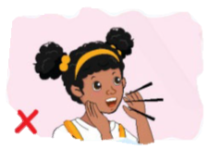
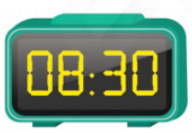
0.
 | I play the guitar  on Tuesday. | ✗ |  | It’s ten o’clock. | ✓
1. |  |  | 2.
 | I enjoy ice skating and dancing. |  |  | My sister usually goes shopping at weekends.
3. |  |  | 4.
 | I’ve got a cough. I can’t shout. |  |  | I have an art class at  half past eight.
Part II. Read and choose the correct answers. There is one example. (1 pt)
- What time is it?
- It’s fifteen. | - It’s a quarter to five. | - It’s six years old.
- What is your favourite animal?
- Giraffes eat leaves. | - I like watching TV. | - I like monkeys.
- When is Lucy’s birthday?
- Her birthday is  in May. | - Today is Sunday. | - It’s seven o’clock.
- What are you doing in the kitchen?
- I’m playing games with my brother. | - I’m cooking with my mother. | - I’m having a shower.
- What was the weather like yesterday?
- It was wet and windy. | - It is cool and sunny. | - I don’t like wet weather.
Part III. Read the text and tick (✓) True or False. There is one example. (1 pt)
I’m Emma. There are three people in my family. We do a lot of things at weekends. On Sunday, I don’t go to school. But I have art classes at half past eight in the morning. I usually go shopping with my mother or walk the dog at a quarter past ten. In the afternoon, I am going to see the dentist with my father because I’ve got a toothache. My family often watches television in the evening and drinks tea together. It’s cold and windy at night. We go to bed at ten o’clock.
 | True  ✓ | False
- Emma doesn’t go to school on Sunday. | …………… | ……………  ✓
There are four people in Emma’s family. | …………… | ……………
- Emma has art classes on Sunday. | …………… | ……………
- Emma and her mother go shopping at a quarter to ten. | …………… | ……………
- Emma has got a stomach-ache. | …………… | ……………
- At night, it’s cold and windy. | …………… | ……………
SECTION 3 – WRITING (2.0 pts)

Part I. Choose the best answer and write them on the line.
There is one example. (1 pt)
animals
My grandfather has a lot of (0) _________ in his house. He has got an (1) _________ fish. It is cute. My grandmother’s has got a cat. It usually eats sausages. It’s (2) _________ and clever. The cat wants to (3) _________ next to me after dinner, then I feed it some sausages. My uncle’s got a (4) _________, It’s green. It eats grass and eggs. I think it is silly and ugly.
- A. trees B. animals C. insects
- A. ant B. orange C. outside
- A. funny B. ugly C. scary
- A. fly B. swim C. sit
- A. insects B. lizard C. crocodiles
Part II. Re-order the words to make complete sentences.
There is one example. (1 pt)
- turn / Don’t / on / the / television.
Don’t turn on the television.
➔…………………………………………………………………………………………………………………
- sunny / It’s /and windy / outside.
➔…………………………………………………………………………………………………………………
- I / want / to / fishing. / go
➔…………………………………………………………………………………………………………………
- do / giraffes / What / eat?
➔…………………………………………………………………………………………………………………
- is / His birthday / December. / in
➔…………………………………………………………………………………………………………………
_The end_

