
Period:87

UNIT 11: SCIENCE TECHNOLOGY
Lesson 1: Getting started P₁₁₄₋₁₁₅
You know what? Great news for students
Class | Date of planning | Date of teaching
8A | 01/3/2024 | 25/3/2024

I. OBJECTIVES: * By the end of this unit, students will be able to:
- Gain an overview about the topic Science technology
- Gain vocabulary to talk about Science technology
1. Knowledge:
+ Vocabulary: technology(n); face to face (adj); epidemics (n); contact lens (n); breakout room (n); invention (n).
+ Language: Reported speech (statements); Giving and responding to good news.
+ Pronunciation: Sentence stress
2. Competence:
a) General competencies:
- Develop communication skills and creativity.
- Be collaborative and supportive in pair work and teamwork.
- Actively join in class activities.
b) Specific competencies:
- Group work and independent working, pair work, linguistic competence, cooperative learning and communicative competence.
3. Qualities: - Love talking about themselves and their problems. Have good attitude to science and technology. Raise ss’ knowledge of science and technology. Ss have the good attitude to working in groups, individual work, pair work, cooperative learning.
II. PREPARATIONS
Teacher: Grade 8 textbook, laptop, TV, pictures and realia, Computer connected to the Internet. Phần mềm tương tác hoclieu.vn
Students: Text books, pencils, pics, blank papers, realia,….
III. PROCEDURE
1. WARM-UP (5’-IW)
a. Objectives:
- To create an active atmosphere in the class before the lesson;
- To review the previous unit;
- To lead into the new unit.
- Review the previous unit before Ss open their books:
b. Content:
- Have the game HIDDEN WORD to create a friendly and relaxed atmosphere to inspire Ss to warm up to the new class.
c. Product:
- Having a chance to speak English and focus on the topic of the lesson.
d. Implementation: Teacher’s instruction
TEACHER’S AND STUDENTS’ ACTIVITIES | CONTENTS
GAME: HIDDEN WORD  Step 1: Task delivering  - T introduces the rule of the game:  Step 2: Task performance  - Ss’ observation  - Ss read the questions or situations  Step 3: Report and discussion  - Ss find a word to answer each question or fill in each situation.  - Student’s talk  Step 4: Judgement  - T leads to the new unit. Write the unit title SCIENCE TECHNOLOGY on the board.  - Ask Ss to guess what they are going to learn about in this unit.  - T checks ss’ vocabulary and give feedback | 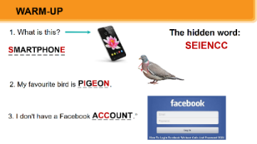  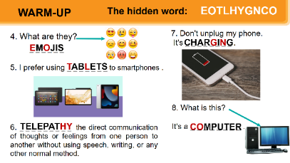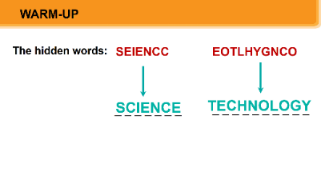
2. KNOWLEDGE FORMATION (10’- IW, PW)
a. Objectives:
- To set the context for the introductory dialogue;
- To introduce the topic of the unit.
b. Content:
- Learn some new words. Read the conversation and find out new words.
c. Product:
- Know more new words
- Understanding the conversation; topic of the lesson,…
d. Implementation: Teacher’s instruction
Vocabulary pre-teaching  Step 1: Task delivering  - Teacher introduces the vocabulary.  - Teacher explains the meaning of the new vocabulary by pictures/ explanation/ examples.  - Teacher reveals that these seven words will appear in the reading text and asks students to open their textbooks to discover further.  Step 2: Task performance  - Ss’ observation  - Ss copy the vocabs.  Step 3: Report and discussion  - Ss listen and repeat.  - Ss read vocabs.  Step 4: Judgement  - Teacher checks students’ pronunciation and gives feedback.  Task 1. Listen and read.  Set the context:  Step 1: Task delivering  - Teacher has Ss to look at the pictures in the book and answer the questions.  Step 2: Task performance  - Ss’ observation  - T encourages ss to answer the questions, but doesn’t confirm their answers.  Step 3: Report and discussion  - Teacher plays the recording.  - Ss listen and read along.  - T invites some pairs of Ss to read the conversation aloud.  Step 4: Judgement  - T refers to the questions previously asked and confirms the correct answer. | * Vocabulary  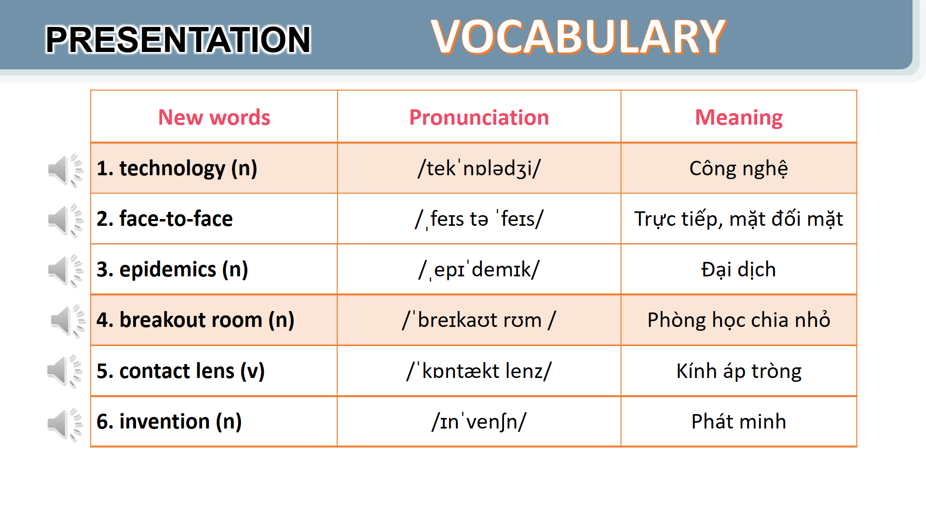  1. Listen and read.  Questions:  - Who are the girl and the boy?  - Where do you think they are?  - What might they be talking about?  - What can you see in the bubble?  Suggested answer:  They are Minh and Ann. They are at school.  They are discussing their online class / robot teacher.
3. PRACTICE (20’-IW, PW)
a. Objectives:
- To help Ss read for specific information about the conversation.
- To help Ss learn words and phrases related to different modern technologies;
- To help Ss have more information about inventions.
b. Content:
- Listen and read the conversation, Labelling the pictures, Sentence completing activity.
- To learn some more words about different modern technologies and inventions.
c. Product:
- Know more new words about different modern technologies and inventions, understand the conversation; topic of the lesson.
d. Implementation: Teacher’s instruction
Task 2. Read the conversation again and tick (v) T (True) or F (False)  Step 1: Task delivering  - Ask Ss to work in pairs to read the conversation.  Step 2: Task performance  - Ss’ observation  - Ss read the conversation.  - Ss work in pairs to underline the key words and phrases in the statements.  Step 3: Report and discussion  - Pairs work for one or two minutes to check if the statements are true or false.  - Ss read out the statements and say if the statements are true or false.  - Student’s talk  Step 4: Judgement  - Make sure they pronounce the words correctly.  - Check the answers as a class.  Task 3. Label each picture with a phrase from the box.  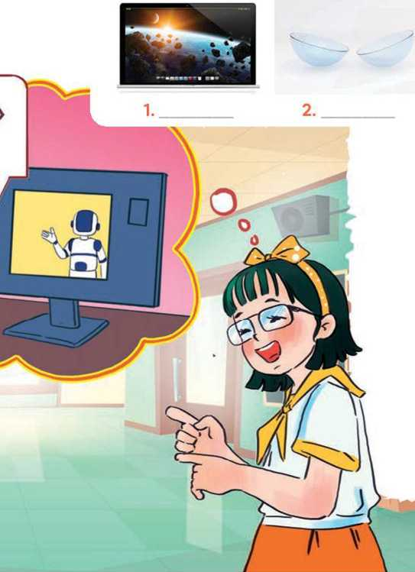    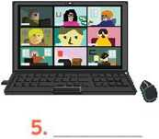  Step 1: Task delivering  - Ask Ss to say the phrases aloud.  - Make sure they pronounce the phrases correctly.  Step 2: Task performance  - Ss’ observation  - Ask Ss to work in pairs to label the pictures with the appropriate words or phrases.  Step 3: Report and discussion  - Student’s talk.  Step 4: Judgement  - Check the answers as a class.  Task 4. Complete the sentences, using the phrases in 3.  Step 1: Task delivering  - Ask Ss to work independently to complete each sentence with a phrase from the box in 3.  Step 2: Task performance  - Ss’ observation  - Ss refer to the pictures and phrases in Activity 3 or the conversation if needed.  - Ss complete each sentence.  Step 3: Report and discussion  - Student’s answers  - Ask several Ss to read aloud the full sentences. Correct Ss’ pronunciation if needed.  Step 4: Judgement  - Check the answers as a class.  - Teacher checks students’ exercise individually and give feedback. | 2. Read the conversation again and tick (v) T (True) or F (False)  Answer key:  1. F 2. T 3. F  4. T 5. T  3. Label each picture with a phrase from the box.  Answer key:  1. computer screen  2. 3D contact lenses  3. online class  4. robot teacher  5. breakout rooms  6. Internet connection  4. Complete the sentences, using the phrases in 3.  Answer key:  1. computer screen  2. breakout rooms  3. robot teacher  4. online class  5. 3D contact lenses
4. APPLICATION (10’-IW, PW)
a. Objectives:
- To introduce some inventions
- To create a fun atmosphere in the class.
b. Content:
- Find out the things that were invented in the given years.
- Home assignment.
c. Product:
- Ss can find out the things that were invented in the given years.
- Take note home assignment.
d. Implementation: Teacher’s instruction
Task 5: Quiz: Do you know what things were invented in these years? Work in pairs and find out.  Step 1: Task delivering  - Ask Ss to work in pairs to read the information and to make guesses.  Step 2: Task performance  - Ss’ observation  - Ss to work in pairs  - Ss read the information and to make guesses.  Step 3: Report and discussion  - Encourage Ss to guess as many things as possible.  - Ask some Ss to report things they have thought of / work out.  - Student’s talk  Step 4: Judgement  - T comments and gives feedback on Ss’ answers.  * Home assignment  - T assigns the homework.  - Ss copy their homework.  - T explains it carefully | 5: Quiz: Do you know what things were invented in these years? Work in pairs and find out.  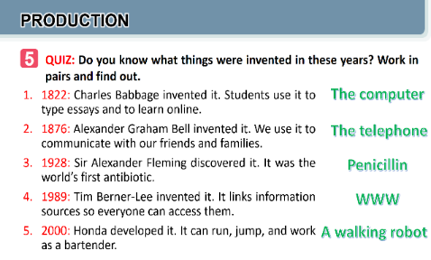  * Home assignment  - Name technologies and inventions they have learnt about in the lesson.  - Learn the new words and phrases by heart.  - Do Exercise ...page…Unit 11 in Workbook  - Prepare Project: P₁₂₄₋₁₂₅  + Ask Ss to organise their report into a presentation.  + Ask Ss to work in groups to make an interview with their friends, then collect and present data)

V. FEEDBACK:
With 8A …………………………..……………………...…………………………………..…
With 8B …………………………………….……………………………………..……………
With 8C …………………………………….…………………………………………….……

Period:88
UNIT 11: SCIENCE TECHNOLOGY
Lesson 2: A closer look 1 P₁₁₅₋₁₁₆
Class | Date of planning | Date of teaching
8A | 01/3/2024 | 27/3/2024

I. OBJECTIVES: * By the end of this unit, students will be able to:
- Identify some nouns related to the topic of science and technology and some new technologies.
- Identify some new verb phrases that used to talk about inventions, discoveries, creations and development. Identify sentence stress.
1. Knowledge:
+ Vocabulary: face recognition (n); experiment (n); eye-tracking (n); fingerprint scanner(n); digital communication (n).
+ Language: Reported speech (statements); Giving and responding to good news.
+ Pronunciation: Sentence stress
2. Competence:
a) General competencies:
- Develop communication skills and creativity.
- Be collaborative and supportive in pair work and teamwork.
- Actively join in class activities.
b) Specific competencies:
- Group work and independent working, pair work, linguistic competence, cooperative learning and communicative competence.
3. Qualities: - Love talking about themselves and their problems. - Have good attitude to science and technology. - Raise ss’ knowledge of science and technology. Ss have the good attitude to working in groups, individual work, pair work, cooperative learning.
II. PREPARATIONS
Teacher: Grade 8 textbook, laptop, TV, pictures and realia, Computer connected to the Internet. Phần mềm tương tác hoclieu.vn
Students: Text books, pencils, pics, blank papers, realia,….
III. PROCEDURE
1. WARM-UP (5’- IW)
a. Objectives:
- To create an active atmosphere in the class before the lesson;
b. Content:
- Have some warm-up activities to create a friendly and relaxed atmosphere to inspire Ss to warm up to the new class.
c. Product:
- Having a chance to speak English and focus on the topic of the lesson.
d. Implementation: Teacher’s instruction
TEACHER’S AND STUDENTS’ ACTIVITIES | CONTENTS
Game: Labelling the pictures  Step 1: Task delivering  - Give Ss a few minutes to play a game.  - Give Ss pictures of things and strips of paper with phrases including computer screen, breakout rooms, robot teacher, online class, 3D contact lenses, connection.  Step 2: Task performance  - Ss’ observation  - Have Ss play in two groups.  Step 3: Report and discussion  - Ask teams to stick the phrases to the right pictures.  - The team with the most correct answers wins.  Step 4: Judgement  - Ask Ss to open their books to page 116.  - T checks ss’ vocabulary and give feedback. | Observation  Questions & answers  Student’s talk  Key:  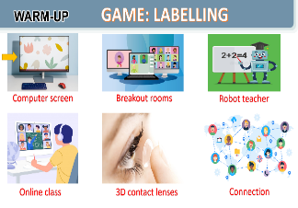
2. KNOWLEDGE FORMATION (6’-IW, PW)
a. Objectives:
- To introduce visually some nouns related to the topic of science and technology
b. Content:
- Learn some nouns related to new technologies.
c. Product:
- Know more new nouns related to new technologies.
d. Implementation: Teacher’s instruction
Task 1. Write the words and phrases under each picture.      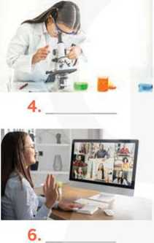    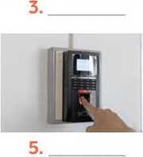  Step 1: Task delivering  - Have Ss read aloud the words / phrases in the box.  - Ask Ss to work in pairs to look at the pictures and describe the pictures.  Step 2: Task performance  - Ss’ observation  - Ss work in pairs  - Have pairs write the correct words / phrases under the pictures.  - Explain the meaning of the new words / phrases in Vietnamese, if needed.  Step 3: Report and discussion  - Ss take turns to read out their answers.  - Student’s talk  Step 4: Judgement  - Correct their pronunciation if needed.  - Check the answers as a class.  - Teacher checks students’ pronunciation and gives feedback. | 1. Write the words and phrases under each picture.  1. digital communication  2. face recognition  3. eye-tracking  4. experiment  5. fingerprint scanner  6. video conferencing  * Vocabulary:  1. face recognition (n): Công nghệ nhận biết gương mặt  2. eye-tracking (n): Công nghệ theo dõi cử động mắt.  3. experiment (n): thí nghiệm  4. fingerprint scanner (n): Thiết bị quét vân tay.  5. digital communication (n): Giao tiếp kỹ thuật số
3. PRACTICE (25’-IW, PW, GW)
a. Objectives:
- To introduce some new verb phrases that are used to talk about inventions, discoveries, creation and development
- To allow Ss to use the learnt words / phrases in different contexts.
- To help Ss be aware of which words in a sentence should be stressed, and which are not;
- To help Ss say sentences with the correct stress.
- To help Ss be aware of the words to stress in a sentence;
- To help Ss practise saying sentences with the correct stress.
b. Contents:
- Use the nouns to go with the verbs that are used to talk about inventions, discoveries, creation and development
- To say sentences with the correct stress; Listen and repeat.
c. Product:
- Knowing how to use learned words/phrases in context.
- Say sentences with the correct stress.
d. Implementation: Teacher’s instruction
Task 2. Choose the option that best completes each phrase.  Step 1: Task delivering  - Ask Ss to read aloud the given verbs and nouns.  - Explain the verbs and if possible, give some examples. Also explain the verbs in Vietnamese.  Step 2: Task performance  - Ss’ observation  - Ss work in pairs to choose the correct options to complete the phrases.  Step 3: Report and discussion  - Have some Ss read aloud the phrases.  - Correct Ss’ pronunciation if necessary.  - Check the answers as a class.  Step 4: Judgement  - Also ask Ss to add more words / phrases to the verbs to make up other phrases.  - This way, T can broaden Ss’ vocabulary if they are ready.  Task 3. Complete the sentences with the words and phrases from the box.  Step 1: Task delivering  - Ask Ss to work individually to choose the correct answer for each sentence.  Step 2: Task performance  - Ss’ observation  - Ss complete the sentences with the words and phrases from the box.  Step 3: Report and discussion  - Have Ss swap their answers with partners.  - Ss check the answers as a class.  Step 4: Judgement  - Also ask some Ss to read out their answers. Then have some Ss read the sentences aloud as a class.  Correct Ss’ pronunciation if necessary.  Task 4. Listen and repeat the words. Pay attention to the sounds /sp/ and /st/.  Step 1: Task delivering  - T asks Ss to look at the screen.  - Play the video clip pronoucing the sounds /sp/ and /st/.  - Have Ss listen to the recording once first.  - Ask them to pay attention to the stressed syllables.  Step 2: Task performance  - Ss’ observation  - Play the recording again for them to listen and repeat each word as a class, then as individuals.  - Play the recording as many times as possible.  Step 3: Report and discussion  - Ss listen and repeat each word  - Ss read out the sentences.  Step 4: Judgement  - Correct their pronunciation and stress if needed.  - Introduce the rules in the Remember! Box: stress sentences, which words in a sentence should be stressed, and which are not.  - Remind Ss of the words that receive stress in a sentence, which they leant in Unit 11 Tiếng Anh 8.  Task 5. Listen and repeat the sentences. How many stressed words are there in each sentence.  Step 1: Task delivering  - Play the recording for Ss to listen and repeat each sentence after the recording.  - Ask Ss to count the number of stressed words in each sentence.  Step 2: Task performance  - Ss’ observation  - Correct Ss’ pronunciation if necessary.  - Check if Ss have counted enough stressed words in each of the sentences.  Step 3: Report and discussion  - Call on some Ss to read the sentences.  - Play the recording multiple times if necessary.  Step 4: Judgement  - Teacher checks students’ answers and their pronunciation and gives feedback. | 2. Choose the option that best completes each phrase.  - To create something = To bring into existence out of nothing.  E.g.: She created a new robot.  - To invent = to design a new process or mechanism. E.g: He invented a new electric cooker.  - To develop = grow gradually or become bigger, stronger, etc.  E.g.: They developed a relationship / a method to work better / a computer programme.  3. Complete the sentences with the words and phrases from the box. Answer key:  1. discovered  2. invented  3. created  4. experiments  5. fingerprint scanner  4. Listen and repeat the words. Pay attention to the sounds /sp/ and /st/.  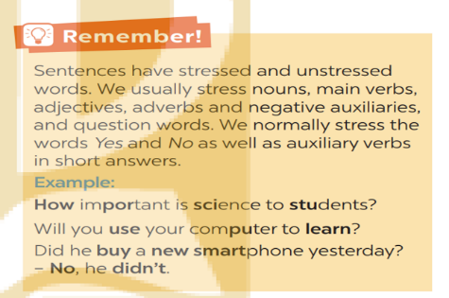  5. Listen and repeat the sentences. How many stressed words are there in each sentence.  - He is an inventor.  - We won’t have a robot teacher next year.  - She likes learning online.  - Was she checking attendance when you came? - No, she wasn’t.  - What did he invent?  Key: 1. 1 2. 5 3. 3  4. 6 5. 2
4. APPLICATION /PRODUCTION (10’- IW, GW)
a. Objectives:
- To test students' imitation and memorizing ability of stress sentence.
b. Content:
- To practice reading the sentences with their stress correctly; Listen and repeat
c. Product:
- Remember the sentences and repeat it correctly in stress and content.
d. Implementation: Teacher’s instruction
GAME: BROKEN TELEPHONE  Step 1: Task delivering  - Teacher explains the rule: RULE:  Step 2: Task performance  - Ss’ observation  - Gather 3 or more players.  -The person starting the game thinks of SENTENCE and whispers it into the next player’s ear only once, with no repeats allowed.  - That listener tries to correctly repeat that SENTENCE into the next player’s ear (Paying attention to the sentence’s stress). The last person in the line or at the end of the circle repeats the SENTENCE.  Step 3: Report and discussion  - Allow a moment for giggles if the message is “broken” or changed. The player who started announces the correct SENTENCE  - Players take turns thinking of the next SENTENCE to pass through a whisper.  Step 4: Judgement  - T comments and gives feedback on Ss’ answers.  * Home assignment  - T assigns the homework.  - Ss copy their homework.  - T explains it carefully | 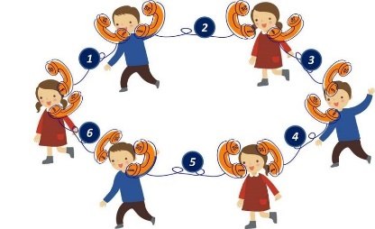  * Home assignment  - Learn by heart words and phrases related to new technologies and new verb phrases that are used to talk about inventions, discoveries, creation, and development.  - Learn by heart “REMEMBER” about sentence stress  - Do Ex B₁₋₃ P₈₇₋₈₈ Unit 11 in Workbook.
V. FEEDBACK:
With 8A …………………………..……………………...…………………………………..…
With 8B …………………………………….……………………………………..……………
With 8C …………………………………….…………………………………………….……

Period:
UNIT 11: SCIENCE TECHNOLOGY
Lesson 3: A closer look 2 P₁₁₇₋₁₁₈
Class | Date of planning | Date of teaching
8A | 01/3/2024 | 30/3/2024

I. OBJECTIVES: * By the end of this unit, students will be able to:
- identify what direct speech and reported speech are.
- realize some differences between a direct speech and a reported speech (statements).
- be aware of changes in tenses, pronouns, time, and place expressions.
1. Knowledge:
+ Vocabulary: face recognition (n); experiment (n); eye-tracking (n); fingerprint scanner(n); digital communication (n).
+ Language: Reported speech (statements); Giving and responding to good news.
+ Pronunciation: Sentence stress
2. Competence:
a) General competencies:
- Develop communication skills and creativity.
- Be collaborative and supportive in pair work and teamwork.
- Actively join in class activities.
b) Specific competencies:
- Group work and independent working, pair work, linguistic competence, cooperative learning and communicative competence.
3. Qualities: - Have a positive attitude to using reported speech in daily life. Have good attitude to science and technology. - Raise ss’ knowledge of science and technology. Ss have the good attitude to working in groups, individual work, pair work, cooperative learning.
II. PREPARATIONS
Teacher: Grade 8 textbook, laptop, TV, pictures and realia, Computer connected to the Internet. Phần mềm tương tác hoclieu.vn
Students: Text books, pencils, pics, blank papers, realia,….
III. PROCEDURE

1. WARM-UP (5’-IW, GW)
a. Objectives:
- To create an active atmosphere in the class before the lesson;
b. Content:
- Have some warm-up activities to create a friendly and relaxed atmosphere to inspire Ss to warm up to the new class.
c. Product:
- Having a chance to speak English and focus on the topic of the lesson.
d. Implementation: Teacher’s instruction
TEACHER’S AND STUDENTS’ ACTIVITIES | CONTENTS
Game: MEMORIZING - RULE:  Step 1: Task delivering  - Work in 4 groups  - Look at the pictures in 30 seconds and try to remember what each people said.  Step 2: Task performance  - Ss’ observation  Step 3: Report and discussion  - Write down on the posters what each of the people in the picture said.  - The group with the most correct answers is the winner.  Step 4: Judgement  - T checks ss’ answers and gives feedback. | Observation  Questions & answers  Student’s talk  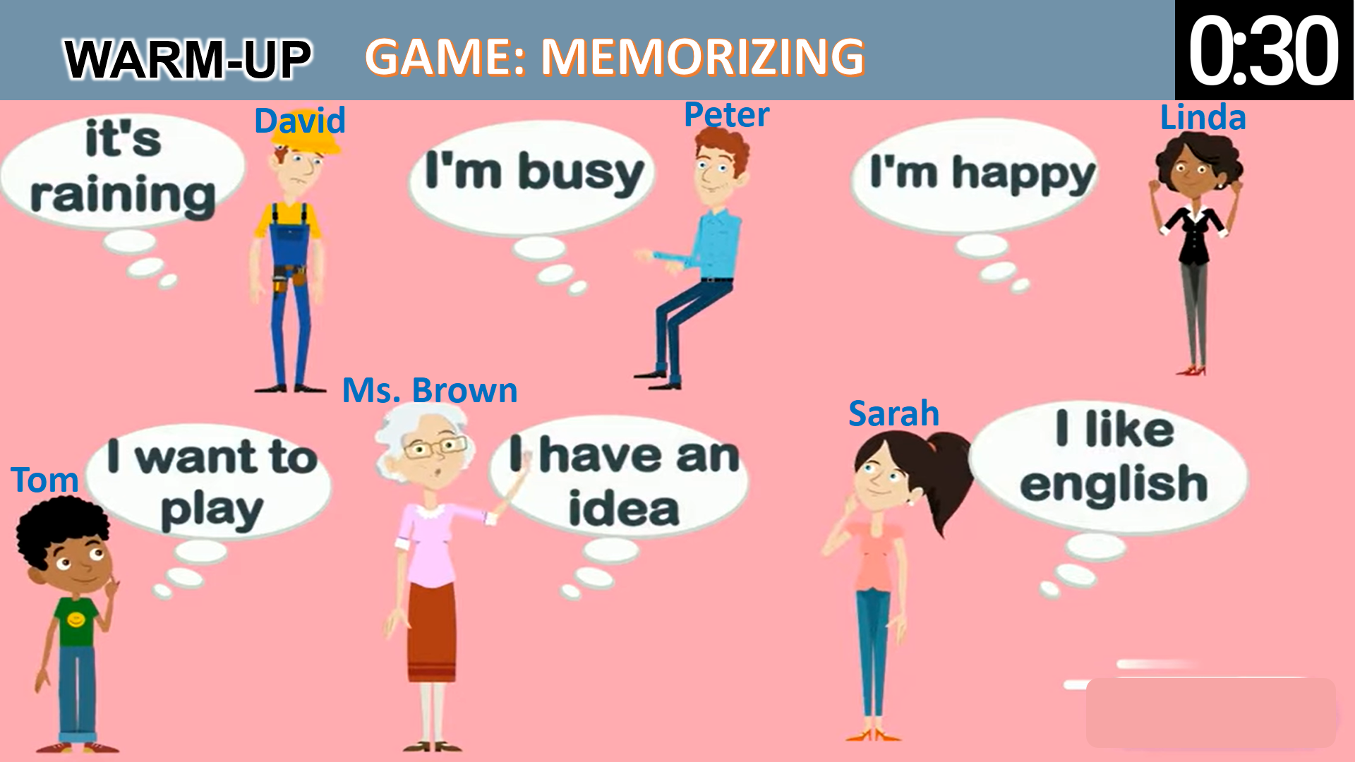
2. KNOWLEDGE FORMATION (10’-IW, PW)
a. Objectives:
- To realize some differences between direct speech and reported speech (Statements)
- To be aware of the changes in verb tenses, pronouns, time and place expressions.
b. Content:
- Match direct speech with its reported speech.
- Know the changes in verb tenses, pronouns, time and place expressions.
c. Product:
- Know what direct speech and reported speech are.
- Understand the changes in verb tenses, pronouns, time and place expressions.
d. Implementation: Teacher’s instruction
Task 1. Look at part of the conversation in GETTING STARTED again. Then match Minh’s uncle’s direct speech with his reported speech.  Step 1: Task delivering  - Ask Ss to work individually to look at the part of the conversation from GETTING STARTED.  - Ask Ss to underline the sentences in GETTING STARTED  - Have Ss work individually to read the Remember! box.  - Write examples of direct speech and reported speech on the board.  Step 2: Task performance  - Ss’ observation  - Have Ss work in pairs to look at direct speech and reported speech boxes to match.  Step 3: Report and discussion  - Check the answers as a class.  - Ask some Ss to underline the differences in the pairs of sentences they have just matched.  - Emphasize will in direct speech is turned into would in the reported speech.  Step 4: Judgement  - Ask some Ss to point out the differences between pairs of sentences (direct and reported speech sentences)  - Remark on the differences in (1) verb form, (2) time expressions, (3) time and place expression, and (4) pronouns. | Grammar:  Reported speech (Statements)  1. Look at part of the conversation in GETTING STARTED again. Then match Minh’s uncle’s direct speech with his reported speech.  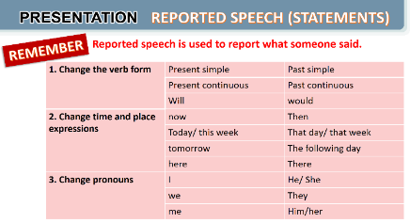  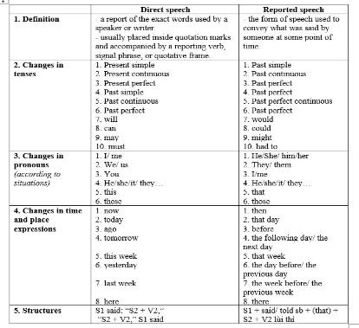
3. PRACTICE (25’-IW, PW, GW)
a. Objectives:
- to be aware of how to change verb forms when they report information.
- to apply rules of changes in time and place expressions when they report information
- to practise changing direct sentences into reported sentences.
b. Content:
- Apply the changes in verb tenses, time and place expressions to complete the sentences.
- Apply the changes in verb tenses, time and place expressions, and pronouns to transform the direct sentences into reported speech.
c. Product:
- Remember the rules of changes in verb tenses, time and place expressions, and pronouns when reporting information.
d. Implementation: Teacher’s instruction
Task 2. Complete the second sentences using the correct verb form.  Step 1: Task delivering  - Remind Ss that they should put the verb one tense back when they report something.  Step 2: Task performance  - Ss’ observation  - Ss complete the second sentences using the correct verb form.  - Have Ss work in pairs to finish the sentences with the correct verb forms.  Step 3: Report and discussion  - Ask some Ss to write their answers on the board.  Step 4: Judgement  - Check Ss’ answers. Correct any mistakes and re-explain the rule if necessary.  - Have Ss read out loud sentences again and correct pronunciation if necessary.  Task 3. Complete the second sentences with the words and phrases from the box.  Step 1: Task delivering  - Have Ss work individually to underline the expressions denoting time and place in the direct sentences.  Step 2: Task performance  - Ss’ observation  - Ask Ss to choose the correct word / phrase from the box to fill each of the reported sentence.  - Remind them of the expressions they have just underlined in each of the direct speech sentences.  Step 3: Report and discussion  - Ask some Ss to read out the direct and reported speech sentences.  - Correct pronunciation if necessary.  - Check the answers as a class.  Step 4: Judgement  - Students do peer correction  - Teacher checks students’ answers as a class and give feedback.  Task 4. Complete the second sentence in each pair so that it means the same as the first one.  Step 1: Task delivering  Step 1: Task delivering  - Have Ss work individually for five minutes to complete the reported sentences.  Step 2: Task performance  - Ss’ observation  - T asks them to work in pairs to swap their answers.  Step 3: Report and discussion  - Students do peer correction  - Ask some Ss to write their reported sentences on the board.  - Check the answers as a class.  - Have the class read out the sentences.  Step 4: Judgement  - Correct pronunciation when necessary.  - Teacher checks students’ answers as a class and give feedback. | 2. Complete the second sentences using the correct verb form.  1. was  2. would take  3. was talking  4. were going  5. didn’t have  3. Complete the second sentences with the words and phrases from the box.  1. the next day  2. then  3. that day  4. that year  5. there  4. Complete the second sentence in each pair so that it means the same as the first one.  1. The scientist said that we would live much longer in the future.  2. Our teacher said that our school was going to have a new laboratory there.  3. My dad said that they were developing technology to monitor students better.
4. APPLICATION/PRODUCTION (5’-IW)
a. Objectives:
- To enable Ss to practise reporting speech;
- To create an atmosphere of playing and learning.
b. Content:
- To report the information
c. Product:
- Reporting direct sentences correctly.
d. Implementation: Teacher’s instruction
Task 5. Work in pairs. One student says a sentence and the other changes that sentence into reported speech. Then swap roles- PW.  GAME: He/ She said that…  Step 1: Task delivering  - Divide the class into groups.  - Instruct Ss to play the game in groups.  Step 2: Task performance  - Ss’ observation  - Give groups two minutes to prepare. Tell them that groups can write down their group’s sentences.  Step 3: Report and discussion  - Invite one group to read out or say aloud a direct speech sentence and the other to say out the sentence in reported speech, starting with She / He said...  Step 4: Judgement  - T corrects any grammar and pronunciation mistakes if necessary.  * Home assignment  - T assigns the homework.  - Ss copy their homework.  - T explains it carefully | 5. Work in pairs. One student says a sentence and the other changes that sentence into reported speech. Then swap roles- PW.  GAME: He/ She said that…    * Home assignment  Learn the rules of changing direct speech into reported speech by heart.  - Retell what direct speech and reported speech are  - Retell the rules of changing direct speech to reported speech.  Do Ex A₁₋₂; B_{4,5} P₈₇₋₈₉ Unit 11 in Workbook.
V. FEEDBACK:
With 8A …………………………..……………………...…………………………………..…
With 8B …………………………………….……………………………………..……………
With 8C …………………………………….…………………………………………….……
Period:90
UNIT 11: SCIENCE TECHNOLOGY
Lesson 4: Communication P₁₁₉
Class | Date of planning | Date of teaching
8A | 10/3/2024 | 1/4/2024

I. OBJECTIVES: * By the end of this unit, students will be able to:
- identify how to give and respond to good news.
- know about the benefits and problems of online learning.
1. Knowledge:
+ Vocabulary: face recognition (n); experiment (n); eye-tracking (n); fingerprint scanner(n); digital communication (n).
+ Language: Giving and responding to good news: - Great news for us; Great!;
+ Pronunciation: Sentence stress
2. Competence:
a) General competencies:
- Develop communication skills and creativity.
- Be collaborative and supportive in pair work and teamwork.
- Actively join in class activities.
b) Specific competencies:
- Group work and independent working, pair work, linguistic competence, cooperative learning and communicative competence.
3. Qualities: - Have a positive attitude to using reported speech in daily life. Have good attitude to science and technology. - Raise ss’ knowledge of science and technology. Ss have the good attitude to working in groups, individual work, pair work, cooperative learning.
II. PREPARATIONS
Teacher: Grade 8 textbook, laptop, TV, pictures and realia, Computer connected to the Internet. Phần mềm tương tác hoclieu.vn
Students: Text books, pencils, pics, blank papers, realia,….
III. PROCEDURE
1. WARM-UP (5’-IW)
a. Objectives:
- To create an active atmosphere in the class before the lesson;
b. Content:
- Have students watch a clip to create a friendly and relaxed atmosphere to inspire Ss to warm up to the new class.
c. Product:
- Having a chance to speak English and focus on the topic of the lesson.
d. Implementation: Teacher’s instruction
TEACHER’S AND STUDENTS’ ACTIVITIES | CONTENTS
Clip watching:  Step 1: Task delivering  - T lets ss watch a clip.  Step 2: Task performance  - Ss’ observation  - Ss tell what the clip is about.  Step 3: Report and discussion  - Student’s talk  - T leads in the new lesson.  Step 4: Judgement  - Ask Ss to look at COMMUNICATION on page 118.  - T checks ss’ answers and give feedback | Expected answers:  - Giving and responding the news
2. KNOWLEDGE FORMATION (10’-IW)
a. Objectives:
- To introduce how to give and respond to good news
- To help Ss practise giving and responding to good news
b. Content:
- Use everyday expressions to develop language skills (Giving and responding good news)
c. Product:
- Leaning how to give and respond to good news
d. Implementation: Teacher’s instruction
Task 1: Listen and read the conversation, paying attention to the highlighted parts.    Step 1: Task delivering  - Play the recording.  - Ss to listen and read the conversation between Nick and Mi.  Step 2: Task performance  - Ss’ observation  - Ask Ss to pay attention to the highlighted parts.  Step 3: Report and discussion  - Emphasise the ways to give good news and respond to good news:  - Tell Ss that Great! and Congratulations! are different ways to respond to good news in different contexts. Tell them that if good news is general and good for everyone, we can say Great!; if the news is good for the speaker only, the responder may say Congratulations!  - Have Ss practise the conversation.  Step 4: Judgement  - T comments and gives feedback on Ss’ answers.  Task 2: Work in pairs. Give news and respond to the news in the following situations.  Step 1: Task delivering  - Ask Ss to work in pairs to make similar conversation.  Step 2: Task performance  - Ss’ observation  - Tell them to use the contexts given and the sample expressions.  Step 3: Report and discussion  - Give feedback on their conversation.  - Teacher listens to students’ pronunciation and gives feedback.  Step 4: Judgement  - T comments and gives feedback on Ss’ answers. | * Everyday English:  Giving and responding to good news  1: Listen and read the conversation, paying attention to the highlighted parts.  To give and respond to good news, you can use:  - Great news for us.  - Great!  - Congratulations!  2: Work in pairs. Give news and respond to the news in the following situations.  1. You tell your classmate about the new vending machine at your school.  2. You tell your classmate about a new laptop that your dad gave you on your birthday.
3. PRACTICE (20’-IW, PW)
a. Objectives:
- To help Ss learn the language to describe the benefits and problems of online learning;
- To help Ss practise reading for specific information.
b. Content:
- Read the posts from some students about the benefits and problems of online learning.
- Talk about a platform ss use for online classes or one ss know about.
c. Product:
- Knowing the benefits and problems of online learning.
- Practising reading for specific information and practising speaking about a platform ss use for online classes or one ss know about.
d. Implementation: Teacher’s instruction
Task 3. Work in pairs. Read the posts from some students about online learning and complete the table.  Step 1: Task delivering  - Ask some Ss to read the posts aloud.  - Have Ss work in pairs.  Step 2: Task performance  - Ss’ observation  - Ss read the posts to get information from the post and to fill in the table below.  Step 3: Report and discussion  - Ask some pairs to read out their answers.  - Make corrections if necessary.  Step 4: Judgement  - Check the answers as a class.  - If time allows, ask some students to retell information from the posts or to role play the four friends to tell class about the platform their teacher uses for their classes.  Task 4. Work in groups. Talk about a platform you use for your online classes or one you know about. What are the benefits and problems of using it?  Step 1: Task delivering  - Have Ss work in groups to talk about the benefits and problems of their online learning platform.  - Ask them to think of the platform they use and use the table in Activity 3 to make notes.  Step 2: Task performance  - Ss’ observation  - Ss work in groups.  - Tell them to use adjectives or phrases as in Activity 3.  Step 3: Report and discussion  - Invite some Ss to tell about their online learning platforms.  - Student’s talk  Step 4: Judgement  - Correct any grammar or pronunciation mistakes if necessary.  - T listens to ss’ reports and gives feedback on their pronunciation and content. | * ONLINE LEARNING  3. Work in pairs. Read the posts from some students about online learning and complete the table.  Benefits Problems  1. It’s convenient. 1. Some students don’t have computers or  2. Students don’t have to get up early. smart phones.  2. The Internet connection is poor.  3. It helps students become more 3. It makes some students feel more  independent. stressed when learning online.  4. It helps students avoid traffic jams. 4. Students can’t meet their classmates.  5. Some students get tired eyes and can’t  concentrate well.  4. Work in groups. Talk about a platform you use for your online classes or one you know about. What are the benefits and problems of using it?
4. APPLICATION/PRODUCTION (10’-IW, GW)
a. Objectives:
- To provide Ss with an opportunity to talk about the platform his / her friends use for online learning, the benefits and problems of that online learning platform;
- To help Ss practise reported speech
b. Content:
- Talk about the platform his / her friends use for online learning, the benefits and problems of that online learning platform.
- Home assignment.
c. Product:
- Apply what they have learnt so far in this unit (ideas, vocabulary, grammar) to talk about their the platform his / her friends use for online learning, the benefits and problems of that online learning platform.
- Take note home assignment.
d. Organization: Teacher’s instruction
Task 5. Report the answers of one of your group members to the class.  Step 1: Task delivering  - Have Ss work in groups to discuss their online learning platforms.  Step 2: Task performance  - Ss’ observation  - Tell them that they can make notes about what their friends like and dislike about the platform their classes /teachers use.  - Ask them to use ideas from the posts and the table in Activity 3.  Step 3: Report and discussion  - Invite group representatives to report one of their group member’s answers.  Step 4: Judgement  - Give feedback on Ss’ reports.  * Home assignment  - T assigns the homework.  - Ss copy their homework.  - T explains it carefully | 5. Report the answers of one of your group members to the class  Expected outcome:  * You can conclude:  - The name of the platform you use for your online classes or one you know about.  + Its benefits  + Its problems  Example:  Lan said that her extra class used Microsoft Teams. She said that she and her classmates found it difficult to use. However, it is convenient to have online classes on Microsoft Teams when the weather is bad.  * Home assignment  - Learn the ways of giving and responding to good news.  - Write a paragraph of 50-70 words about the benefits and problems of a platform you use for your online classes.  Do Ex Part C P₈₉₋₉₀ Unit 11 in Workbook.
V. FEEDBACK:
With 8A …………………………..……………………...…………………………………..…
With 8B …………………………………….……………………………………..……………
With 8C …………………………………….…………………………………………….……

Period:91
UNIT 11: SCIENCE TECHNOLOGY
Lesson 5: Skills 1 P₁₂₀₋₁₂₁
Class | Date of planning | Date of teaching
8A | 01/3/2024 | 3/4/2024

I. OBJECTIVES: * By the end of this unit, students will be able to:
- improve the skill of reading advertisements for details.
- remember the lexical items related to some new technologies that are applied at schools
- recognize how to make a conversation to ask and answer information about an invention or a technology.
1. Knowledge:
+ Vocabulary: biometrics (n); truancy (n); Nanolearning (n); effortless (adj); platform (v); cheating (n).
+ Language: Reported speech (statements); Giving and responding to good news:
+ Pronunciation: Sentence stress
2. Competence:
a) General competencies:
- Develop communication skills and creativity.
- Be collaborative and supportive in pair work and teamwork.
- Actively join in class activities.
b) Specific competencies:
- Group work and independent working, pair work, linguistic competence, cooperative learning and communicative competence.
3. Qualities: - Raise ss’ awareness of some new technologies that are applied at schools. Have a good attitude to applying and using new technology or inventions at schools. Ss have the good attitude to working in groups, individual work, pair work, cooperative learning.
II. PREPARATIONS
Teacher: Grade 8 textbook, laptop, TV, pictures and realia, Computer connected to the Internet. Phần mềm tương tác hoclieu.vn
Students: Text books, pencils, pics, blank papers, realia,….
III. PROCEDURE
1. WARM-UP (5’-IW)
a. Objectives:
- To create an active atmosphere in the class before the lesson;
- To elicit from Ss some reasons why they go shopping
b. Content:
- Have Brainstorming activities to elicit some reasons why Ss go shopping
c. Product:
- Having a chance to speak English and focus on the topic of the lesson.
d. Implementation: Teacher’s instruction
TEACHER’S AND STUDENTS’ ACTIVITIES | CONTENTS
Brainstorming:  Step 1: Task delivering  - Ask ss to name the technological applications your school uses.  Step 2: Task performance  - Ss’ observation  - Ask Ss to look at SKILLS 1 on P_{120-121.}  Step 3: Report and discussion  - T listens to ss’ answers and gives feedback | Observation  Questions & answers  Student’s talk  Expected answers:  - Fingerprint scanner  - Face recognition
2. KNOWLEDGE FORMATION (10’-IW)
a. Objectives:
- To set the context for the reading;
- To help Ss practice describing pictures.
- To introduce some new words related to some new technologies;
b. Content:
- Learn some new words.
- Read the list of the technological applications
c. Product:
- Know more new words and some technological applications
d. Implementation: Teacher’s instruction
I. PRE-READING  Vocabulary pre-teaching  Step 1: Task delivering  - Teacher introduces the vocabulary.  - Teacher asks ss to look through the text and pay attention to the underlined words.  - Teacher reveals that these seven words will appear in the reading text and asks students to open their textbooks to discover further.  Step 2: Task performance  - Ss’ observation  - Ss copy the vocabs.  - Ss guess the meaning of the new vocabulary through context.  Step 3: Report and discussion  - Ss listen and repeat.  - Ss read vocabs.  Step 4: Judgement  - Teacher checks students’ pronunciation and gives feedback.  Task 1: Work in pairs. Name the technological applications in the pictures. Can they be used in  schools?    Step 1: Task delivering  - Have the class work in pairs.  Step 2: Task performance  - Ss’ observation  - Ss describe the pictures and say what technology the pictures are about.  Step 3: Report and discussion  - Ss to discuss if these technologies can be used at schools.  Step 4: Judgement  - Teacher listens to students’ pronunciation and gives feedback. | * Vocabulary:  1. biometrics (n) /ˌbaɪəʊˈmetrɪks/ Khoa học sinh trắc  2. truancy (n) /ˈtruːənsi/ Trốn học, nghỉ học không phép  3. Nanolearning (n) /’nænəʊlɜːnɪŋ/Dạy học với bài dạy kích thước nhỏ  4. effortless(adj) /ˈefətləs/ Không cần nhiều nỗ lực  5. platform(v) /ˈplætfɔːm/ Nền tảng  6. cheating (n) /tʃiːtɪŋ/ Gian lận  1: Work in pairs. Name the technological applications in the pictures. Can they be used in  schools?  1. eye tracking  2. fingerprint scanner  3. face recognition
3. PRACTICE (20’-IW, PW, GW)
a. Objectives:
- to improve Ss’ skill of reading advertisements for details
- to improve Ss’ skill of reading for general information and details.
b. Content:
- Read the reading passage about new technologies that are applied at schools and tick B (Biometrics) or N (Nanolearning) and choose the best answer to the questions.
c. Product:
- Understanding the text about the benefits of the two new technological applications.
d. Implementation: Teacher’s instruction
* WHILE-READING  Task 2. Read the passage and tick (v) B (Biometrics) or N (Nanolearning)  Step 1: Task delivering  - Ask Ss to work individually to read the texts and to decide if the statements from text are about biometrics or nanolearning.  Step 2: Task performance  - Ss’ observation  - Ss write B (Biometrics) or N (Nanolearning).  - Ss underline the key words in each of the statements then search for the information in the two texts.  Step 3: Report and discussion  - Ss to work in pairs to swap answers or to check answers together.  - Ask some Ss to read out loud the statements and say B or N.  - Ask them to show the parts in the reading where they find the answers.  Step 4: Judgement  - Check the answers as a class.  Task 3. Read the passage and choose the correct answer A, B, or C.  Step 1: Task delivering  - Have Ss work individually for five minutes and choose the correct answers.  Step 2: Task performance  - Ss’ observation  - Ss underline the key words in the questions and the evidence for the answers.  Step 3: Report and discussion  - Ss take turns to give the answers.  - Ss show the parts in the reading texts where they find the answers.  Step 4: Judgement  - T can also ask one or two Ss to say which technology they prefer and why or ask them to orally summarise each of the texts.  - T checks the answers as a class and give feedback | * READING  2. Read the passage and tick (v) B (Biometrics) or N (Nanolearning)  Answer key:  1. N  2. B  3. B  4. N  5. N  3. Read the passage and choose the correct answer A, B, or C.  Suggested answers:  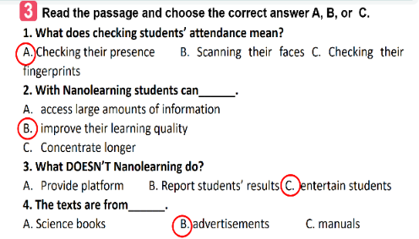
4. APPLICATION/PRODUCTION (15’-IW, PW, GW)
a. Objectives:
- To have Ss practise asking and answering questions for information about an invention or a technology;
- To give Ss an opportunity to practise explaining how the technology can help us;
- To improve Ss’ confidence in speaking in front of the class.
b. Content:
- Practise asking and answering questions for information about an invention or a technology;
- Practise explaining how the technology can help us.
c. Product:
- Speak about information about an invention or a technology and its benefits.
d. Implementation: Teacher’s instruction
* POST-READING  Task 4. Work in pairs. Discuss and match the questions in A with the answers in B, and then make a conversation about an invention.  Step 1: Task delivering  - Have Ss work in pairs to match the questions in A with the answers in B.  - Have them practise asking and answering questions about biometrics in the example.  Step 2: Task performance  - Ss’ observation  - Assist Ss to make full questions when necessary.  - Ask them to ask and answer questions about an invention or a technology they like or know.  Step 3: Report and discussion  - Ask some pairs to role-play it.  - Prepare cue cards about different inventions / technologies and ask Ss to practise asking and answering questions about those inventions / technologies.  Step 4: Judgement  - Ask the class to offer feedback on their questions, answers, and pronunciation.  - This activity helps prepare Ss for 5.  Task 5. Work in groups. Ask and answer questions about a technology or an invention. Use the example in 4 as a cue. Then report your answers to the class.  Step 1: Task delivering  - Have Ss work in groups.  - Ask Ss to ask and answer questions about a invention or a technology.  Step 2: Task performance  - Ss’ observation  - Ask them to explain what they can use the technology or invention for.  Step 3: Report and discussion  - Invite one representative of each group to report their group’s answers to the class.  - Student’s talk  Step 4: Judgement  - Give feedback on their reports in terms of language, reported verb forms, and pronunciation.  - T asks the class to give feedback on their questions and answers, and pronunciation.  - T gives feedback on their reports in terms of language, reasoning skills, and pronunciation.  * Home assignment  - T assigns the homework.  - Ss copy their homework.  - T explains it carefully | * SPEAKING  4. Work in pairs. Discuss and match the questions in A with the answers in B, and then make a conversation about an invention.  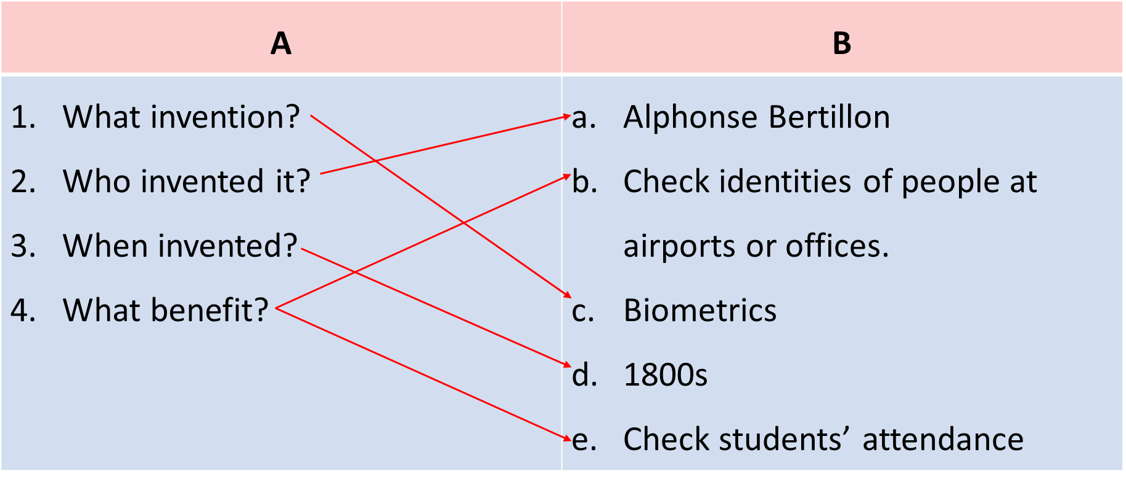  A: What technology do you like?  B: I like biometrics.  A: Who invented it?  B: Alphonse Bertillon  A: When did he invent it?  B: In 1880s  A: How can we use it?  B: It can help us check students’ attendance. We can also use it to check identities of people at airports or offices.  5. Work in groups. Ask and answer questions about a technology or an invention. Use the example in 4 as a cue. Then report your answers to the class.  Example:  Mi likes biometrics. Alphonse Bertillon invented it in 1800s. It is a very important technology. We use it to …  * Home assignment  - Learn the new words by heart.  - Do Ex part D P₉₀₋₉₁ Unit 11 in Workbook
V. FEEDBACK:
With 8A …………………………..……………………...…………………………………..…
With 8B …………………………………….……………………………………..……………
With 8C …………………………………….…………………………………………….……

Period:92
UNIT 11: SCIENCE TECHNOLOGY
Lesson 6: Skills 2 P₁₂₁
Class | Date of planning | Date of teaching
8A | 01/3/2024 | 6/4/2024

I. OBJECTIVES: * By the end of this unit, students will be able to:
- improve the skill of reading advertisements for details.
- remember the lexical items related to some new technologies that are applied at schools
- recognize how to make a conversation to ask and answer information about an invention or a technology.
1. Knowledge:
+ Vocabulary: interact with (v); emotional (adj).
+ Language: Reported speech (statements); Giving and responding to good news:
+ Pronunciation: Sentence stress
2. Competence:
a) General competencies:
- Develop communication skills and creativity.
- Be collaborative and supportive in pair work and teamwork.
- Actively join in class activities.
b) Specific competencies:
- Group work and independent working, pair work, linguistic competence, cooperative learning and communicative competence.
3. Qualities: - Raise ss’ awareness of what a robot teacher can do and can’t do. Have the right attitude toward whether a robot teacher will replace human teachers at school. Have a good attitude to applying and using new technology or inventions at schools. Ss have the good attitude to working in groups, individual work, pair work, cooperative learning.
II. PREPARATIONS
Teacher: Grade 8 textbook, laptop, TV, pictures and realia, Computer connected to the Internet. Phần mềm tương tác hoclieu.vn
Students: Text books, pencils, pics, blank papers, realia,….
III. PROCEDURE
1. WARM-UP (5’-IW)
a. Objectives:
- To create an active atmosphere in the class before the lesson;
- To help ss focus on the listening writing topic
b. Content:
- Have Naming the pictures activity to elicit from students some types of robots in which there is a teacher robot
c. Product:
- Having a chance to speak English and focus on the topic of the lesson.
d. Implementation: Teacher’s instruction
TEACHER’S AND STUDENTS’ ACTIVITIES | CONTENTS
Naming the pictures  Step 1: Task delivering  - Ask ss to look at the five pictures on the screen and name 5 types of robots.  Step 2: Task performance  - Ss’ observation  - Ss name 5 types of robots.  Step 3: Report and discussion  - Student’s talk  Step 4: Judgement  - Lead in the lesson: There are many types of robots nowadays. Today we are going to learn about teacher robots and what a teacher robot can do and what it can’t do in Lesson 6. SKILLS 2 on page 122.  - T check ss’ answers and gives feedback | Suggested answers:  1. doctor robot  2. space robot  3. worker robot  4. home robot  5. teacher robot
2. KNOWLEDGE FORMATION (5’-IW)
a. Objectives:
- To help Ss focus on the topic and prepare for the listening text.
- To help Ss brainstorm keywords/phrases for listening.
- To set the context for the listening;
b. Content:
- Learn some new words.
c. Product:
- Know more new words
d. Implementation: Teacher’s instruction
* PRE-LISTENING  Vocabulary pre-teaching  Step 1: Task delivering  - Teacher introduces the vocabulary.  - Teacher asks ss to look through the text and pay attention to the underlined words.  - Teacher reveals that these seven words will appear in the reading text and asks students to open their textbooks to discover further.  Step 2: Task performance  - Ss’ observation  - Ss copy the vocabs.  - Ss guess the meaning of the new vocabulary through context.  Step 3: Report and discussion  - Ss listen and repeat.  - Ss read vocabs.  Step 4: Judgement  - Teacher checks students’ pronunciation and gives feedback.  Task 1. Listen and tick () the things that you think a robot teacher can do.  Step 1: Task delivering  - Ask Ss to work in pairs to tick the things that a robot teacher can do.  Step 2: Task performance  - Ss’ observation  - Ss work in pairs.  - Ask Ss to add more things a robot teacher can do.  Step 3: Report and discussion  - Student’s talk  - Ss list things robots in general can do (for example: doing boring housework, hard work in factories, delivering letters at workplaces, etc.)  Step 4: Judgement  - Tell Ss that they are going to listen to a conversation about a robot teacher and fill in each of the blanks with ONE word.  - Teacher listens to students’ pronunciation and gives feedback. | Observation  Questions & answers  Student’s talk  Vocabulary  1. emotional (adj): thuộc tình cảm  2. interact with (v): tương tác  1. Listen and tick () the things that you think a robot teacher can do  Suggested answers:  - 1, 2  - A robot teacher can dance, teach subjects, play with students...
3. PRACTICE (20’-IW, PW, GW)
a. Objectives:
- To improve Ss’ skill of listening for specific information.
- To improve Ss’ listening comprehension and note-taking skills.
b. Content:
- Listen to a conversation and fill in each blank.
- Listen to the conversation and tick T or F
c. Product:
- Understanding the conversation about what a robot teacher can do and can’t do.
d. Implementation: Teacher’s instruction
* WHILE- LISTENING  Task 2. Listen to the conversation and fill in each blank with ONE word.  Step 1: Task delivering  - Ask Ss to work individually to read the table and guess the possible words to fill in each of the blanks.  - Remind them to think of the part of speech of that word (noun, verb, adjective, adverb or number). and forms of nouns (singular, plural).  Step 2: Task performance  - Ss’ observation  - Play the recording once for Ss to fill in the blanks. Remind Ss that they should write only ONE word for each blank.  Step 3: Report and discussion  - Check Ss’ answers and play the recording again for them to better understand the conversation between Tom and Lan.  - Stop or rewind the recording where necessary.  Step 4: Judgement  - T comments and gives feedback on Ss’ answers.  Task 3. Listen again and tick (v) T (True) or F(False).  Step 1: Task delivering  - Ask Ss to work in pairs to read the statements.  Step 2: Task performance  - Ss’ observation  - Ss underline the key words in the statements.  Step 3: Report and discussion  - Play the recording once.  - Give them two minutes to decide if the sentences are T (True) or F (False).  - Student’s answers  Step 4: Judgement  - Play the recording again and check their answers as a class.  - T checks the answers as a class and gives feedback. | * LISTENING  2. Listen to the conversation and fill in each blank with ONE word. Answer key:  1. languages  2. maths  3. interact  4. behave  5. problems  3. Listen again and tick (v) T (True) or F(False).  Suggested answers:  1. T 2. T 3. F  4. F 5. F
4. APPLICATION/PRODUCTION (15’- IW, PW, GW)
a. Objectives:
- To provide Ss with vocabulary and ideas about whether a robot teacher will replace human teachers at schools
- To improve ss’ skill of writing a paragraph expressing opinions about whether robots will replace teachers at schools.
b. Content:
- Discuss if ss agree or disagree that robots will soon replace teachers at school and give the reasons.
- Write a paragraph to express opinions about whether robots will replace teachers at schools.
c. Product:
- Give at least 3 reasons why you agree or disagree on whether robots will replace teachers at schools.
- Have a paragraph to express opinions about whether robots will replace teachers at schools.
d. Implementation: Teacher’s instruction
* POST-LISTENING  Task 4. Work in pairs. Discuss if you agree or disagree that robots will soon replace teachers at schools. Write the reasons in the table.  Step 1: Task delivering  - Ask Ss to work in pairs to brainstorm ideas and fill in the blanks.  Step 2: Task performance  - Ss’ observation  - Ss get ideas from the listening and add any more ideas they have.  Step 3: Report and discussion  - Ask some Ss to read out loud ideas for each column.  - Student’s talk  Step 4: Judgement  - Correct their pronunciation where necessary.  Task 5. Now write a paragraph (80-100 words) to express your opinion. Use the notes in 4.  Step 1: Task delivering  - T records the ideas Ss have brainstormed in Activity 4 on the board.  - Ask Ss to work individually to write for 15 minutes.  - Tell them to use the information in Activity 4 and any other ideas they may think of.  Step 2: Task performance  - Ss’ observation  - Ss choose only three ideas for their paragraph.  Step 3: Report and discussion  - T asks one student to read out his / her paragraph.  - If time allows, also ask Ss to work in groups to write on an A1 / A0 size piece of paper, then T organises a gallery walk.  - Ss walk round and offer feedback on peers’ writing in terms of ideas, grammar and connectors.  Step 4: Judgement  - T gives feedback on their writing in terms of spelling, grammatical mistakes, cohesion, and content.  * Home assignment  - T assigns the homework.  - Ss copy their homework.  - T explains it carefully | * WRITING  4. Work in pairs. Discuss if you agree or disagree that robots will soon replace teachers at schools. Write the reasons in the table  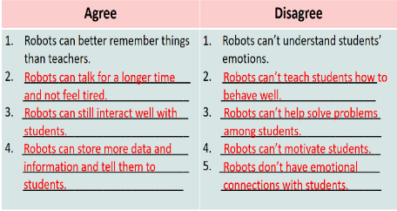  5. Now write a paragraph (80-100 words) to express your opinion. Use the notes in 4.  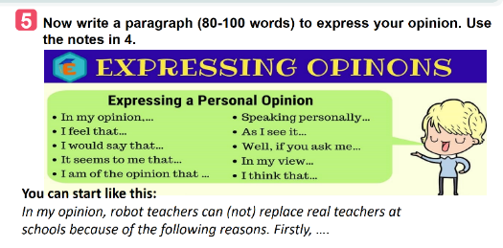  * Home assignment  - Learn the new words by heart.  - Rewrite the paragraph expressing opinions about whether a robot teacher can(not) replace teachers at school.  - Do Ex Part E1,2 P₉₃ Unit 11/Workbook
V. FEEDBACK:
With 8A …………………………..……………………...…………………………………..…
With 8B …………………………………….……………………………………..……………
With 8C …………………………………….…………………………………………….……

Period:93
UNIT 11: SCIENCE TECHNOLOGY
Lesson 7: Looking back - Project P₁₂₂₋₁₂₃
Class | Date of planning | Date of teaching
8A | 01/3/2024 | 8/4/2024

I. OBJECTIVES: * By the end of this unit, students will be able to:
- Memorize the vocabulary about new technologies and words and phrases that are used to talk about inventions, discoveries, inventions, and creations.
- Review reported speech (statements)
- Brainstorm ideas about problems they have at home or at school
- Be creative to deal with problems by imagining an invention.
1. Knowledge:
+ Vocabulary: interact with (v); emotional (adj).
+ Language: Reported speech (statements); Giving and responding to good news:
+ Pronunciation: Sentence stress
2. Competence:
a) General competencies:
- Develop communication skills and creativity.
- Be collaborative and supportive in pair work and teamwork.
- Actively join in class activities.
b) Specific competencies:
- Group work and independent working, pair work, linguistic competence, cooperative learning and communicative competence.
3. Qualities: - Consolidate ss’ awareness of science and technology. Have a positive attitude toward problems that they have at home or at school and think creatively to find solutions to those problems. Ss have the good attitude to working in groups, individual work, pair work, cooperative learning.
II. PREPARATIONS
Teacher: Grade 8 textbook, laptop, TV, pictures and realia, Computer connected to the Internet. Phần mềm tương tác hoclieu.vn
Students: Text books, pencils, pics, blank papers, realia,….
III. PROCEDURE
1. WARM-UP (5’-IW)
a. Objectives:
- To create an active atmosphere in the class before the lesson;
b. Content:
- Have ss play the game “Kim’s game”
c. Product:
- Having a chance to speak English and focus on the topic of the lesson.
d. Implementation: Teacher’s instruction
TEACHER’S AND STUDENTS’ ACTIVITIES | CONTENTS
Kim’s game:  Step 1: Task delivering  - T asks students to work in groups of three or four students  Step 2: Task performance  - Ss watch a video clip.  - Ask Ss to try to remember all the inventions mentioned in the clip without taking notes.  Step 3: Report and discussion  - After finishing watching the clip, ss write down as inventions as possible.  - T gets ss to swap the posters and give correction after T shows the answers.  - The group with the most correct answers will win.  Step 4: Judgement  - T leads in the lesson. | Answers:  10. The paper  9. The compass  8. The refrigeration  7. The printing press  6. Plumbing  5. Medicine  4. Engines  3. The wheel  2. Communication  1. Electricity
* VOCABULARY (10’-IW)
a. Objectives:
- To help Ss review the vocabulary learnt.
- To help Ss review reported statements
- To help Ss use the reported statements correctly
b. Content:
- review some new words related to the topic
- review reported statements
c. Product:
- Remember the vocabulary learnt
- Remember the changes in tenses, pronouns, time and place expressions to report information.
d. Implementation: Teacher’s instruction
Task 1. Circle the option that goes with each verb.  Step 1: Task delivering  - Have Ss work individually.  Step 2: Task performance  - Ss’ observation  - Ask Ss to circle the option that can combine with the given verbs.  Step 3: Report and discussion  - Have Ss read out their phrases.  - Check answers as a class.  Step 4: Judgement  - Correct Ss’ pronunciation if necessary.  Task 2. Fill in each gap with a word or phrase from the box. You may have to change the form of the word or phrase.  Step 1: Task delivering  - Have Ss work individually.  - Ask Ss to fill in each blank with the correct form of the words /phrases from the box.  Step 2: Task performance  Ss’ observation  - Ss work individually.  - Ss fill in each blank  Step 3: Report and discussion  - Ask some Ss to read aloud the sentences.  - Student’s talk  Step 4: Judgement  - Check answers as a class.  - Correct Ss’ pronunciation if necessary. | 1. Circle the option that goes with each verb.  Suggested answers:  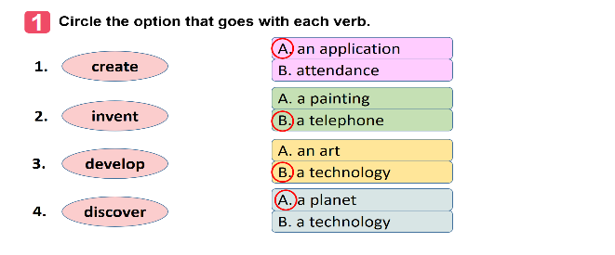  2. Fill in each gap with a word or phrase from the box. You may have to change the form of the word or phrase.  Suggested answers:  1. robot teacher  2. application  3. face recognition  4. eye-tracking  5. check attendance
* GRAMMAR
Task 3. Which of the underlined parts in each question is incorrect? Find and correct it.  Step 1: Task delivering  - Have Ss work individually.  - Ask Ss to circle a mistake in each of the sentences.  - Remind them that only the underlined words will have mistakes.  Step 2: Task performance  - Ss’ observation  - Ask Ss to work in pairs to swap and check their answers.  Step 3: Report and discussion  - Ask one student to read out his/her sentences.  - Check answers as a class.  Step 4: Judgement  - Correct his / her pronunciation if necessary.  Task 4. Rewrite the following sentences, using the words in BOLD.  Step 1: Task delivering  - Ask Ss to work individually to complete the sentences as requested in the book.  - Ask the class to work in pairs.  Step 2: Task performance  - Ss’ observation  - Ask one or two Ss to go to the board and write their full sentences.  Step 3: Report and discussion  - Tell them to swap their writings and check their partner’s answers.  - Have all Ss correct their partner’s answers.  - Check the sentences written on the board.  Step 4: Judgement  - Correct Ss’ language and pronunciation if necessary.  - Teacher checks students’ answers and corrects Ss’ language and pronunciation if necessary.  - Ask some Ss to read out their sentences. | 3. Which of the underlined parts in each question is incorrect? Find and correct it.  Suggested answers:  1. B discovers  -> discovered  2. B is -> was  3. B will make  -> would make  4. C a day ago  -> a day before  5. C next year  -> the next/following year  4. Rewrite the following sentences, using the words in BOLD.  Suggested answers:  1. Tom said they couldn’t connect to the Internet to work online there.  2. Mr. Thompson said (that) science was becoming a more important subject in schools then.  3. The headmaster said (that) the school would use a machine to check students’ attendance the following year.  4. The monitor said to the class (that) they were having a science competition that week.  5. The students said (that) they didn’t like robot teachers at all.
* PROJECT (20’-IW, GW)
a. Objectives:
- To help Ss to brainstorm ideas about problems they have at home or at school;
- To raise Ss’ awareness of their ability to be creative to deal with the problems;
- To improve Ss’ teamwork and public speaking skills.
b. Content:
- Think about a problem you have at home or at school.
- Imagine an invention (a tool, a machine, an application…) that helps you deal with your problem.
- Prepare a poster presentation with pictures or a paper model of the invention and present it to your class.
- Home assignment.
c. Product:
- Present a poster with pictures or a paper model of the invention.
- Take note home assignment.
d. Implementation: Teacher’s instruction
Think about a problem you have at home or at school. Imagine an invention (a tool, a machine, an application…) that helps you deal with your problem.  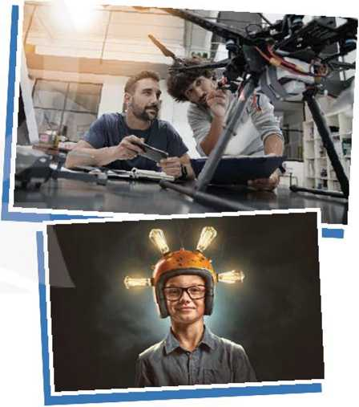  Step 1: Task delivering  - Have Ss work in groups of 3-4 students  - Ask Ss to read the instructions and suggestions carefully.  - Encourage Ss to think about a problem they have at home or at school and imagine an invention (a tool, a machine, an application…) that helps them deal with your problem.  Step 2: Task performance  - Ss’ observation  - Have Ss work in groups to discuss a problem they have at home or at school.  - Ask them to think of an invention that can help them deal with their problem.  - Ask them to answer the suggested questions.  Step 3: Report and discussion  - Prepare a poster presentation with pictures or a paper model of the invention and present it to your class.  - Tell Ss that they can draw pictures, create models or take photos to illustrate their invention.  - Ask groups of Ss to pin / tape / glue the pictures / photos / models and write how it can help them on a large piece of paper and present it to the class.  - If time is limited, T can assign the project in earlier lessons such as in GETTING STARTED lesson.  - Make sure you guide Ss in detail and check their progress after each lesson. In the last lesson (LOOKING BACK), ask Ss to present their poster.  Step 4: Judgement  - T checks ss’ grammatical and spelling mistakes on their poster, listens to their presentation, and gives feedback.  * Home assignment  - T assigns the homework.  - Ss copy their homework.  - T explains it carefully | Think about a problem you have at home or at school. Imagine an invention (a tool, a machine, an application…) that helps you deal with your problem.  Suggested answers:  - What is the name of the invention?  - What is it look like?  - How can it help you solve the problem?  Suggested outcome  You can include:  - Name of the invention  - What the invention looks like  How it can help deal with their problems.  * Home assignment  - Do Exercise ………..page ……Unit 11Workbook.
V. FEEDBACK:
With 8A …………………………..……………………...…………………………………..…
With 8B …………………………………….……………………………………..……………
With 8C …………………………………….…………………………………………….……

