Period: 42
UNIT 6: LIFESTYLES
Lesson 1: Getting started - Lifestyles differences ! P₆₀₋₆₁
Class | Date of teaching | Date of teaching
8A | 4/12/2023 | 18/12/2023
I. OBJECTIVES: * By the end of this unit, students will be able to:
- gain an overview about the topic Lifestyle
- gain vocabulary to talk about Lifestyle
1. Knowledge:
+ Vocabulary: greet (v), greeting (n), serve (v), common practice (n), in the habit of, waiter, waitress.
+ Language: Future simple; First conditional; Expressing certainty
+ Pronunciation: Sounds: /br/ and /pr/
2. Competence:
a) General competencies:
- Develop communication skills and creativity.
- Be collaborative and supportive in pair work and teamwork.
- Actively join in class activities.
b) Specific competencies:
- Group work and independent working, pair work, linguistic competence, cooperative learning and communicative competence.
- Sts can introduce themselves or one another fluently.
3. Qualities: Love talking about different lifestyles. Having benefits of their hobbies in daily life. Ss have the good attitude to working in groups, individual work, pair work, cooperative learning.
II. PREPARATIONS
Teacher: Grade 8 textbook, laptop, TV, pictures and realia, Computer connected to the Internet. Phần mềm tương tác hoclieu.vn
Students: Text books, pencils, pics, blank papers, realia,….
III. PROCEDURE
1. WARM-UP (5’-IW, PW)
a. Objectives:
- To set the context for the introductory dialogue;
- To introduce the topic of the unit.
b. Content:
- Asking questions to lead in the lesson.
c. Product:
- Students know the topic of the unit and be ready for the conversation.
d. Implementation:
TEACHER’S AND STUDENTS’ ACTIVITIES | CONTENTS
Asking questions:  Step 1: Task delivering  - T asks Ss some questions.  Step 2: Task performance  - Ss’ observation  - Ss answer the question individually.  - Teacher shows students a video of different ways of greetings and asks students to guess what the video is about.  Step 3: Report and discussion  - Students guess what the video is about.  - Student’s talk  Step 4: Judgement  - T sets the context for the listening and reading text:  - Write the title on the board Lifestyle – Lifestyle differences. | Questions and suggested answers:  - In Viet Nam, how do two men greet each other when they meet?  -> They shake hands or say hello.  - Do people in Thailand shake hands when meeting?  -> No. They greet each other with a “Wai” and say “Sawadee”.
2. KNOWLEDGE FORMATION (10’-IW, PW)
a. Objectives: - To prepare vocabulary for students to understand the conversation.
b. Content: - Vocabulary pre-teaching.
c. Product: - Students know how to use the target vocabulary.
d. Implementation
Vocabulary pre-teaching.  Step 1: Task delivering  - Teacher explains the meaning of the new vocabulary by pictures.  - Teacher reveals that the words according to the pictures will appear in the reading text and asks students to open their textbook to find these words.  - Teacher introduces the vocabulary.  Step 2: Task performance  - Ss’ observation  - Listen and repeat.  Step 3: Report and discussion  - Read and pronouce vocabulary.  Step 4: Judgement  - Teacher checks students’ understanding with the “Rub out and remember” technique.  Task 1: Listen and read.  Step 1: Task delivering  - Ask Ss to look at the title of the conversation and the pictures.  - Guess what the conversation between Nam and Tom might be about.  Step 2: Task performance  - Ss’ observation  Step 3: Report and discussion  - T plays the recording once or twice.  - Ss to listen and read along silently or aloud.  Step 4: Judgement  - Have some pairs of Ss read the conversation aloud. | Observation  Questions & answers  Vocabulary:  1. greet (v)  2. greeting (n)  3. serve (v)  4. common practice (n)  5. in the habit of  1: Listen and read  - What do you think Nam and Tom are talking about?  -> They are talking about lifestyles and lifestyle diﬀerences.
3. PRACTICE (20’-IW, PW, GW)
a. Objectives:
- To help Ss use words and phrases related to lifestyles.
- To help Ss further understand the text.
- To introduce some vocabulary items and collocations related to lifestyles.
b. Content:
- Task 2: Read the conversation again and complete the table.
- Task 3: Complete each sentence with a word or phrase from the box.
- Task 4: Label each picture with a word or phrase from the box.
c. Product:
- Students understand the conversation and know the vocabulary related to the topic.
d. Implementation
Task 2: Read the conversation again and complete the table.  Step 1: Task delivering  Teacher asks Ss to read the dialogue in detail to answer the questions.  - Ask them how to do this kind of exercise.  Explain the strategies, if necessary (e.g. reading the statements in the table, underlining the key words in the statements, locating the key words in the text, and then completing the table).  Step 2: Task performance  - Ss’ observation  - Ss underline parts of the dialogue that help them with the answers.  - T Set a strict time limit to ensure Ss quickly read the text for information.  Step 3: Report and discussion  - Read the dialogue in detail.  - Complete the table  - Ss compare their answers in pairs before sharing them with the class.  - Ss give evidence to support their answers.  Step 4: Judgement  - Confirm the correct answers.  - Teacher checks the answers as a class and gives feedback.  Task 3: Complete each sentence with a word or phrase from the box.  Step 1: Task delivering  - Teacher tells Ss to read the conversation again.  - T can ask for translation of some of the words and phrase in the box to check their understanding.  Step 2: Task performance  - Ss’ observation  - Ss share their answers with one or more partners.  Step 3: Report and discussion  - T asks 2 students to write their answers on the board.  Step 4: Judgement  - Check the answers as a class.  Task 4: Label each picture with a word or phrase from the box.  Step 1: Task delivering  - T has Ss work individually to label the pictures with the words and phrases in the box.  Step 2: Task performance  - Ss’ observation  - Ss compare their answers with a partner.  Step 3: Report and discussion  Ss quickly write their answers on the board without confirming the correct answers.  - T has Ss listen to the recording, check their answers, and repeat the words / phrases.  - Ask Ss to look at the answers on the board and say if they are right or wrong.  Step 4: Judgement  - Confirm the correct answers.  - Teacher checks the answers as a class and gives feedback.  - Teacher corrects the students as a whole class. | 2: Read the conversation again and complete the table.  Answer key:  1. surnames  2. on the street  3. store / restaurant  3: Complete each sentence with a word or phrase from the box.  Answer key:  ﻿1. lifestyle  2. greet  3. serve  4. practice  5. in the habit of  4: Label each picture with a word or phrase from the box.  Answer key:  ﻿1. street food  2. food in restaurants  3. pizza  4. online learning  5. greeting
4. APPLICATION (10’-IW, PW, GW)
a. Objectives: - To introduce greetings around the world.
b. Content: - Task 5: QUIZZ: Greetings around the world.
c. Product: - Students know about greetings around the world.
d. Implementation
Task 5: QUIZZ: Greetings around t he world.  Step 1: Task delivering  - Model this activity with a strong student.  - Ss finish the task in 2 - 3 minutes.  - T goes round to help weaker Ss.  Step 2: Task performance  - Ss’ observation  - Ss work in pairs. ﻿  Step 3: Report and discussion  - Ss share the answers.  - Student’s talk  Step 4: Judgement  - Confirm the correct answers.  - T may need to explain to Ss if they do not know the answers  * Home assignment  - T assigns the homework.  - Ss copy their homework.  - T explains it carefully | 5: QUIZZ: Greetings around the world.  Answer key:  ﻿1. A  2. B  3. B  4. B  5. A  * Home assignment  - Learn by heart vocabulary  - Name a list of 10 ways of greetings from different countries.  - Prepare the next lesson: A closer look 1  - Prepare Project:  + Ask Ss to organize their posters into a presentation.  + Ask Ss to work in groups to choose a village (in Viet Nam or another country) that they will make a poster of, and decide what information they should include and what pictures or photos they should use to illustrate it.

Period: 43
UNIT 6: LIFESTYLES
Lesson 2: A closer look 1 P₆₂₋₆₃
Class | Date of teaching | Date of teaching
8A | 04/12/2023 | 20/12/2023
I. OBJECTIVES: * By the end of this unit, students will be able to:
- gain an overview about the topic Lifestyle
- gain vocabulary to talk about Lifestyle
1. Knowledge:
+ Vocabulary: dogsled (n), make craft, tribal (a), native (a), weave (v),
+ Language: Future simple; First conditional; Expressing certainty
+ Pronunciation: Sounds: /br/ and /pr/
2. Competence:
a) General competencies:
- Develop communication skills and creativity.
- Be collaborative and supportive in pair work and teamwork.
- Actively join in class activities.
b) Specific competencies:
- Group work and independent working, pair work, linguistic competence, cooperative learning and communicative competence.
- Sts can introduce themselves or one another fluently.
3. Qualities: Love talking about different lifestyles. Having benefits of their hobbies in daily life. Ss have the good attitude to working in groups, individual work, pair work, cooperative learning.
II. PREPARATIONS
Teacher: Grade 8 textbook, laptop, TV, pictures and realia, Computer connected to the Internet. Phần mềm tương tác hoclieu.vn
Students: Text books, pencils, pics, blank papers, realia,….
III. PROCEDURE
1. WARM-UP (5’-IW, PW)
a. Objectives:
- To create an active atmosphere in the class before the lesson.
- To lead into the new lesson.
b. Content:
- Matching game (Task 1)
c. Product:
- Students get some vocabulary from the lesson and be ready for the lesson.
d. Implementation:
TEACHER’S AND STUDENTS’ ACTIVITIES | CONTENTS
Matching game:  Step 1: Task delivering  - T gives out the handouts and divides the class into 10 groups and explains the rules.  Step 2: Task performance  - Ss’ observation  Step 3: Report and discussion  - Ss match the given words to the pictures and they have to send one to stick the handout onto the board as quickly as possible.  Step 4: Judgement  - T shows students the answer on the screen and announces the winning group.  - T sets the context for the lesson. | Suggested answers:  1. dogsled (n)  2. make crafts (v)  3. native art (n)  4. weave (v)  5. tribal dance (n)
2. KNOWLEDGE FORMATION (5’-IW)
a. Objectives: - To prepare vocabulary for students to do the tasks.
b. Content: - Vocabulary teaching.
c. Product: - Students know how to use the target vocabulary.
d. Implementation:
Vocabulary pre-teaching  - Teacher asks students to guess the meaning of the words that they have matched in Warm-up activity.  - Teacher introduces the vocabulary.  - Teacher checks students’ understanding by the follow-up tasks in the student's book. | * Vocabulary:  1. dogsled (n)  2. make crafts (v)  3. weave (v)  4. native (adj)  5. tribal (adj)
3. PRACTICE (20’-IW, PW, GW)
a. Objectives:
- To prepare vocabulary for students to do the tasks.
- To present some nouns that describe different aspects of lifestyles.
- To give Ss more practice on how to use words related to lifestyles in sentences.
b. Content:
- Task 2: Complete the sentences with the words and phrases from the box.
- Task 3: ﻿Choose the correct answer A, B, or C to complete each sentence.
c. Product:
- Students know how to use the target vocabulary.
d. Implementation:
Task 1: Match the words and phrases with the pictures.  Step 1: Task delivering  - Have Ss work in pairs.  - Tell them to match the words and phrases on the left with the pictures on the right.  Step 2: Task performance  - Ss’ observation.  - Match the words and phrases on the left with the pictures on the right.  Step 3: Report and discussion  - Student’s talk  - Ss’ questions & answers  Step 4: Judgement  - Check their answers as a class.  - Have Ss read the words and phrases aloud.  - Correct their pronunciation if necessary.  Task 2: Complete the sentences with the words and phrases from the box.  Step 1: Task delivering  - T has Ss read the sentences and choose the correct word given to fill each blank in the sentences.  ﻿- T tells Ss to read the sentences carefully and look for clues so that they can choose the correct words.  Step 2: Task performance  - Ss’ observation  - Choose the correct word given to fill each blank in the sentences.  Step 3: Report and discussion  - Student’s talk  - T asks Ss to check their answers with their partners.  - Ask for translation of some of the words to check their understanding.  Step 4: Judgement  - T confirms the correct answers.  Task 3: ﻿Choose the correct answer A, B, or C to complete each sentence.  Step 1: Task delivering  - Have Ss read the sentences.  - Choose the correct options to complete the sentences.  Step 2: Task performance  - Ss’ observation  - Student’s talk  Step 3: Report and discussion  - Go around and give assistance if necessary and check their answers.  Step 4: Judgement  - Confirm the correct answers as a class. | VOCABULARY  1: Match the words and phrases with the pictures.  Answer key:  ﻿1. e  2. d  3. c  4. a  5. b  2: Complete the sentences with the words and phrases from the box.  Answer key:  ﻿1. weaving  2. tribal dances  3. native art  4. making crafts  5. dogsled  3: ﻿Choose the correct answer A, B, or C to complete each sentence.  1. A  2. B  3. A  4. C  5. B
4. APPLICATION (20’-IW)
a. Objectives:
- To help Ss identify how to pronounce the sounds /br/ and /pr/;
- To help Ss practise pronouncing these sounds in words.
b. Content:
- Task 4: Listen and repeat the words. Pay attention to the sounds /br/ and /pr/.
- Task 5: Listen and practise the sentences. Underline the words with the sound /br/ and circle the words with /pr/.
c. Product:
- Students repeats the words correctly
d. Implementation:
Task 4: Listen and repeat the words. Pay attention to the sounds /br/ and /pr/.  Step 1: Task delivering  - Teacher asks some Ss to read out the words first.  - T plays the recording for them to listen and repeat the words they hear.  - Explain to Ss the difference between the two sounds if needed:  + /br/: Put your lips together, then open them slowly to let the air out to make the sound /b/. Close your tongue up and round your lips to make the sound /r/.  + /pr/: Press your lips together, then open your mouth suddenly to let the air out to make the sound /p/. Close your tongue up and round your lips to make the sound /pr/. The puff of air that happens with the /r/ sound is bigger for the /pr/ cluster than the puff of air for the /br/ cluster.  Step 2: Task performance  - T plays the recording as many times as necessary.  - Ss pay close attention to the two sounds.  Step 3: Report and discussion  - Ss’ observation  * T can show Ss the pronunciation video of this Unit:  Unit 6: Lifestyles - /br/ and /pr/  Step 4: Judgement  - Invite some Ss to say some words they know that include the two sounds.  Task 5: Listen and practise the sentences. Underline the words with the sound /br/ and circle the words with /pr/.  Step 1: Task delivering  - Teacher aks Ss to quickly read the sentences and underline the words having the sounds /br/, and circle the words having the sound /pr/.  - T plays the recording for Ss to listen and check.  Step 2: Task performance  - Ss’ observation  - Play the recording again for Ss to repeat the sentences.  Step 3: Report and discussion  - Have Ss practise the sentences in pairs. Invite some pairs to read the sentences aloud.  - Invite some Ss to share their answers.  Step 4: Judgement  - Confirm the correct ones.  - Comment on their pronunciation of the sounds.  * Home assignment  - T assigns the homework.  - Ss copy their homework.  - T explains it carefully | * PRONUNCIATION  4: Listen and repeat the words. Pay attention to the sounds /br/ and /pr/.  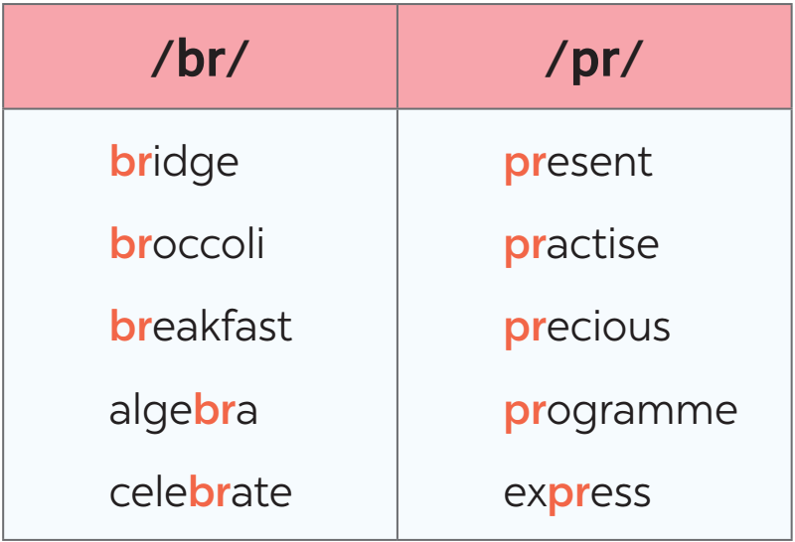  Answer key:  1. A  2. B  3. A  4. C  5. B  5: Listen and practise the sentences. Underline the words with the sound /br/ and circle the words with /pr/.  Answer key:  ﻿1. My brother says online learning improves our IT skills.  2. Santa Claus brings a lot of presents to children.  3. She briefly introduced the new programme.  4. He spent a lot of time preparing for his algebra test.  5. My mum prays at the temple before breakfast on Sundays.  * Home assignment  - Learn by heart vocabulary  - Practice pronounces the sounds /br/ and /pr/.  Prepare: A closer look 2
V. FEEDBACK:
With 8A ………………………………………………………………………………………..…
With 8B ……………………………….……...……………………………………..……………
With 8C ……………………………….…………………………………………………….……

Period: 44
UNIT 6: LIFESTYLES
Lesson 3: A closer look 2 P₆₃₋₆₄
Class | Date of teaching | Date of teaching
8A | 04/12/2023 | 21/12/2023
I. OBJECTIVES: * By the end of this unit, students will be able to:
- gain an overview about the topic Lifestyle
- gain vocabulary to talk about Lifestyle
1. Knowledge:
+ Vocabulary: dogsled (n), make craft, tribal (a), native (a), weave (v),
+ Language: Future simple; First conditional.
+ Pronunciation: Sounds: /br/ and /pr/
2. Competence:
a) General competencies:
- Develop communication skills and creativity.
- Be collaborative and supportive in pair work and teamwork.
- Actively join in class activities.
b) Specific competencies:
- Group work and independent working, pair work, linguistic competence, cooperative learning and communicative competence.
- Sts can introduce themselves or one another fluently.
3. Qualities: Love talking about different lifestyles. Having benefits of their hobbies in daily life. Ss have the good attitude to working in groups, individual work, pair work, cooperative learning.
II. PREPARATIONS
Teacher: Grade 8 textbook, laptop, TV, pictures and realia, Computer connected to the Internet. Phần mềm tương tác hoclieu.vn
Students: Text books, pencils, pics, blank papers, realia,….
III. PROCEDURE
1. WARM-UP (5’-IW)
a. Objectives:
- To introduce the term of first conditional
b. Content:
- Asking questions to lead in the lesson.
c. Product:
- Students’ answers.
d. Implementation
TEACHER’S AND STUDENTS’ ACTIVITIES | CONTENTS
Asking questions:
- Teacher asks Ss “What will you buy if you have 1,000,000 VND?”
- Ss answer the question individually.
- Teacher leads in the introduction of the target grammar point.
- Teacher sets the context for the lesson.
2. KNOWLEDGE FORMATION (10’-IW)
a. Objectives:
- To teach Ss the forms of future simple and first conditional
b. Content:
- Teacher asks Ss to do the exercise individually and then check their answer in pairs.
- Invite some Ss to share their answers. Confirm the correct answers.
c. Product:
- Students know how to use the target grammar.
d. Implementation
Grammar teaching  Step 1: Task delivering  - Teacher reminds students that they have already learnt The future simple and First conditional.  Step 2: Task performance  - Ss’ observation  - Tell them to read the Remember! box in pairs (P_{63, 64})  Step 3: Report and discussion  - Read the Remember! box in pairs (P_{63, 64})  - Make examples.  Step 4: Judgement  - Teacher explains again the form and use of future simple and first conditional. | 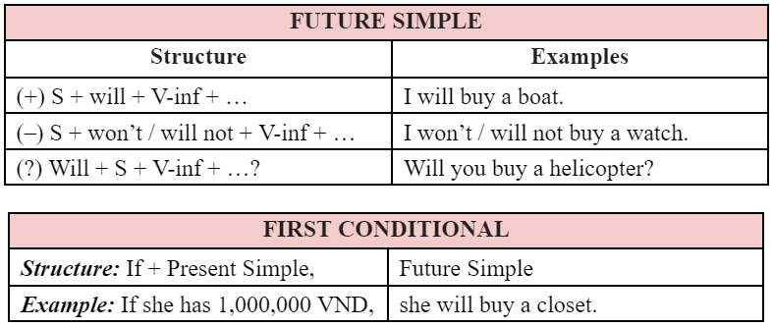
3. PRACTICE (20’ - IW, PW, GW)
a. Objectives:
- To help Ss practise future simple and first conditional in sentences
b. Content:
- Task 1: Use the verbs from the box with will or won’t to complete these dialogues.
- Task 2: Arrange these words and phrases in the correct order to form meaningful sentences.
- Task 3: Give the correct tense of the verbs in brackets, using the first conditional.
- Task 4: ﻿Fill in each blank with IF or UNLESS.
c. Product:
- Students understand how to use the target grammar.
d. Implementation
Task 1: Use the verbs from the box with will or won’t to complete these dialogues.  Step 1: Task delivering  - Give Ss some time to work by themselves and write down the answers.  - T observes and help when and where necessary.  Step 2: Task performance  - Ss’ observation  - Ss read their sentences.  Step 3: Report and discussion  - Call on some Ss to write their answers on the board.  - Student’s talk  Step 4: Judgement  - Confirm the correct answers.  - Explain to Ss another use of the future simple (to describe future possibilities or conditions), and give one or two examples before moving onto 2.  Task 2: Arrange these words and phrases in the correct order to form meaningful sentences.  Step 1: Task delivering  - Have Ss work individually.  - Ss put the words in correct order to build meaningful sentences.  Step 2: Task performance  - Ss’ observation  - Tell them to pay attention to the form of the future simple.  Step 3: Report and discussion  - Student’s talk  - T lets Ss work in pairs to compare their answers before sharing their answers.  Step 4: Judgement  - T checks and confirms the correct answers.  Task 3: Give the correct tense of the verbs in brackets, using the first conditional.  Step 1: Task delivering  ﻿- Draw Ss’ attention to the form and use of the first conditional: main clause (future simple) and if-clause (present simple).  Step 2: Task performance  - Ss’ observation  - Have Ss look at the sentences and write down their answers.  Step 3: Report and discussion  - T asks Ss to check their answers with their partners.  - Ask for translation of some of the words to check their understanding.  Step 4: Judgement  - T confirms the correct answers.  Task 4: ﻿Fill in each blank with IF or UNLESS.  ﻿- Have Ss do the exercise individually and then exchange their answers with a partner.  - Call on some Ss to read the sentences aloud. Other Ss comment.  - T confirms the correct answers. | 1: Use the verbs from the box with will or won’t to complete these dialogues.  Answer key:  ﻿1. will tell  2. will attend – won’t join  3. won’t have – will do  2: Arrange these words and phrases in the correct order to form meaningful sentences.  Answer key:  ﻿1. We will take our first-term exams very soon.  2. Will they stay in an igloo when they visit Alaska?  3. She will work with the tribal groups to help them revive their culture.  4. I won’t choose online learning in the second semester.  5. I’ll come to see you if I go to London this summer.  3: Give the correct tense of the verbs in brackets, using the first conditional.  Answer key:  ﻿1. eat  2. goes  3. will have  4. don’t do  5. Will she be  4: ﻿Fill in each blank with IF or UNLESS.  Answer key:  ﻿1. Unless  2. if  3. unless  4. If  5. unless
4. APPLICATION (10’-IW, PW, GW)
a. Objectives:
- To help Ss ﻿apply the uses of the first conditional with if and unless in real contexts by making sentences about themselves
b. Content:
- Task 5: ﻿Complete the following sentences to make them true for you. Then share your answers with a partner.
- Home assignment
c. Product:
- Students can make sentences using the learned grammar points.
- Take note home assignment.
d. Implementation
Task 5: ﻿Complete the following sentences to make them true for you. Then share your answers with a partner.  Step 1: Task delivering  - Give them some time to work independently.  Step 2: Task performance  - Ss’ observation  - Write down their sentences.  Step 3: Report and discussion  - Then let them work in pairs to exchange their sentences.  - T goes round giving help when and where necessary.  - Some Ss may write their answers on the board.  Step 4: Judgement  - Other Ss comment and T makes corrections.  - Teacher checks the answers as a class and gives feedback.  * Home assignment  - T assigns the homework.  - Ss copy their homework.  - T explains it carefully | 5: ﻿Complete the following sentences to make them true for you. Then share your answers with a partner.  Suggested answers:  ﻿1. If it rains tomorrow, I will stay at home.  2. Unless I get good marks, I will be upset.  3. If I have free time this weekend, I will visit my grandparents  4. If I study harder, I will get good marks.  5. Unless I go to bed early, I will be tired tomorrow.  * Home assignment  - Do exercise in workbook  - Prepare: Communication
V. FEEDBACK:
With 8A …………………………………………………………….…………………………..…
With 8B …………………………...…………………………………….…………..……………
With 8C ………………………………………………………………..…………………….……

Period: 45
UNIT 6: LIFESTYLES
Lesson 4: Communication P₆₄₋₆₅
Class | Date of teaching | Date of teaching
8A | 04/12/2023 | 25/12/2023
I. OBJECTIVES: * By the end of this unit, students will be able to:
- Gain an overview about the topic Customs And Traditions
- Gain vocabulary to talk about Customs and Traditions
1. Knowledge:
+ Vocabulary: admire (v), chase away, pray (v), offering (n), ornamental tree,
+ Language: - express certainty: - Sure; - Yes, certainly.
+ Pronunciation: Sounds: /n / and /ŋ/
2. Competence:
a) General competencies:
- Develop communication skills and creativity.
- Be collaborative and supportive in pair work and teamwork.
- Actively join in class activities.
b) Specific competencies:
- Group work and independent working, pair work, linguistic competence, cooperative learning and communicative competence.
- Sts can introduce themselves or one another fluently
3. Qualities: - Be ready and confident in real life conversations. Ss have the good attitude to working in groups, individual work, pair work, cooperative learning.
II. PREPARATIONS
Teacher: Grade 8 textbook, laptop, TV, pictures and realia, Computer connected to the Internet. Phần mềm tương tác hoclieu.vn
Students: Text books, pencils, pics, blank papers, realia,….
III. PROCEDURE
1. WARM-UP (5’-IW)
a. Objectives:
- To create an active atmosphere in the class before the lesson;
- To lead into the new lesson.
b. Content: -Jumbled conversation
c. Product: - Students’ answers.
d. Implementation
TEACHER’S AND STUDENTS’ ACTIVITIES | CONTENTS
Jumbled conversation:
Step 1: Task delivering
- Teacher gives out a jumbled conversation
- Teacher asks students to rearrange it to make a meaningful conversation.
Step 2: Task performance
- Ss’ observation
- Rearrange it to make a meaningful conversation.
Step 3: Report and discussion
- Student’s answers
- Student’s talk

Step 4: Judgement
- Teacher give some follow-up questions to lead in the introduction of the target grammar point.
- Teacher corrects students (if needed).
2. KNOWLEDGE FORMATION
a. Objectives:
- To introduce ways of expressing certainty.
- To help Ss practise expressing certainty.
b. Content:
- Task 1: Listen and read the conversations. Pay attention to the highlighted sentences.
- Task 2: Work in pairs. Make similar conversations to express certainty in the following situations.
c. Product:
- Students know how to use the structures to express certainty.
d. Implementation
Task 1: Listen and read the conversations. Pay attention to the highlighted sentences.  Step 1: Task delivering  - Play the recording for Ss to listen and read the two dialogues between Tom and Nam, Alice and Mai at the same time.  Step 2: Task performance  - Ss’ observation  - Ss pay attention to the questions and answers.  Step 3: Report and discussion  - Have Ss practise the dialogues in pairs.  - Some pairs to practise the dialogues in front of the class.  Step 4: Judgement  - T comments and gives feedback on Ss’ answers.  Task 2: Work in pairs. Make similar conversations to express certainty in the following situations.  Step 1: Task delivering  - Ask Ss to work in pairs to make similar dialogues with the given cues.  Step 2: Task performance  - Ss’ observation  - Make similar dialogues with the given cues.  - Move around to observe and provide help.  Step 3: Report and discussion  - Some pairs to practise in front of the class.  Step 4: Judgement  - Comment on their performance. | * EVERYDAY ENGLISH  1: Listen and read the conversations. Pay attention to the highlighted sentences.  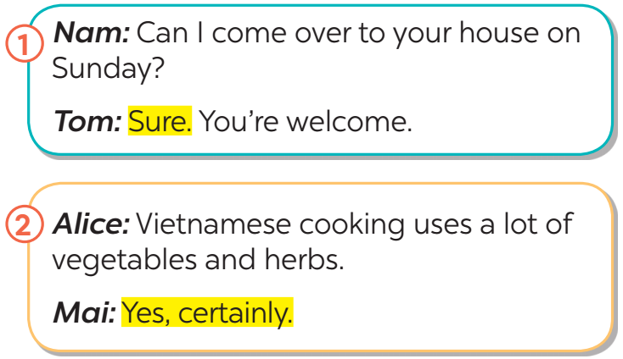  2: Work in pairs. Make similar conversations to express certainty in the following situations.  Suggested answers:  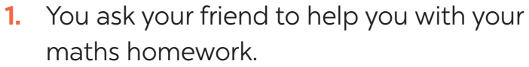  ﻿A: Can you help me with my maths homework?  B: Yes, certainly. / Yes, sure.  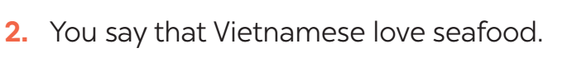  A: Vietnamese love seafood.  B: Yes, certainly. / Yes, sure.
3. PRACTICE
a. Objectives:
- To help Ss ﻿learn about the cuisine of different countries around the world.
- To help Ss develop their reading skill for specific information (scanning).
- To provide Ss with practice in ﻿talking about their opinions and giving reasons.
- To provide Ss with practice in asking and answering about typical food in their area.
b. Content:
- Task 3: How much do you know about the cuisines of different countries? Do the quiz to find out.
- Task 4: Work in groups. Read the two passages and discuss the questions below.
c. Product:
- Students know about the cuisine of different countries around the world.
- Students can talk about their opinion and give reasons; ask and answer questions about food.
d. Implementation
Task 3: How much do you know about the cuisines of different countries? Do the quiz to find out.  ﻿- Ss work in pairs and do the quiz.  - Give explanations if necessary.  - Check their answers as a class.  Task 4: Work in groups. Read the two passages and discuss the questions below.  Step 1: Task delivering  - ﻿Ss read the passages for a few minutes.  - T makes sure they understand the main ideas, and explain if needed.  Step 2: Task performance  - Ss’ observation  - Ss work in groups. Each gives their preference (Italian or Indian food), and gives reasons.  - T goes round the class to monitor.  Step 3: Report and discussion  - Some Ss to perform the task in front of the class.  - T and other Ss listen and make comments.  Step 4: Judgement  T corrects Ss’ mistakes only when it is really necessary. | * CUISINES AROUND THE WORLD  3: How much do you know about the cuisines of different countries? Do the quiz to find out  Answer key:  ﻿1. B  2. A  3. C  4. A  5. B  4: Work in groups. Read the two passages and discuss the questions below.
4. APPLICATION
a. Objectives:
- To provide Ss with practice in ﻿talking about their opinions and giving reasons.
- To provide Ss with practice in asking and answering about typical food in their area.
b. Content:
- Task 5: Work in groups. Talk about the typical food in your area. Discuss.
- Home assignment.
c. Product:
- Students can talk about their opinion and give reasons; ask and answer questions about food.
- Take note home assignment.
d. Implementation
Task 5: Work in groups. Talk about the typical food in your area. Discuss.  Step 1: Task delivering  - Have Ss work in groups, taking turns to ask and answer.  Step 2: Task performance  - Ss’ observation  - Ss think and give the answers.  - Encourage them to say what they know and what they think. Their opinions may differ.  Step 3: Report and discussion  - Call on some pairs to perform the task in front of the class.  - Student’s talk  Step 4: Judgement  T and other Ss listen and make comments.  * Home assignment  - T assigns the homework.  - Ss copy their homework.  - T explains it carefully | 5: Work in groups. Talk about the typical food in your area. Discuss.  Suggested outcome:  ﻿- staple food: rice, corn, bread, ...  - favourite food: pork, chicken, beef, fish, seafood, ...  - foods eaten on special occasions: banh chung, moon cakes, sticky rice, ...  * Home assignment  - Practice express certainty  - Prepare: Skills 1
V. FEEDBACK:
With 8A …………………………..………………………………………………………………..…
With 8B …………………………………………...……………………………………..……………
With 8C ………………………………………………………………………………………….……

Period: 46
UNIT 6: LIFESTYLES
Lesson 5: Skills 1 P₆₅₋₆₆
Class | Date of teaching | Date of teaching
8A | 04/12/2023 | 27/12/2023
I. OBJECTIVES: * By the end of this unit, students will be able to:
- read about Alaska;
- talk about how people in their area maintain traditional lifestyles;
1. Knowledge:
+ Vocabulary: maintain (v); experience (v), style (n), musher (n)
+ Language: - express certainty: - Sure; - Yes, certainly.
+ Pronunciation: Sounds: /n / and /ŋ/
2. Competence:
a) General competencies:
- Develop communication skills and creativity.
- Be collaborative and supportive in pair work and teamwork.
- Actively join in class activities.
b) Specific competencies:
- Group work and independent working, pair work, linguistic competence, cooperative learning and communicative competence.
- Sts can introduce themselves or one another fluently
3. Qualities: - Be ready and confident in real life conversations. Ss have the good attitude to working in groups, individual work, pair work, cooperative learning.
II. PREPARATIONS
Teacher: Grade 8 textbook, laptop, TV, pictures and realia, Computer connected to the Internet. Phần mềm tương tác hoclieu.vn
Students: Text books, pencils, pics, blank papers, realia,….
III. PROCEDURE

1. WARM-UP (5’ - GW)
a. Objectives:
- To help Ss understand and activate their knowledge of the topic;
b. Content:
- Task 1: Read the text and check your answers in the Warm-up part.
- Discuss the pictures.
c. Product:
- Students gain knowledge about Alaska.
d. Implementation
TEACHER’S AND STUDENTS’ ACTIVITIES | CONTENTS
Task 1: Work in groups. Look at the picture, and discuss what you know about Alaska.  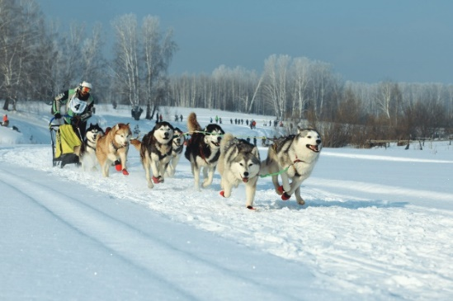  Step 1: Task delivering  - Ask Ss to work in pairs discussing what they can see in the picture.  Step 2: Task performance  - Ss’ observation  - Ask some Ss to say their answers in front of the class.  ﻿Encourage Ss to talk as much as possible. It is not important whether they give the right answers or not; it is important that they can speak in English.  Step 3: Report and discussion  - Have them read the text and check their answers.  - Student’s talk  Step 4: Judgement  - T comments and gives feedback on Ss’ answers. | 1: Work in groups. Look at the picture, and discuss what you know about Alaska.  Suggested answers:  ﻿+ Alaska: a state of the US (49th)  + location: northwest of North America  + population: over 700,000  + climate: oceanic climate, very cold  + native people: Alaskan Natives  + languages: English 86.3%, Alaska Native languages
2. KNOWLEDGE FORMATION (5’-IW)
a. Objectives:
- To help Ss learn new vocabulary in the reading text.
- To improve Ss’ skill of reading for details (scanning)
b. Content:
- Vocabulary
c. Product:
- Students know more new words and how to use the target vocabulary.
d. Implementation
Pre-READING  - Teacher explains the meaning of the new vocabulary by pictures.  - Teacher reveals that the words according to the pictures will appear in the reading text and asks students to open their textbook to find these words  - Teacher introduces the vocabulary.  - Teacher checks students’ understanding with with follow up questions | * Vocabulary:  1. maintain (v)  2. experience (v)  3. style (n)  4. musher (n)
3. PRACTICE (20’-IW)
a. Objectives:
- To help Ss learn new vocabulary in the reading text.
- To improve Ss’ skill of reading for details (scanning)
b. Content:
- Task 2: Match the highlighted words in the text with their meanings.
- Task 3: Read the text again and answer the questions.
c. Product:
- Students know more new words and how to use the target vocabulary.
d. Implementation
WHILE-READING  Task 2. Match the highlighted words in the text with their meanings.  Step 1: Task delivering  - Ask Ss to work individually to read the passage and find the highlighted words.  Step 2: Task performance  - Ss’ observation  - Have Ss read aloud the highlighted words.  Step 3: Report and discussion  - Have Ss match the highlighted words with their meaning in the table.  Step 4: Judgement  - Correct their pronunciation if needed.  - Remind them to use the context to help them.  - Check the answers as a class.  Task 3. Read the text again and answer the questions.  Step 1: Task delivering  - ﻿Ask Ss to do the task individually.  - Tell them to read the passage two or three times, then read each question, pause to identify where it appears in the text, read that part carefully and give the correct answer.  Step 2: Task performance  - Ss’ observation  - Ask Ss to work with a partner to discuss the answers.  - Explain the new words and clarify anything difficult. T may ask more questions to see if they understand the text fully.  Step 3: Report and discussion  - Call on some Ss to read the answers aloud before the class.  - Student’s talk  Step 4: Judgement  - Check their pronunciation and intonation.  - Check the answers as a class. | 2. Match the highlighted words in the text with their meanings.  Suggested answers:  1. d  2. a  3. c  4. b  3. Read the text again and answer the questions.  Answer key:  ﻿1. It is about 730,000 / 730 thousand.  2. We can find it in their villages.  3. Various native group have their own special styles of carving or weaving.  4. It is 1,510 km (long).  5. Yes, it is.
a. Objectives:
- To help Ss ﻿practice of asking and answering about what people in some places do to maintain their traditional lifestyle;
- To ﻿provide Ss with an opportunity to revise and use vocabulary related to the topic of the unit
b. Content:
- Task 4: Work in pairs. Look at the pictures and use the cues to talk about what people in some places do to maintain their traditional lifestyle.
- Task 5: Work in pairs. Ask and answer about how people in your area maintain their traditional lifestyle. You can use the ideas in 4 and the reading text in 1.
c. Product:
- Students can be able to speak about the topic Lifestyles
d. Implementation
* POST-READING  Task 4: Work in pairs. Look at the pictures and use the cues to talk about what people in some places do to maintain their traditional lifestyle.  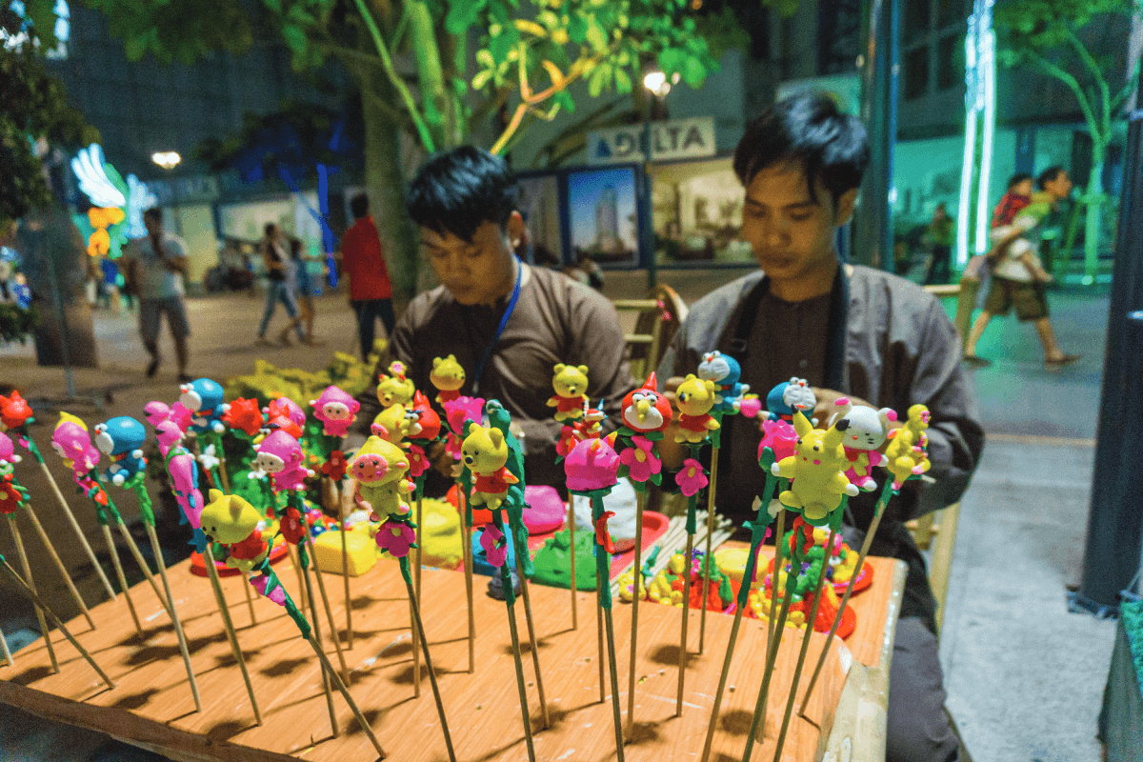  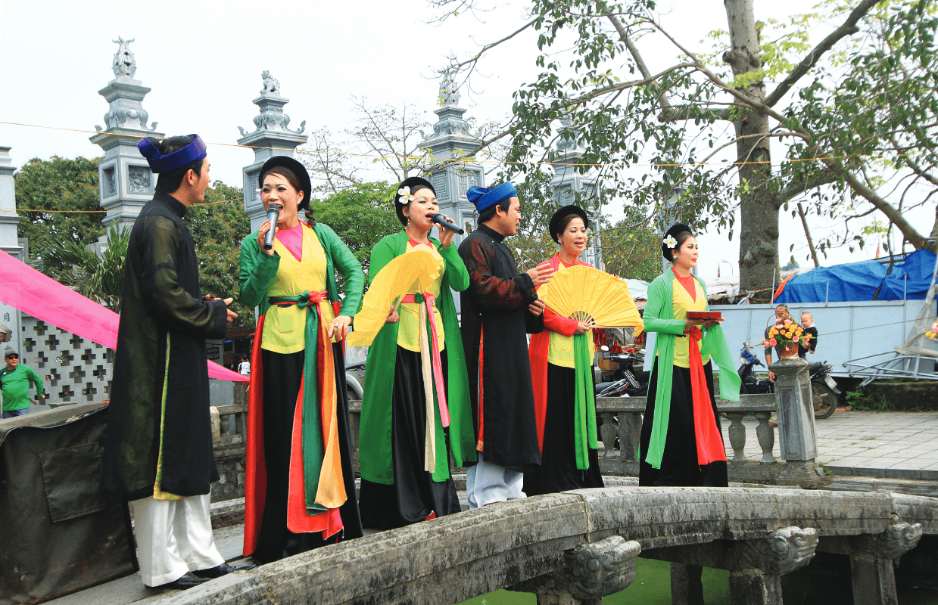  Step 1: Task delivering  - ﻿Give Ss time to study the example, the pictures, and the phrases given.  Step 2: Task performance  - Ss’ observation  - Ss work in pairs.  - T goes round to monitor and give help when necessary.  Step 3: Report and discussion  - Call on some pairs to perform the task in front of the class.  - Student’s talk  Step 4: Judgement  T and other Ss listen and comment. | * SPEAKING  4: Work in pairs. Look at the pictures and use the cues to talk about what people in some places do to maintain their traditional lifestyle.  Suggested outcome:  ﻿A: What do people in Chau An Village  do to maintain their traditional  lifestyle?  B: They perform traditional dances.  They also …
Task 5: Work in pairs. Ask and answer about how people in your area maintain their traditional lifestyle. You can use the ideas in 4 and the reading text in 1. (8 mins)  Step 1: Task delivering  - ﻿Allow some time for Ss to think about how people in their area maintain traditional lifestyle.  Step 2: Task performance  - Ss’ observation  - Ss work in pairs (or groups of 4-5).  - Ask them to use the ideas in Activity 4, and the vocabulary learnt in the unit.  Step 3: Report and discussion  - Student’s talk  - Give help when they have difficulty expressing their ideas.  - Call on some pairs to talk in front of the class.  Step 4: Judgement  T and other Ss listen and comment. | Suggested outcome:  I live in Bat Trang, which is a pottery village not far from Ha Noi centre. To maintain the traditional lifestyle, local people will make pottery and paint on the ceramic statues. Then they will sell those pottery products to tourists.
- Learn by heart vocabulary  - Prepare for skills 2 | Students’ notes  Observation
V. FEEDBACK:
With 8A …………………………..………………………………………………………………..…
With 8B …………………………………………...……………………………………..……………
With 8C ………………………………………………………………………………………….……

Period: 47
UNIT 6: LIFESTYLES
Lesson 6: Skills 2 P₆₇
Class | Date of teaching | Date of teaching
8A | 04/12/2023 | 28/12/2023
I. OBJECTIVES: * By the end of this unit, students will be able to:
- Listening to someone’s opinion about the impact of modern technology
- Writing a paragraph about the advantages or disadvantages of online learning
1. Knowledge:
+ Vocabulary: dogsled (n), make craft, tribal (a), native (a), weave (v),
+ Language: Expressing certainty: Sure; Yes, certainly.
+ Pronunciation: Sounds: /br/ and /pr/
2. Competence:
a) General competencies:
- Develop communication skills and creativity.
- Be collaborative and supportive in pair work and teamwork.
- Actively join in class activities.
b) Specific competencies:
- Group work and independent working, pair work, linguistic competence, cooperative learning and communicative competence.
- Sts can introduce themselves or one another fluently.
3. Qualities: - Love reading and talking about activities in the countryside. Having benefits of their hobbies in daily life. Ss have the good attitude to working in groups, individual work, pair work, cooperative learning.
II. PREPARATIONS
Teacher: Grade 8 textbook, laptop, TV, pictures and realia, Computer connected to the Internet. Phần mềm tương tác hoclieu.vn
Students: Text books, pencils, pics, blank papers, realia,….
III. PROCEDURE

1. WARM-UP (5’-IW)
a. Objectives:
- To create an active atmosphere in the class before the lesson;
- To lead into the new lesson.
b. Content:
- Game: Broken telephone
c. Product:
- Students have a chance to speak English and know the topic of this lesson.
d. Implementation
TEACHER’S AND STUDENTS’ ACTIVITIES | CONTENTS
Broken telephone game:  Step 1: Task delivering  - T divides the class into 5 groups. Each group stands in one line.  - T shows a word to the last students of all groups. These students must quickly whisper the word to their teammates in order. The first member of each team writes the word on the board. The fastest student writes the correct word earns 1 point for the team.  Step 2: Task performance  - Ss’ observation  - Ss work in groups.  Step 3: Report and discussion  - Whisper the word to their teammates in order.  - Writes the word on the board.  Step 4: Judgement  - T leads to the new lesson: Listening and Writing about opinions on technology and online learning.  - T introduces the objectives of the lesson. | Words:  - lifestyle  - communication  - online learning  - technology
2. KNOWLEDGE FORMATION (10’-IW, PW)
a. Objectives:
- To help Ss understand and activate their knowledge of the topic
b. Content:
- Task 1: Work in groups. Which of the following do you think is more influenced by modern
technology? Tick your choice(s).
c. Product:
- Students know more new words and knowledge through the listening tasks.
d. Implementation
* PRE-LISTENING (5’)  Task 1: ﻿Work in groups. Which of the following do you think is more influenced by modern technology? Tick (﻿✓) your choice(s).  Step 1: Task delivering  - Let ﻿Ss work in groups.  Give them 2 - 3 minutes to think and tick the correct answer(s).  Questions:  Which of the following do you think is more influenced by modern technology? Tick (﻿✓) your choice(s).  Step 2: Task performance  - Ss’ observation  - Work in group.  Step 3: Report and discussion  - Tick (﻿✓) your choice(s).  - Ss share their answers in front of the class.  - Student’s answers  Step 4: Judgement  - T ask them some other questions about the reasons for their answers. | 1: ﻿Work in groups. Which of the following do you think is more influenced by modern technology? Tick (﻿✓) your choice(s).  ﻿Suggested answers:  - ways of communicating ﻿✓  - traditional food and drink  - ways of learning ✓
3. PRACTICE (20’-IW, PW, GW)
a. Objectives:
- To help Ss understand and activate their knowledge of the topic
- To help Ss develop their skill of listening for specific information
b. Content:
- Task 2: ﻿Listen to the conversation and tick (✓) T (True) or F (False).
- Task 3: Listen again and choose the correct answer to each question.
c. Product:
- Students know more new words and knowledge through the listening tasks.
d. Implementation
Task 2. ﻿Listen to the conversation and tick (✓) T (True) or F (False).  Step 1: Task delivering  - Have Ss read the questions in this activity quickly and underline the key words. This helps them have some idea of what they are going to listen to and the information they need for answering the questions.  ﻿- Tell Ss that they are going to listen to a conversation about modern technology and online learning.  - Play the recording twice.  Step 2: Task performance  - Ss’ observation  - Ss do the exercise.  Step 3: Report and discussion  - For stronger classes, ask Ss to take notes of the information to explain their answers.  - Have Ss share their answers in pairs.  Step 4: Judgement  - Invite some pairs to answer and confirm the correct ones.  - Play the recording again if needed, stopping at places where Ss are having difficulties  Task 3. Listen again and choose the correct answer to each question.  Step 1: Task delivering  - Have Ss read the questions and the options, and quickly underline the key words. ﻿  - Have Ss read through the sentences first.  - Play the recording once or twice.  Step 2: Task performance  - Ss’ observation  - Ss listen carefully and circle the correct answers.  Step 3: Report and discussion  - Ss share their answers in pairs.  - Student’s answers  Step 4: Judgement  - Some pairs answer and confirm the correct ones.  - Play the recording again if needed, stopping at the places where Ss are having difficulties. | 2. ﻿Listen to the conversation and tick (✓) T (True) or F (False).Answer key:  ﻿1. T  2. T  3. F  4. F  5. T  3. Listen again and choose the correct answer to each question. Answer key:  1. A  2. B  3. C  4. C
4. APPLICATION (15’-IW, PW, GW)
a. Objectives:
- To help Ss practise writing a paragraph ﻿ about the advantages OR disadvantages of online learning.
b. Content: Task 4, 5 in Student book; Home assignment.
c. Product: Students’ speaking; Take note home assignment.
d. Implementation
* POST- LISTENING  Task 4: ﻿Look at the list below. Put the ideas about online learning in the correct columns.  Step 1: Task delivering  ﻿- Have Ss work in pairs.  - Tell them to read all the ideas given.  Step 2: Task performance  - Ss’ observation  - Think about the ideas given.  - Put them in the correct columns.  Step 3: Report and discussion  - Ss share their answers in pairs.  - Student’s answers  Step 4: Judgement  - T comments and gives feedback on Ss’ answers.  Task 5: ﻿Write a paragraph (80 – 100 words) about the advantages OR disadvantages of online learning. You can refer to the listening and the ideas in 4.  Step 1: Task delivering  - Set up the writing activity.  - T reminds Ss that the first important thing is always to think about what they are going to write.  - Ss use the ideas they have prepared in 4.  Step 2: Task performance  - Ss’ observation  - Ss brainstorm the ideas and needed language for writing.  Step 3: Report and discussion  - Ss use proper connectors (first/ firstly, second/  secondly, etc.), and pay attention to grammar, use of words, spelling and punctuation.  - Ss write the first draft individually.  - Ss write the paragraph (in time given)  - T may display all or some of the Ss’ writings on the wall / bulletin board.  Step 4: Judgement  - T and other Ss comment.  - Ss edit and revise their writing as homework. If time is limited, T may ask Ss to write the final version at home.  * Home assignment  - T assigns the homework.  - Ss copy their homework.  - T explains it carefully | WRITING  4: ﻿Look at the list below. Put the ideas about online learning in the correct columns.  Answer key:  ﻿Advantages: convenient, comfortable, more freedom, independent  5: ﻿Write a paragraph (80 – 100 words) about the advantages OR disadvantages of online learning. You can refer to the listening and the ideas in 4.  Suggested outcome:  Students’ first draft  * Home assignment  - Do the exercises in the workbook  - Prepare: Looking back and Project

Period: 48
UNIT 6: LIFESTYLES
Lesson 7: Looking back - Project P₆₈₋₆₉
Class | Date of teaching | Date of teaching
8A | 04/12/2023 | 01/12/2024
I. OBJECTIVES: * By the end of this unit, students will be able to:
- review the vocabulary and grammar of Unit 6
- apply what they have learnt (vocabulary and grammar) into practice through a project.
1. Knowledge:
+ Vocabulary: review
+ Language: review
+ Pronunciation: review
2. Competence:
a) General competencies:
- Develop communication skills and creativity.
- Be collaborative and supportive in pair work and teamwork.
- Actively join in class activities.
b) Specific competencies:
- Group work and independent working, pair work, linguistic competence, cooperative learning and communicative competence.
- Sts can introduce themselves or one another fluently.
3. Qualities: - Love talking about traditional lifestyles. Having benefits of their hobbies in daily life. Ss have the good attitude to working in groups, individual work, pair work, cooperative learning.
II. PREPARATIONS
Teacher: Grade 8 textbook, laptop, TV, pictures and realia, Computer connected to the Internet. Phần mềm tương tác hoclieu.vn
Students: Text books, pencils, pics, blank papers, realia,….
III. PROCEDURE

1. WARM-UP (5’-IW, PW)
a. Objectives:
- To create an active atmosphere in the class before the lesson;
- To lead into the revision
b. Content:
- Revision
c. Product:
- Ss can tell the teacher what they have learnt in unit 6.
d. Implementation
TEACHER’S AND STUDENTS’ ACTIVITIES | CONTENTS
Revision  Step 1: Task delivering  - Teacher asks Ss to think of what they have learnt already in Unit 6.  Step 2: Task performance  - Ss’ observation  - Ss work in pairs to do the task.  Step 3: Report and discussion  - Teacher calls some students to retell.  - Student’s talk  Step 4: Judgement  - Teacher confirms and leads them to do all the exercises in books. | Suggested answers:  ﻿- use the words related to the topic lifestyles;  - pronounce the sounds /br/ and /pr/ in words and sentences correctly;  - use the future simple and the first conditional;  - express certainty;  - read for specific information about an interesting lifestyle and ways to maintain a traditional lifestyle;  - talk about maintaining traditional lifestyles;  - listen for general and specific information about the impact of modern technology on lifestyles;  - write a paragraph about the advantages or disadvantages of online learning.
2. KNOWLEDGE FORMATION (10’-IW, PW)
a. Objectives:
- To help Ss review the vocabulary of Unit 6
b. Content:
- Task 1: Match each word or phrase with its meaning.
- Task 2: ﻿Complete each sentence with a word or phrase from the box
c. Product:
- Students’ answers.
d. Implementation
Task 1: ﻿Match each word or phrase with its meaning.  Step 1: Task delivering  - Have Ss do these activities individually.  Step 2: Task performance  - Ss’ observation  - Match each word or phrase with its meaning  Step 3: Report and discussion  - Compare their answers with their partners.  - Ss read out their answers in front of the class.  Step 4: Judgement  - Confirm the correct answers.  Task 2: ﻿Complete each sentence with a word or phrase from the box  Step 1: Task delivering  - Have Ss do these activities individually.  Step 2: Task performance  - Ss’ observation  - Match each word or phrase with its meaning  Step 3: Report and discussion  - Compare their answers with their partners.  - Ss read out their answers in front of the class.  Step 4: Judgement  - Confirm the correct answers. | * VOCABULARY REVISION  1: ﻿Match each word or phrase with its meaning.  Answer key:  1. c  2. d  3. e  4. a  5. b  2: ﻿Complete each sentence with a word or phrase from the box  Answer key:  1. in the habit of  2. greeted  3. lifestyle  4. online lessons  5. maintain
3. PRACTICE (10’-IW, PW, GW)
a. Objectives:
- To help Ss revise the forms and uses of future simple and first conditional
b. Content:
- Ask Ss to do the exercise individually first. Then they can check their answers with a partner before discussing the answers as a class.
- Remind Ss to keep a record of their original answers so that they can use that information in the Now I can … section.
c. Product: - Students’ answers.
d. Implementation
Task 3: Complete the sentences, using the correct tense of the verbs in brackets.  Step 1: Task delivering  - Ask Ss to do the exercise individually first.  Step 2: Task performance  - Ss’ observation  - Complete the sentences.  Step 3: Report and discussion  - Ss check their answers with a partner before discussing the answers as a class.  - Ss keep a record of their original answers so that they can use that information in the Now I can … section.  Step 4: Judgement  - T comments and gives feedback on Ss’ answers.  ﻿Task 4: Rewrite the following sentences, so that their meaning stays the same.  Step 1: Task delivering  - Ask Ss to do the exercise individually first.  Step 2: Task performance  - Ss’ observation  - Complete the sentences.  Step 3: Report and discussion  - Ss check their answers with a partner before discussing the answers as a class.  - Ss keep a record of their original answers so that they can use that information in the Now I can … section.  Step 4: Judgement  - T comments and gives feedback on Ss’ answers. | GRAMMAR REVISION  3: Complete the sentences, using the correct tense of the verbs in brackets.  Answer key:  1. will send  2. won’t be  3. will become  4. win  5. Will we have to  4: Rewrite the following sentences, so that their meaning stays the same.  Answer key:  1. If you play computer games for long, you will harm your eyes.  2. My dad will visit Coober Pedy next summer.  3. If it doesn't rain, we'll go to the beach.  4. Unless you hurry up, you will be late.  5. If the teacher doesn’t explain the lesson again, we won’t understand it very well.
4. APPLICATION (20’-IW, PW, GW)
a. Objectives:
- To help Ss practise making their own poster about an interesting way of life around the world.
b. Content: - Present the poster to the class; Home assignment.
c. Product:
- Students can present their posters about an interesting way of life around the world.
- Take note home assignment.
d. Implementation
Find information about an interesting way of life around the world. Make a poster about it.  Step 1: Task delivering  - Ask Ss to display all the posters on the wall or bulletin board.  Step 2: Task performance: - Ss’ observation  Step 3: Report and discussion  - Each group to present their poster to the whole class.  Step 4: Judgement  - T comments and gives feedback on Ss’ answers.  * Home assignment  - T assigns the homework.  - Ss copy their homework.  - T explains it carefully | * PROJECT (20 minutes)  Suggested outcome:  Students’ posters & presentations  * Home assignment  - Prepare for the next lesson  - Revise lesson at home

