ĐỀ 5
PART 1: LISTENING
Question 1: Listen and number (1 pt)
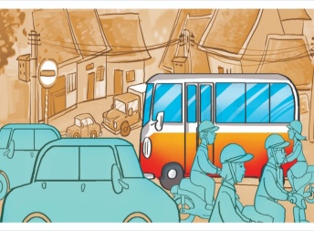 | 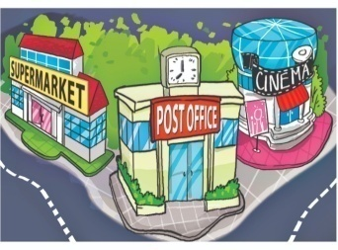 | 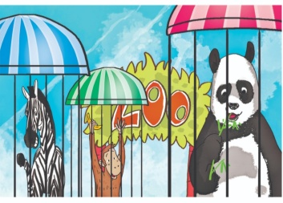 | 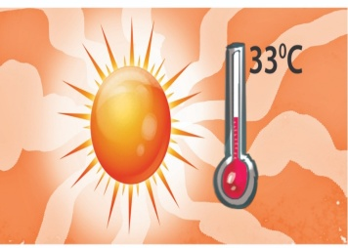
a. | b. | c. | d.
Question 2: Listen and tick (1pt)
1..
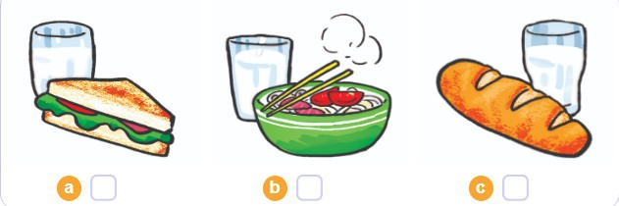 | 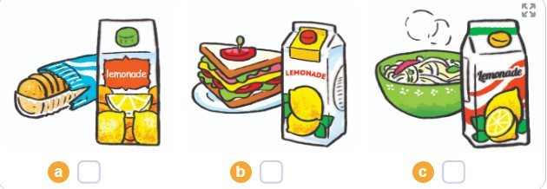  2...
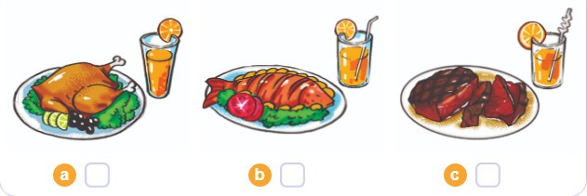  3.. | 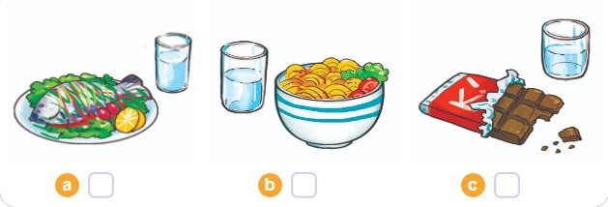  4..
Question 3: Listen and complete (1pt)
- Quan has a stomach ache. He should go to the ..………………….
- Tony has a ................................. He shouldn’t go to school
- Phong has a …………………............ He shouldn’t eat ice- cream.
- Mrs Green has a backache. She shouldn’t …………………… heavy things.
PART II. READING
Question 4: Odd one out. (1.5pt)
1. a. stomatch ache | b. fever | c. headache | d. health
2. a. kind | b. hard-working | c. character | d. greedy
3. a. nurse | b. write | c. pilot | d. architect
4. a. weather | b. windy | c. stormy | d. rainy
5. a. museum | b. pagoda | c. park | d. history
6. a. expect | b. attractive | c. interesting | d. exciting
Question 5: Choose the best answers. (1.5 pt)
1. You shouldn’t run ………. the stairs.
a. off | b. across | c. down | d. away
2. Don’t ………… with matches!
a. play | b. playing | c. plays | d. played
3. Which place would you like …………….? I’d like to visit the City theater.
a. visit b. to visiting c. visiting d. to visit
4. What do you think ………… Ha Long Bay? - It’s more beautiful than I expected.
a.in b. on c. from d. of
5. Don’t climb the tree! -………………..
a. Ok, I will. b. Yes, I do. c. No, I don’t. d. Ok, I won’t.
6. He should not play with the knife because he may cut ………..
a. yourself | b. himself | c. herself | d. itself
Question 6: Read and complete with the words given (1,25pts)
weather | Watch | forecast | go | stormy
Mai: Let's (1)..................for a picnic tomorrow.
Tony: What will the (2).........................be like tomorrow?
Linda: Well, it will be cold and (3) .................
Mai: How do you know that?
Linda: I watched the weather (4) .................... on TV.
Tony: We can't go for a picnic if it's stormy.
Mai: OK, let's stay home, eat popcorn and ......................(5) cartoons.
Tony and Linda: Great idea!
Question 7: Read and choose the best answer (1,25pts)
Dear Linda,
I'm happy you're going to visit me. You can take bus Number 12 at West Street and get off at the fifth stop. Then walk along the street for five minutes. You will see Pear Street at the end of the street. Turn left and you will see a pharmacy on the left. My house is opposite the pharmacy. It is behind a green fence.
See you!
Tony
1. Linda should take bus number ………………to go to Tony’s house.
- two b. twelve c. ten d. fifteen
2. She should get off at the........................
a. five stop b. fifth stop c. the fifth stop d. fifth
3. The name of the road at the end of the street is ……………………….
a. Lemon street b. Hight street c. West street d. Pear street
4. Tony’s house is …………………………the pharmacy.
a. next to b. behind c. opposite d. near
5. The fence of Tony’s house is ………………..
a. grey b. green c. blue d. brown
PART IV.WRITING
Question 8: Arrange the words to make sentences ( 1.5pt)
- would/ like / what / you/ drink to / ? /
………………………………………………………………………………….…………
- is/ hot/ in / summer / usually / It /./
…………………………………………………………………………………………...
- will/ what/ like/ weather/ be/ the/ tomorrow/ ? /
……………………………………………………………………………………………
- spring/ in / what/ country/ is/ like/ your/ ?/
……………………………………………………………………………........................
- a/ I’d / an / sandwich, / apple / please / and / like/. /
………………………………………………………………………………………….…
- do/ eat / you / sausages / every / many / how/ day/ ? /
...........................................................................................................................................

