Class: 3A Teaching date:29/10/2024
Unit 5: My hobbies
Lesson 2 (Activity 1-3)
A. OBJECTIVES:
By the end of the lesson, Ss will be able to:
1. Knowledge:
- understand and correctly repeat the sentences in two communicative contexts (pictures) focusing on asking and answering about hobbies.
- correctly say the words and use What's your hobby? – I like………… to ask and answer questions about someone's hobby.
- enhance the correct use of What's your hobby? – I like ………... to ask and answer questions about someone's hobby.
- Vocabulary: run, paint, walk, cook, like
- Skills: speaking and listening
2. Competences:
- Critical Thinking: self-introduce
- Co-operation: ready to help friends in pair work/ group work.
- Sociability: Talk to each other, say good words to others.
3. Attitude/ Qualities:
- Kindness: Help partners to complete learning tasks.
- Honesty: tell the truth about feelings and emotions
B. TEACHING AIDS:
- Teacher: Teacher’s guide Pages 43, 44; audio Tracks 48, 49, website sachmem.vn, posters, laptop, pictures, textbook, lesson plan, TV or projector.
- Students: Pupil’s book Page 36, notebooks, workbooks, school things.
C. PROCEDURES:
Teacher’s activities | Students’ activities
1.Warm- up: (3’)  Game: Guessing and Choosing  *Aims: to create a friendly and active atmosphere in the class to beginning the lesson.  *Procedure:  - T shows 4 pictures of hobbies and calls 4 Ss to come to the board and choose.  - T asks 4 Ss to come to the board and choose 1 picture of hobby and keep them in secret by covering them.  - The others will write their hobbies in the board at their desks and keep their ides in secret.  - The Ss on the board will 1 by 1 show their pictures they chose.  - When the teacher says the word of the pictures 1 by 1 shown on the board, who has the same hobby will raise their board or raise their hands.  - The Ss on the board will get the same points as the numbers of Ss raising their hands.  - Say “Open your book page 36” and look at “Unit 5, Lesson 2 (1,2,3)”.  2. Presentation (16’)  Activity 1. Vocabulary.  *Aims: Ss will be able to know the vocabulary in front of starting the new lesson.  *Procedure:  -T elicits the new words  + run- running : chạy (mime)  + paint- painting: tô màu (mime)  + walk- walking : đi bộ (mime)  + cook- cooking : nấu ăn (mine)  + like : thích (situation)  - T models (3 times).  - T writes the words on the board.  - Checking: What and where  Activity 2. Look, listen and repeat:  *Aims: Ss will be able to understand and correctly repeat the sentences in two communicative contexts (pictures) focusing on asking and answering about hobbies.  *Procedure:  - Have Ss look at Pictures a and b and identify the characters in the pictures.  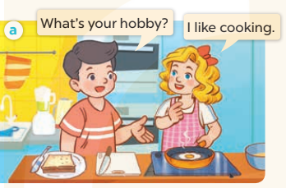  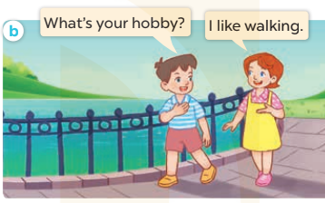  - Play the audio twice (sentence by sentence). Correct their pronunciation where necessary.  - Have Ss to practice the diaguage  - T invites a few pairs to the front of the class to practice.  - T checks pronunciation for ss.  Activity 3. Listen, point and say.  *Aims: Ss will be able to correctly say the words and use What's your hobby? – I like ……. to ask and answer questions about someone's hobby.  *Procedure:  * Model sentences:  - T asks Ss look at picture a and helps Ss know the structure from the dialogue.  - T introduces new structure for Ss.  - T explains, models and gives meaning.  - Have Ss repeat the model sentences.  A: What’s your hobby?  B: I like cooking  3.Practice: (7’)  *Drill pictures  - Have Ss look at the pictures and elicit the names of the hobbies.  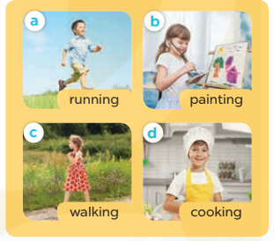  - Run through all the pictures.  - Run through model sentences.  + Run through the questions  + Run through the answers  - Have Ss to practise:  + T asks – Ss answer (change role).  + Ss – Ss (change role).  - Ask Ss to work in pairs.  - T controls and corrects.  - Invite a few pairs to come to the front of the classroom, point at the pictures and say the questions and answers in front of the class.  - T gives feedbacks.  4.Production: (7’)  Activity 4. Let’s talk.  *Aims: Ss will be able to enhance the correct use of What's your hobby? – I like ……. to ask and answer questions about someone's hobby.  *Procedure:  - T asks ss to guess each character and what the children say.  + What can you see in the picture?  +Who are they?  +Where are they?  +What are they doing?  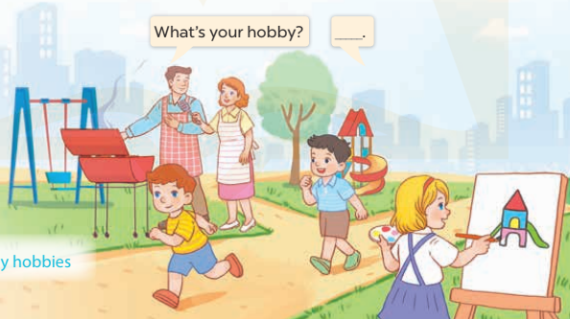  - Put Ss into pairs and encourage them to ask and answer questions using What’s your hobby? I like….  - Invite some pairs to stand up to perform their exchanges.  *Consolidation  *Aims: Ss will be able consolidate and wrap up the content of the lesson.  *Procedure:  - T asks ss to answer the following questions:  + What have you learnt from the lesson today?  +What are the core values of the lesson? (if the teacher can take from the lesson).  - T review the vocabulary and model sentences.  - T praises some Ss who are hardworking / active/ good…. as well as encourage others to try more.  5. Homework. (2’)  - Learn the vocabulary and model sentences by heart  - Prepare the new lesson: Unit 5, Lesson 2 (4,5,6). | - Ss listen  - Ss play the game  -Ss play game  - Ss open their books  -Ss listen and answer  - - Ss listen and repeat  + Choral repetition (3 times).  + Individual repetition (3 ss)  - Ss take note  - Ss look, remember and slap  -Look at the pictures and get to know the characters in the pictures.  + In picture a: Nam asks: What's your hobby? And Mary answers I like cooking.  – In picture b: Minh asks What's your hobby? And Lucy answers: I like walking  -Ss listen and repeat in chorus (twice)  -Ss work in pairs to practice  -Ss practice the diaguage  -Ss listen  -Ss look at the picture and answer.  -Ss listen  -Ss listen and repeat  -Ss repeat to the hobbies  -Ss listen and answer  +Picture a: a boy running  +Picture b. a girl painting  +Picture c. a girl walking  +Picture d. a boy cooking  - Ss look, listen and repeat  - Ss practice in chorus  -Ss work in pairs to practice  -Ss listen  -Ss go to the board and point and say  -Ss listen  -Ss look at the picture and answer  + There are several people doing different activities in the park.  -Ss work in pairs  -Ss ask and answer  -Ss answer the questions  - Ss listen  -Ss listen and clap their hands  -Ss listen and take note

