Class: 5
Period 45 Unit 7:Lesson 1 Activity 4-6
A. OBJECTIVES:
By the end of the lesson, Ss will be able to:
1. Knowledge:
- listen to and understand four exchanges in which the speakers ask and answer questions about someone’s favourite school activities and number the pictures.
- complete four gapped exchanges with the help of picture cues.
- listen to and complete What school activities does she like? song and to sing it with the correct pronunciation, rhythm and melody.
- Vocabulary: Review
- Skills: speaking, listening, reading and writing.
2. Competences:
- Communication and collaboration: work in pairs and groups to complete the learning tasks.
- Self-control and independent learning: perform pronunciation and speaking tasks.
3. Attitude/ Qualities:
- Show their pride in their school and show their interest in their favorite school activities
B. TEACHING AIDS:
- Teacher: Teacher’s guide Pages 104, 105, 106; audio Tracks 68, 69; website hoclieu.vn, posters, laptop, pictures, textbook, lesson plan, TV or projector.
- Students: Student’s book Page 51, notebooks, workbooks, school things.
C. PROCEDURES:
Teacher’s activities | Students’ activities
1.Warm- up and review: (5’)  Game: Football game  *Aims: to revise the learned words *Procedure:  - Explain how to play the game.  - Tell ss they are going to look at the pictures and answer the questions.  - Divide the class into 3 teams.  - Ss take turns to answer the question.  - Check the pupils’ answers as a whole class.  - If they give the correct answers, they can play football and get the goal.  - The team with more goals will be the winner.  - Say “Open your book page 51” and look at “Unit 7, Lesson 1(4,5,6)”.  2.Practice: (25’)  Activity 1. Listen and number:  *Aims: Ss will be able to listen to and understand four exchanges in which the speakers ask and answer questions about someone’s favourite school activities and number the pictures.  *Procedure:  - Draw ss’ attention to the pictures and ask questions to elicit what each child is doing.  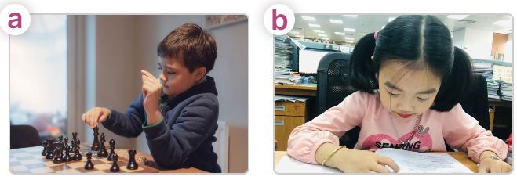  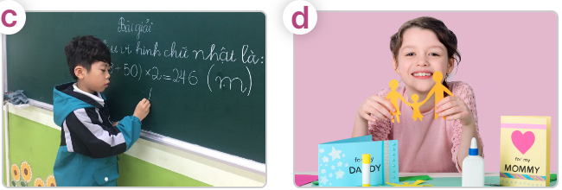  - T ask Ss to guess the answers.  + T writes Ss’guessing on the board.  - Listen to the tape:  + Play the recording  + Play the recording again for pupils to do the task.  + Play the recording a third time for pupils to check their answers.  - Get Ss to swap books with their partner, then check answers as a class.  + Write the answers on the board for Ss to correct their answers. Then checks Ss’ guessing.  - Have Ss to listen and repeat individually and in chorus  Key: 1. b 2. c 3. a 4. d  Activity 2. Read and complete  *Aims: Ss will be able to complete four gapped exchanges with the help of picture cues.  *Procedure:  - Have Ss look at the pictures and read the question and answer, and guess the missing word in the answer.  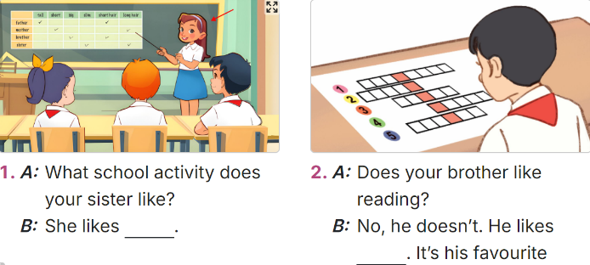  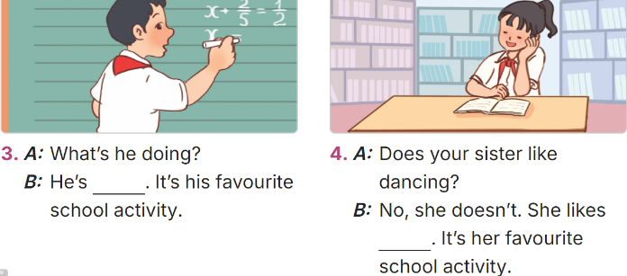  - T models: have Ss read the question and asks what words are missing (doing projects)  - Give Ss a time limit to read the gapped dialogues, look at the pictures and do the task independently.  - Get Ss to swap books with a partner and check their answers before checking as a class.  + Invite one student to write the answers on the board.  - Invite two pairs of Ss to act out the completed dialogues.  Key:  1. doing projects  2. doing word puzzles  3. solving a maths problem  4. reading books  Activity 3. Listen, complete and sing  *Aims: Ss will be able to listen to and complete the song What school activity does she like? and to sing with the correct pronunciation, rhythm and melody.  *Procedure:  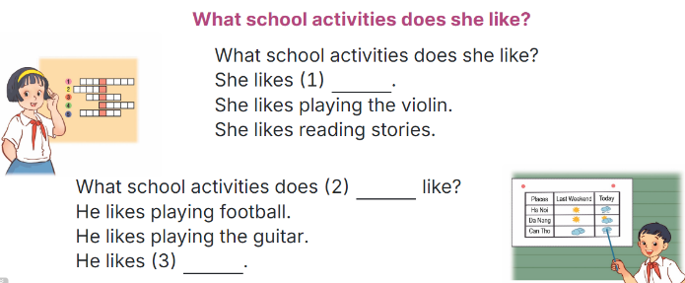  -  - Have ss read the song lyric, look at the relevant picture and guess the missing words and fill in the gap.  - Play the recording all the way through for ss to listen to the whole song.  - Play the recording again for ss to fill in the gaps with the missing words.  - Check answers together as a class.  - Play the recording line by line for ss to listen and repeat.  - Divide the class into two halves to take turns singing the questions and answer.  3. Fun corner and wrap- up (5’)  Game: Lucky number  - Tell ss they are going to choose a number, look at the picture and answer the question or complete the question.  - Divide ss in 2 teams and play the game.  - Give points as the diamonds shown on the screen.  - Which team has more diamonds will be the winner. | -Ss listen to the teacher  -Ss play the game  -Ss play the game  - Ss open their books  -Look at the pictures and say:  + Picture a: a boy playing chess  + Picture b: a girl reading a book  + Picture c: a boy solving a maths problem at the board  + Picture d: a girl making a paper craft  -Ss guess the answers  - Ss listen to the tape  - Ss listen again and do the task.  - Ss listen and check their answers  - Ss swap books with their partner, then check answers as a class and guessing  -Ss write the answer on the board  -Ss listen and repeat  -Ss look at the picture and say  -Ss follow the teacher  - Ss do the task independently.  - Ss swap books with a partner and check their answers.  - Ss write the answers on the board  - Pairs of Ss read the completed dialogues aloud  - Ss pay attention to the title and lyrics of the song and guess the missing words.  - Ss listen  - Ss listen and complete the song.  -Ss check the answer  - Ss listen to the recording and repeat.  - Ss sing  -Ss listen to the teacher  - Ss play the game.

