UBND HUYỆN CÁT HẢI  TRƯỜNG TH NGUYỄN VĂN TRỖI |  | ĐỀ KIỂM TRA ĐỊNH KÌ LẦN I  Năm học: 2023 - 2024  Môn: Tiếng Anh 3 Thời gian 35 phút
Họ và tên:.........................................  Lớp 3:....... | Điểm  ............ | Giám thị  .............................. | Giám khảo  ..........................
 | Listening, reading and writing | Speaking | Total
Mark
Comments

I.LISTENING
Task 1. Listen and number . 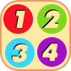

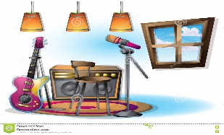  a. | b. | 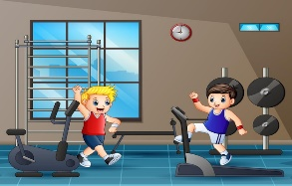  c. | d.
Task 2. Listen and tick .

1. | a. | b. | c.
 |  | 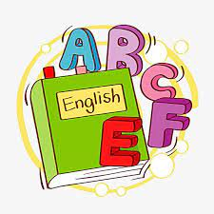
2. | a. | b. | c.

II. READING AND WRITING
Task 1. Read and match.
0. May I go out? Please! | 0. e | a. I play volleyball.
1. What are your hobbies? | 1. | b. They are yellow.
2. Do you have a pencil? | 2. | c. Yes, I do.
3. What do you do at break time? | 3. | d. I like dancing and singing.
4. What colour are your pencils? | 4. | e. No, you can’t

Task 2. Read and circle.
- ___________colour are your pencils?

- When b. What c. where

- I play basketball __________break time?

- in b.on c. at

Task 3. Read and complete with the given words.
room | Minh | school | playground

Hi, I am Nam . I’m in Class 3A. This is my (1)___________ . It’s big. My classroom is big too. Now it is break time. Many of my friends are in the (2)____________. I’m in the computer (3)____________ with my friend (4)____________
Task 4: Look and write. There is one example.(1 point)

- Let’s go to the ____________ | 2. A. What do you do at break time?  B. I play ____________

Task 5. Reorder the words to make sentences
- name /What/is/your/?
What is your name ?
- Let’s / go/music room/ the / to/.
_______________________________________________________________
- is/ This / computer / room/ my/.
_______________________________________________________________
- play/ break time/I / word/ badminton/ do/and/ puzzles/at /.
________________________________________________________________

