|  |  |  |  |
| --- | --- | --- | --- |
| UBND HUYỆN CÁT HẢI  **TRƯỜNG TH NGUYỄN VĂN TRỖI** | | **ĐỀ KIỂM TRA CUỐI HỌC KÌ II**  **Năm học: 2023 - 2024**  Môn: Tiếng Anh 3 Thời gian 35 phút | |
|  |  | Giám thị  ................................ | Giám khảo  ............................ |

**I.LISTENING**

**Task 1. Listen and number .** 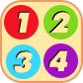

|  |  |  |  |
| --- | --- | --- | --- |
|  | **D:\KIM NHUNG\2022-2023\DE ON TAP\LOP 3\anh de on\z5383742166399_eaf490853dd969c77b1cde715ec40cdf.jpg** |  | **D:\KIM NHUNG\2022-2023\DE ON TAP\LOP 3\anh de on\z5383743215199_579d2af0b960ee6d87e7a6c3357b51c7.jpg** |
| a. | b. | cbccc. | dcbccc. |

**Task 2. Listen and tick .** 

|  |  |  |  |
| --- | --- | --- | --- |
|  |  |  |  |
| 1. | a. | b. | cbccc. |
|  |  |  |  |
| 2. | a. | b. | cbccc. |

**II. READING AND WRITING**

**Task 1. Read and match.**

|  |  |  |
| --- | --- | --- |
| 0. What colour is you pen? | **0. c** | a. I have three. |
| 1. What can you see? | 1. | b. She’s listening to music. |
| 2. Do you have any cats? | 2. | c. It’s yellow. |
| 3. How many birds do you have? | 3. | d. I can see a tiger. |
| 4. What’s she doing? | 4. | e. Yes, I do. |

**Task 2. Read and circle.**

1. \_\_\_\_\_\_\_\_\_\_\_is Engish room?
2. When b. What c. where
3. He is playing football \_\_\_\_\_\_\_\_\_\_ the park.
4. in b. on c. of

**Task 3. Read the passage and tick Description: https://s.sachmem.vn/public/sm-quizz/icons/checkbox-tick.png True or False.** 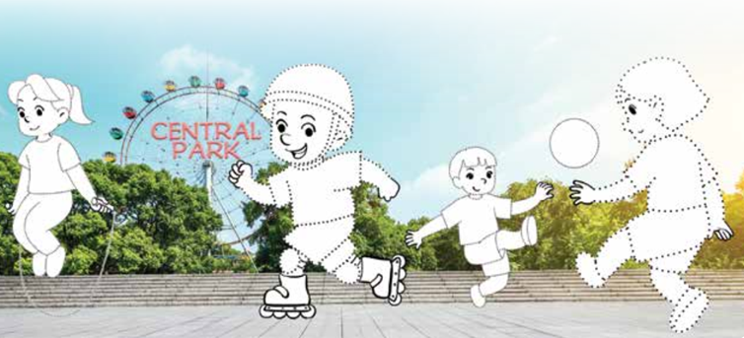

|  |  |  |  |
| --- | --- | --- | --- |
| **Mai** | **Tom** | **Phong** | **Linh** |

|  |  |
| --- | --- |
| **True** | **False** |
|  |  |
|  |  |
|  |  |
|  |  |

My name is Mai. I have three friends: Tom, Phong and Linh. We like sports and games. We are in the park now. I am skipping. Tom is skating. Phong and Linh are playing football.

1. Mai has three friends.
2. They don’t like sports.
3. They are in the play ground now.
4. Phong and Linh are playing football.

**Task 4: Look and write.**

|  |  |
| --- | --- |
| 1. A. What can you see?  B. I can see \_\_\_\_\_\_\_\_\_\_\_\_\_\_\_\_ | 2. A. What is he doing?  B. He’s \_\_\_\_\_\_\_\_\_\_\_\_\_\_\_\_\_\_\_\_\_\_\_ |

**Task 5. Reorder the words to make sentences**

1. singing / She / is / song. /a

She is singing a song ?

|  |
| --- |
| 1. do / have? / many / How / goldfish / you /   \_\_\_\_\_\_\_\_\_\_\_\_\_\_\_\_\_\_\_\_\_\_\_\_\_\_\_\_\_\_\_\_\_\_\_\_\_\_\_\_\_\_\_\_\_\_\_\_\_\_\_\_\_\_\_\_\_\_\_\_\_\_\_   1. am / I / playing / badminton /friends./ my / with   \_\_\_\_\_\_\_\_\_\_\_\_\_\_\_\_\_\_\_\_\_\_\_\_\_\_\_\_\_\_\_\_\_\_\_\_\_\_\_\_\_\_\_\_\_\_\_\_\_\_\_\_\_\_\_\_\_\_\_\_\_\_\_ |
| 1. see/ I /can /a/ tiger /and/ elephant./an   \_\_\_\_\_\_\_\_\_\_\_\_\_\_\_\_\_\_\_\_\_\_\_\_\_\_\_\_\_\_\_\_\_\_\_\_\_\_\_\_\_\_\_\_\_\_\_\_\_\_\_\_\_\_\_\_\_\_\_\_\_\_\_\_ |