UBND HUYỆN CÁT HẢI  TRƯỜNG TH NGUYỄN VĂN TRỖI |  | BÀI KIỂM TRA CUỐI HỌC KÌ II  Năm học: 2023 - 2024  Môn: Tiếng Anh 5 Thời gian 35 phút
 |  | Giám thị  ................................ | Giám khảo  ............................
I. LISTENING
Task 1. Listen and Tick 
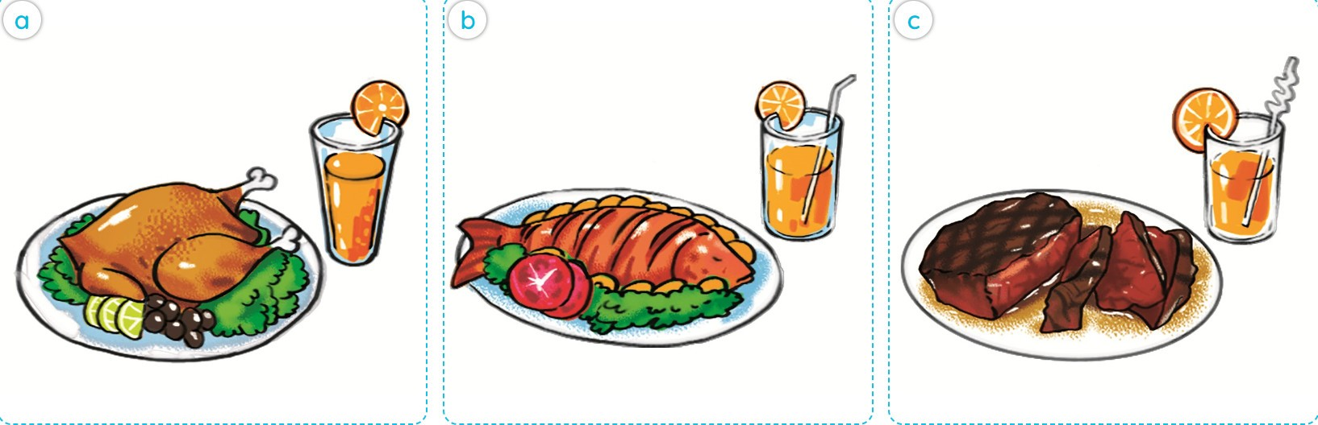
1.A.  | B. | C.
 |  | 
2.A. | B. | C.
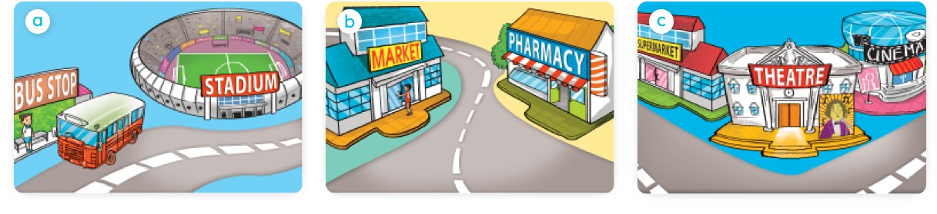
3.A. | B. | C.

Task 2. Listen and number . 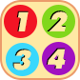
 | 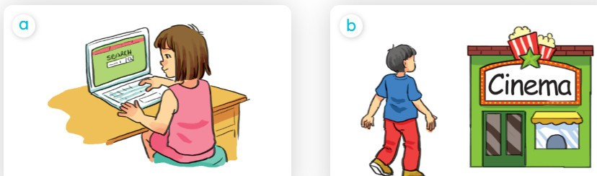 |  | 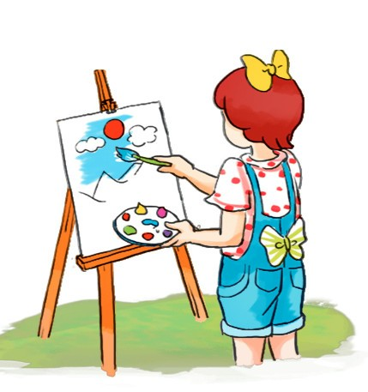
A. | B. | C. | D.

II. READING AND WRITING
Task 1. Choose the correct answer.
1. You should go to the ______________ because you have a toothache.
- Yes, I will. Thanks.
A. teacher B. dentist C. doctor
2. How____________water do you drink every day? – I drink three bottles.
A. much B. many C. often
Task 2: Read and match.
1. What do you do in your free time ? | 0.___ | a. Because he may cut himself.
2. What will you do this weekend ? | 1.___ | b. Because you may get a burn.
3. Why shouldn’t I play with the stove? | 2.___ | c. I will go shopping with my mother.
4. Why shouldn’t he play with the knife? | 3.___ | d. I surf the internet, read books and swim in the sea.
Task 3: Read and tick  True or False.
Hello. My name’s Tony. My hobbies are reading books and listening to music. I’d like to be a writer in the future. I’d like to write stories for children. It’s very interesting. I hope my dream will come true one day.
Hello. My name’s Linda. My hobby is singing English songs. I usually go to the music club in my free time. I’d like to be an architect when I grow up. I’d like to design buildings and houses. I’d like to work with other people in a company. It’s hard work but very exciting.

 | True | False
1. Tony would like to be a writer in the future.
2. He’d like to look after children.
3. Linda usually draws pictures and sings English songs in her free time.
4. She’d like to be an architect because she’d like to design buildings and houses.
Task 4. Look and write.
1. What will the weather be like tomorrow?  It will be hot and ______________. | 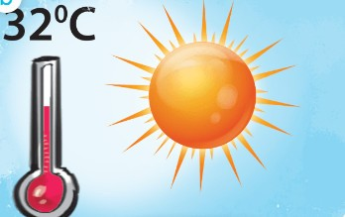
2. What would you and your mother like to eat ?  We’d like two apples and a _________________________, please. | 
Task 5. Put the words in order to make sentences.
1. | think of / What /do / Cat Ba Island / you/ ?
 | _________________________________________________________________
2. | I /It’s/ beautiful/ than /expected/ more/.
 | _________________________________________________________________
3. | his classmates/ visited/ Tom/ yesterday /Tran Quoc Pagoda/and/.
 | _________________________________________________________________
4. | he / summer /his/ because/ friends / likes/ can/ with/ for/ go/ a/ picnic/ Peter/.
 | _________________________________________________________________

