ANH 4 – ĐỀ SỐ 9
Question 1 : Listen and number (1pt)
a. 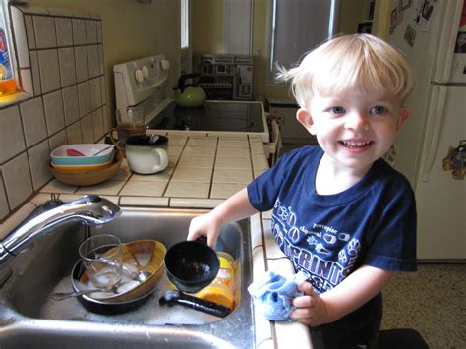 | b.  | c.  |  | d. 
Question 2: Listen and tick (1pt)
1. 2.
a. 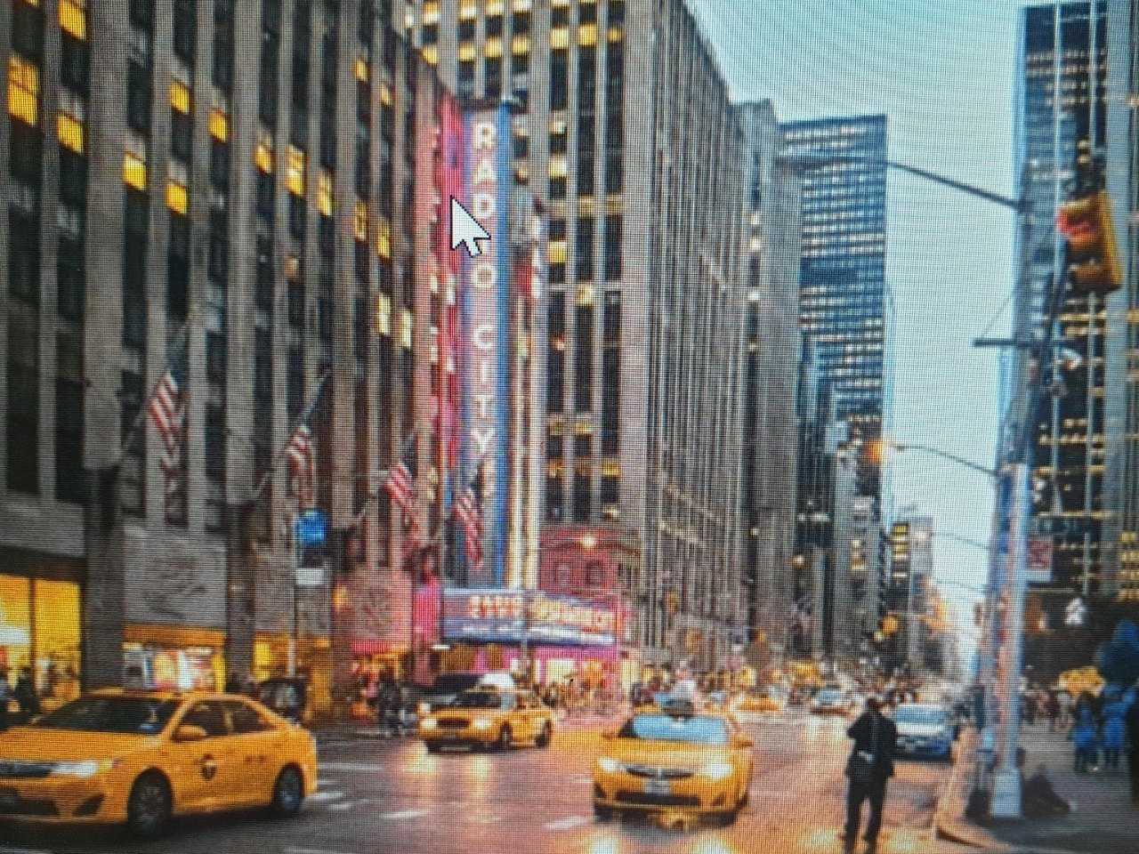 | b. 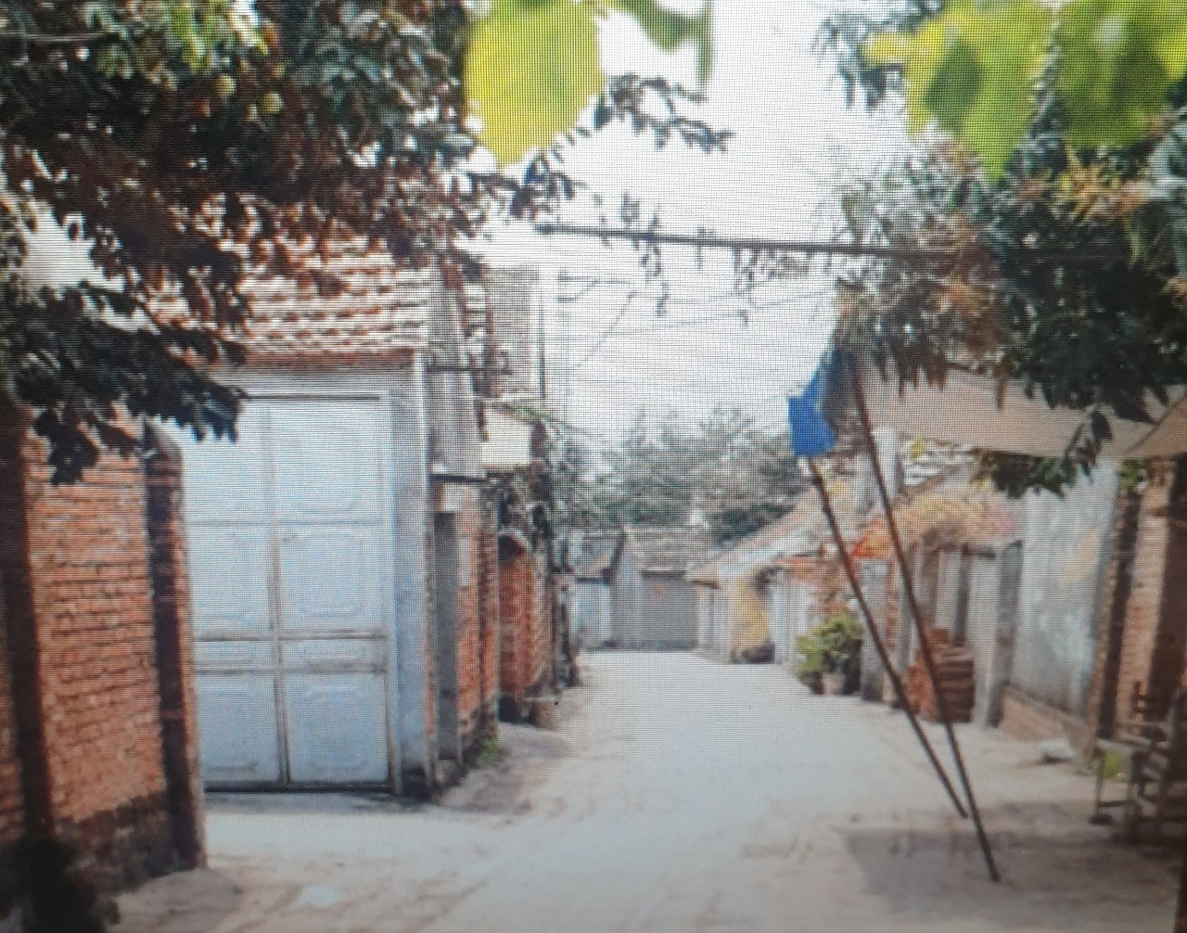 | a. 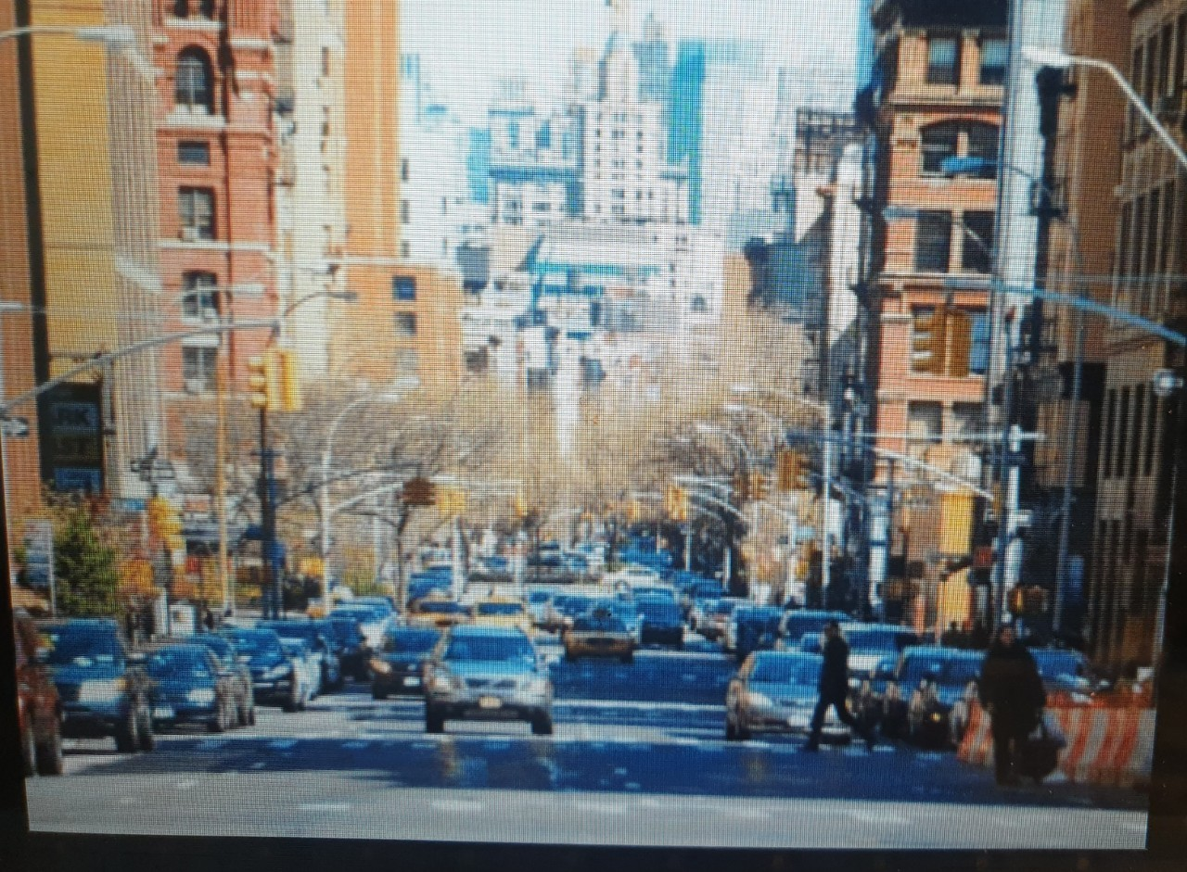 |  | b. 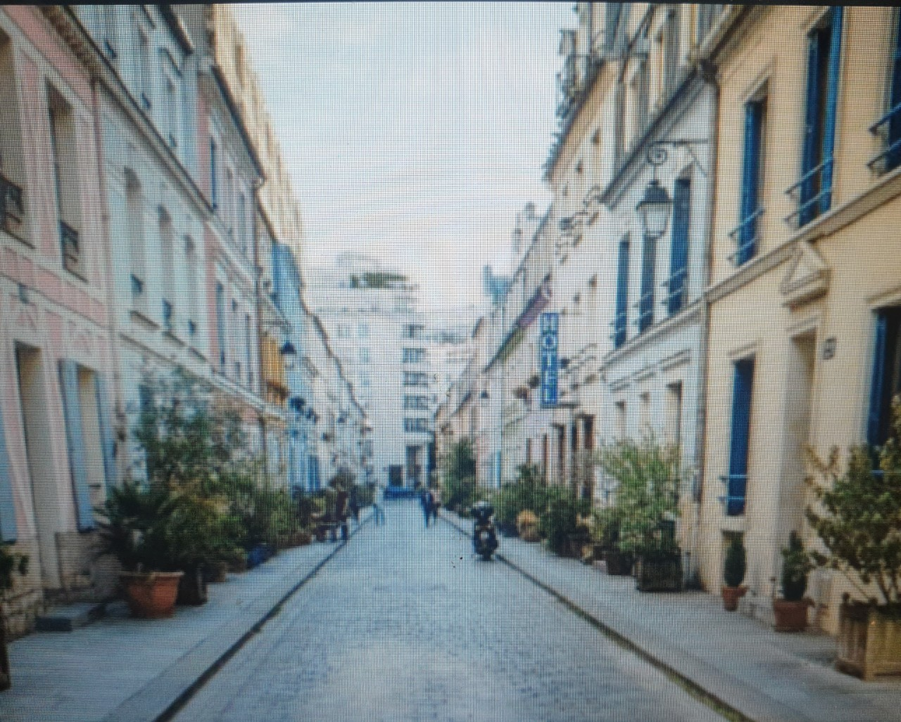
3. 4.
a. 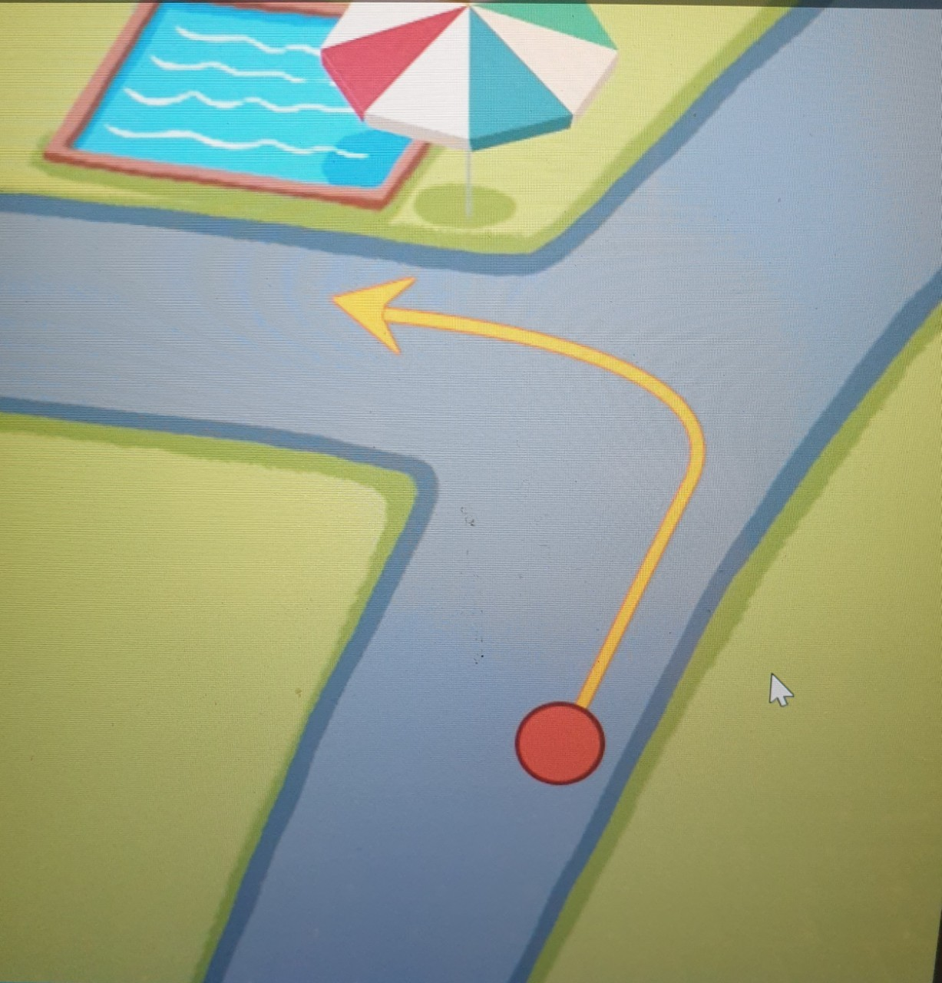 | b. 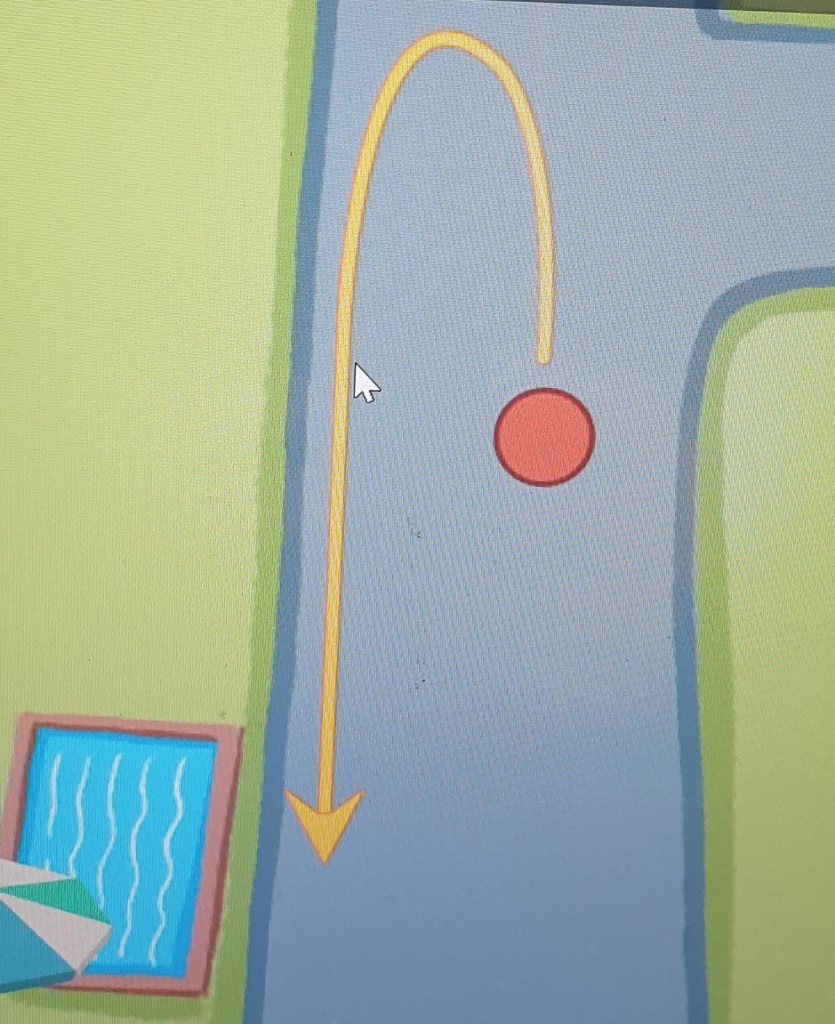 | a. 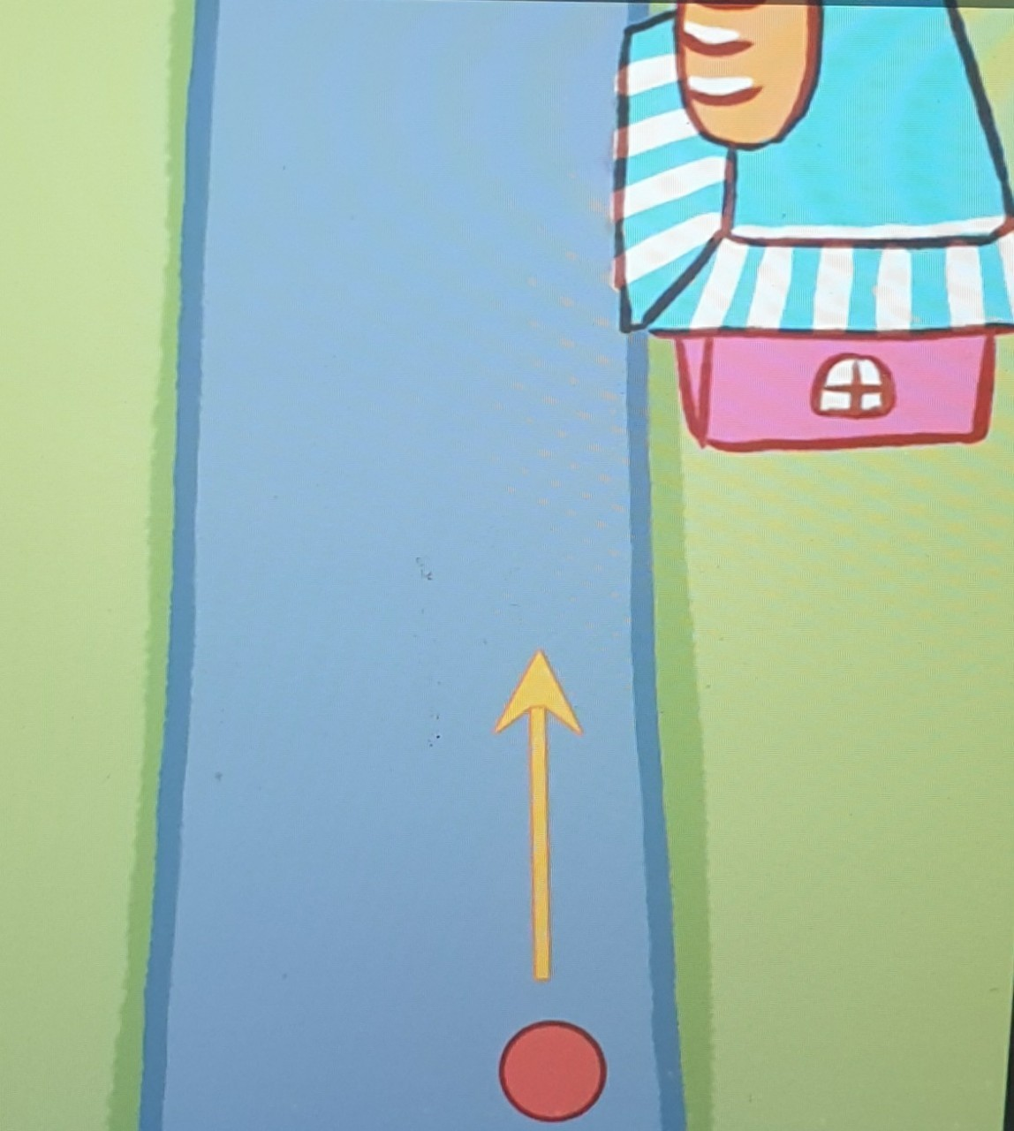 |  | b. 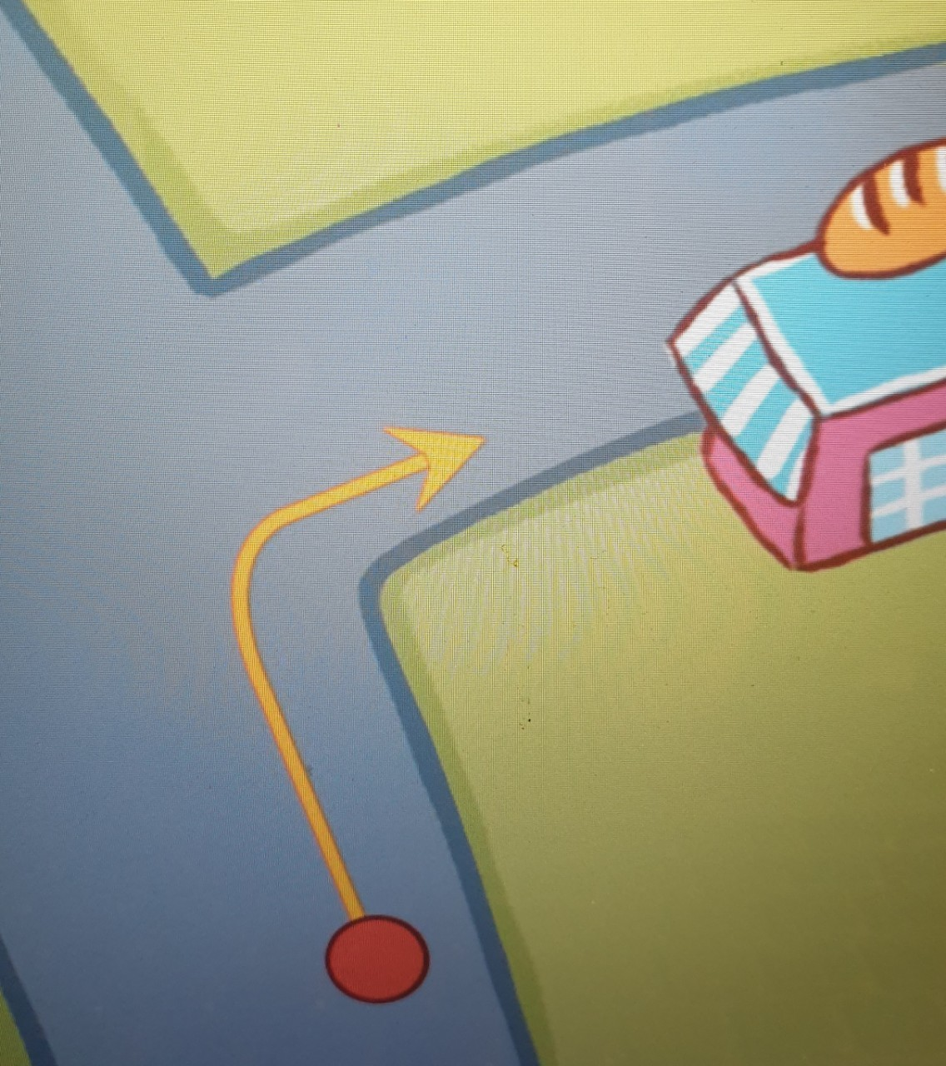
Question 3. Listen and complete .(1 pt)
1. A: What does she look like?
B: She has a (1).............. face.
2. A: What does she look like?
B: She has short (2)..............
3. A: What does she look like?
B: She has (3)............ hair.
4. A: What does she look like?
B: She has big (4) ......................
Question 4: Choose the words which have stress different from the others (1 pt)
1. a. sunny  2. a. between  3. a. bookshop  4. a. repeat | b. behind  b. opposite  b. hotel  b. complete | c. weather  c. city  c. campsite  c. visit
Question 5: Odd one out (1,25 pt)
1. a. gym | b. cinema | c. sports centre | d. tennis
2. a. animals | b. hippos | c. crocodiles | d. giraffes
3.a. quickly | b. beautiful | c. loudly | d. merrily
4. a. telling | b. building | c. taking | d. morning
5. a. cooker | b. doctor | c. nurse | d. teacher
Question 6. Choose the best answer (1.25pt)
1. What ..............your father do?
a. do b. is c. does
2. She ...............at a nursing home.
a. goes b. works c. work
3...................does he look...........?
a. where/like b. where/likes c. what/like
4. She ............a round face and big ............
a. have/eye b. has/eyes c. has/eye
5. Look........the photo.............my family.
a. in /on b. at/of c. at/to.
Question 7. Read and tick True or False (1 pt)
We are at the shopping centre. We can see many shops. The bookshop is opposite the pet shop. The toy shop is behind the pet shop. The bakery is between the bookshop and the sports shop. Mai wants to buy a book. It is 30.000 dong. Linh wants to buy a doll. It is 50.000 dong. I want to buy an ice cream. It is 10,000 dong.
True False
1. We are at the sports centre.
2. The pet shop is opposite the bookshop.
3. The bookshop is between the bakery and the sports shop.
4. Mai wants to buy a book and Linh wants to buy an ice cream.
Question 8. Look at the pictures and write (1 pt)
1.  | 2. 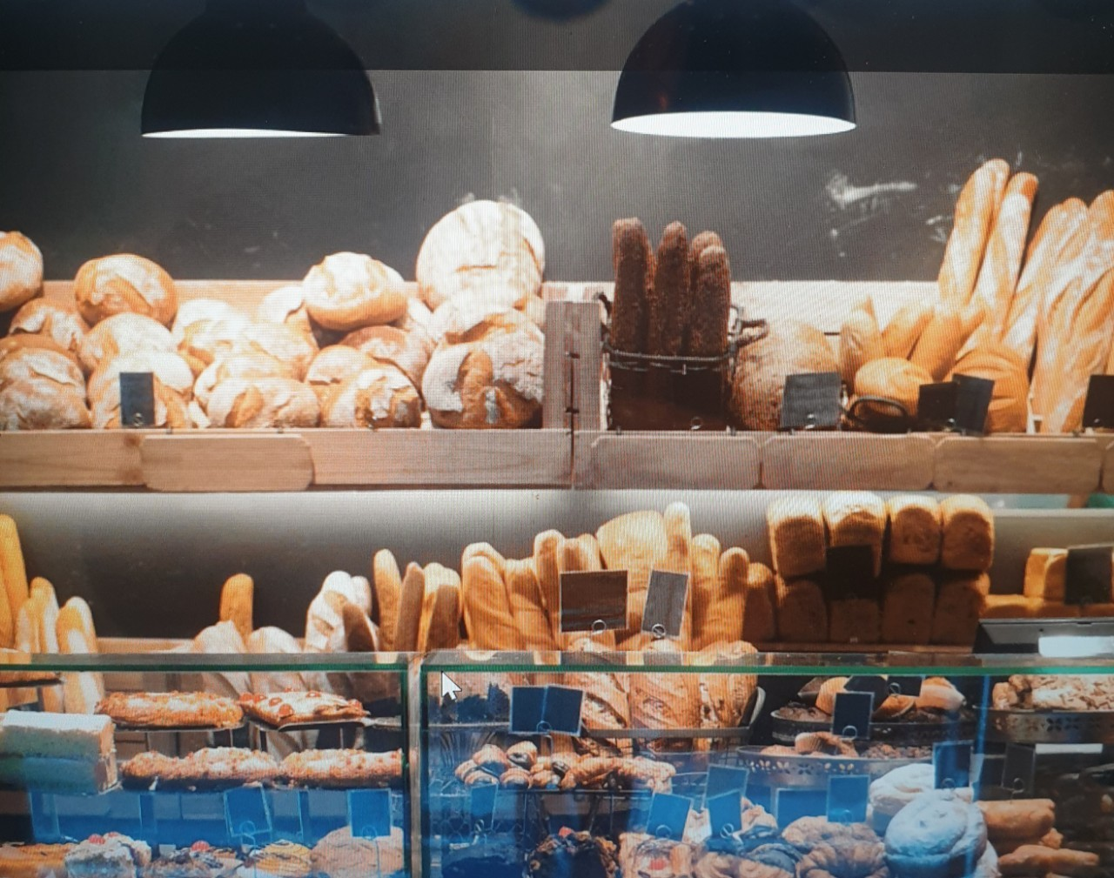 | 3.  | 4. 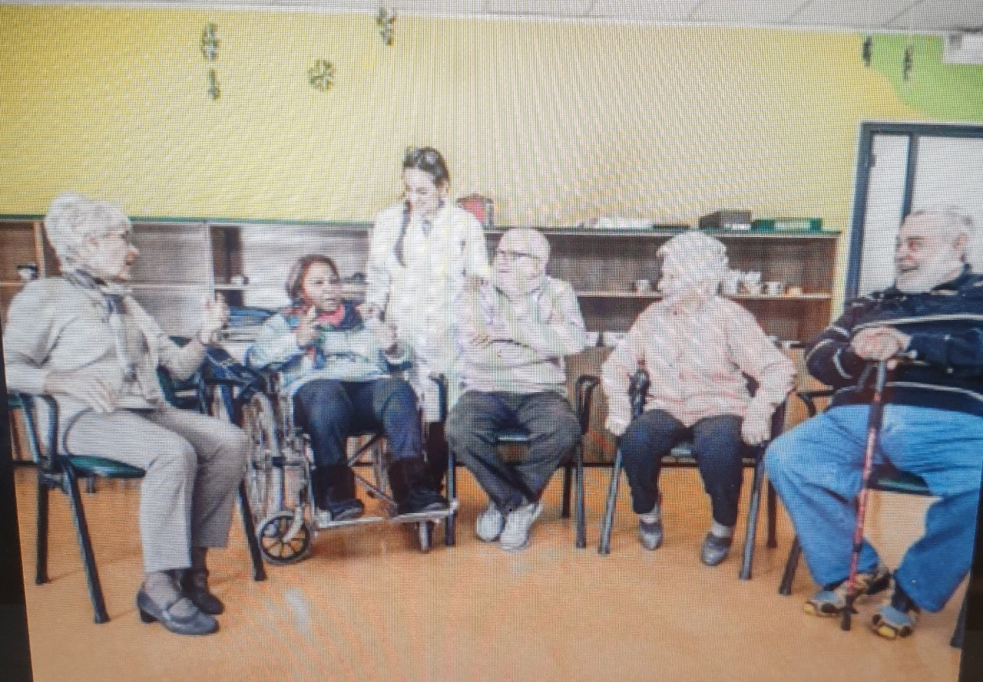
It was ............................. | Do you want to go to the ...............................? | He's a .............................. | She works at a ..............................
Question 9. Arrange the words to make sentences (1.5 pt)
1. do/you/when/watch/TV?
_________________________________________________________________________
2.can/giraffes/run/quikly/very.
__________________________________________________________________________
3. you/clean/floor/do/the/on/Sundays? __________________________________________________________________________
4. have/these/animals/long/legs/necks/and.
__________________________________________________________________________
5.my/help/I/mother/the/with/cooking/the/in/afternoon. __________________________________________________________________________
6.at/the/zoo/I/and/my/are/friends/we/because/want/see/animals/to/the. __________________________________________________________________________

