QUAN TRU PRIMARY SCHOOL  Name: ……………..……………………  Class: 2……  Exam Teacher: ...................................... | THE FIRST SEMESTER TEST  ENGLISH 2  School year: 2023-2024  Time: 35 minutes

Points | Teacher’s remark

PARTI:LISTENING (4pts)
Question1: Listenand circle (1pt)

1. | s | R | 2. | r | p
3. | p | K | 4. | s | k
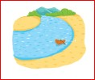




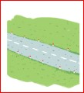
Question2: Listenand tick (1pt)

1. a. | b. | c.
2. a. | b. | c.
3. a. | b. | c.
4. a. | b. | c.





Question3:Listenandmatch.(1pt)

a. | b.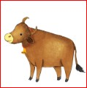 | c. | d. 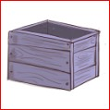

1
2
3
4
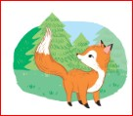
Question4: Listenand number.(1pt)

a  | b. | c. | d.

PARTII: READING AND WRITING (4pts)
Question 5: Lookand complete.(1pt)
  1._itten | 2._ x | 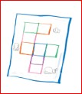  3._uiz | 4._izza

Question 6:Look andwrite.(1pt)
pasta | river | road popcorn

1.…………… | 2.………….. | 3..…………. |   4.………………
Question7:Readandtick. (2pts)

1.  - Thepopcornisyummy.  - Thepastaisyummy. | 2.  - Let’slook atthesand!  - Let’slook atthesea!
3.  - He’sflying akite.  - She’sflying akite. | 4.  - I can seea bike.  - Ican seearainbow.

PARTIII:SPEAKING(2pts)
- Listen and repeat (1pt)
- Point, ask and answer (1pt)
Key
Question | Answer
1 | 1.s  2.r  3. p  4. k
2 | - He’s flying a kite  - I can see the sand  - There’s a rainbow  - I like popcorn  1.c 2.b 3.a 4.c
3 | - She’s answering a question  - Let’s look at the sea!  - Is there a box? – yes, there is  - I can see an ox on the farm  1.c 2.a 3.d 4.b
4 | - he’s flying a kite  - The pasta is yummy  - She’s colouring a square  - I can see a fox on the farm  1.d 2.b 3.a 4.c
5 | 1.k 2.o 3.q 4.p
6 | 1.road2.pasta 3.river 4. popcorn
7 | 1.b 2.a 3.a 4.b

