QUAN TRU PRIMARY SCHOOL  Name: ………………..…………………  Class: 4 ……  Exam Teacher: ..................................... | THE FIRST SEMESTER TEST  ENGLISH 4  School year: 2023-2024  Time: 35 minutes
Points | Teacher’s remark

I. Listen and number. (1 point)

 | 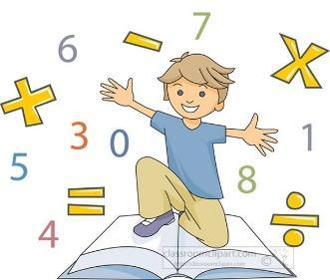 |  | 
a. ⬜ | b. ⬜ | c. ⬜ | d. ⬜

II. Listen and draw lines. (1 point)

a.  | b.  | c.  | d. 
1. 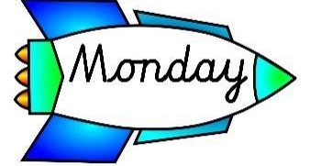 | 2. 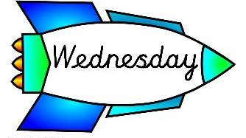 | 3. 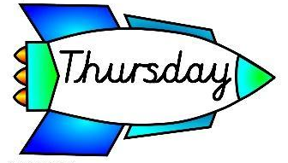 | 4. . 

1. …………….. 2. …………….. 3. ……………… 4. ………………..

III. Listen and complete. (1 point)

1. When’s your birthday? – It’s in ___________________.
2. Where’s your school? – It’s in the _________________.
3. Why do you like _________________? – Because I want to be a painter.
4. Were you at the ______________ last weekend? – Yes, I was.

IV. Read and choose A, B or C. (0,75 point)
1. | 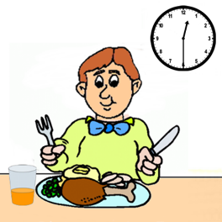 | What time do you have lunch?  A. I have lunch at twelve fifteen.  B. I have lunch at half past twelve.  C. I have lunch at twelve o’clock.
2. |  | What subjects do you have today?  A. I have Vietnamese.  B. I have maths.  C. I have English and science.
3. | 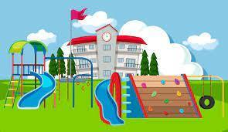 | How many playgrounds are there at your school?  A. There are one.  B. There is one playgrounds.  C. There is one.

V. Read and match (1p)

1. Is your birthday in September? | a. I do my homework. | 1. ____
2. What’s your favourite subject? | b. No, it isn’t. It’s in August. | 2. ____
3. What do you do on Saturday? | c. I want a cake and some fruits. | 3. ____
4. What do you want at your birthday party? | d. It’s Science. | 4. ____

VI. Read and write T (True) or F (False). (0,75 point)

This is Jack. He is my best friend. He is from Australia. He has been in Thailand for two years. He has two older brothers. They all live in a big house in Bangkok. Jack and his brothers go to the beach in the summer. They play beach ball or go swimming. Jack is very strong and he can swim fast.
1. Jack is from Thailand. ___________
2. Jack goes to the beach in the summer. ___________
3. Jack can swim fast. ___________
VI. Look and fill in the missing words (0,75 point)
1. |  | Why do you like ____________?  - Because I want to be an English teacher.
2. | 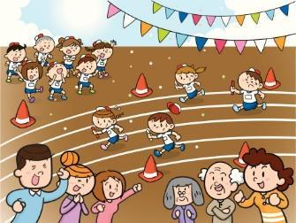 | When’s your ___________________?  - It’s in October.
3. |  | What do you want to eat?  - I want some ______________.
VII. Fill in the blanks. (0,75 point)

playground | garden | classrooms

Hi, I’m Sue. I’m 7 years old. This is my school. It’s not big but it’s beautiful. There are twenty (1) __________________ in my school. There is a small (2) ______________. We often run and play there at break time. There is also a (3) ____________. We plant trees and flowers there. We often have lunch at the school canteen.

VIII. Reoder the words to make meaningful sentences (1 point)
1. are / from / Where / you?
⭢ _____________________________________________________________
2. English/ My / is / subject / favorite?
⭢ _____________________________________________________________
3. can’t / but / He / swim / can / he / a horse / ride / ?
⭢ _____________________________________________________________
4. Science / don’t / on/ I / have / Mondays./ I / it / on / have / Wednesdays.
⭢ _____________________________________________________________

IX. Speaking (2 points)

ANSWER KEY
I.
Audio script:
1. I want to drink some juice.
2. She was on the beach yesterday.
3. My favourite subject’s maths.
4. I go to school on Mondays.
Key: 1. d 2. c 3. b 4. a
II.
Audio script:
1. What do you do on Mondays?
– I study at school.
2. What do you do on Wednesdays?
– I listen to music.
3. What do you do on Thursdays?
– I do housework.
4. What do you do on Sundays?
– I go swimming.
Key: 1. a 2. c 3. d 4. b
III.
Audio script:
1. When’s your birthday?
– It’s in September.
2. Where’s your school?
– It’s in the mountains.
3. Why do you like art?
– Because I want to be a painter.
4. Were you at the campsite last weekend?
– Yes, I was.
Key:
1. September 2. mountains 3. art 4. campsite
IV.
1. B 2. A 3. C 4. C
V.
1. Why do you like English?
2. When is your sports day?
3. What do you want to eat?
VI.
1. F 2. T 3. T
VII.
(1) classrooms (2) playground (3) garden (4) have lunch
VIII.
1. It’s in the city.
2. Because I want to be a maths teacher.
3. I have art and science.
4. I have it on Tuesdays.

IX. Pupil’s answer

