QUAN TRU PRIMARY SCHOOL  Name: ………………………….…………  Class: 5 …….  Exam Teacher: ........................................ | THE FIRST SEMESTER TEST  ENGLISH 5  School year: 2023-2024  Time: 40 minutes
Points | Teacher’s remark

I. LISTENING (3pts)
QUESTION 1: Listen and tick the correct pictures (1pt)

1 | 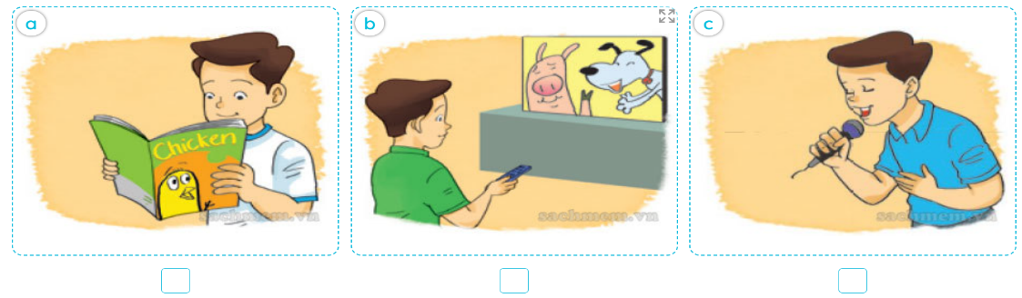
2 | 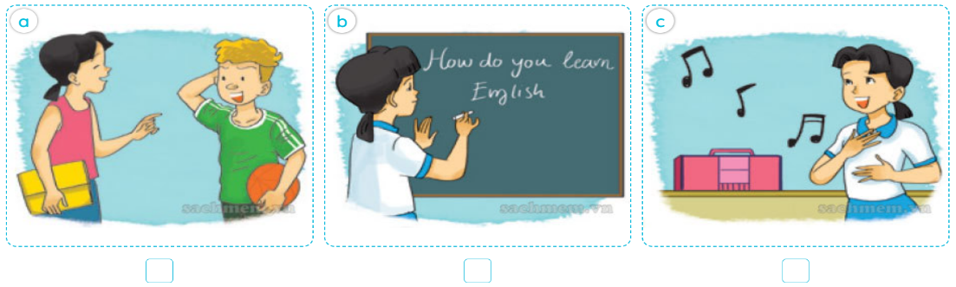
3 | 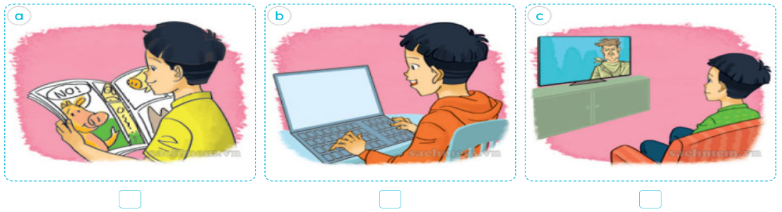
4 | 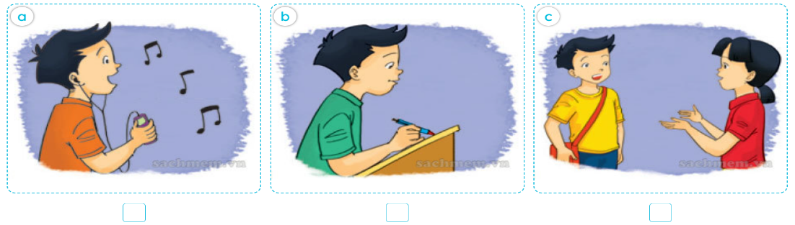

QUESTION 2: Listen and number (1pt)

 |  |  | 

QUESTION 3: Listen and complete (1pt)
- Where will you be this weekend?
I think I’ll be in the ………………………
- What will you do at Halong Bay?
I think I’ll ………….….the caves
- How often do you have Music ?
I have ………….…...a week
- What’s the city like?
It’s big and …………..…
II. READING ( 2,5pts)
QUESTION 4:Read and Circle the odd one out (0,5 pt)
1. a.like | b.did | c.sang | d.got
2. a.generous | b.hard-working | c.gentle | d.character
QUESTION 5: Choose the best answer ( 1pt)
1. What did you do at the party yesterday? I ……………cartoon
a. watched | b.watch | c.watches | d.watchs
2. How do you practise ……………..Engish? I read short stories
a. readed | b.read | c.reads | d. reading
3.Why do you learn English ?
- ………………… I want to talk with my foreign friends
a. And | b. So | c. Because | d. Today
4. What did the pythons do when you were there? - They …………………..
a. roared loudly |  | b. moved beautifully
c. moved quietly |  | d. ate slowly
QUESTION 6: Read and writeYes/No ( 1pt)
My name is Nam. I go to school from Monday to Friday. I have Maths and Vietnamese every school day. I have English four times a week. English is my favourite subject. I practise reading by reading English comic books and storybooks. Now I can read Aladdin and the Magic Lamp in English. I practise speaking by talking to my foreign friends. Every day, I practise writing English by sending emails to my friend Hakim in Malaysia. I learn English because I want to watch English cartoons on TV.
1.Namhas English every school day……………………
2. He practises reading by reading English comic……………………
3. He practises speaking by talking to his foreign friends……………………
4. He learns English because he wants tosend emailsto his friend………………
III. WRITING (2,5pt)

QUESTION 7: Fill in the blank (1pt)

What timetoolessonsan favourite

Phong: I don’t havemy(1) .What do we have today,Minh?
Minh: We haveMaths,History andEnglish.
Phong: (2) do we haveEnglish?
Minh: We have it from 7:45 to 8:30.
Phong: What isyour(3) subject, Minh?
Minh: I like Maths.It’s(4) interesting and importantsubject.
Phong: Yes, I like Maths(5)
QUESTION 8: Arrange the words to make sentences (1,5pt)
1.gentle/Snow /White/is/and/kind/.
………………………………………………………………………………….
2. Ancient /to/ I / Hoi An/ on/ went/ Town/ holiday/
………………………………………………………………………………….
3. because/ to become an English teacher/ Hoa/ she wants/ learns English/ .
………………………………………………………………………………….
IV. SPEAKING (2pts)

ĐÁP ÁN

QUESTION 1: Listen and tick the correct pictures
1B 2C 3A 4B
QUESTION 2: Listen and number
2 | 1 | 3 | 4
QUESTION 3: Listen and complete
1. countryside 2. Explore 3. It once 4. busy
QUESTION 4: Read and Circle the odd one out.
1.a 2.d
QUESTION 5: Choose the best answer
1A 2D 3C 4C
QUESTION 6: Read and tick (Yes/No)
1.NO2.NO 3. YES 4. NO
QUESTION 7: Fill in the blank
- lesson 2 what time 3. favourite 4. an 5. too
QUESTION 8: Arrange the words to make sentences
- Snow White is gentle andkind.
- I went to Hoi An Ancient Town on holiday
3. Hoa learns English because she wants to become an English teacher.
IV. SPEAKING
I.Getting to know each other. 0,5pt
Ask 3 questions below
1.What is your name?
2.How are you?
3.How do you spell your name?
II.Talking about a familiar object. 0,5pt
Give some story book and ask some question
- What are you reading?
- What is he/ she like?
- Who is the main character?
III.Describing the picture. 1pt
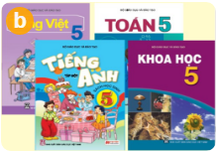 | 1. What subjects do you have today?  2. Do you like English? Why/ why not?  3. What’s your favourite subjects?

