 | Quan Tru primary school Full name: ............................................  Class: 2............. |  |  | THE TEST OF TERM I  School year: 2022-2023  SUBJECT: ENGLISH  Time: 40 minutes
Points |  | Teacher’s remark

PART I: LISTENING (2pts)
Question 1. Listen and circle: (1pt)
- q p
- k x
- v s
- r j
Question 2. Listen and tick: (1 pt)

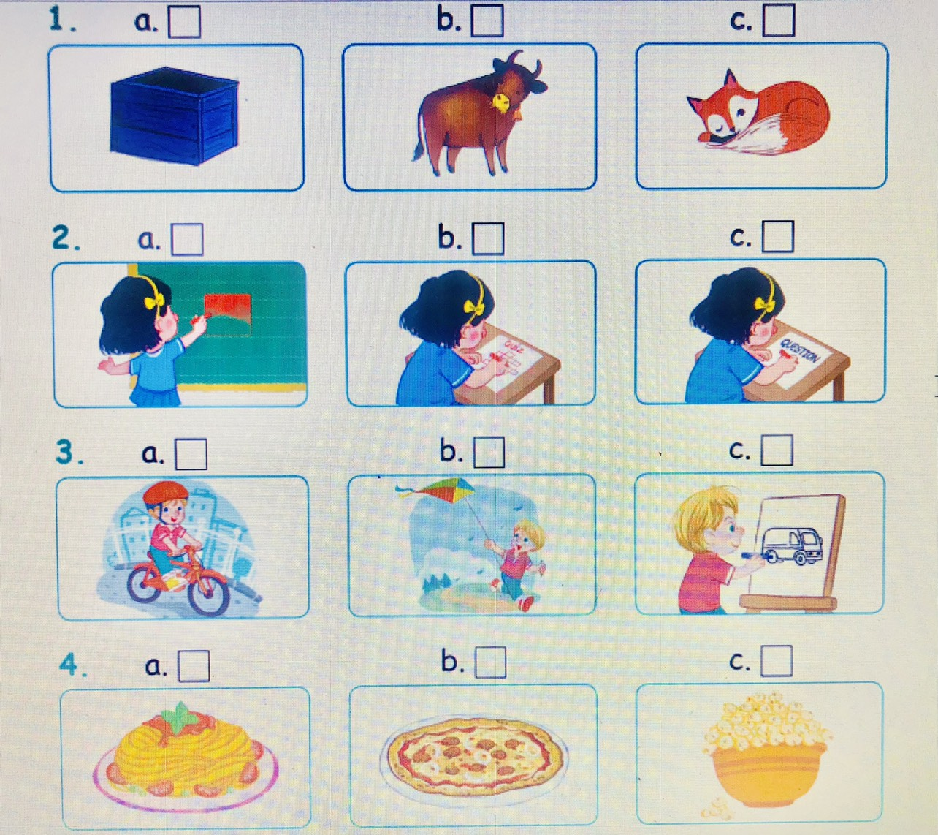

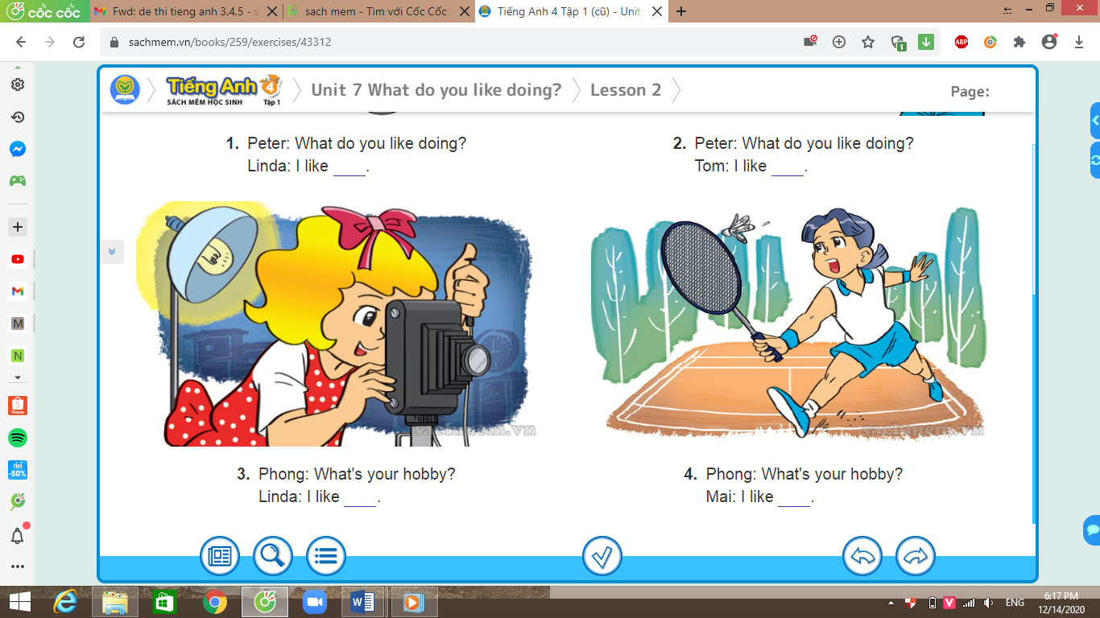

PART III: WRITING (3pts)
Question 3 : Reorder letters to correct words. (3 pts)
1.kiet……………………………..
2.sqeuar…………………………..
3.chsee…………………………….
4.werans…………………………..
5.paast…………………………….
6.ranibow…………………………
PART III: READING (4pts)
Question 4 : Look at the pictures and circle the correct word. (2 pts)

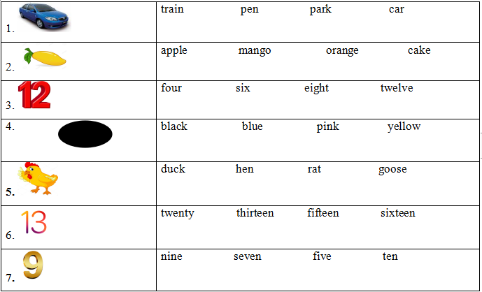

Question 5: Read and match.(2pts)
a.Goodbye, Linh.
0.How
1.I’m fine
b.thank you.

2.Goodbye , Lucy
c.Mai.
3.Hello, I’m
d.are you?

PART IV: SPEAKING (1pt)

The end – Good luck !

