 | Quan Tru primary school Full name: ............................................  Class: 5............. |  |  | THE TEST OF TERM I  School year: 2022-2023  SUBJECT: ENGLISH  Time: 40 minutes
Points |  | Teacher’s remark

I. LISTENING
Question 1 . Listen and tick. (1,0 pt)
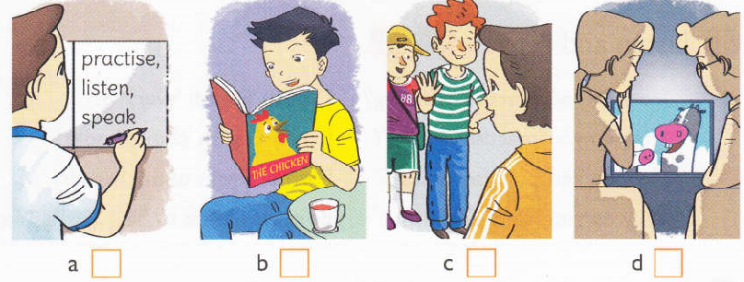
Question 2. Listen and tick (1,5 pts)
1. What did Tom see at the zoo? | 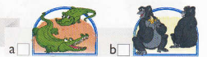
2. What did Mai see at the park? | 
3. What did Tony see at the circus? | 
II. USE OF LANGUAGE
Question 3: Choose the odd one out (0,5 pt)
- A. fox B. crow C. lamp D. hare
- A. kind B. gentle C. story D. clever
Question 4. Choose the best answer (1,5 pts)
1. How many _____ do you have at school?
A. subjects | B. song | C. language | D. book
2. I want _______ with my foreign friends Tony.
A. to talking | B. talking | C. talk | D. to talk

3. They learn to write________emails to each other every day.
A. write | B. writing | C. by writing | D. by write
4. How do you _________ listening? – I watch English cartoons on TV.
A. practise | B. learn | C. want | D. have
5. She practices _____ by ______ English short stories.
A. reading/ read | B. reading/ reading | C. read/ reading | D. read/ read
6. We learn English _______ we want to read comic books.
A. because | B. so | C. and | D. why
Question 5: Read the text carefully
My name is Linh. I’m a pupil at Kim Dong Primary School. I’m in class 5A with Lee and John. I love reading comic books. I often read them in my free time. When I see a new word, I try to guess its meaning. I write the word in my notebook and say it many times. I often stick new words on my bedroom walls and practise reading them aloud. Lee and John love learning English too. We often learn to speak English by talking with our foreign friends in our free time. Lee is very good at English. She usually practises listening by watching cartoons on TV. She learns to write my writing emails to her friends every day. John loves reading. He goes to the library twice or three times a week. He usually read English books to practise reading. They always help me to learn English. We are happy because we can understand each other. English is necessary for communication.
A. Tick True or False (1,5 pt)
1. Linh, Lee and John are in class 5A.
2. They love learning English.
3. Lee loves reading English books.
4. Linh likes watching cartoons.
5. They can understand each other.
6. John sticks new words in his bedroom.
B. Answer the following questions:(1,0 pt)
- How do they learn to speak English?
…………………………………………………….……………………………………………………..
- How often does John go to the library?
…………………………………………………….……………………………………………………..
III. WRITING: Reorder to make right sentences (2,0 pts)
- Did/week/ you/to/the/ go/zoo/,/Phong/last/?
…………………………………………………….……………………………………………………..
- did/the/ do/What/when/ you/there/ peacocks/were/?
…………………………………………………….……………………………………………………..
- pandas/saw/ two/at/the/She/zoo/.
…………………………………………………….……………………………………………………..
- moved/The/python/ slowly/ really/ and/quietly/.
…………………………………………………….……………………………………………………..

IV. SPEAKING ( 1,0 pt)

