QuanTru primary school  Full name: .............................................. |  |  | THE TEST OF TERM II  School year: 2022-2023
Class: 5............. |  |  | SUBJECT: ENGLISH  Time: 40 minutes
Points | Teacher’s remark

PART I: LISTENING (2pts)
Question 1. Listen and circle the word (a or b, c) to complete the sentences (1pt)
1. How many……are there in England?
a. towns | b. seasons | c. cities
2.The dry season lasts ……November to April.
a. in | b. on | c. of
3. What’s………like in your country ?
a. summer | b. winter | c.autumn
4. Her favourite season is …………………
a. summer | b. winter | c. autumn
5. What’s the……..season like?
a . hot | b. rainy | c. dry
Question 2. Listen and numbers the sentences to make dialouge (1pt)
A.You should n’t eat sausages everyday. They are not healthy
B. I usually eat two sausages for breakfast.
C. Milk.
D. What kind of food do you like best ,Tan?
E. Sausages
F. How many sausages do you eat a day?
G. How about drink? What’s your favourite drink?
PART III: READING (4pts)
Question 3. Choose the word which the underlined part is pronounced differently from the others.(1pt)
1. A. when B. what C. why D. who
2. A. chair B. cheap C. chemist D. child
3. A. beat B. meat C. bean D. threat
4. A. large B. war C. starter D. card
5. A. since B. sign C. sugar D. surface
6. A. fry B. windy C. rainy D. daily

Question 4: Circle the correct answer (1pt)
1.The bakery is …………………of the pharmacy.
A. next to B. opposite C. behind D. in front
2. …………………can I get there? – By train.
A. Where B. Who C. How D. How often
3. Would you like ……………these letters.
A. send B. sending C. to send D. to sending
4. Could you tell me how …………………to the bank?
A. get B. to get C. getting D. to getting
Question 5: Fill in the blank with one word. (2pts)
1. I think that Ha Noi is busier………………….. ………..my home town.
2. I like living here…………………………………… people are friendly.
3. What do they think …………………………………… that place? .
4. What are you……………………………….. to do this summer?.
5. You can go ……………………………… foot.
6. ……………………………………. did you visit it?. - Last week
PART III: WRITING (3pts)
Question 6: Look and answer. (2pts)
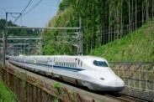 | 1. How can I get to the stadium?  ………………………………..………….…………….
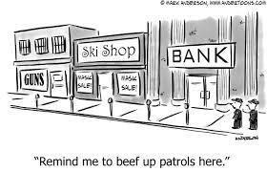 | 2. Excuse me, where’s the bank?  ……………………………………………….…………
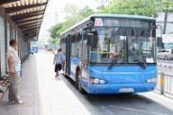 | 3. How can I get to the museum?  …………………..……………….…..………………….
 | 4. How are you going to Ho Chi Minh city, Nam and Hoa?  ………………………………………………………..….

Question 7 : Write questions for the underlined part.(1pt)
1. Yes. Lan is listening to music……………………………………………………….
2. She often does her homework in the evening……………………………………….
3. Tim is drawing pictures……………………………………………………………...
4. They like Science because it is interesting………………………………..…………
PART IV: SPEAKING (1pt)

