**Name:………………………………………………… Class:………..**

**PART A: LISTENING**

**I. Listen and number the pictures from 1 to 4.**

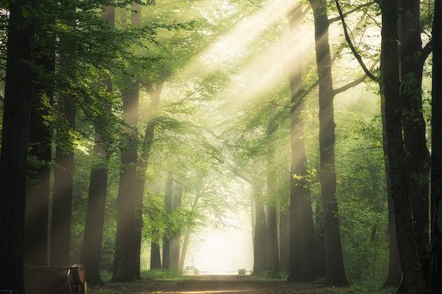

**II. Listen and circle the correct answer.**

|  |  |
| --- | --- |
|  |  |
| 5. Anna.… | A. finishes lessons at 7 a.m. B. has lunch at school. C. has lunch at 4 p.m at school. |
| 6. Bob … | A. rides a bike on rainy days.  B. takes a bus on rainy days. C. is off on rainy days. |
| 7. Mia… | A. doesn’t do exercise. B. gets up at 6.30. C. does exercise in the morning. |
| 8. Rosie……. | A. has history on Wednesdays. B. has maths at 2 p.m. C. has maths on Tuesdays. |

**PART B: READING & WRITING**

**I. Circle the one with different ending sound.**

|  |  |  |  |
| --- | --- | --- | --- |
| 0. | A. plays | B. sings | C. works |
| 9. | A. kisses | B. does | C. brushes |
| 10. | A. sings | B. walks | C. wakes |

**II. Circle the word which is stressed differently.**

|  |  |  |  |
| --- | --- | --- | --- |
| 0. | A. expensive | B. fantastic | C. funny |
| 11. | A. projector | B. mother | C. banana |
| 12. | A. computer | B. develop | C. favourite |
| 13. | A. father | B. happy | C. fantastic |
| 14. | A. fantastic | B. clever | C. friendly |

**II.** **Circle the best answer A, B , C or D to complete the sentences.**

15. When you were nine years old, my favourite toys ___________ balls.

|  |  |
| --- | --- |
| A. were | B. is |
| C. was | D. are |

16. My favourite thing is my comic book. It is interesting ______________fun.

|  |  |
| --- | --- |
| A. but | B. because |
| C. when | D. and |

17. She sometimes __________ to art clubs after school.

|  |  |  |  |
| --- | --- | --- | --- |
| A. go | B. goes | C. going | D. is going |

18. Children don’t go to school __________ the weekend.

|  |  |  |  |
| --- | --- | --- | --- |
| A. at | B. in | C. on | D. by |

**III. Look and match.**

|  |  |  |  |  |  |  |
| --- | --- | --- | --- | --- | --- | --- |
|  | | |  | | | |
| 19. What time do they start their lessons? | | | A. Yes, she does. | | | |
| 20. What does she have at 8 p.m? | | | B. They start their lessons at 7 a.m. | | | |
| 21. Does she often wash her bike? | | | 1. I go there by bus. | | | |
| 22. How do you go to art clubs? | | | 1. She has maths lesson at 8 p.m. | | | |
|  | | 19. ______ | 20. ______ | | 21. ______ | 22.___________ |

**IV. Read and write T (True) or F (False).**

|  |  |  |  |
| --- | --- | --- | --- |
|  | This is my friend, Linda. She usually gets up at 6 in the morning. She always has breakfast with her parents at 6.30 a.m. She leaves the house at 7 a.m. and walks to the bus stop. She goes to school by bus. Linda starts her lessons at 8 a.m. Her mother always picks her up from school at 4 p.m. Sometimes they go to the supermarket. However, every Wednesday afternoon Linda goes to art clubs. In the evening, Linda often has dinner at 7 p.m. After dinner, she watches TV with her sister. She goes to bed at 10 p.m. at night. At the weekend she meets her friends and goes to the park. | | |
|  | |  |
| 23. Linda walks to school at 7 o’clock. | |  |
| 24. Linda finishes school at 5 o’clock. | |  |
| 25. Linda often has dinner at 7 p.m. | |  |
| 26. Linda’s sister watches TV after dinner. | |  |