ĐỀ KIỂM TRA HỌC KÌ 1 TIẾNG ANH LỚP 3
NĂM HỌC 2019 - 2020

I. THE MATRIX – MA TRẬN
 |  | Môn: Tiếng Anh |  |  |  | Thời gian: 35 phút
Stt | Nội dung | Số câu | Các mức độ cần đánh giá |  |  |  |  |  | Tổng điểm
Stt | Nội dung | Số câu | Nhận biết-M1 |  | Thông hiểu -M2 |  | Vận dụng- M3 |  | Tổng điểm
Stt | Nội dung | Số câu | TNKQ | Tự luận | TNKQ | Tự luận | TNKQ | Tự luận | Tổng điểm
Listening |  |  |  |  |  |  |  |  | 5,0
1 | Listen and number | 4 |  |  | 4 |  |  |  | 1
2 | Listen and write | 4 |  |  |  |  | 4 |  | 1
3 | Listen and draw the line | 4 |  |  | 4 |  |  |  | 1
4 | Listen and tick | 4 |  |  | 3 |  | 1 |  | 1
5 | Listen and complete | 4 |  |  |  |  |  | 4 | 1
Speaking
 | Speaking | Theo dõi cả học kỳ
Reading |  |  |  |  |  |  |  |  | 3,0
6 | Look, read and tick | 4 |  | 4 |  |  |  |  | 1
7 | Read and write Yes or No | 4 |  |  | 4 |  |  |  | 1
Writing |  |  |  |  |  |  |  |  | 2,0
8 | Look and write | 4 |  |  |  | 4 |  |  | 2
 |  |  |  |  |  |  |  |  | 10

II. Content

Họ và tên :……………………………  Lớp: 3…………………………..……. | BÀI KIỂM TRA TIẾNG ANH HK I- LỚP 3  NĂM HỌC: 2018-2019
PART 1: LISTENING
Question1. Listen and number. (1 pt)
A. | B. | C. | D.

Question2. Listen and write T (True) or F (False) (1pt).
1. That is the computer room.
2. It’s a big school.
3. I like badminton.
4. I play chess

Question3. Listen and draw the line. There is an example. ( 1 pt)
0

1

2

3

4
5
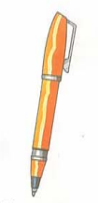
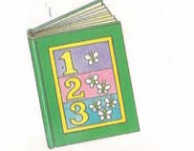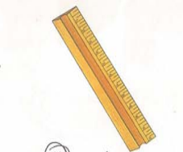
Question4. Listen and tick. (1 pt)
A  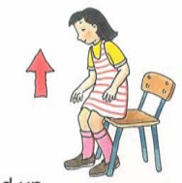  1. | B  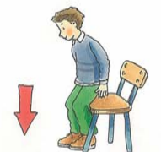 |  | A    3. | B  
A    2. | B   |  | A    4. | B  
Question5. Listen and complete. (1pt)
A : (1) ______, I’m Mai. What’s your name?
B : My name’s (2) ________.
A : How old are you?
B : I’m (3) ______ years old.
A : What colour is your school bag?
B : It’s (4) _______.
PART II: READING AND WRITING
Question6. Look and read. Put a tick ( ) or cross (X) in the box. (1pt).
 | 0. This is pen. | ✓
 | 0. This is a pencil | X
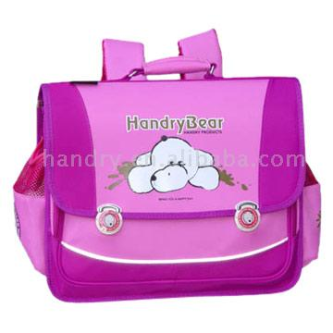 | 1. This is a school bag.
 | 2. We are in the school gym.
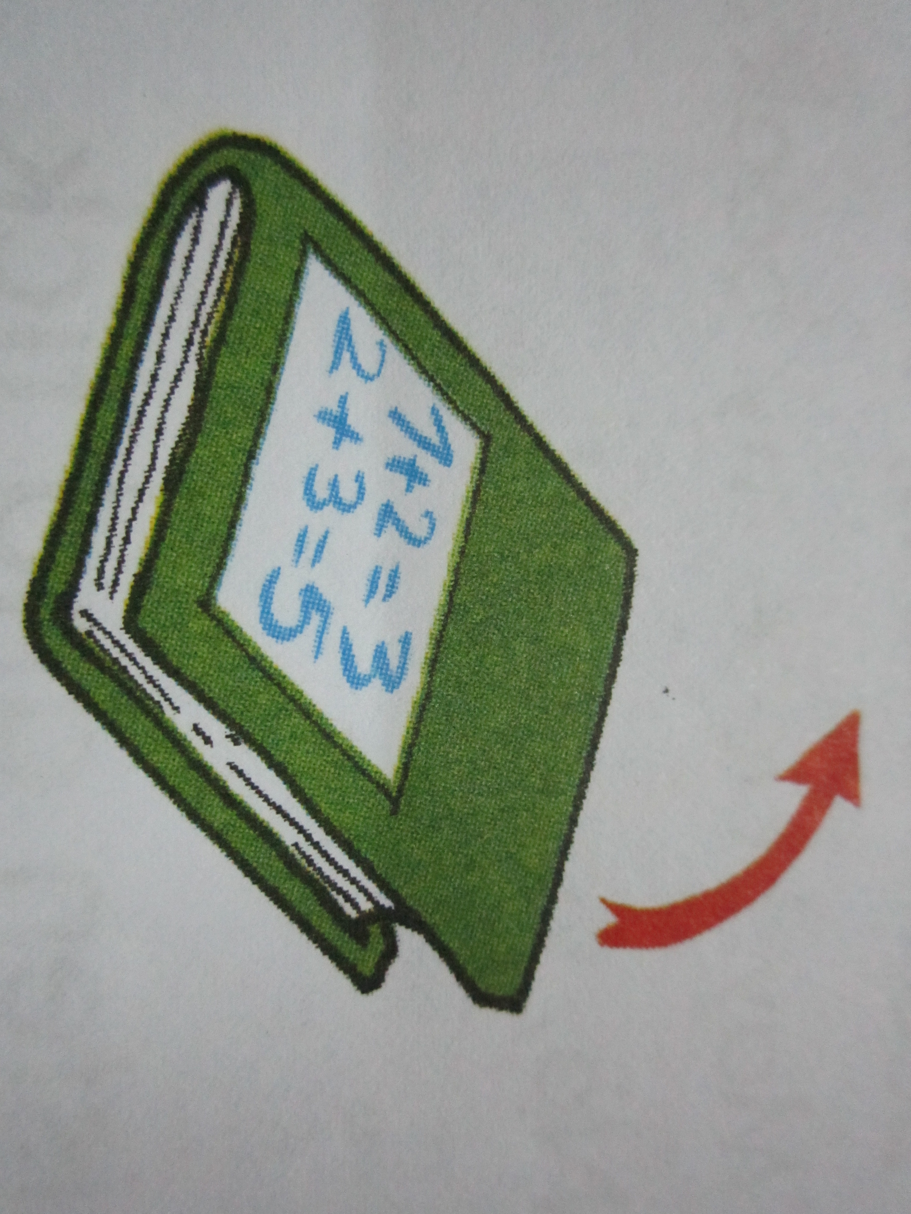 | 3. May I close my book?
 | 4. These are my notebooks.
Question7. Look and read. Write Yes or No as example: (1pt).

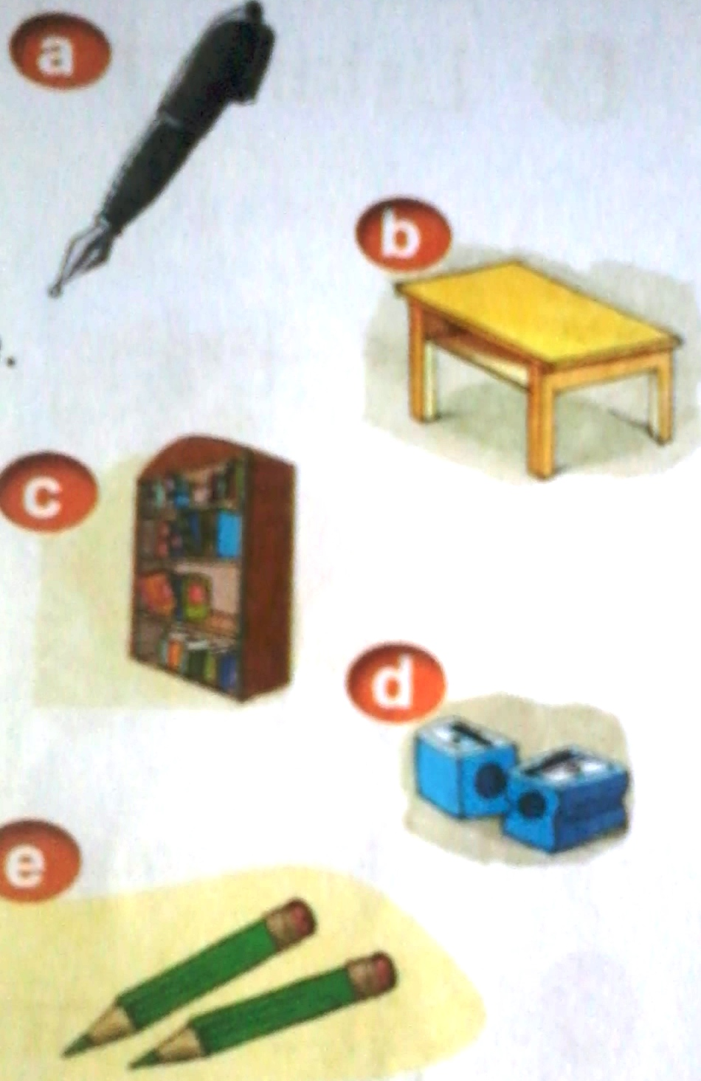 | a. This is a pen. Yes  b. That is a desk. _______  c. Is it a book? Yes it is. ________  d. These are my pencil sharpeners. ___________  e. Those are pencil cases _________

Question8. Look at the pictures. Look at the letters. Write the words .(2 pt)
- n p e  → _ _ _ | - r b e u b r  →_ _ _ _ _ _ |   - o l s h o c  →_ _ _ _ _ _ | - o ok b  →_ _ _ _

ĐÁP ÁN ANH VĂN LỚP 3

PART 1: LISTENING
Question1. Listen and number. (1 pt)
- This is my school bag.
- This is my classroom.
- That’s the library
- That’s my rubber.
Mỗi câu nghe đúng được 0.25 điểm
1.a 2.c 3.d 4.b
Question2. Listen and write T (True) or F (False) as examples (1pt).
1. This is the computer room.
2. What coulour is your pen? It’s red.
3. May I go out?
4. Let’s play.
Mỗi câu nghe đúng được 0.25 điểm
1.T 2.F 3.F 4.T
Question3. Listen and draw the line. There is an example. ( 1 pt)
Mỗi câu nghe đúng được 0.25 điểm
1. This is my book.
2. That is my rubber.
3. This is my pencil.
4. Is that your ruler?
1. book 2. rubber 3. pencil 4. ruler
Question4. Listen and tick. (1 pt)
- Sit down!
- Open your book!
- This is my pencil case.
- This is the computer room.
Mỗi câu nghe đúng được 0.25 điểm
1.b 2.a 3.b 4.b
Question5. Listen and complete. (1pt)
Mỗi câu nghe đúng được 0.25 điểm
1. hi 2. Linda 3. (9) nine 4. red
PART II: READING AND WRITING
Question6. Look and read. Put a tick ( ) or cross (X) in the box. (1pt).
Mỗi câu làm đúng được 0.25 điểm
1.T 2.F 3.F 4.T
Question7. Look and read. Write Yes or No as example: (1pt).
Mỗi câu làm đúng được 0.25 điểm
b. Yes c. No c. No d. No
Question8. Look at the pictures. Look at the letters. Write the words .(2 pt)
Mỗi câu làm đúng được 0.5 điểm
1. pen 2. rubber 3. school 4. book

