ĐỀ KIỂM TRA HỌC KÌ II TIẾNG ANH LỚP 3

I. THE MATRIX – MA TRẬN
 | Ma trận đề thi cuối học kì 2 Tiếng Anh 3: 2017 - 2018 ( 2 tiết/ tuần nên bỏ M4)
 |  | Môn: Tiếng Anh |  |  |  | Thời gian: 35 phút
Stt | Nội dung | Số câu | Các mức độ cần đánh giá |  |  |  |  |  | Tổng điểm
Stt | Nội dung | Số câu | Nhận biết-M1 |  | Thông hiểu -M2 |  | Vận dụng- M3 |  | Tổng điểm
Stt | Nội dung | Số câu | TNKQ | Tự luận | TNKQ | Tự luận | TNKQ | Tự luận | Tổng điểm
Listening |  |  |  |  |  |  |  |  | 4,0
1 | Listen and number | 4 |  |  | 4 |  |  |  | 1
2 | Listen and write | 4 |  |  |  |  | 4 |  | 1
3 | Listen and tick | 4 |  |  | 4 |  |  |  | 1
4 | Listen and complete | 4 |  |  |  |  |  | 4 | 1
Speaking |  |  |  |  |  |  |  |  | 1,0
 | Speaking | Theo dõi cả học kỳ
Reading |  |  |  |  |  |  |  |  | 3,0
6 | Look, read and tick | 4 |  | 4 |  |  |  |  | 1
7 | Read and write Yes or No | 4 |  |  | 4 |  |  |  | 1
9 | Read and fill in | 4 |  |  |  |  |  | 4 | 1
Writing |  |  |  |  |  |  |  |  | 2,0
8 | Look and write | 4 |  |  |  | 4 |  |  | 1
 |  |  |  |  |  |  |  |  | 10

THE SECOND SEMESTER ENGLISH TEST
Time allowed: 40 minutes
Name:……………………………………
Class: 3…………
PART I. LISTENING
Question 1: . Listen and number ( from 1 to 4). (1 pt)
 |  |  | 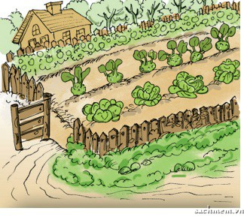
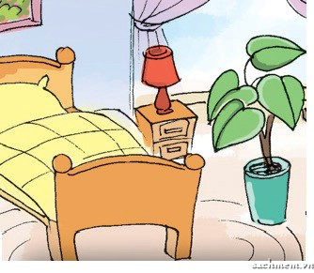 |  |  | 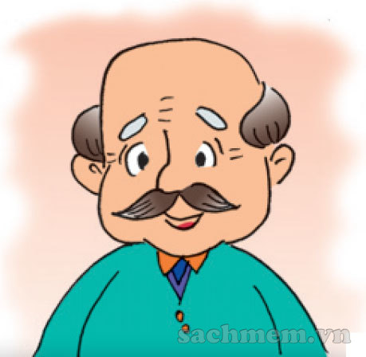
Question 2: Listen and write T( true) or F ( False) (1 pt)

1. Linda is reading a book. -> ……………
2. Peter is playing the piano. -> ……

3. Nam and Mai are watching TV -> ……

4. I’m drawing a picture -> …………

Question 3. Listen and tick. (1 pt)
1. Laura: What is the weather like ?
Jimmy. | A.  | B. 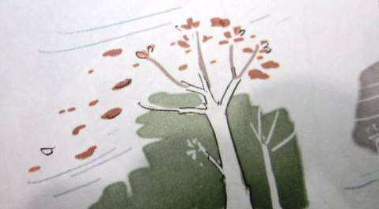 |   C.
2. Lilly: What are they doing ?
John | 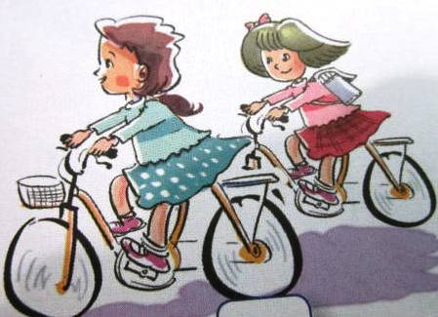  .  A |   B. | 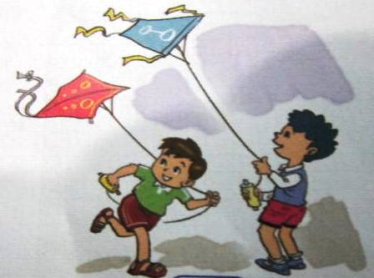  C.
3. Mary: What pets do you have?
Peter. |   A. |   B. | 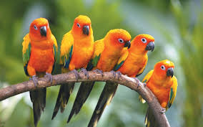  C.
4Jane: What toys do you like?
Tom. | A.  | 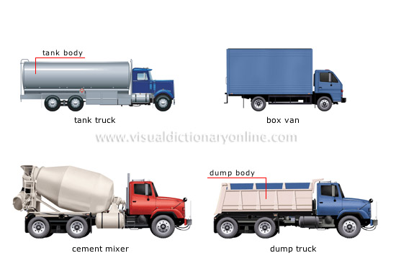  B. | C.

Question 4: Listen and complete. (1 pt)
Nam: Where are my ………………., Mum?
Mum : They're over there, under the ………………………..
Nam: Is the ……………… there with the cats, Mum?
Mum: No. He's in the ………………….Look! He's there.

PART 2. READING AND WRITING .
Question 5: Look and read. Put a tick () or a cross( x) in the box (1 pt)

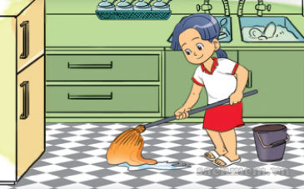

1. She’s cooking. 2. He’s cleaning the floor

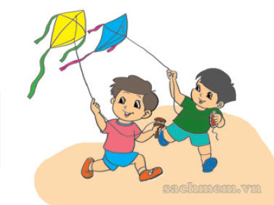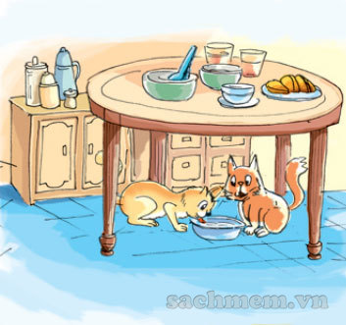

4. The cats are on the table

3. The girls are flying kites

 5. Ha Long Bay is in north Viet Nam.

Question 6: Look and read. Write Yes or No as example (1 pt )

Hi. My name is Nam. I have a lot of toys. I have a red plane, a blue car, a green ship
and a yellow ball. Dong is my brother. He also has many toys. He has two robots. They are
black and red. He has a red ship, a green car and a yellow yo-yo. We always play together.
We have much fun.

1. Nam and Dong have many toys.

2. Nam has a yellow ball and a blue car.

3. Dong is Nam’s friend.

4. They always play together.

Question 7: Look at the picture. Look at the letters. Write the words. ( 2 pt)
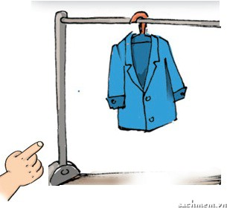 | 1. aotc | à | ………………………..
 | 2. hips | à | …………………………
 | 3. gfihsold | à | …………………………
 | 4. yunsn | à | …………………………

Question 8: Fill in the each gap with a suitable word from the box. (1pt)

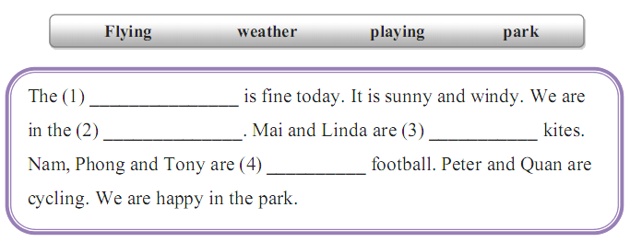
III. Speaking 1point

Đáp án :

PART I. LISTENING
Question 1: . Listen and number ( from 1 to 4). (1 pt)
1. How old is your grandfather?
He’s eighty years old
2. What’s the weather like?
It’s sunny
3. There is a big garden in front of my house.
4. There is a bed in my bedroom.
Question 2: Listen and write T( true) or F ( False) (1 pt)
Today is Sunday. We are at Nam’s house. Linda is reading a book. Peter is playing the piano. Mai, Nam and I are watching TV. We are having a good time.

1. Linda is reading a book. -> ……………
2. Peter is playing the piano. -> ……

3. Nam and Mai are watching TV -> ……

4. I’m drawing a picture -> …………

Question 3. Listen and tick. (1 pt)
1. Laura: What is the weather like ?
Jimmy. |  |  | C.
2. Lilly: What are they doing ?
John | .  A
3. Mary: What pets do you have?
Peter. |  | B.
4Jane: What toys do you like?
Tom. |  |  | C.

Question 4: Listen and complete. (1 pt)
Nam: Where are my cats, Mum?
Mum : They're over there, under the table
Nam: Is the dog there with the cats, Mum?
Mum: No. He's in the garden. Look! He's there.

PART 2. READING AND WRITING .
Question 6: Look and read. Put a tick () or a cross( x) in the box (1 pt)

x
v
1. She’s cooking. 2. He’s cleaning the floor

x
4. The cats are on the table
x
3. The girls are flying kites

5. Ha Long Bay is in north Viet Nam.
v

Question 7: Look and read. Write Yes or No as example (1 pt )

Hi. My name is Nam. I have a lot of toys. I have a red plane, a blue car, a green ship
and a yellow ball. Dong is my brother. He also has many toys. He has two robots. They are
black and red. He has a red ship, a green car and a yellow yo-yo. We always play together.
We have much fun.
T
1. Nam and Dong have many toys.
F
2. Nam has a yellow ball and a blue car.
F
3. Dong is Nam’s friend.
T
4. They always play together.

Question 8: Look at the picture. Look at the letters. Write the words. ( 1 pt)
 | 1. aotc | à | …coat……………………..
 | 2. hips | à | ……ship……………………
 | 3. gfihsold | à | ……goldfish……………………
 | 4. yunsn | à | …sunny………………………

Question 9: Fill in the each gap with a suitable word from the box. (1pt)
1. weather
2. park
3.flying
4. playing

PART III: SPEAKING (1 pt)
Question 10:
a) Listen and repeat.
b) Point, ask and answer.
c) Listen and comment.
d) Interview

III. KEYS - ĐÁP ÁN VÀ BIỂU ĐIÊM
PART I. LISTENING ( 20 minutes)
Question 1: . Listen and number ( from 1 to 4). (4 x 0.25 =1 pt)
Tapescript:
- a small computer
- a long pen
- a short pen
- a big computer
 | 1)  4 |  | 2)  1
 | 3)  3 |  |  | 4)  2
Question 2: Listen and write T( true) or F ( False) (4 x 0.25 = 1 pt)
1. Voice 1: Is this a computer room?
Voice 2: Yes, it is.
2. Voice 1: Is your school big?
Voice 2: No, it isn’t.
3. Voice 1: Do you like badminton?
Voice 2: No, I don’t.
4. Voice 1: Do you like chess?
Voice 2: Yes, I do

1.
-> T
2.
-> F
3.
-> F
4.
-> T

Question 3: Listen and draw the line. (4 x 0.25 = 1 pt)
2
3
4
5
1
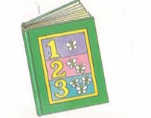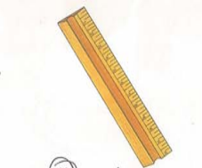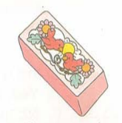
Tapescript:
- a pen
- a ruler
- a book
- a pencil
- a rubber

Question 4: Listen and tick. (4 x 0.25 = 1 pt)
Tapescript:
- Sit down, please.
- Open your book, please.
- Voice 1: What do you do at breaktime?
Voice 2: I play hide – and -seek.
- Voice 1: Is this a classroom?
Voice 2: No, it isn’t. It’s a library.

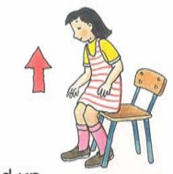 | 1a) | 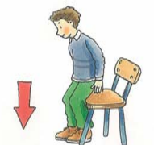 | 1b)  
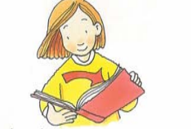 | 2a)   |  | 2b)
 | 3a)   |  | 3b)
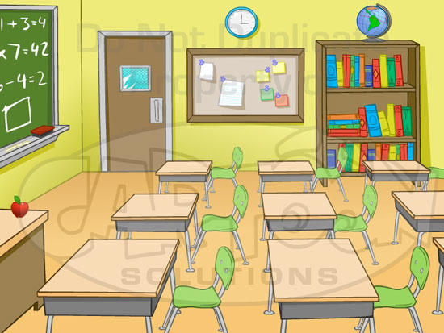 | 4a) | 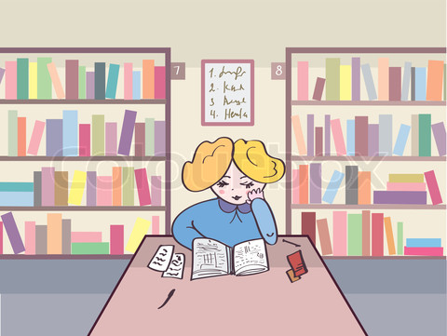 | 4b)  

Question 5: Listen and complete. (4 x 0.25 = 1 pt)
1. Voice 1: What’s that?
Voice 2: It’s my book.
2. Voice 1: What colour are they?
Voice 2: They are blue.
3. Voice 1: How old are you?
Voice 2: I’m nine.
4. Voice 1 : What are those?
Voice 2: They are bags.
1. that 2. blue 3. nine 4. those

PART 2. READING AND WRITING ( 20 minutes)

Question 6: Look and read. Put a tick () or a cross( x) in the box as example (4 x 0.25 = 1 pt)


X
1) This is a book. 2) This is a pen.


3) This is a ruler. 4 ) This is a school bag.
X

Question 7: Look and read. Write Yes or No as example (4 x 0.25 = 1pt )

1) The school is small. | No
2) The classroom is big. | Yes
3) Many of my friends are in the classroom. | No
4) I’m in the computer room. | Yes

Question 8: Look at the picture. Look at the letters. Write the words.
(4 x 0.25 = 1 pt)

1) BLACK
2) CHESS

3) FOOTBALL

4) LIBRARY

Question 9: Choose a word from the box and write it next to numbers from 1 - 4.(4 x 0.25 = 1 pt).

1. classroom
2. is
3. it
4. new

PART III: SPEAKING (1 pt 25 x 4)
Question 10:
a) Listen and repeat.
b) Point, ask and answer.
c) Listen and comment.
d) Interview

