PEOPLE’S COMMITTEE OF AN LAO DISTRICT  TRUONG THO PRIMARY SCHOOL  ------------------------- | THE FIRST SEMESTER TEST  School year : 2020- 2021  Subject: English 4 - Time: 40'
Name: ........................................................................................ Class: 5….
PART I. LISTENING
Question 1: Listen and number:(1pt) Nghe và đánh số thứ tự
 | A. | 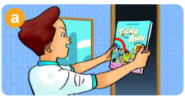 | B. | 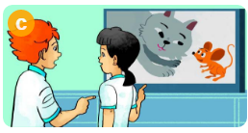 | C. |  | D.

Question 2 . Listen and tick ( 1 pt ) . Nghe và đánh dấu 

1. 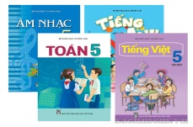A. | 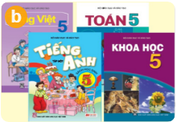 B. | 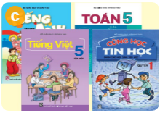 C.
2.A. | 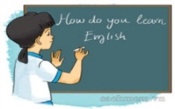 B. |  C.
3.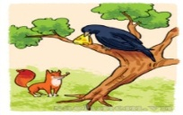 A. | 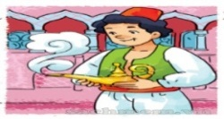 B. | C.
4.A. |  B. |  C.
Question 3. Listen and circle (2pts) Nghe và khoanh từ trong ngoặc
1. Where did you go last Sunday, Linda? - I went to ( the cinema/ the zoo).
2. How many lessons do you have today? - I have three : (Maths/ Vietnamese), IT and Science.
3. What’s Tam like? - She’s (kind/ generous)
4. What did the (lions/ tigers) do when you were there?

PART 2. READING AND WRITING
Question 4. Read the text carefully. Tick () True or False (x).(1 pt)
Đọc đoạn văn điền () (đúng) hoặc (x) sai.
Mai is a student at Tan An Primary school. There are forty students in her class. Today she has Maths, Music and Art. She likes Music because she likes to sing. She doesn’t go to school on Saturday and Sunday.
Statement | T | F
0. Mai is a student. | 
1. There are six students in her class.
2. Today she has Vietnamese, English and Science.
3. She likes Music.
4. She doesn’t go to school on Saturday and Sunday.

Question 5. Fill in each gap with a suitable word from the box ( 1 pt ) .
Dùng các từ trong khung để điền vào cỗ trống

Art | four | lessons | Wednesday | Tuesday

My name is Trung. I’m a new pupil in Class 5B. Today is (0) ..........Tuesday....... I have five (1) ........................ : Maths, Vietnamese, Science, IT and PE. Tomorrow is (2) ...................... I’ll have (3) ..........................lessons: Maths, Vietnamese, Music and (4) ........................

Question 6. Put the letters in the correct order to make a correct word.(2 pts)
Nhìn tranh xếp các chữ thành từ đã học.

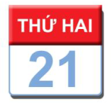  1. | dayMon => | ________________
2.  | dnPaas => | ________________
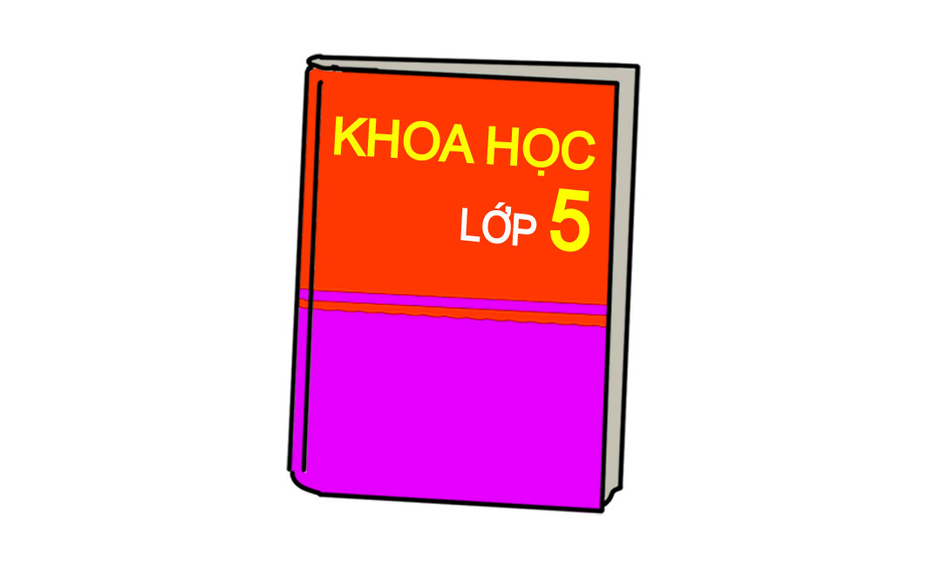  3. | Scceien => | ________________
4.  | dRea => | ________________

Question 7. Reorder the words to make sentences .(1 pt)
Sắp xếp các từ thành câu đã học

- zoo?/ you/ did/ What/ see/ at/ the =>……………………………………………………….………..
- I / times / have / a / English / four / week / =>………………………………………………………..……….
- kind / Aladdin / and / is / generous / . =>………………………………………………………..……….
4. about / reading / I / a / am / story / Halloween /.
=>………………………………………………………..……….
PART III- SPEAKING. (1pt)

MA TRẬN HKI MÔN TIẾNG ANH 5
NĂM HỌC 2020 -2021

Kỹ năng | Nhiệm vụ đánh giá/kiến thức cần đánh giá | Mức/Điểm |  |  |  | Tổng số câu, số điểm, tỷ lệ %
Nghe | Nhiệm vụ đánh giá/kiến thức cần đánh giá | M1 | M2 | M3 | M4 | 12 câu  4 điểm  40%
Nghe | Listen and number | 2  0,5đ | 1  0,25đ | 1  0,25đ |  | 12 câu  4 điểm  40%
Nghe | Listen and tick | 1  0,25đ | 1  0,25đ | 1  0,25đ | 1  0,25đ | 12 câu  4 điểm  40%
Nghe | Listen and complete | 2  1đ | 1  0,5đ | 1  0,5đ |  | 12 câu  4 điểm  40%
Đọc | Read the text and tick True or False | 2  0,5đ | 1  0, 5đ | 1  0,25đ |  | 8 câu  2 điểm  20%
Đọc | Fill in the blank with a suitable word | 1  0, 25đ | 2  0,5đ |  | 1  0,25đ | 8 câu  2 điểm  20%
Viết | Put the letters in the correct order to make a correct word.(1pt) | 1  0,25đ | 1  0,25đ | 1  0,25đ | 1  0,25đ | 8 câu  3 điểm  30%
Viết | Order the word to make sentences | 2  0,25đ | 1  0,25đ |  | 1  0,25đ | 8 câu  3 điểm  30%
Nói | Getting to know each other | 1  0,25đ | 2  0,5đ |  |  | 10 câu  1 điểm  10%
Nói | Talking about familiar object |  | 1  0,25đ | 3  0,75đ |  | 10 câu  1 điểm  10%
Nói | Describing the picture |  | 1  0,25đ | 1  0,25đ | 1  0,25đ | 10 câu  1 điểm  10%
Tổng |  | 12  32% | 12– 32% | –9 24% | 5 – 12%

KEY FOR TEST – GRADE 5

Question | Answer | Point | Total
1 | 1. B 2. D 3. C 4. A | 0.25/ each | 1
2 | 1. C 2. C 3. A 4. B | 0.25/ each | 1
3 | 1.Hanoi 2.Maths  3. kind 4. lions | 0.5/ each | 2
4 | 1.F 2.T 3.F 4.T | 0.25/ each | 1
5 | 1. lessons 2. Wednesday  3. four 4. Art | 0.25/ each | 1
6 | 1.Monday 2.Pandas  3. Science 4. Read | 0.5/ each | 2
7 | 1. What did you see at the zoo?  2. I have English four times a week.  3. Aladdin is kind and generous.  4. I am reading a story about Halloween. | 0.25/ each | 1

Phần nghe.
Question1.
- What subjects do you like best?. – English.
- What are you reading ? Snow White and the seven dwarfs.
- How do you practice listening ? I watch English cartoons on TV
- Where are you going next week end? I’m going to Ha Long Bay.

Question 2.
- How many lessons do you have today? I have 4: Maths, Vietnamese, English and IT.
- How do you learn English? I learn English songs.
- What are you reading ? I am reading “The fox and the crow”.
- What did you do at the park? I saw a lot of peacocks.

Question 3.
1. Where did you go last Sunday, Linda? - I went to the zoo.
2. How many lessons do you have today? - I have three : Maths, IT and Science.
3. What’s Tam like? - She’s kind.
4. What did the lions do when you were there?

