UBND HUYỆN VĨNH BẢO  4 | ĐỀ KHẢO SÁT CHẤT LƯỢNG HỌC KỲ II  MÔN TIẾNG ANH LỚP 4  NĂM HỌC 2023 - 2024  (Thời gian làm bài: 40 phút)
PART I: Listening
Question 1. Listen and number (1pt)
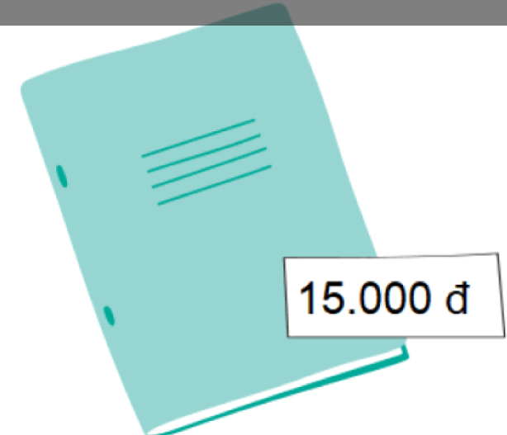
a. | b. | c. | d.
Question 2: Listen and tick (1pt)
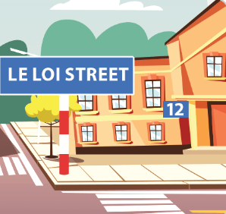 | 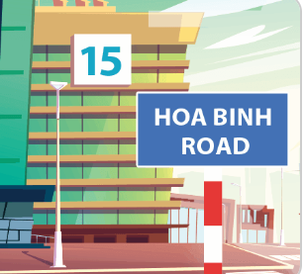 | 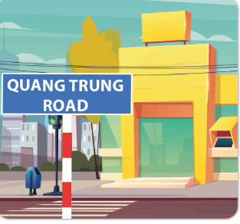
1 a | b | 2 a | b
3 a | b | 4 a | b
Question 3: Listen and complete (1pt)
1. My grandfather has a......................... 2. My brother has long.....................
3. A:What was the weather like last 4. A: Where were you last Sunday?
..................................... B: I was in the countryside.
B: It was cloudy A: What was the weather like?
B: It was...............................
PART II: PRONUNCIATION
Question 4: Choose the words which have stress different from the others.(1pt)
1. a. rainy b. windy c. sunny d. behind
2. a. between b. village c. cloudy d. bookshop
3. a. sunny b. giraffe c.visit d. email
4. a. campsite b. quickly c. weekend d. rainy
PART III: READING
Question 5: Odd one out ( 1.25pts )
1. a. cinema b. zoo c. sports centre d. go
2. a. putting b. telling c. play d. building
3. a. animal b. giraffe c. hippo d. lion
4. a. quickly b. ready c. loudly d. merrily
5. a. cook meals b. do yoga c. weekend d. watch films
Question 6: Choose the best answer (1.25pts)
1. Where does your...............(parents / grandparents / father ) work?
2. My sister is an.................(policeman / nurse / office worker )
3. The baby has ..............( short hair / a short hair / a long hair )
4. ( What / Who / Where ) does your sister look like?
5. Her father works on a .............( nursing home / farm / factory )
Question 7: Read and tick T/F.( 1pt )
Mai lives in a small flat with her parents. It is in Le Lai Street. The street is very busy. At the weekend, she visits her grandparents. They live in a big house with a beautiful garden in a village. The village is quiet and beautiful.
 | True | False
1. Mai lives in a big flat.
2. Her flat is in Le Lai Street.
3. She visits her grandparents at the weekend.
4. The village is not quiet.

PART IV: WRITING
Question 8: Look at the picture and write the word ( 1pt )

1............................. 2................................ 3........................... 4..........................

Question 9: Arrange the words to make sentences ( 1.5pts )
1. watch / in / I / evening / TV / the.
.............................................................................................................................
2. animal / are / what / these?
..............................................................................................................................
3. do / in / what / morning / do / you / the?
...............................................................................................................................
4. long / have / animals / necks / these / and / legs.
................................................................................................................................
5. help / mum / floor / my / clean / with / cooking / the / I / and / the.
..............................................................................................................................
6. friends / to / the / Ben / because / animals / at / and / the / want / his / zoo / they / see / are.
.......................................................................................................................................

Answer keys:
Q1: 3-1-4-2
Q2: 1-a 2-b 3- a 4-b
Q3: 1 - round face 2- hands 3- weekend 4 - sunny
Q4: 1 - d 2 - c 3 - b 4 - c
Q5: 1 -d 2-c 3 - a 4 - b 5 - c
Q6: 1 - father 3 - short hair 4 - what
2 - office worker 5 - farm
Q7 : 1 - F 2 - T 3 - T 4 - F
Q8: 1 - policeman 2 - nursing home 3- windy 4 - bakery
Q9 :
1. I watch TV in the evening.
2 . What are these animals?
3 . What do you do in the morning?
4. These animals have long necks and legs.
5. I help my mum with the cooking and clean the floor.
6. Ben and his friends are at the zoo because they want to see the animals.

