BÀI ÔN HKII K4
Ex2. Odd one out (Chọn từ khác loại)
1. A. Swimming pool B. cinema C. see a film
2. A. cook B. meal C. yoga
3. A. play tennis B. sport centre C. stay at home
4. A. gym B. cinema C. go shopping
Ex2. Odd one out (Chọn từ khác loại)
- a. giraffe b. lion c. animal
- a. crocodile b. roar c. hippo
- a. peacock b. quickly c. merrily
- a. family b. loudly c. beautiful
Ex2. Odd one out (Chọn từ khác loại)
- A. put B. tell C. tent
- A. taking B. telling C. morning
- A. songs B. build C. stories
- A. am B. I C. is
- A. now B. at the moment C. yesterday
Ex3. Circle the correct answer (Chọn đáp án đúng)
- What does your __________ do? She’s a farmer.
A.brother B. sister C. father
- __________ does your brother do? __________ an actor.
A. What / He B. What / He’s C. Where / He’s
- Is your mother an office worker?
A. No, He isn’t B. No, She isn’t C. Yes, I am
- __________ does he work? - at a nussing home.
A. What B. Where C. How
- She __________ on a farm.
A. work B. worked C. works
- Does he __________at a factory?
A. workes B. work C. worked
- My father is a worker. He works __________
A. at a school B. at a nursing home C. at a factory
- She is __________. She works on a farm.
A. a farmer B. an office worker C. a teacher
Ex3. Circle the correct answer (Chọn đáp án đúng)
- Do you have a brother?
A. No, I don’t B. Yes, I don’t C. No, you don’t
- What does she look like? 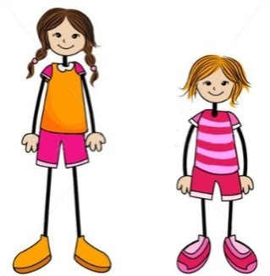
A. She’s short B. She’s tall C. She’s big
- What does he look like?
A. He has short hair B. He has a short hair C. He has a big eyes
- My sister __________ a round face.
A. have B. haves C. has
- I have __________ .
A. long hair B. a long hair C. a hair long
- Her face is __________ .
A. tall B. round C. heavy
- Is your father slim?
A. Yes, he is B. He is slim C. He has slim
- What do they look like?
A. They have big eyes B. They has big eyes C. They are a big eyes
Ex5. Reading
I live in a small flat with my parents. It is in Le Lai Street. The street is very busy. At the weekend, I visit my grandparents. They live in a big house with a beautiful garden in a village. The village is quiet and beautiful.
A. Read and circle
- I live in a __________ flat.
A. big B.small C. quiet D. noisy
- Le Lai Street is very __________
A. noisy B. busy C. small D. quiet
- My grandparents live in a __________
A. town B. city C. village D. flat
- The village is __________
A. quiet and beautifyl B. small and busy C. quiet and small D. beautiful and busy
- Do you live with your grandparents?
A. Yes, I do B. No, I don’t C. I live with me grandparents B. I live with my parents
Ex5. Reading
We are at the shopping centre. We can see many shops. The bookshop is opposite the pet shop. The toy shop is behind the pet shop. The bakery is between the bookshop and the sports shop.
Mai wants to buy a book. It is 30,000 dong. Linh wants to buy a doll. It is 50,000 dong. I want to buy an ice cream. It is 10,000 dong.
A. Read and circle
- We are at the ____________ .
a. shopping centre b. sports shop c. bakery
- The bookshop is ____________ the pet shop.
a. opposite b. near c. behind
- How much is a book? ____________ thousand dong.
a. ten b. fifty c. thirty
- What does Linh want to buy?
a. a ball b. a doll c. an ice cream
- How much is an ice cream?
a. 30,000 dong b. 50,000 dong c. 10.000 dong
Ex7. Look and write (nhìn và viết)
…………………….. …………………….. …………………….. ……………………..
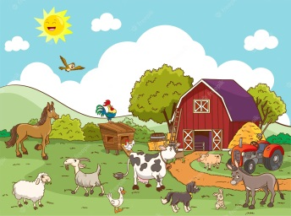
…………………….. …………………….. …………………….. ……………………..
Ex7. Look and write (nhìn và viết)

....................................... ...................................... ..................................... . ......................................
....................................... ...................................... ..................................... . ......................................
Ex6. Reorder the word to make a sentence. (Sắp xếp các từ để tạo thành câu)
- are / What / animals / these / ……………………………………………......................................................………..
- giraffes / They / lions / and / are / .………………………………......................…………...............................……..
- like / Why / you / peacocks / do / ?….................…………………………………………....................................……..
- dance / because / beautifully / they /………………………………………............……...............................…………..
- sing / The / merrily / birds / .…………………………………….......................………..............................…………..
- are / those / What / animals / ……………………………………….................……………...............................……..
- want / they / the / see / to / animals / …………………………………………..........………............................………..
- have / necks / the / long / giraffes / and / legs / ………………………………………………......................…………..
Ex6. Reorder the word to make a sentence. (Sắp xếp các từ để tạo thành câu)
1. does / on / Where / go / Saturdays / she / ?…….................……………………………………….................................……..
2. goes / to / He / cinema / the / ………………………………………....................................….......................................………..
3. does / father / What / Sundays / your / do /on ?…………………………………..……………......................................………..
4. watches / She / films / Thursdays / on / .……………………………..................…………….................................……………..
5. Sunday / Today / is / .………………………………………………..............................................................................………..
6. stays / at / Ben / home / weekends / at / the / …………………………………….............................................…………………..
7. cook / I / with / meals / my / mother / .…………………………………………..................................................…………………..
8. family / have / my / together / meal / a / nice / .

