ĐỀ 15
PART I: LISTENING
Question 1: Listen and number. (1pt)
. 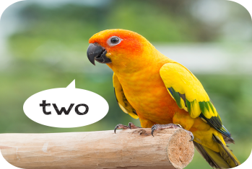  a. | 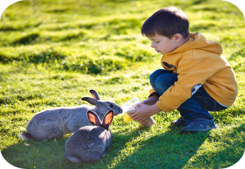  b. | 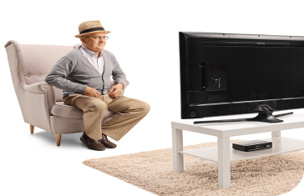  c. |   d.
Question 2: Listen and circle. (1pt)
1. Is she a ......................? - Yes, she is.
a. doctor b. farmer c. teacher
2. Is .................... mother a cook? - Yes, she is.
a. you b. the c. your
3. Is your mother a doctor? - No, she .............. . She’s a nurse.
a. isn’t b. is not c. aren’t
4. Is she a teacher? - No, she isn’t. She’s a .................... .
a. driver b. singer c. farmer
Question 3: Listen and complete. (1pt)
1. A: How old is your brother? B: He's ................................ years old.
2. A: What's his job? B: He's a .................................... .
3. A: Where are the ........................ ? B: They're on the table.
4. A: Would you like some ............................ ? B: Yes, please.
PART II: READING
Question 4: Look and read: Odd one out. (1,5 pts)
1. a. his | b. she | c. her | d. my
2. a. teacher | b. worker | c. students | d. driver
3. a. house | b. living room | c.bedroom | d. kitchen
4. a. table | b. big | c. chair | d. lamp
5. a. is | b. am | c. are | d. the
6. a.writing | b. dancing | c. evening | d. reading
Question 5: Look and read: Choose the best answer. (1,5pts)
1. A: Do you have any pets? B: ................................ .
a. Yes, I am. | b. Yes, I do. | c. No, I do | d. Yes, I don't.
2. How .............. parrots do you have?
a. old | b. much | c. many | d. any
3. I have one dog .............. five birds.
a. and | b. but | c. so | d. some
4. My sister is .............................. in the park.
a. skate | b. skating | c. skates | d. skateing
5. A: ...................... is Bill doing now? B: He is listening to music.
a. Where | b. How | c. What | d. How old
6. My friends and I ................ playing sports and games ......... the playground.
a. are/in | b. am/in | c. is/ on | d. are/ on
Question 6: Read and complete. (1.5pts)
like | some | drinks | table | family | rice
Nam and his (1)………….. are at the (2) dining ……………. . There is a lot of food and (3) ……………… on the table. His father and mother would (4) ………….. some rice, beans and some water. His sister would like (5) ………………. bread, meat and some milk. Nam would like some (6) ……………… , fish and some juice.
PART III: WRITING
Question 7: Look at the pictures and write the words. (1pt)
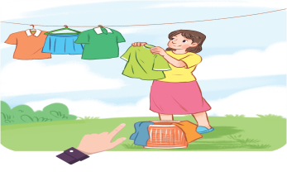  1. A: Who’s this? B: It’s my …………….. . | 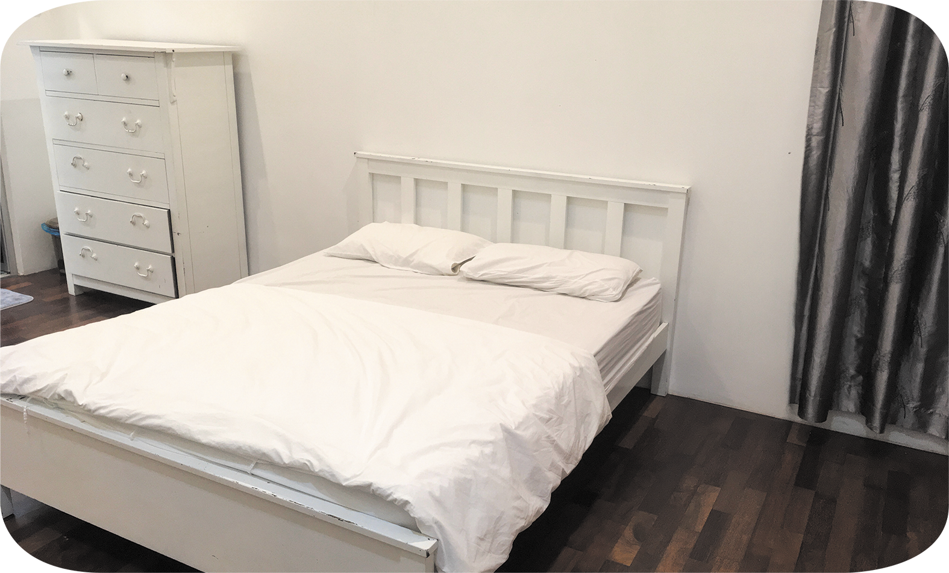  3. There’s a………….in the bedroom. It’s new.
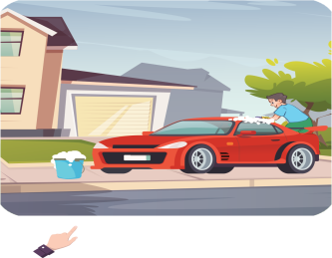  2. A: Who’s that? B: It’s my ……………. . | 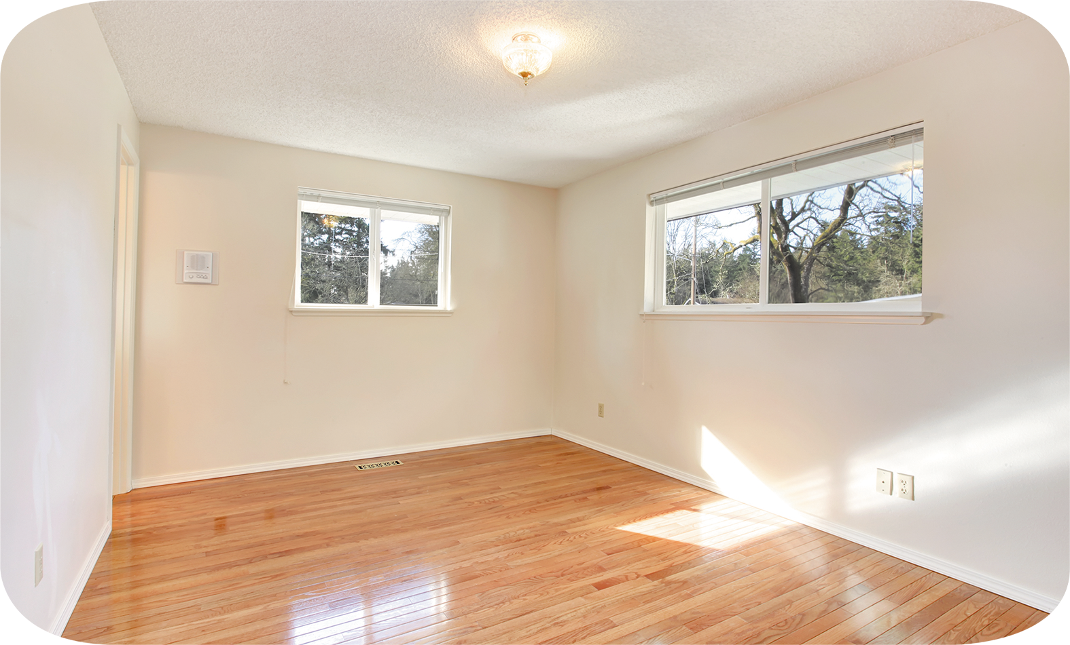  4. There are two windows in the room. They’re …………….. .
Question 8: Arrange the words to make sentences. (1,5 pts)
1. like/ you/ some/ orange/ would/ juice?
-> ................................................................................................................................................
2. would/ like/ eat/, / Nam/ what/ to/ you?
-> ................................................................................................................................................
3. sister/ like/ my/ some/ bread/ and/ would/ milk.
-> ..............................................................................................................................................
4. see/ Mai/ what/ at/ zoo/ can/ the?
-> ……..………………………………………………
5. can/ they/ a/ see/ big/ and/ elephant/ tigers/ some.
-> .............................................................................................................................................
6. are/ what/ animals/ at/ doing/ the/ zoo/ the?
-> .................................................................................................................................................

