**ĐỀ 19 – K3**

**I. LISTENING**

***Question 1. Listen and number (1pt)***

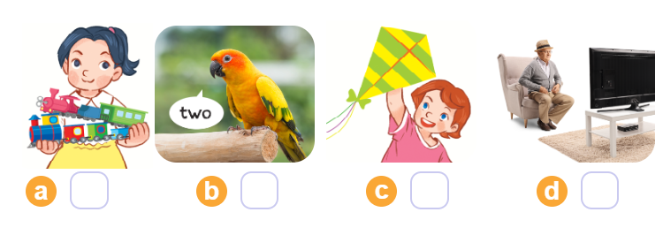

***Question2: Listen and tick(1pt)***

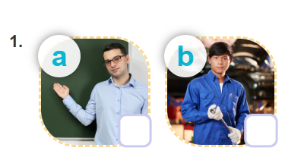 

***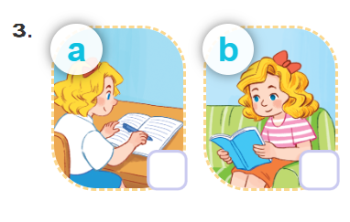* 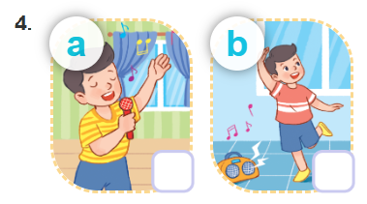**

***Question 3:Listen and complete(1pt)***

**1. *A:*This is my bedroom. There is a …. in the room.  
2. *A:*This is my bedroom. There are two ….. in the room.**  
**3.** A: Where are the ….?-🡪   B: They’re on the the table  
**4.**A:  Would you like some ….? 🡪   B: Yes,please!

***Question 4: Odd one out:(1.5p)***

1. a. doctor b. father c. nurse d. farmer

2. a. bedroom b. living room c. door d. kitchen

3. a. window b. dancing c. reading d. singing

4. a. lamp b. desk c. chair d. goldfish

5.a. worker b. pupil c. mother d. singer

6. a. listening b. watching c. drawing d. color

***Question 5: Choose the best answer:(1.5p)***

1. Do you have any pets?

a. Yes, it is. b. Yes, I do c. No, it is d. No,it don’t

2. … rabbits do you have? – I have four.

a. How much b. What c. How many d. How

3 What are you doing ? – I am ….. in the library.

a. play basketball b. listen to music c. play football d. reading

4. I have four…..

a. goldfish b. goldfishes c. dog d. cat

5. ….are you doing?- I am listening to music in my room.

a. What b. When c. How d. Do

6. What are you doing ?- I am drawing a…..

a. cooking b. music c. picture d. dancing

***Question 6: Read and complete: (1.5p)***

|  |
| --- |
| **Would eat has some lemonade planes** |

1. What would you like to ……? I would like some fish, please.

2. He …. a car and robot.

3. …… you like some milk?-No, thanks. I would like some juice, please.

4. Lucy and Mai have six …..

5. Would you like….chicken? Yes, please.

6. Would you like some ….? No, thanks. I would like some water.

***Question 7:Look at the pictures and write the words: (1.0p)***

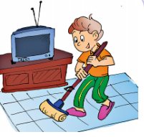 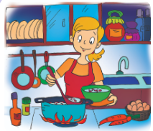

1.A. Who is this? 2. A:This is my …

B. It is my … B:Oh! She is young.

*** ***

3. There are two….in my room 4. I have a …in my bedroom.

It’s small

***Question 8: Reorder these words to make sentences: (1.5p)***

1. like / some/ Would/ you/rice?.

-> ……………………………………..

2. can/What/you/see?

-> ………………………………………………...

3. can/see/I/a/tiger/monkey/and/

-> ………………………………………

4./you/like/eat/to/What/would/?

-> ………………………………………

5./some/We’d /like /chicken/ rice/ and/

->………………………………..

6. the/monkey/What’s/doing ?

-> ………………………………………...