**ĐỀ 20-K3**

**Question 1.Listen and number(1pt)**

**Question2.Listen and tick(1pt)**

1. 2

3 4

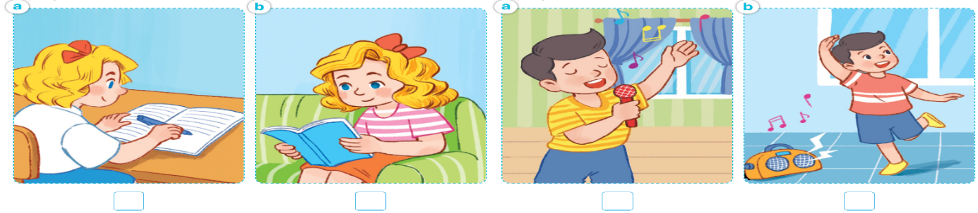

**Question 3.Listen and complete(1pt)**

*1. A:* How old is your brother?

*B:*He’s .........................years old.

2. *A:* What’s his job?

*B:* He’s a ..............................

*3. A:* Where are the...................?  
*B:*They’re on the table.

4. *A:* Would you like some ............?

*B:*Yes, please.

**Question 4. Odd one out (1.5pts)**

1. a. nurse b. job c. worker d. teacher

2. a. teacher b. cook c. music d. farmer

3. a. pens b. tables c. lamps d. room

4. a. writing b. listen c. reading d. singing

5. a.drawing b. picture c. watching d. listening

6. a. bedroom b. bathroom c. room d. living room

**Question 5.Choose the best answer(1.5pts)**

1. Do you have any rabbits?-Yes, I ..................

a. don’t b. am c. is d. do

2.She’s .........................

a. skating b. cycling c. skipping d. flying

3. How many .................. do you have?

a. dogs b. parrot c. rabbit d. cat

4. I have some…………..

a. bird b. a bird c. a birds d. birds

5 . Tony is …………. a picture.

a. a drawing b. draw c. draws d. drawing

6. Do you .............. any birds?

a. has b. is c. have d. are

**Question 6. Read and complete.(1.5pts)**

|  |  |  |  |  |  |
| --- | --- | --- | --- | --- | --- |
| would | and | some | table | drinks | like |

Quang and his family are at the dining (1).......................... . There is a lot of food and(2).............. on the table . His father and mother would (3)................  some rice, fish (4)................. some water. His sister would like (5)...................  bread, meat and some milk. Quang (6)............ like some rice, chicken and some juice.

**Question 7.Look at the pictures and write the word(1pt)**

................................ ............................... .................................. ..................................

**Question 8.Arrange the words to make sentences(1.5pts)**

1. Linh/ zoo./ are/ her/ the/ mother/ and/ at/

....................................................................................

1. at/zoo?/can/the/What/see/you

....................................................................................

1. doing?/is/ parrot / What/the/

....................................................................................

1. /fish?/like/you/some/ would

.......................................................................................

1. would/meat/like/beans/My mother/some/and

.......................................................................................

1. peacock/ dancing./ A/ is/

.......................................................................................