PART I: Listening
Question 1: Listen and tick or cross (1pt)
1. 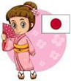 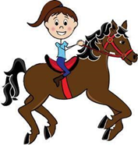 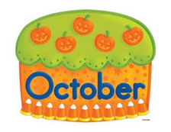 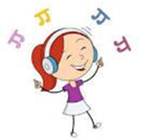

Question 2: Listen and number (1pt)
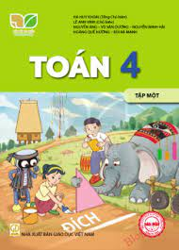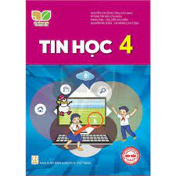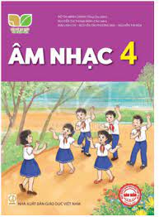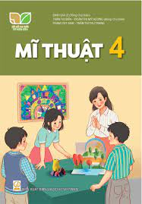
a b c d
Question 3: Listen and write one word in the blank (1pt)
1. When do you have ……………….?
2. They have ………………. today ?
3. Can he ………….?- Yes, he can.
4. Can ………….. draw?- No, they can’t.
PART II: Pronunciation
Question 4: Circle the word which has pronounced differently (1pt)
1 | a. table | b. may | c. play | d. hand
2 | a. run | b. fun | c. music | d. jump
3 | a. July | b. fly | c. sky | d. party
4 | a. first | b. bike | c. like | d. nine
III. Reading.
Question 5: Odd one out (1,25 pts)
1 | a. want | b. chips | c. go | d. work
2 | a. chat | b. wash | c. clean | d. teeth
3 | a. what | b. when | c. jam | d. how
4 | a. January | b. Monday | c. Thursday | d. Saturday
5 | a. Tokyo | b. Japan | c. Sydney | d. London
Question 6. Choose the best answer (1,25 pts)
1. What can Ben and Ba do?
a. I can swim b. He can roller skate c. They can dance.
2. What’s Mai’s favourite subject?
a. It’s English b. She like English c. Her likes English.
3. What day ………… today?
a. it is b. is it c. isn’t it.
4. Do you have Maths from Mondays to Fridays? – Yes, I have it ……………a week.
a. six days b. fine days c. five days
5.
Question 7: Read and complete (1pt)

Hi. My name is Mary and I am from (1) _____________ . Today is the
sixth of March. It is my birthday. I am having a great time. I have a big birthday
(2) ________ from my parents. Lots of friends come to my party. We eat some (3) _________ and drink some (4) 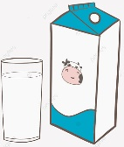 __________. They give
me many beautiful presents.
IV. Writing.
Question 8. Look at the pictures and write the words(1 pt)
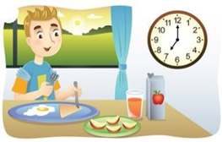  1. I have ……………… at seven o’clock. | 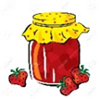  2. I eat some bread and …….…. for lunch.
  3. I was in ……………… last summer. | 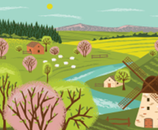  4. Were you in the ……………. last weekend?

Question 9. Arrange the words to make sentences (1,5 pts)
- are/ from, / where/ Tom/ you/? /
…………………………………………………………………………………
- do/ subjects/today/ what/ ? / have/ you/
…………………………………………………………………………………
- roller/ Ben/ can/ can/ skate/ dance/ not/ but/ he/. /
………………………………………………………………………………
- Art/ her/ favourite / subject/ is/. /
…………………………………………………………………………………
- does/ this/ why/ like/ subject/ he/? /
……………………………………………………………………………………

