UBND HUYỆN VĨNH BẢO  TRƯỜNG T H TÂN LIÊN  (Đề đề xuất) | ĐỀ KHẢO SÁT CHẤT LƯỢNG HỌC KÌ I  MÔN TIẾNG ANH LỚP 4  NĂM HỌC 2023 – 2024  (Thời gian làm bài: 40 phút)
PART I: Listening
Question 1: Listen and tick or cross (1pt) 1.
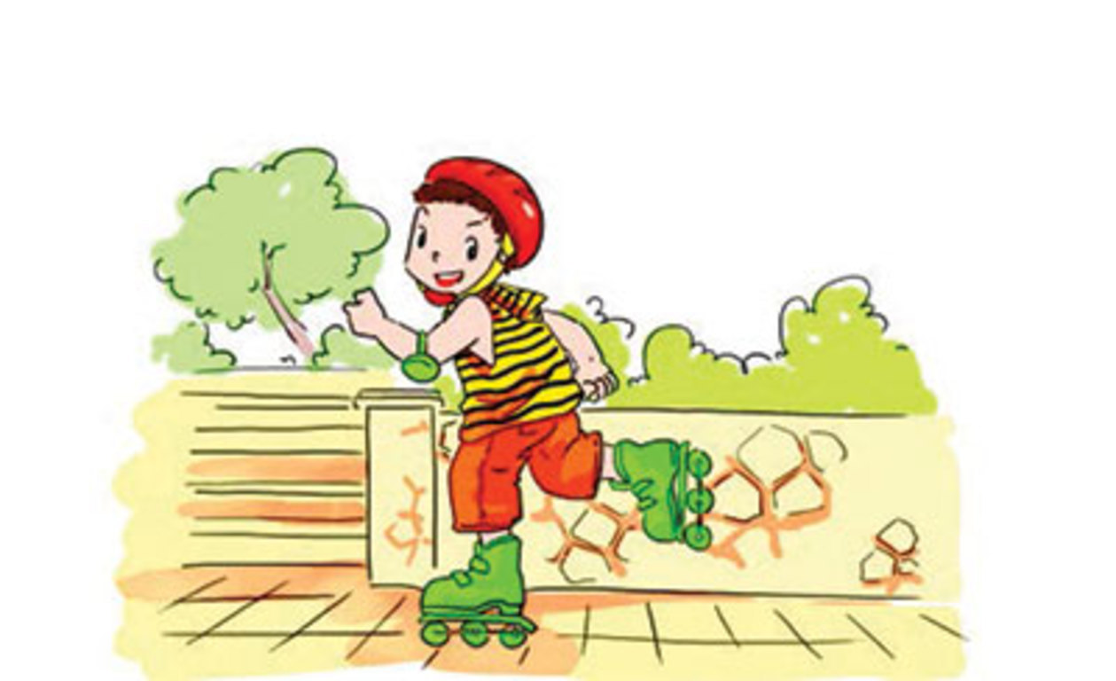

Question 2: Listen and number (1pt)
 a b c d
Question 3: Listen and write one word in the blank (1pt)
1. A: Is that your brother? -> B: Yes, it is. My brother can …………….
2. A: Can your sister ………………..? -> B: Yes, she can.
3. A: Can your sister …………..? -> B: No, she can't, but she can swim.
4. A: Can your brother play badminton? -> B: No, he can't, but he can ………..
PART II: Pronunciation
Question 4: Odd one out (1,25 pts)
1 | a. London | b. America | c. Australia | d. Britian
2 | a. sing | b. juice | c. dtink | d. eat
3 | a. what | b. who | c. wednesday | d. when
4 | a. lemonade | b. chips | c. orang juice | d. water
5 | a. May | b. sunday | c. april | d. august
III. Reading.
Question 5: Circle the word which has pronounced differently (1pt)
1 | a. april | b. may | c. have | d. day
2 | a. sunday | b. run | c. music | d. lunch
3 | a. sing | b. drink | c. swim | d. like
4 | a.lunch | b. school | c. march | d. teacher
Question 6. Choose the best answer (1,25 pts)
1. What do you do ……….. Sundays? ?
a. in b.at c. on
2.Can Nam roller skate ?
a.Yes, he can’t b. No, he can c. Yes, he can
3. What subjects do you ………….. today?
a. has b. have c. having
4. Do you have Maths from Mondays to Fridays? – Yes, I have it ……………a week.
a. six days b. fine days c. five days
5. My favourite subject is …………………because I want to be an English teacher.
a .english. b. maths c. sicence
Question 7: Read and complete (1pt)
Hello, my name is Alice. I’m from (1) ____________. I speak English.
In my country, we like to (2)  _____________ or baseball. Our favourite food is fish and (3)  ___________. Most people like tea or coffee, but my favourite drink is (4)  __________.
IV. Writing.
Question 8. Look at the pictures and write the words(1 pt)

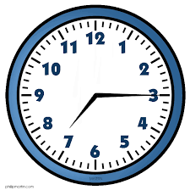  1. It’s ……………………. a.m |   2. I want some ………………………………...
  3. My birthday is in ……………………... | 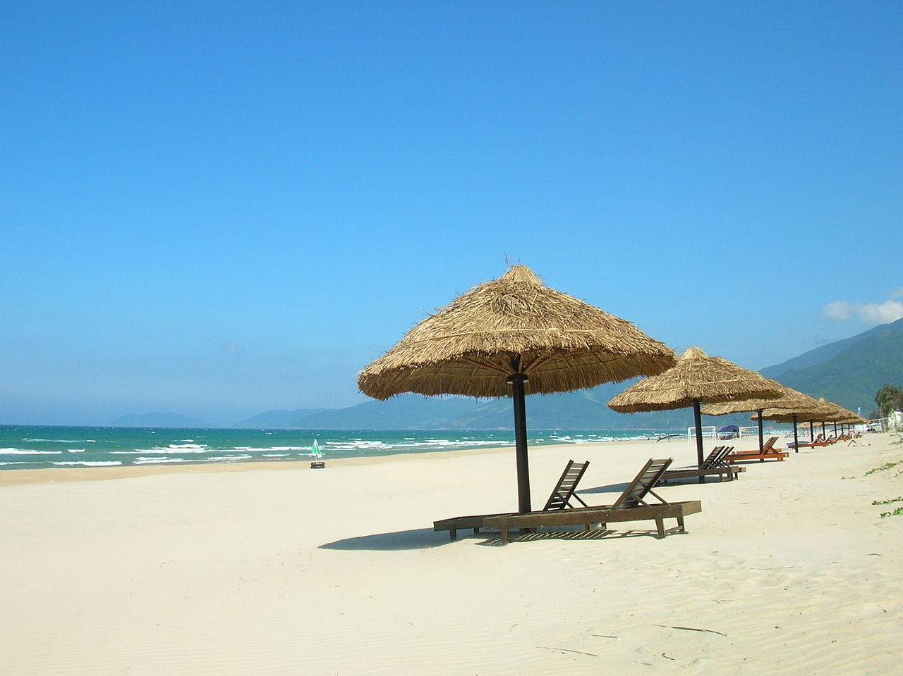  4.I was …………………… last weekend.

Question 9. Arrange the words to make sentences (1,5 pts)
- are/ from / where/ friends / your /? /
…………………………………………………………………………………
- do/ subjects/today/ what/ ? / have/ you/
…………………………………………………………………………………
- ride/ brother/ can/ can/ bike / swim / not/ a/ but/ he/My /. /
………………………………………………………………………………
- has / her/ today / science / sister /. /
…………………………………………………………………………………
- do/ Art / why/ like / you/? /
……………………………………………………………………………………

