UBND HUYỆN VĨNH BẢO  TRƯỜNG TH TAM ĐA | ĐỀ KHẢO SÁT CHẤT LƯỢNG HỌC KỲ 1  MÔN TIẾNG ANH LỚP 4  NĂM HỌC 2023 - 2024  (Thời gian làm bài: 40 phút)
Question 1: Listen and tick (1pt)
1.
 |  | 
a. | b. | c.
2.
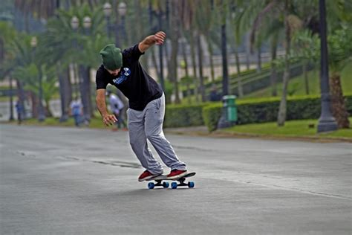 | 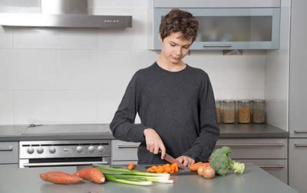 | 
a. | b. | c.
3.
 |  | 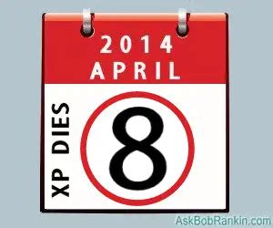
a. | b. | c.
4.
 |  | 
a. | b. | c.
Question 2 : Listen and number (1pt)
a. 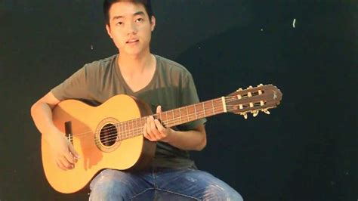 | b. 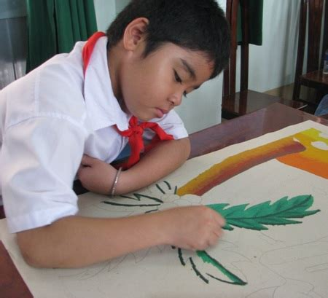 | c.  |  | d. 
Question 3. Listen and complete .(1 pt)
1. A: Is that your brother?
B: Yes, it is. My brother can (1)................
2. A: Can your sister (2)..............?
B: Yes, she can.
3. A: Can your sister (3)............... a bike?
B: No, she can’t, but she can swim.
4. A: Can your brother play badminton?
B: No, he can’t, but he can (4).................
Question 4: Odd one out (1,25 pt)
1. a. country  2. a. eight o'clock  3. a. Wednesday | b. Singapore  b. time  b. April | c. Thailand  c. 9 p.m  c. March
4. a. grapes b. juice c. jam
5. a. were b. are c. was
Question 5: Circle an underlined word that has a different pronunciation (1 pt)
1. a. America  2. a. music  3. a. why | b. March  b. Sunday  b. July | c. England  c. study  c. January
4. a. chicken b. school c. chips
Question 6. Choose the best answer (1.25pt)
1. ................day is it today?
a. What b. How c. When
2. My father can............badminton .
a. plays b. play c. playing
3.What's your.................subject?
a. like b. music c. favourite
4. She likes Art, Music............English.
a. or b. and c. but
5. I like English because I want to be .............English teacher.
a. an b. a c. the.
6. My mother does house work................Sundays.
a. in b. at c. on
Question 7. Read and tick True or False (1 pt)
Our sport day is in November. It is in the school playground. There are many pupils and teachers. We play different sports and games. The boys play badminton. The girls play football. The teachers play basketball. It is a lot of fun!
True False
1. The sports day is in November
2. The sports day is in the school gym.
3. The boys play badminton.
4. The girls play basketball.
Question 8. Look at the pictures and write (1 pt)
1.  | 2.  | 3.  | 4. 
A.What time is it?  B. It's........................ | A. When's your birthday?  B. It's in............................ | I was in................ | We were at the..........................
Question 9. Arrange the words to make sentences (1.5 pt)
1. are/you/Where/ from?
_________________________________________________________________________
2.brother/can/play/my/the/piano.
__________________________________________________________________________
3. do/you/like/Why/English? __________________________________________________________________________
4. I/because/like/Music/I/to/be/a/want/singer.
__________________________________________________________________________
5.I/can/can't/but/dance/sing/I. __________________________________________________________________________
6.do/not/I/I/am/like/Maths/because/not/at/good/it. __________________________________________________________________________
UBND HUYỆN VĨNH BẢO  TRƯỜNG TH TAM ĐA | ĐÁP ÁN ĐỀ KHẢO SÁT CHẤT LƯỢNG HỌC KỲ 1  MÔN TIẾNG ANH LỚP 4  NĂM HỌC 2023 - 2024  (Thời gian làm bài: 40 phút)
Question 1: Listen and tick (1pt)
1.c 2.a 3.c 4.b
Question 2 : Listen and number (1pt)
1.b 2. D 3.a 4.c
Question 3. Listen and complete .(1 pt)
1. cook 2. Roller 3. Ride 4. draw
Question 4: Odd one out (1,25 pt)
1.a 2.b 3.c 4.b 5.b

Question 5: Circle an underlined word that has a different pronunciation (1 pt)
1. b 2.a 3.a 4.b
Question 6. Choose the best answer (1.25pt)
1. a 2.b 3.c 4.b 5.a 6.c

Question 7. Read and tick True or False (1 pt)
1. T 2.F 3.T 4.F
Question 8. Look at the pictures and write (1 pt)
1. eight o'clock 2. February 3. Sydney 4. campsite
Question 9. Arrange the words to make sentences (1.5 pt)
1. Where are you from?
2. My brother can play the piano.
3. Why do you like English?
4. I like Music because I want to be a singer.
5. I can dance but I can't sing.
6. I do not like Maths because I am not good at it.

