UBND HUYỆN VĨNH BẢO  4  (Đề đề xuất) | ĐỀ KHẢO SÁT CHẤT LƯỢNG HỌC KỲ II  MÔN TIẾNG ANH LỚP 5  NĂM HỌC 2023- 2024  (Thời gian làm bài: 40 phút)
PART I: Listening
Question 1. Listen and number (1pt)
a. 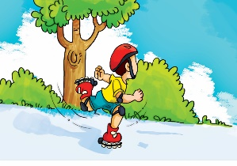 b.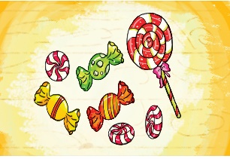 c.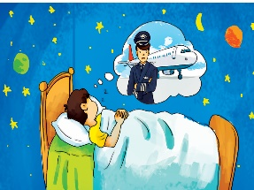 d. 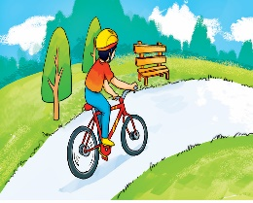

Question 2. Listen and tick.(1pt)
1.Da Lat is more ___________ than London.
a.interesting b.exciting c.peaceful
2.Ha Long City is more ___________ than Sydney.
a.beautiful b.wonderful c.exciting
3.New York City is more ___________ than Da Lat.
a.beautiful b.exciting c.expensive
4.London is more ___________ than Da Lat.
a.peaceful b.beautiful c.exciting
Question 3: Listen and complete with one word (1.0pt)

 | Health problems | should | shouldn't
1. Quan | stomach ache | go..............
2. Tony | fever |  | go...............
3. Phong | toothache |  | eat...............
4. Mrs Green | backache |  | carry............
Part II:Pronunciation
Question 4:Circle the word which has pronounced differently.(1,5pts)
- a. fever b.headache c.toothache d.health
- a.big b.small c.interesting d.quiet
- a.go a head b.stop c. turn left d.turn right
- a. pear b.apple c. orange d.lemonade
- a.windy b.rain c.cold d.cool
- a.visit b. temple c. museum d. pagoda
Part III:Reading
Question 5:Choose the best answer (1,5pts)
1. What do you .............. of Dam Sen Park?
a. do b.think c. have d. thing
2. Don't .............. your bike too fast!
a. rides b. rode c. riding d. ride
3. Why ...................I run down the stairs?- Because you may fall and break your arm.
a. don't b.does c. shouldn't d.should
4. Which place ..................you like to visit, Thu Le zoo or Ho guom Lake?
a. would b. could c. should d. will
5. You shouldn't .......................with matches because you may get a burn.
a. have b. plays c. play d. played
6. Ha Long is more beautiful ........................I expected.
a. then b.than c. thank d. more
Question 6: Choose the correct words and write them on the lines (1.25pt)
watch | free | twice | go | dance
Hoa: What do you do in your (1)….................….. time, Quan?
Quan: I often (2)……….............. sports programmes on TV. What about you, Hoa?
Hoa: I (3)…….............… to the music club with my friends.
Quan: How often do you go to the music club?
Hoa: (4)…….................…. a week.
Quan: What do you do there?
Hoa: I (5)…..................... and sing songs .
Question 7:Read and answer (1,25pt)
Hi, I'm Nam. My hobby is reading folk tales. Folk tales are usually short and interesting. They often give me one surprise after another. The characters are sometimes honest, sometimes greedy, sometimes wise, sometimes stupid. I like The Fox and the Crow very much. The fox was clever and the crow was not. The crow lost its delicious meat and the fox got it. I love folk tales very much because each of them gives me a lesson in life.
1. Nam.................reading folk tales.
a. lives b. likes c. liked d.like
2. The Fox was ......................... and the Crow was not.
a. honest b.stupid c.clever d. gentle
3. Folk tales are usually ................ and intereting.
a. long b. boring c. interesting d. short
4. The .........are somtimes honest, somtimes greedy, somtimes wise, sometimes stupid.
a. characters b. character c. people d. main
5. Nam likes folk tales very much because each of them..............him a lesson in life.
a. give b. gave c. gives d. giving
Part IV:Writing
Question 8:Arrange the words to make sentences.(1,5pts)
1. would / you / what / to / like / eat?
.................................................................................................................................
2. be / weather / what / tomorrow / will / like / the ?
..................................................................................................................................
3.much / drink / every day / how / you / do / milk?
..................................................................................................................................
4.are / two / the / Viet Nam / only / there / seasons / South / in /of..
...................................................................................................................................
5. juice / orange / good / or / for / apple / breakfast / is.
....................................................................................................................................
6. wet / it / hot / Can Tho / the / is / rainy / in / usually / season / and / in
....................................................................................................................................
Answer key:
Q1: 2 - 1 - 3 - 4
Q2: 1- c 2 - a 3 - b 4 -c
Q3: 1 - to the doctor 2 - to school 3 - ice cream 4 - heavy things
Q4: d - c - b - d - b - a
Q5: b - d - c - a - c - b
Q6: 1 - free 2 - watch 3 - go 4 - twice 5 - dance
Q7: b - c - d - a - c
Q8:
1. What would you like to eat?
2. What will the weather be like tomorrow?
3. How much milk do you drink every day?
4. There are only two seasons in the South of Viet Nam.
5. Apple or orange juice is good for breakfast.
6. It is usually hot and wet in the rainy season in Can Tho.

