UBND HUYỆN VĨNH BẢO  TRƯỜNG TH ………… | ĐỀ KHẢO SÁT CHẤT LƯỢNG HỌC KỲ II  MÔN TIẾNG ANH LỚP 5  NĂM HỌC 2023 - 2024  (Thời gian làm bài: 40 phút)
PART I: Listening
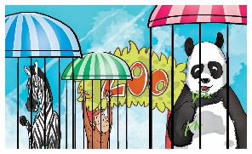
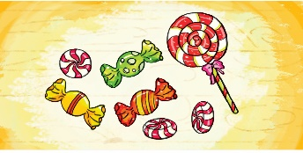
Question 1: Listen and number (1pt)
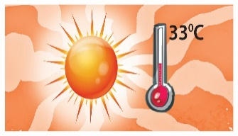
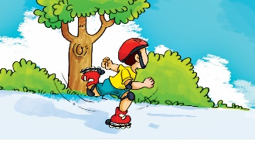
a b c. d.
Question 2: Listen and tick (1pt)
1..
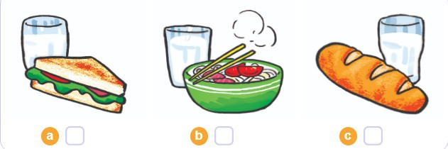 | 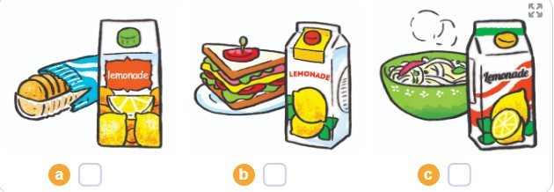  2...
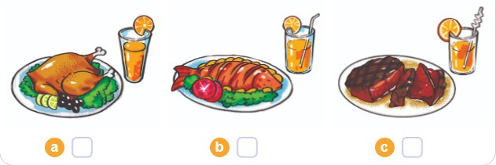  3.. | 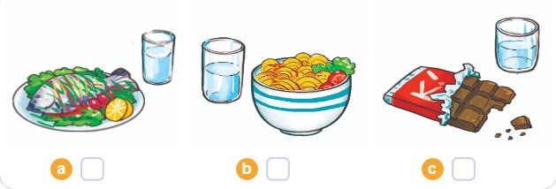  4..
Question 3: Listen and complete (1pt)
1. Trung would like to be an __________________.
2. Mai would like to look after________________.
3. Tony would like to ____________ a plane.
4. Tom would like to work on a _____________.
PART II: READING
Question 4: Odd one out ( 1,5pt)
1. a. toothache | b. earache | c. headache | d. dentist
2. a.sausage | b. water | c. lemonade | d. juice
3. a. cinema | b. museum | c. architect | d. supermarket
4. a. summer | b. warm | c. spring | d.winter
5. a. opposite | b. between | c. near | d. turn
6. a. intelligent | b. pogoda | c. kind | d. greedy
Question 5: Choose the best answer (1,5pts)
1.Why shouldn’t he climb the tree? -Because he may………………………….
a) break his arm b) cut himself c) get a burn d) break her leg
2. Don’t………………. the stove! You may get a burn.
a) play b) ride c) touch d) climb
3. What do you think…………Trang Tien Bridge? - It’s more beautiful than I expected.
a) of b) in c) for d) to
4. Which place would you like …………….? I’d like to visit the Museum of History.
a) visit b) to visiting c) visiting d) to visit
5. Tony shouldn’t ride too fast because he may fall off ……………. bike.
a) he b) his c) him d) her
6. She shouldn’t play with the knife because she may cut…………………………
a) yourself b) myself c) himself d) herself
Question 6: Read and complete with the words given (1,25pts)
watch free songs go twice
Linda: What do you do in your (1) ______________ time, Quan?
Quan: I often (2) ______________ sports programmes on TV. What about you, Linda?
Linda: I (3) _______________ to the music club with my friends.
Quan: How often do you go to the music club?
Linda: (4) ________________ a week.
Quan: What do you do there?
Linda: I dance and sing (5) ________________.
Question 7: Read and choose the best answer (1,25pts)
First, King Hung ordered Mai An Tiem and his family to live on an island. The island was very far away. Then one day, An Tiem found some black seeds and he grew them. The seeds gave watermelons. Next, An Tiem’s family exchanged the watermelons for food and drink. In the end, King Hung heard about the story and he let An Tiem and his family go back home.
- King Hung ordered Mai An Tiem’s family to live on…………….
a. a house b. a tent c. an island d. a street
2. An Tiem found some…………………….
a. black apples b. green seeds c. red nuts d. street
3. An Tiem grew the seeds and they gave……………………………
a. oranges b. watermelons c. lemons d. bananas
4. An Tiem’s family ………….the watermelons for food and drink.

a. changed b. threw c. exchanged d. gave
5. In the end, King Hung let An Tiem’s family _______________home.
a. live at b. go back c. turn around d. come
IV. WRITING
Question 8: Arrange the words to make sentences (1,25pt)
1. would / eat/ to /like/ you /what?
............................................................................................................................................
2. bottles / five / water / of / a / drink / day / I.
..............................................................................................................................................
3. will / what / like / weather / be / the / tomorrow?
...........................................................................................................................................
4. be/ cool / will / tomorrow / and / windy / it
............................................................................................................................................
5. are / seasons / there / in / four / country / my.
..............................................................................................................................................
6. you / how / eat / do /bowls / day / every / rice / many/ of?
..............................................................................................................................................

