ANH 5 – ĐỀ SỐ 2
PART I: LISTENING
Question 1: Listen and number. (1pt)
- 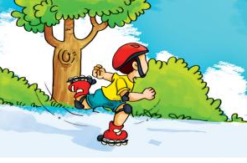 b. 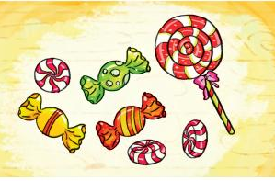 c. 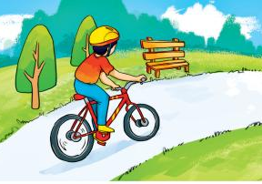 d. 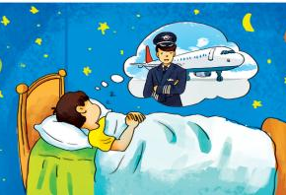

Question 2: Listen and tick the correct pictures. (1pt)
1. a. 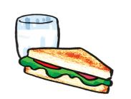 b. c.

2. a. 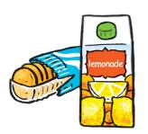 b. 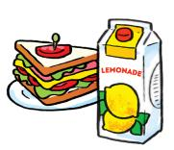 c. 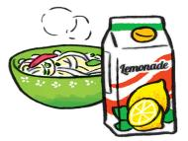

3. a. 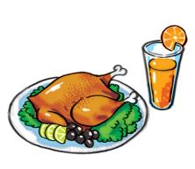 b. 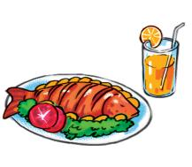 c. 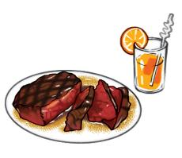

4. a. 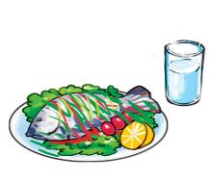 b. 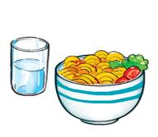 c. 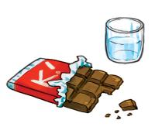

Question 3: Listen and complete. (1pt)
 | Health problem | Should | Shouldn’t
- Quan | stomach ache | -
- Tony | fever |  | -
- Phong | toothache |  | -
- Mrs Green | backache |  | -
PART II. READING
Question 4: Odd one out (1,5pts)
1. A. a nurse B. an artist C. future D. an architect
2. A. a headache B. a sore throat C. hospital D. an earache
3. A. between B. bus stop C. opposite D. next to
4. A. cinema B. climb C. design D. run
5. A. biscuits B. orange juice C. sausage D. apple
6. A. story B. intelligent C. kind D. greedy
Question 5: Choose the best answer. (1,5pts)
1. Don’t play with the knife! You may _______________
A. cut yourself B. get a burn C. break your leg
2. _______ shouldn’t I run down the stairs? - Because you may break your arm.
A. What B. Why C. Where
3. ________ place would you like to visit, a museum or a pagoda? - I’d like to visit a pagoda.
A. How B. Who C. Which
4. What do you think of Phu Quoc Island? - It’s more ___________ than I expected
A. visit B. go C. attractive
5. I’d like to visit Hoa Lu __________
A. Island B. Temple C. Zoo
6. What ______ you think of the Museum of History? - It’s more interesting than I expected.
A. does B. will C. do
Question 6: Read and complete. (1,25pts)

weather | watch | forecast | go | stormy
Mai: Let’s (1) _________ for a picnic tomorrow?
Tony: What will the (2) ___________ be like tomorrow?
Linda: Well, it will be cold and (3) ___________.
Mai: How do you know that?
Linda: I watched the weather (4) ___________ on TV.
Tony: We can't go for a picnic if it's stormy.
Mai: OK, let's stay home, eat popcorn and (5) _________ cartoons.
Tony and Linda: Great idea!
Question 7: Read and choose the best answer. (1,25pts)
Hi, I'm Mai. My hobby is reading folk tales. Folk tales are usually short and interesting. They often give me one surprise after another. The characters are sometimes honest, sometimes greedy, sometimes wise, sometimes stupid. I like The Fox and the Crow very much. The fox was clever and the crow was not. The crow lost its delicious meat and the fox got it. I love folk tales very much because each of them gives me a lesson in life.

1. What kinds of stories does Mai like reading?
A. fairy tale B. folk tale C. short story
2. What does she think of folk tales?
A. short and interesting B. funny C. long and boring
3. Mai’s favourite story is ………………….
A. The story of Mai An Tiem B. The story of Tam and Cam C. The Fox and The Crow
4. What does she think of The Fox?
A. clever B. kind C. hard-working
5. Why does she love folk tales? Because ……………..
A. it’s very long B. it’s very interesting C. it gives her a lesson in life
PART IV. WRITING
Question 8: Arrange the words to make sentences. (1,5pts)
1. to / What / you / like / eat / would / ? /
_________________________________________________________________________?
2. Vietnam/ four/ There/ in/ seasons/ are / . /
__________________________________________________________________________.
- favourite / My / is / summer / season / . /
__________________________________________________________________________.
4. will / It / in / Sa Pa / be / tomorrow / sunny / . /
__________________________________________________________________________
5. How / every / day / water / much / does / Mai / drink / ? /
__________________________________________________________________________?
6. I / four / of / eat / a / day / bowls / rice / . /
__________________________________________________________________________.

