ĐỀ 8
Part I . Listening .
Question 1 : : Listen and number-1đ
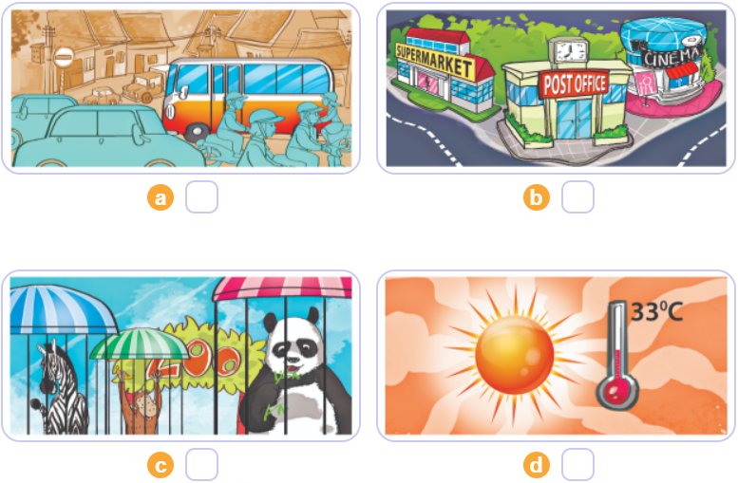

Question 2 :Listen and circle a,b or c
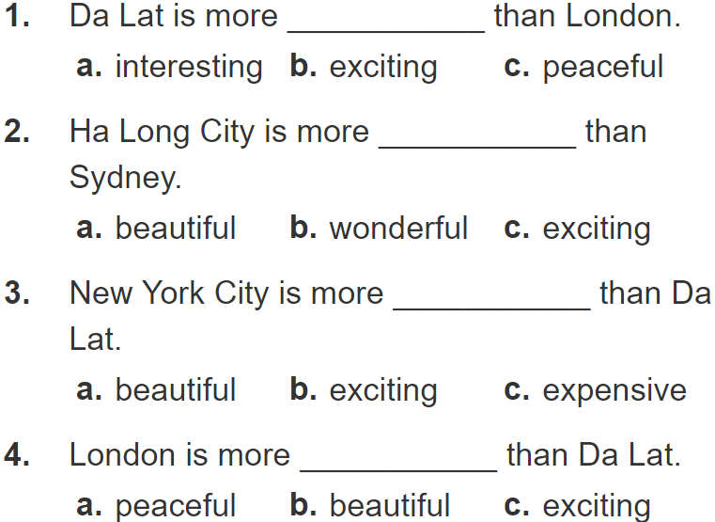
Question 3 : Listen and complete .
1,Trung would like to be……………
2,Mai would like to be ……………..
3,Tony would like to……………
4,Tom would like to……………..
Part II. Reading
Question 4 . Look and read:Odd one out
1,a,countryside b,expensive c,exciting
2,a,pagoda b,temple c,visit
3,a,summer b,spring c,cold
4,a,packet b,biscuit c,carton
5,a,bus stop b,opposite c,theatre
6,a,future b,writer c,architect
Question 5 .Look and read: Choose the best answer
1,Don’t touch the stove!>>You may…………………
a.get a burn b,fall c,cut yourself
2,Tom shouldn’t ride too fast because he may …………….
a.cut your self b,fall off your bike c,fall off his bike
3,…………….I play with the knife?Because you may cut yourself.
a.What b,Why shouldn’t c,Why
4,I’d like to visit a…………….BD
a.Thong Nhat Park b,Bai Dinh Pagoda c,Trang Tien Bridge
5,………………..would you like to visit the Museum of History or the City Theatre?
I’d like to visit the Museum of History.
a.How many b,Which place c,Which
6.It’s more beautiful …………I expected.
a.and b,but c,than
Question 6. Read and complete
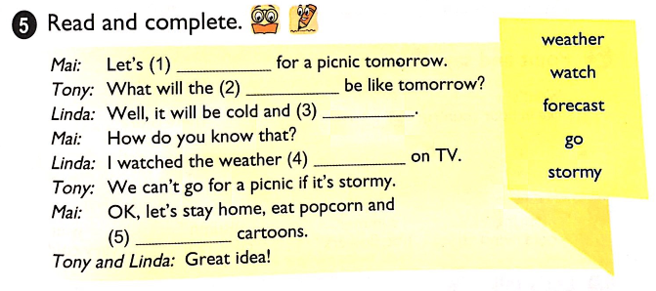
Part III. Writing.
Question 7:Look at the pictures and write the words
My name is Ha My. I don’t have to go to school on Saturday and Sunday. I often go to the town to visit my grandparents. The town where our grandparents live is not big but it’s pretty. There is a small cinema near my grandparents’ house. I often walk there to watch films with my friends. There is a bookshop near the cinema. We sometimes go to the bookshop to buy books and school things. The sweetshop is on the street, too. We can buy sweets easily. I think this area is a lovely place to live.
1. What does Ha My do at weekends?
A. She reads books
B. She visits her grandparents
C. She goes to the cinema
D. She plays games
2. How is the town?
A. It’s pretty
B. It’s large
C. It’s old
D. It’s modern
3. What is there near her grandparents’ house?
A. A small bank
B. A zoo
C. A library
D. A small cinema
4. Where is the bookshop?
A. It’s far from the cinema
B. It’s near the pharmacy
C. It’s near the cinema
D. It’s far from the pharmacy
5. What does she do at the bookshop?
A. She buys books
B. She buys school bag
C. She buys school things
D. She buys books and school things
Question 8, Arrange the words to make sentences.
1,will/the weather/tomorrow/like/What/be?
…………………………………………………………………………………………..
2,be/It /will/and/snowy/cold……………………………………………………………
3,usually/and/cool/foggy/It…………………………………………………………….
4,rice/you/do/every day/How much/eat?
………………………………………………………………………………………….
5,eggs/How many/eat/do/every day/you?
………………………………………………………………………………………....
6,please/I’d /a carton/like/apple juice/of.
………………………………………………………………………………………….

Đáp án và biểu điểm
Lớp 5
Part I. Listening
Question 1 : Listen and number. 4câu X 0,2 = 1 đ
a. 2 b. 1 c. 4 d. 3
Question 2 :. Listen and circle -4 câu x 0,25 = 1đ
1. c 2.a 3.b 4. c
Question 3. Listen and complete. 4 câu x 0,25 = 1đ
1,an architect 2,a nurse 3,fly a plane 4,work on farm
II,Reading
Question 4. 6câu x 0,25 = 1,5 đ
1,a 2,c 3,c 4,b 5,b 6,a
Question 5. 6 câu x 0,25 = 1,5 đ
1.a 2,c 3b 4,b 5,b 6c
Question 6. 5 câu x 0,25 = 1,25 đ
(1) go (2) weather (3) stormy (4) forecast (5) watch
Question 7. 5 câu x 0,25 = 1,25 đ
1,b 2,a 3,d 4,c 5,d
Question 8:6 câu x 0,25 = 1,5đ
1.What will the weather be like tomorrow?
2,It will be cold and snowy.
3,It usually cool and foggy.
4,How much rice do you eat every day?
5,How many eggs do you eat every day?
6,I’d like a carton of apple iuice,please.

