Grade 5
Period 65 Unit 10:Lesson 2 Activity 4-6
A. OBJECTIVES:
By the end of the lesson, Ss will be able to:
1. Knowledge:
- listen to and understand two communicative contexts in which characters ask and answer questions about what they did on their school trips and tick the correct pictures.
- complete two gapped exchanges with the help of picture cues.
- revise the target vocabulary items and structures through the game What did they do there?
- Vocabulary: Review
- Skills: speaking, listening, reading and writing.
2. Competences:
- Communication and collaboration: work in pairs and groups to complete the learning tasks.
- Self-control and independent learning: perform pronunciation and speaking tasks.
3. Attitude/ Qualities:
- Show their pride in famous places of Viet Nam.
- Show their love and interest in school trips.
B. TEACHING AIDS:
- Teacher: Teacher’s guide Pages 161, 162, 163; audio Tracks 102; website hoclieu.vn, posters, laptop, pictures, textbook, lesson plan, TV or projector.
- Students: Student’s book Page 71, notebooks, workbooks, school things.
C. PROCEDURES:
Teacher’s activities | Students’ activities
1.Warm- up and review: (5’)  Game: pass the bag  *Aims: to revise the learned words *Procedure:  - Put some flashcards about places and activities in a bag.  - Have ss sit in a circle.  - Ask ss to pass the bag around the circle while music plays.  - When the music stops, ask the pupil holding the bag to take out a flashcard in the bag and ask a question about the place and invite their friend to answer the question.  - Give stickers if they ask and answer the questions correctly.  - Say “Open your book page 71” and look at “Unit 10, Lesson 2(4,5,6)”.  2.Practice: (25’)  Activity 1. Listen and tick:  *Aims: Ss will be able to listen to and understand two communicative contexts in which characters ask and answer questions about what they did on their school trips and tick the correct pictures.  *Procedure:  - Draw ss’ attention to the pictures and identify the characters. 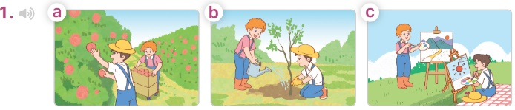  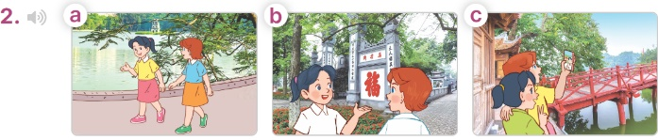  - T ask Ss to guess the answers.  + T writes Ss’guessing on the board.  - Listen to the tape:  + Play the recording  + Play the recording again for pupils to do the task.  + Play the recording a third time for pupils to check their answers.  - Get Ss to swap books with their partner, then check answers as a class.  + Write the answers on the board for Ss to correct their answers. Then checks Ss’ guessing.  - Have Ss to listen and repeat individually and in chorus  Key: 1. b 2. a  Activity 2. Read and complete  *Aims: Ss will be able to complete two gapped exchanges with the help of picture cues.  *Procedure:  - Have Ss look at the pictures and read the question and answer, and guess the missing word in the answer.  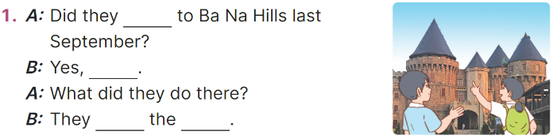  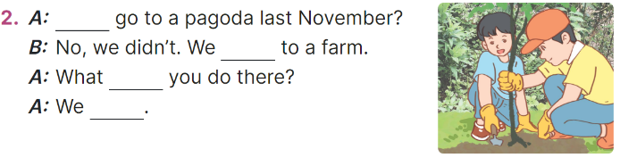  - T models: have Ss read the question and says what words are missing (go)  - Give Ss a time limit to read the gapped dialogues, look at the pictures and do the task independently.  - Get Ss to swap books with a partner and check their answers before checking as a class.  + Invite one student to write the answers on the board.  - Invite two pairs of Ss to act out the completed dialogues.  Key:  1. go; they did; visited; buildings  2. Did; went; did; planted trees  Activity 3. Let’s play  *Aims: Ss will be able to revise target vocabulary items and structures through the game What did they do there?  *Procedure:  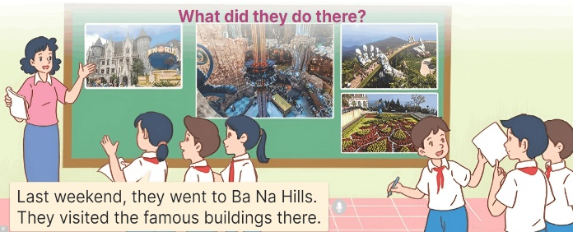  - Explain how the game is played.  - Hang four or six pictures on the board.  + Invite two groups of ss (three or four pupils each) to the front of the class.  + Give ss a time limit to look at the pictures, discuss and make notes of the place they went to and the activities they did.  - Let the group members take turns, pointing at the pictures and telling the class about the place they went to and the activities they did there.  - The group that presents more correct sentences in a short time will win the game.  3. Fun corner and wrap- up (5’)  Game: Throw the dice  - Prepare some pictures about famous places and number them from 1 to 6.  - Invite a volunteer to throw the dice and choose a picture to answer the teacher’s question about activities someone did on a school trip.  - Give stickers to ss if they have correct answers. | -Ss listen to the teacher  -Ss play the game  -Ss play the game  - Ss open their books  -Look at the pictures and say:  + Picture 1a: Bill and Minh picking apples on a farm  + Picture 1b: Bill and Minh planting trees on a farm  + Picture 1c: Bill and Minh painting pictures on a farm  + Picture 2a: Mai and Lucy walking around Hoan Kiem Lake  + Picture 2b: Mai and Lucy walking around Hoan Kiem Lake  + Picture 2c: Mai and Lucy walking around Hoan Kiem Lake  -Ss guess the answers  - Ss listen to the tape  - Ss listen again and do the task.  - Ss listen and check their answers  - Ss swap books with their partner, then check answers as a class and guessing  -Ss write the answer on the board  -Ss listen and repeat  -Ss look at the picture and say  -Ss follow the teacher  - Ss do the task independently.  - Ss swap books with a partner and check their answers.  - Ss write the answers on the board  - Pairs of Ss read the completed dialogues aloud  - Ss listen to the teacher’s explanation.  - Ss look at pictures, discuss and make notes  - The group members take turns, pointing at the pictures and telling the class  -Ss praise the winner  - Ss to the teacher  - Ss play the game  Ex:  1. Ba Na Hills 2. Suoi Tien Theme Park  3. Hoan Kiem lake 4. Thu Le Zoo  5. Opera House 6. Bai Dinh Pagoda

