Week 19
Period 55 UNIT 7: TELEVISION
Lesson 1: GETTING STARTED
Class | Date of teaching | Attendance
6A
6B
6C
I. OBJECTIVES:
By the end of the lesson, students are expected to achieve the following objectives:
1. Knowledge:
*Vocabulary:
- Understand the key words: talent, progamme, animated, prefer, character, educational.
* Pronunciation:
- Pronounce the key words correctly: talent, progamme, animated, prefer, character, educational.
* Grammar:
- Use Wh-question to make questions
- Use conjunctions to make clauses in compound sentences
2. Competencies:
a. General competencies:
- Form and improve such competencies as: teamwork, presentation, problem-solving skill.
b. Specific competencies:
- Read for specific information about television;
- Use the vocabulary and structures to talk about famous children’s programmes.
3. Qualities:
- To educate the proper attitute towards TV progammes and how to watch TV as well as how to use freetime usefully.
- Ss have the good attitude to working in groups, individual work, and pairwork, cooperative learning and working.
II. PREPARATIONS
Teacher: Text book, laptop, TV/ projector
Students: Text books, pencil, eraser
III. PROCEDURE

ACTIVITY 1: WARM-UP (5’- GW)
1. Aim:
- To create a friendly and atmosphere in the class before the lesson;
- To give T and Ss a chance to introduce themselves;
- To lead into the unit
2. Content:
- Have some warm-up activities to create a friendly and relaxed atmosphere to inspire Ss to warm up to the new class.
3. Products:
- Interest and concentration of Sts on the class activities.
- Introducing themselves to make more new friends.
4. Implementation:
- Teacher instructs
- Sts do as required
TEACHER AND STUDENTS' ACTIVITIES | CONTENTS
Step 1: Task delivering  - Chatting  Step 2: Task performance  Teacher draws a spider web on the board with the word Names of TV programmes in the middle.  Teacher asks students to give any words they know relating to the topic.  Students give their answers.  Teacher writes down the answers on the board.  Teacher draws students’ attention to the title of the conversation and the picture in the textbook and asks them questions.  Step 3: Report and discussion  - Sts work in group to introduce themselves  - Sts join in the discussion  Step 4: Judgement  - T summarizes the discussion and leads to Activity 2. | * Spider web completion:  Suggested answer:  Names of TV programmes  Game shows  ...  news  cartoon  comedy  Questions:  1. Do you like watching TV? Why/Why not?  2. How many hours a day do you watch TV?  3. What channel do you like best?  Suggested answers:  1. Yes, I do. I love watching TV because it’s fun.  2. I spend about thirty minutes/ one hour a day watching TV.  3. I like Cartoon Network/ VTV3/ VTV1.
ACTIVITY 2: KNOWLEDGE FORMATION (15'- IW, PW)
1. Aim:
To introduce the vocabulary appearing in the text.
To practice the targeted language and the background knowledge of the topic Television.
2. Content:
Learn some new words. Read the conversation and find out new words.
3. Products:
- Vocabulary about the topic
- Understanding the conversation; topic of the lesson, grammar points…
4. Implementation:
TEACHER AND STUDENTS' ACTIVITIES | CONTENTS
Step 1: Task delivering  - T sets the scene/ context for the listening and reading.  Step 2: Task performance  Vocabulary  Teacher introduces the vocabulary by:  + providing the pronunciation of the words.  + providing the definition of the words.  Task 1: Listen and read.  Teacher plays the recording, asks students to underline the words they have learned in the vocabulary part.  Teacher can play the recording more than once.  Students listen and read.  Teacher invites some pairs of students to read the dialogue aloud.  Step 3: Report and discussion  - Sts write down the new vocabulary  - T asks, Sts answer some more questions about the conversation  Step 4: Judgement  - T gives feedback on the reaction of Sts | 1. Vocabulary  - talent (for)(n)  - programme (n)  - animated (adj)  - prefer (v)  - character (n)  - educational (adj)  2. Practice  Task1: Listen and read.  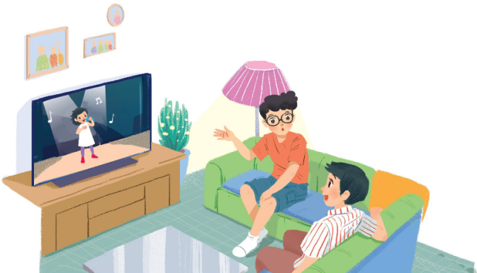
ACTIVITY 3: PRACTICE (20' – IW, PW)
1. Aim:
To help Ss understand the conversation.
To introduce some vocabulary related to the topic of the unit;
To introduce the grammar point of this unit: Wh-questions.
To give students a change to apply what they have learnt.
2. Content:
Listen and read the conversation. Choose the correct answer A, B, or C., matching.
Understand the conversation; grammar points; Wh-questions
3. Products:
Know more new words.
Understand the conversation; topic of the lesson
Vocab, grammar points…
4. Implementation:
TEACHER AND STUDENTS' ACTIVITIES | CONTENTS
Step 1: Task delivering  - T let Sts learn Task 2-3-4-5 – Getting Started - Unit 7  Step 2: Task performing  Task 2: Choose the correct answer A, B, or C.  Teacher asks students to read the questions carefully and choose the correct answers. Encourage them not to look back at the conversation first.  Teacher allows students to share their answers before discussing as a class.  Teacher checks their answers as a class and shows students where to find the answer in the conversation.  Task 3: Read the conversation again and match the names with suitable descriptions.  Teacher encourages students to do the task without looking back at the conversation. If they cannot, let them read the conversation again to find the answers.  Students work independently.  Teacher allows students to share their answers before discussing as a class.  Teacher checks the answers as a class and asks if any students have watched these programmes.  Task 4: Find and write the adjectives in the conversation which describe the programmes and characters.  Teacher guides students to look back at the conversation and find where the names of the programmes/ characters appear. The answers they need are around.  Students can work in pairs to complete this task.  Teacher calls a student to write the answers on the board.  Teacher asks if other students have other answers and checks as a class.  Task 5: Game – Find someone who…  Teacher gives each student a copy of the worksheet (Appendix 1).  Teacher goes through how to construct “Do you like…?” questions and short answers “Yes, I do. / No, I don’t.” with the class.  Step 3: Report and discussion  - Ss work independently  - Share the answers  Step 4: Judgement  - T gives feedback on the answers. | Task 2. Choose the correct answer A, B, or C.  Answer key:  - C  - A  - A  - A  Task 3: Read the conversation again and match the names with suitable descriptions.  Answer key:  1. c 2. a 3. e 4. b 5. d  Task 4: Find and write the adjectives in the conversation which describe the programmes and characters.  Answer key:  1. interesting  2. wonderful  3. clever  4. educational  Task 5: Game – Find someone who…  Example:  A: Do you like sports programmes on TV?  B: Yes, I do. / No, I don’t.
ACTIVITY 4: APPLICATION (5'- IW)
1. Aim:
To consolidate what students have learnt in the lesson.
To give Home assigment
2. Content:
To revise what Ss have learnt in the lesson.
Home assigment
3. Products:
Revision of the new words and knowledge
Take note Home assigment
4. Implementation:
TEACHER AND STUDENTS' ACTIVITIES | CONTENTS
Step 1: Task delivering (Home assignments)  - Ask one or two Ss to tell the class what they have learnt.  - Ask Ss to say aloud some words they remember from the lesson.  - Home assigment  Step 2: Task performance  - Teacher summarizes all opinions  - Teacher asks students to talk about what they have learnt in the lesson.  - T let Sts take note the home assigment  Step 3: Report and discussion  - T says something about the class time.  Step 4: Judgement  T gives feedback and requires Sts do homework. | * Home assigments:  - Learn the new words by heart  - Do the exercises B1,2 P4 in the work book.
IV. FEED-BACK:
………………………………………………………………………………………………………………
………………………………………………………………………………………………………………
………………………………………………………………………………………………………………
………………………………………………………………………………………………………………….……………………………………………………………………………………………………………

