Week 19
Period 56 UNIT 7: TELEVISION
Lesson 2: A CLOSER LOOK 1
Class | Date of teaching | Attendance
6A
6B
6C
I. OBJECTIVES
1. Knowledge:
* Vocabulary:
- Vocabulary: use the words related to the topic Television. Pronouncing the new words correctly: comedy, viewer, performer, popular, live, boring.
* Pronunciation:
To teach how to pronounce the sounds /θ/ and /ð/.
* Grammar:
- use Wh-question to make questions
- use conjuctions to connect caluses in compound sentences
2. Competencies:
a. General competencies:
- Form and improve such competencies as: teamwork, presentation, problem-solving skill, interpersonal skill, self-study skill,…
b. Specific competencies:
- By the end of the lesson students will be able to use the words related to the topic TV programmes and people. Ss know how to pronounce the sounds /θ/ and /ð/ correctly.
3. Qualities:
- To teach Ss the way to manage relaxing time.
- The awareness about importance of choosing the suitable Tv programmes.
II. PREPARATIONS
Teacher: Text book, laptop, TV/ projector
Students: Text books, pencil, eraser
III. PROCEDURE
ACTIVITY 1: WARM-UP (5’- GW)
1. Aim:
- To create a friendly and atmosphere in the class before the lesson;
- To introduce the topic.
- To lead in the topic of the unit.
2. Content:
- To have some warm-up activities to creat a friendly and relaxed atmostphere to inspire Ss to warm up to the subject and new lesson.
3. Products:
- Interest and concentration of Sts on the class activities.
- A friendly and relaxed atmostphere to the new lesson
- leading in the lesson about vocabulary and pronunciation.
4. Implementation:
- Teacher instructs
- Sts do as required
TEACHER AND STUDENTS' ACTIVITIES | CONTENTS
Step 1: Task delivering  - Chatting  Step 2: Task performance  + Greeting  * Matching  Teacher divides students into 4 groups and delivers a set of 6 pictures about famous TV programmes for children.  Teacher asks students to work in groups and match the names of TV programmes with suitable pictures.  Ss play in groups  The fastest group will say “Bingo” and stick their work on board.  Teacher checks the answers and gives a small gift to the winning group.  Teacher leads students into the lesson by telling them that “In today lesson, we are going to learn more words to talk about TV programmes and two sounds /θ/ and /ð/”.  Ss open their books and notebooks.  Step 3: Report and discussion  - Sts join in the discussion  Step 4: Judgement  - T summarizes the discussion and leads to Activity 2. | * SET OF PICTURES:  Talent shows    The Voice Kids  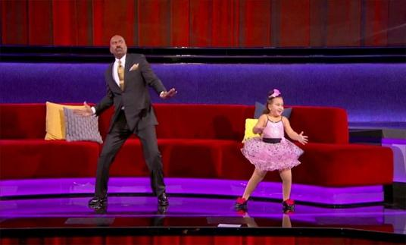  Little Big Shots  Educational shows  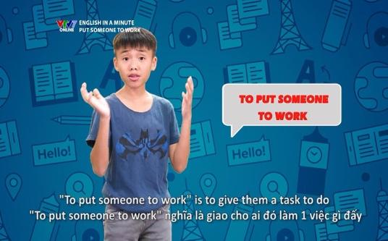  English in a Minute  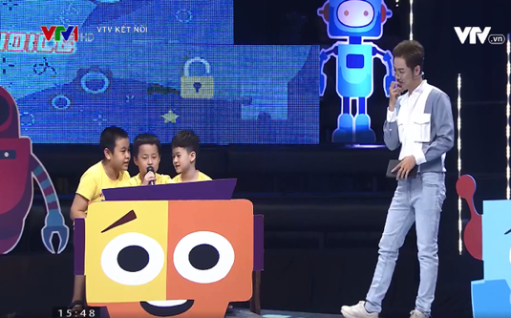  Alo English  Animated films    The Lion King    Moana
ACTIVITY 2: KNOWLEDGE FORMATION (15'- IW, PW)
1. Aim:
- To set the context for the introductory;
- To introduce the topic of the unit, the vocabulary, the sounds, and the grammar points to be learned.
- To teach students some nouns and adjectives to talk about TV programmes.
- To give students further practice on how to use some words/phrases in context.
2. Content:
- Learn some new words .
- vocabulary exercises
3. Products:
- Know more new words. Understanding the conversation; topic of the lesson, grammar points…
4. Implementation:
TEACHER AND STUDENTS' ACTIVITIES | CONTENTS
Step 1: Task delivering  - T sets the scene/ context for the listening and reading.  - T ask the whole class to do the Tasks in A Closer Look 1  Step 2: Task performance  1. Vocabulary  * Vocabulary  Teacher introduces the vocabulary by:  + providing the definition of the words;  + providing the pictures of the words.  * Practice  Task 1: Write the words/phrases in the box next to the definition.  Teacher asks students to read the words/phrases in the box first and see if they can remember some of them from the previous lesson.  Teacher reminds students of the words/phrases they do not remember.  Students read the definition and do the task.  Teacher calls some students to give their answers.  Teacher gives feedback and corrections (if necessary).  Task 2: Complete the sentences with the words/phrases in the box.  Teacher asks students to work in pairs and use the words/phrases in the box to complete the sentences.  Students work in pairs and do the task.  Teacher calls some pairs to share their answers with the whole class.  Teacher gives feedback and corrections (if necessary).  Step 3: Report and discussion  - Sts write down the new vocabulary  - T asks, Sts answer some more questions about the lesson  Step 4: Judgement  - T gives feedback on the reaction of Sts | 1. Vocabulary  * Vocabulary  - comedy (n)  - viewer (n)  - performer (n)  - popular (adj)  - live (adj)  - boring (adj)  * Practice  Task 1: Write the words/phrases in the box next to the definition.  Answer key:  - character  - educational programme  - comedy  - talent show  - viewer  Task 2: Complete the sentences with the words/phrases in the box.  Answer key:  - channel  - character  - animated films  - game show  - comedies  - viewers
ACTIVITY 3: PRACTICE (20' – IW, PW, GW)
1. Aim:
- To introduce some vocabulary related to the topic of the unit;
- To introduce the grammar point of this unit: the present simple.
- To teach students more adjectives to describe television programmes and characters.
- To help students identify and practise the /θ/ and /ð/ sounds.
- To help students pronounce the sounds /θ/ and /ð/ correctly in context.
2. Content:
- Understand the conversation; grammar points; Wh-questions
- To learn some more words indicating TV and TV programmes
- pronounce the sounds /θ/ and /ð/ correctly in context.
3. Products:
- To know about the topic of the lesson, Vocab, grammar points.
- Know more words about Television
- To give students a chance to apply what they have learnt.
4. Implementation:
TEACHER AND STUDENTS' ACTIVITIES | CONTENTS
Step 1: Task delivering  - T let Sts do exercises in A Closer Look 1 – Unit 7  Step 2: Task performing  Task 3: Complete the sentences with the adjectives in the box.  Teacher asks students to use the given adjectives to complete the sentences.  Students work independently.  Teacher allows students to share their answers before discussing as a class.  Teacher asks some students to share the answers and gives corrections (if necessary).  Task 4: Listen and repeat the words.  Teacher asks students to read the words first as they are familiar with students.  Teacher plays the recording and asks students to listen carefully and check if they have pronounced them correctly.  Teacher plays the recording again. Students listen and repeat.  Teacher calls some students to read the words individually.  Task 5: Tongue Twister.  Take turns to read the sentences quickly and correctly.  Teacher allows students to work in pairs and practice reading the tongue twister: slowly at first, then faster and faster.  Teacher asks some students to read the Tongue Twister aloud.  Game: Tongue Twister Race.  Teacher writes two tongue twisters on the board and first practices the tongue twister with the students.  Teacher lets students practice in pairs, then asks students to line up in two teams.  Teacher lets the first team say the first tongue twister, one student at a time and see how long it takes them to say the tongue twister correctly as a team. After, write the total time taken on the board.  Now the second team says the second tongue twister, one student at a time as quickly as they can.  The team who says the tongue twister quicker wins.  Step 3: Report and discussion  - Ss work independently  - Share the answers  Step 4: Judgement  - T gives feedback on the answers and studying attitucde of Sts in class. | Task 3: Complete the sentences with the adjectives in the box.  Answer key:  - popular  - boring  - cute  - live  - funny  - educational  Task 4: Listen and repeat the words.  Task 5: Tongue Twister.  * Tongue Twister sentences  1.The first thing that they think of is this.  2.These things finish sooner than you think.
ACTIVITY 4: APPLICATION (5'- IW)
1. Aim:
To help Ss revise all they have learnt.
To give Home assigment
2. Content:
Make sentences using the new words and structures
Home assigment
3. Products:
Know more some words about television.
Take note Home assigment
4. Implementation:
TEACHER AND STUDENTS' ACTIVITIES | CONTENTS
Step 1: Task delivering (Home assignments)  - Ask one or two Ss to tell the class what they have learnt.  - Ask Ss to say aloud some words they remember from the lesson and make sentences with them  - Home assignments.  Step 2: Task performance  - Teacher summarizes the lesson  - - T let Sts take note the home assignment  Step 3: Report and discussion  - T asks, Sts answer about school  Step 4: Judgement  T gives feedback and requires Sts do home assignments. | * Home assigments:  - Learn the new words by heart  - Do exercises A1,2/ P3 in workbook.
IV. FEED-BACK:
……………………………………………………………………………………………..…………
………………………………………………………………………………………………………..
……………………………………………………………………………………………….………..
…………………………………………………………………………………………………………
………………………………………………………………………………………………………..

