Unit 1: HOBBIES
Lesson 1: GETTING STARTED
My favourite hobby
Week 1- Period: 02
Class | Date of planning | Date of teaching | Attendance
7A
7B
I. OBJECTIVES
1. Knowledge:
*Vocabulary:
- Vocabulary to talk about hobbies: unusual, creativity, dollhouse, cardboard, glue, making models…
* Grammar: use the present simple tense
* Pronunciation: Pronouncing the new words correctly
2. Competencies:
a. General competencies:
- By the end of the lesson students will be able to know the form and use the present simple tense; Students can use Simple present tense to talk about likes and dislikes.
b. Specific competencies:
- Group work and independent working, pair work, linguistic competence, cooperative learning and communicative competence.
- Ability of using Present Simple Tense, some popular verbs of liking.
- Sts can talk about their hobbies fluently
3. Qualities:
- To teach Ss the love of English; the love of their new school.
- The awareness about importance of learning English.
- Ss have the good attitude to working in groups, individual work, and pairwork, cooperative learning and working.
II. PREPARATIONS
Teacher: Text book, laptop, loudspeaker, projector…
Students: Text books, studying equipment’s….
III. PROCEDURE
ACTIVITY 1: WARM-UP GW/PW/IW)
1. Aim:
- To activate Ss’ knowledge on the topic of the unit.
- To set the context for the listening and reading part.
-To enhance Ss’ skills of cooperating with team mates.
2. Content:
- Have some warm-up activities to create a friendly and relaxed atmosphere to inspire Ss to warm up to the new class.
3. Products:
- Interest and concentration of Sts on the class activities.
- Introducing themselves to make more new friends.
4. Implementation:
- Teacher instructs
- Sts do as required
TEACHER AND STUDENTS' ACTIVITIES | CONTENTS
Step 1: Task delivering  - Chatting  Step 2: Task performance  Asking question:  - T asks Ss about what they like doing for pleasure in their free time.  - Ss answer the question individually.  - T sets the context for the listening and reading text: Write the title on the board My favorite hobby.  - Ask Ss to guess what the conversation might be about.- Answer the teacher’s questions and requirements.  - Open their book and write.  + T Leads to the first unit of the new school year.  - Write the unit title Hobbies on the board and ask Ss guest what they are going to learn this unit …  - Ask Ss to open their book to page 6 and introduce what they are going to study…  Step 3: Report and discussion  - Sts work in group to introduce themselves  - Sts join in the discussion  Step 4: Judgement  - T summarizes the discussion and leads to Activity 2. | Chatting.  What do you like doing in your free time?  Do you like collecting dolls?  Do you like collecting glass bottles?  Do you enjoy mountain climbing?
ACTIVITY 2: KNOWLEDGE FORMATION (15')
1. Aim:
- To set the context for the introductory;
- To introduce the topic of the unit, the vocabulary, the sounds, and the grammar points to be learned.
- To help Ss well-prepared for the listening and reading tasks.
2. Content:
Learn some new words. Read the conversation and find out new words.
3. Products:
- Vocabulary about the topic
- Understanding the conversation; topic of the lesson, grammar points…
4. Implementation:
TEACHER AND STUDENTS' ACTIVITIES | CONTENTS
Step 1: Task delivering  - T sets the scene/ context for the listening and reading.  Step 2: Task performance  *Teach vocabulary:  + Teacher uses different techniques to teach vocab (situation, regalia, translation.)  + Teacher introduces the vocabulary.  + Teacher explains the meaning of the new vocabulary by pictures.  + Teacher checks students’ understanding with the “Rub out and remember” technique.  + Teacher checks students’ pronunciation and gives feedback. Teacher reveals that these four words will appear in the reading text and asks students to open their textbook to discover further  + Follow the seven steps of teaching vocab.  + Check vocabulary.  + Sts Take note  - Call on some groups of Ss to read the conversation aloud.  TASK 1:LISTEN AND READ.(Ex 1, p. 8)  - Teacher asks Ss to look at the pictures in the book and answer the questions:  - Ss answer the questions in pairs.  - Teacher plays the recording twice. Ss listen and read.  - Teacher checks Ss’ prediction. T calls 3 Ss to read the conversation aloud.  - Teacher check students’ pronunciation ad give feedback.  Step 3: Report and discussion  - Sts write down the new vocabulary  - T asks, Sts answer some more questions about the conversation  Step 4: Judgement  - T gives feedback on the reaction of Sts | * Vocabulary  1. unusual (adj)  2. creativity (n)  3. dollhouse (n)  4. cardboard (n)  5. glue (n)  6. making models  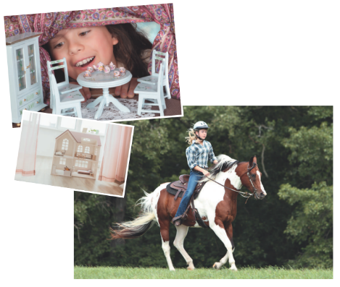  + What can you see in each picture?  + What may the hobby be?
ACTIVITY 3: PRACTICE (20' - GW/PM/IM)
1. Aim:
-To have Ss get specific information of the text.
- To introduce the grammar point of this unit: the present simple.
- To introduce some vocabulary items related to hobbies.
-To help Ss practise using the vocabulary items related to hobbies.
- To learn some more words about hobbies
2. Content:
Listen and read the conversation. True/ false activity, filling in the gaps.
Understand the conversation; grammar points; present simple tense
3. Products:
Know more new words.
Understand the conversation; topic of the lesson
Vocab, grammar points…
4. Implementation:
TEACHER AND STUDENTS' ACTIVITIES | CONTENTS
Step 1: Task delivering  - T let Sts learn Task 2 – Getting Started - Unit 1  Step 2: Task performing  TASK 2: READ THE CONVERSATION AGAIN AND WRITE TRUE (T) OR FALSE (F). (Ex 2, p.9)  - Teacher tells Ss to read the conversation again and work independently to find the answers. Remind Ss to underline the information and correct the false statements.  - Ss work independently to find the answers.  - Teacher has Ss compare the answers in pairs before checking with the whole class.  - Teacher checks the answers as a class and gives feedback.  TASK 3: WRITE THE WORDS AND PHRASES FROM THE BOX UNDER THE CORRECT PICTURES. THEN LISTEN, CHECK, AND REPEAT.  (Ex 3, p. 9)  -T asks Ss to name the pictures.  -T has Ss work individually to match the words and phrases in the box with the pictures. Have them compare their answers with a partner. Then ask for Ss’ answers. Quickly write their answers on the board without confirming the correct answers.  -T has Ss listen to the recording, check their answers, and repeat the words / phrases. Ask Ss to look at the answers on the board and say if they are right or wrong. Confirm the correct answers.  -Teacher checks the answers as a class and gives feedback.  TASK 4: WORK IN PAIRS. WRITE THE HOBBIES FROM 3 IN THE SUITABLE COLUMNS. (Ex 4, p.9)  - Have Ss work in pairs and complete the table.  - Ss work in pairs and complete the table.  - Teacher allows students to share answers before discussing as a class.  - Write their answers on the board. Have Ss add more words to the table.  TASK 5: GAME: FIND SOMEONE WHO… (Ex 5, p.9)  Work in groups. Ask as many classmates as you can about which hobbies they like. Use the question ‘Do you like…?’.  In the table below, write your classmates’ names beside the activities they like.  - T lets Ss to move around the class to ask their classmates about their favourite hobbies in 3-5 minutes.  - Ss write the results into the table.  - Then T asks some Ss to report their results. Whoever has the most names wins.  - Teacher can ask students to read aloud the full sentences and correct their pronunciation if needed.  Step 3: Report and discussion  - Ss work independently  - Share the answers  Step 4: Judgement  - T gives feedback on the answers. | Answer key:  1. F (She made it herself.)  2. T  3. T  4. T  5. F (Her lesson starts at 8 a.m.)  Answer keys:  1. making models  2. riding a horse  3. collecting coins  4. gardening  5. building dollhouses  6. collecting teddy bears  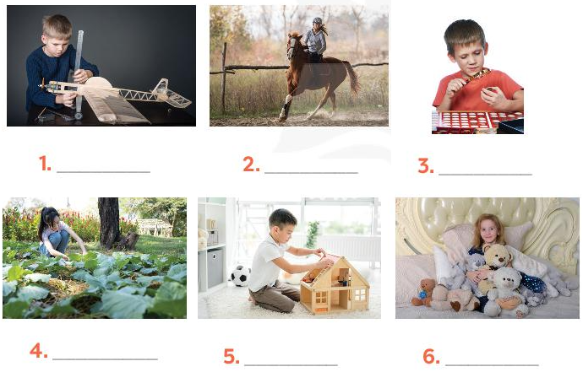  Answer key:  + doing things: riding a horse, gardening (others: travelling, skiing, doing yoga, etc.)  + making things: making models, building dollhouses (others: painting, making pottery, etc.)  + collecting things: collecting coins, collecting teddy bears (others: collecting toys, collecting books,etc.)
ACTIVITY 4: APPLICATION (5' )
1. Aim:
To consolidate what Ss have learnt in the lesson.
To review the lesson and prepare for the next lesson.
To give Home assigment
2. Content:
Home assigment
3. Products:
Know more some words about hobbies
Take note Home assigment
4. Implementation:
TEACHER AND STUDENTS' ACTIVITIES | CONTENTS
Step 1: Task delivering (Home assignment)  - Ask one or two Ss to tell the class what they have learnt.  - Ask Ss to say aloud some words they remember from the lesson.  - Home assigment  Step 2: Task performance  -T asks Ss to talk about what they have learnt in the lesson.  - An overview about the topic Hobbies  - Vocabulary to talk about hobbies  - T lets Sts take note the homework  Step 3: Report and discussion  - T says something about the class time.  -Step 4: Judgement  T gives feedback and requires Sts do homework. | * Home assigment:  - Read again the conversation on page 6.  - Do more exercises in workbook.  - Name a list of cheap hobbies, expensive hobbies, easy and difficult hobbies.
IV. FEED-BACK:
………………………………………………………………………………………………
………………………………………………………………………………………………
……………………………………………………………………………………………….
……………………………………………………………………………………………….
………………………………………………………………………………………………..

