Week 24
Period: 70
Class | Date of teaching | Attendance
7A | 27. 2. 2023
7B | 27. 2. 2023
7C | 27. 2. 2023
7D | 27. 2. 2023

UNIT 9: FESTIVALS AROUND THE WORLD
Lesson 2: A closer look 1
I. OBJECTIVES:
By the end of the lesson, students will be able to:
- Knowledge:
Vocabulary:
- Revise and know the lexical items related to the topic “Festivals around the world” , types of festivals and festival activities.
Cannes Film Festival, Mid-Autumn Festival, Thanksgiving, Easter, carve, perform
- Use adverbial phrases correctly and appropriately.
Pronunciation: pronounce two-syllable words with correct stress.
2. Competences:
- Listening and reading, reading and answering about some festivals around the world.
- Develop communication skills and creativity
- Be collaborative and supportive in pairwork , teamwork. Independent working, linguistic competence, cooperative learning and communicative competence.
- Actively join in class activities
3. Qualities:
- Ss know more festivals around the words and choosing the festivals that they like.
- Develop self-study skills.
- Have positive attitude in English language learning so that they actively participate in all classroom activities.
II. TEACHING AIDS
1. Teacher: Text books, pictures, planning, …
- Grade 7 textbook, Unit 9, A closer look 1
- Smart TV/Pictures, sets of word cards
- Sachmem.vn
2. Students: Text books, notebooks, posters, ….
III. PROCEDURES:
1.Warm-up (5’)
* Aim:
- Review the previous lesson and activate students’ knowledge.
- Activate students’ knowledge on the topic of the unit.
- Set the context for the listening and reading part.
* Content: Game: Kim’s game (about festivals around the world)
* Products: Ss write words exactly on the board.
Teacher’s and Ss’activities | Content
* T asks Ss to look at the picture on page 93 in 20 seconds and try to write the festivals they know as many words as possible.  - Teacher divides the class into two teams.  - Ss go to the board and write the words  - Teacher gets feedback -> Today we are going to learn some festivals around the world. | * Kim's game:  - Easter  - Folk dance  - Firework play  - Mid – Autumn festival  - Thanksgiving  - Christmas  - Tet  …..
2. Presentation (5’)
* Aim: Enrich students’ vocabulary to talk about types of festivals and festival activities.
* Content: Vocabulary about types of festivals and festival activities
* Products: Read and understand the meaning of words
Teacher’s and Ss’activities |  | Content
Pre teach vocabulary  - Teacher use different techniques to teach vocab (pictures, situation, realia)  - Follow the seven steps of teaching vacab.  - Repeat in chorus and individually  - Copy all the words  * Checking vocab: < Matching> |  | * Vocabulary  - Cannes Film Festival (n) : Liên hoan phim Cannes  - Mid-Autumn Festival (n) : Tết trung thu  - Thanksgiving (n) : Lễ tạ ơn  - Easter (n) : Lễ Phục sinh  - carve (v) : Chạm, khắc  - perform (v) biểu diễn
3. Practice (27’)
* Aim:
- Revise / introduce the types of festivals and festival activities.
- combine a verb and a noun to talk about festival activities.
- Pronounce two-syllable words with correct stress.
* Content:
- Write under each picture a festival name from the box.
- Complete the table below with the phrases from the box.
- Fill in each blank with a word or phrase from the box.
- Listen and repeat. Then underline the stressed syllable in each word.
- Listen and repeat the sentences. Underline the stressed syllables in the bold words.
* Products:
Students read vocabularies exactly aloud.
Students pronounce / two-syllable words with correct stress.
Teacher’s and Ss’activities |  | Content
Task 1: (5’) Write under each picture a festival name from the box.  (T-Ss)  - - Teacher has students to look at the pictures and asks them if they know the names of the festivals.  - - Teacher gets students to do the exercise in individuals.  - - Ask them to share their answers in pairs before checking the answers as a class.  - - Teacher then encourages students to explain their answers. Correct if necessary. |  | Task 1: Write under each picture a festival name from the box.  Answer key:  1. Halloween  2. Christmas  3. Mid-Autumn Festival  4. Cannes Film Festival  5. Easter  6. Thanksgiving
Task 2: (5’) Complete the table below with the phrases from the box (p.94).  (T - Ss, Ss – Ss)  - Teacher tells Ss that people celebrate festivals with different food and activities.  - - Teacher asks them to do the task individually.  - Teacher asks students to share their answers in pairs before checking the answers as a class.  - - Teacher then encourages students to explain their answers. Correct if necessary. |  | Task 2: Complete the table below with the phrases from the box (p.94).  *Answer key:  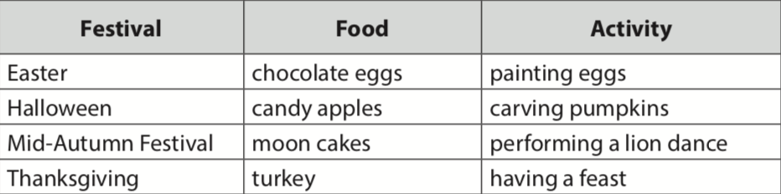
Task 3: (5’) Fill in each blank with a word or phrase from the box (p.94). (T-Ss, Ss-Ss)  - - Teacher asks Ss to work in pairs to complete the sentences with the words/ phrases given.  - - Ss work in pairs.  - - Teacher allows students to cross check first.  - - Teacher invites some pairs to share their answers and gives feedback. |  | Task 3: Fill in each blank with a word or phrase from the box (p.94).  Answer key:  1. Christmas  2. painting eggs  3. candy apples  4. Cannes Film Festival  5. Mid-Autumn Festival  6. turkey
Task 4:(7’)
* Aim: Teach Ss how to pronounce the stress in two-syllable words and practise pronouncing these two-syllable words in correct stress.
* Content: Understand and how to pronounce the stress in two-syllable words.
* Products: Students pronounce the stress in two-syllable words exactly .
Teacher’s and Ss’ activities |  | Content
* Presentation  - Teacher helps Ss to understand what a syllable is. Explain to them that a syllable is a unit of pronunciation having one vowel sound, with or without surrounding consonants, forming the whole part of a word. Give some examples of one-, two- and three-syllable words.  - Tell them that in this lesson, they just focus on two-syllable words and their common stress pattern. Have Ss name some more two-syllable words.  Task 4: Listen and repeat. Then underline the stressed syllable in each word. (p.94). (T-Ss, Ss-Ss)  - Teacher has Ss listen and repeat out the words in the table. Play the recording again for them to underline the stressed syllable in each word.  - Teacher allows students to cross check first.  - - Teacher lets Ss share their answer and gives feedback. Ask Ss if they recognize any rules related to stress in two-syllable words. Share with them the most common rules. |  | * PRONUNCIATION  Stress in two-syllable words  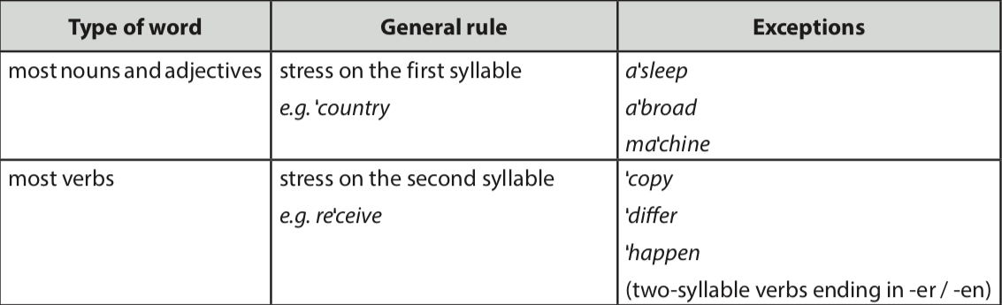  Task 4: Listen and repeat. Then underline the stressed syllable in each word. (p.94).  Key:  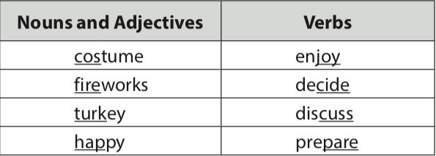
Task 5: (5’) Listen and repeat the sentences. Underline the stressed syllables in the bold words (p.94).  T-Ss, Ss - Ss  - - Teacher has Ss read quickly the sentences and plays the recording. Ask them to pay attention to the bold words and underline the stressed syllables.  - - Students practice in pairs or in groups.  - - Teacher goes around to offer help or correct pronunciation, if necessary.  - - Teacher calls some students to say the sentences in front of the class. Check their pronunciation if necessary. |  | Task 5: Listen and repeat the sentences. Underline the stressed syllables in the bold words (p.94).  Keys:  - Attend  - Party  - Dancers  - Perform  - Christmas  - Presents  - Flower  - Parents  - Clever  - Patient
4. Production (6’)
* Aim:
- To test students' quick reaction to the targeted sounds
- To give students a chance to apply what they have learnt.
* Content: Game: “Up and down”
* Products: Students read aloud their words.
Teacher’s and Ss’ activities |  | Content
- Teacher explains the rules:  Teacher says 1-15 words containing two-syllable words. Students stand up for the ones with first main stress pattern, sit down for the second main stress pattern.  - Students play the game in teams.  - Teacher helps students in the game.  - Teacher gives feedback. |  | * Game: “ Up and down”  Ex: First main stress pattern:  - Custome  - Fireworks  - Turkey  - Happy  Second main stress pattern:  - Enjoy  - Decide  - Discuss
5. Homework (2’)
Teacher’s and Ss’ activities |  | Content
- T reminds Ss to do homework and prepare the new lesson. |  | - Learn by heart all the new words.  - Rewrite the sentences into notebooks.  - Find 4 two – syllable words and pronounce them in correct stress.  - Prepare Lesson 3 ( A closer look 2).
IV. FEED-BACK:
……………………………………………………………………………………
…………………………………………………………………………………....
……………………………………………………………………………………
……………………………………………………………………………………
……………………………………………………………………………………

