Week 29
Period: 88
Class | Date of teaching | Attendance
9A | 11/04/2023
9B | 11/04/2023

UNIT 11 : CHANGING ROLES IN SOCIETYLesson 2: A closer look 1

I./. OBJECTIVE: By the end of the lesson, students can use the lexical items related to changing roles in society.
1.Knowledge: - Vocabulary: use the lexical items related to changing roles in society.
- Pronunciation: identify the rising or falling tones in agreement and disagreement sentences correctly
2. Skills: - Practicing skills.
3.Attitudes: - SS are encouraged to love exploring the changing roles in society.
4.Competences:
- Co-operation: work in pairs, groups
- Self- study: work individually.
- improve their pronunciation..
II./.PREPARATION:
1.Teacher: book, planning, picture, laptop, projector
2.Students: books, notebooks
III. /. ANTICIPATED PROBLEMS AND SOLUTIONS.
Ss may have difficulties in doiing the tasks required, so T should be willing to help them.
IV./.PROCEDURE:30 minutes

T AND SS’ ACTIVITIES | MAIN CONTENTS
Warm- up: ( 3 minutes) Chatting  chatting to ss | UNIT 11 : CHANGING ROLES IN SOCIETY  Lesson 2: A closer look 1  Warm- up: Chatting
Activity 1: Teaching vocabulary ( 20 minutes)
Aims: Ss know how to form a noun, noun (person) and verbs and complete the exercises  Process:  Ex1: Complete the table with appropriate words.  Ask Ss to complete the table individually or in pairs. Then allow them to share their answers with a partner/ another pair. Check as a class.  Note: Ss might have difficulty with the forms of the words. T may allow them to use a dictionary.  Ex2: Use the words in the table in 1 to complete the sentences  This is quite a demanding exercise. Let Ss work in pairs. Ask them to determine the form of the word which is missing from each sentence first. Then ask them to read the whole sentence carefully and determine the meaning of the missing word. After that, they choose the correct word. Allow Ss to share their answers with other pairs. Check the answers as a class.  Ex3: Choose the correct answer A, B or C which is closest in meaning to the underlined word/ phrase in the sentences.  Have Ss work individually. Ask Ss to use the context of each sentence as guidance. Once they have completed the exercise, they can exchange their answers with a partner. Check the answers as a class.  To make sure that Ss understand the meaning of these words/phrases, ask for volunteers, or select Ss, to make new sentences using them. Or T can check by asking questions like:  ‘Can you name some countries which you think are male-dominated?’  ‘Do you always study in a traditional classroom?’  Ex4. Complete the sentences with phrases formed with ‘sense of’.  Before Ss do the task, ask them to read the REMEMBER! box. Ask Ss to read the phrases in the table. Make sure they understand the meanings of the phrases by giving equivalents in Vietnamese. Have Ss then complete all the sentences. Confirm the correct answers as a class.  Conclusion: Students can complete the exercises well |  | I. Vocabulary  Ex1: Complete the table with appropriate words.  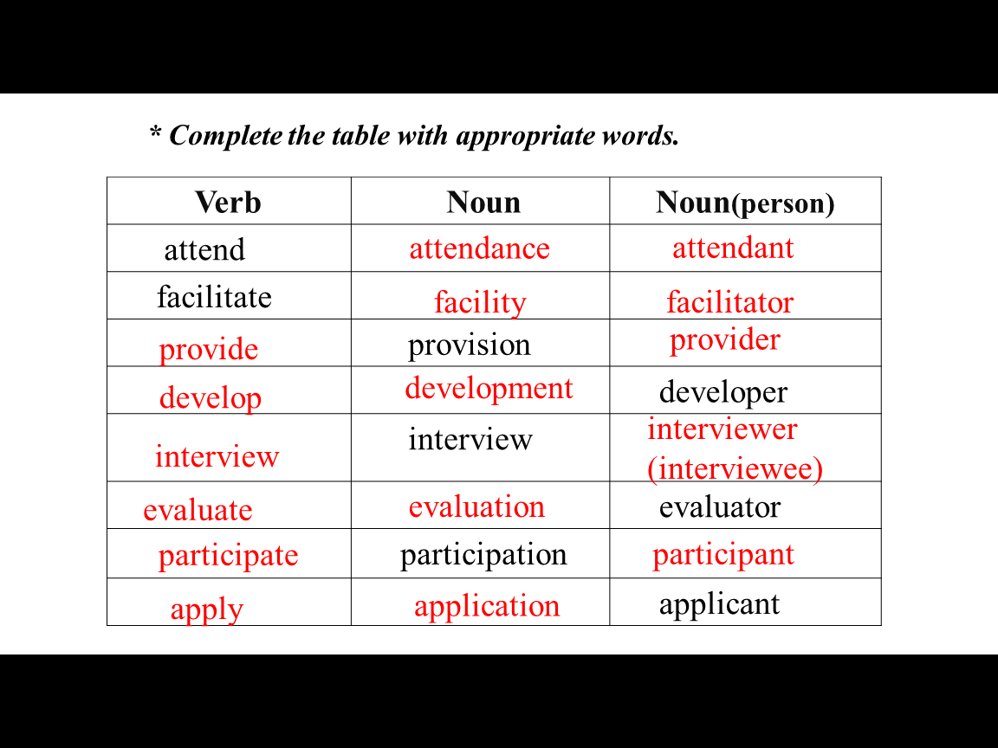  Ex2: Use the words in the table in 1 to complete the sentences  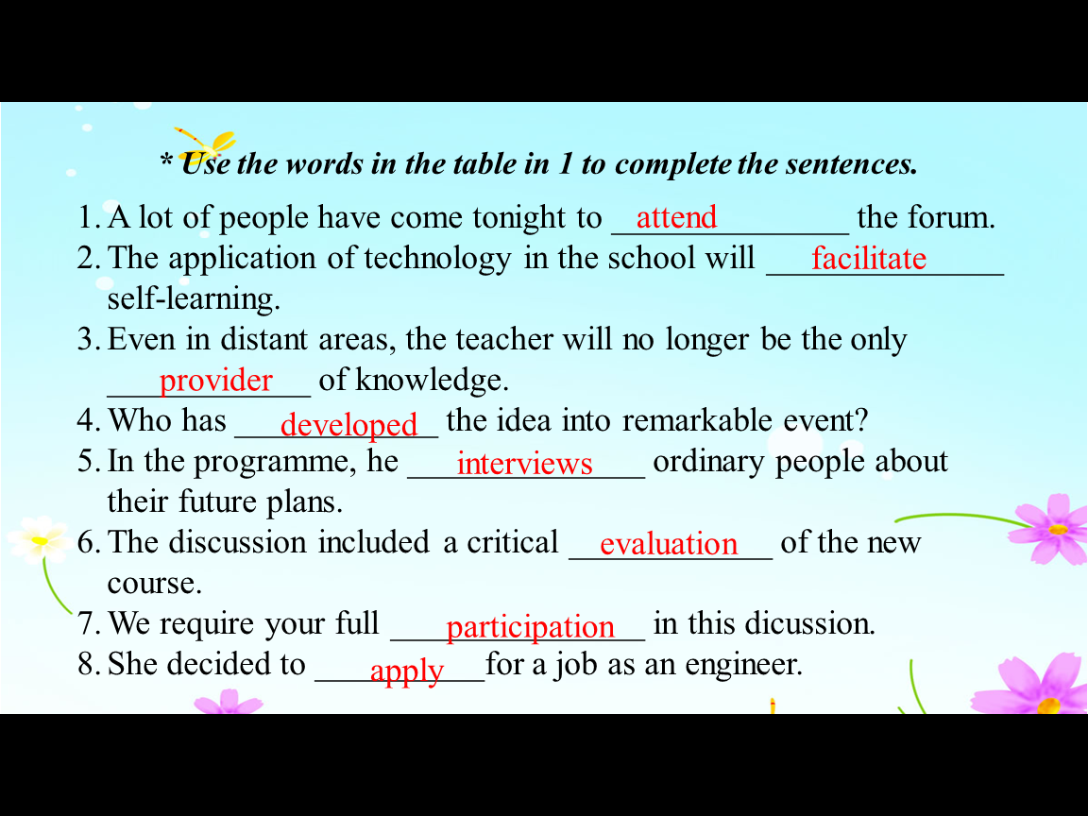  Ex3: Choose the correct answer A, B or C which is closest in meaning to the underlined word/ phrase in the sentences.  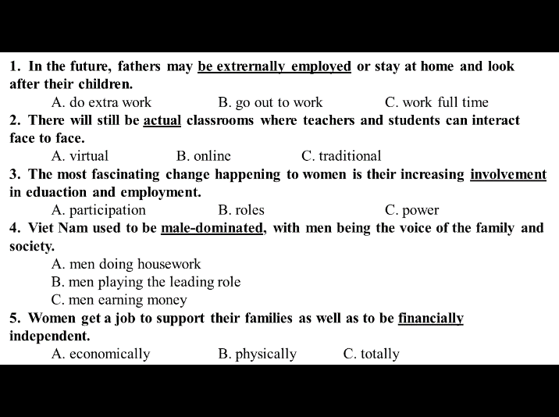  Key:  1. B 2. C 3. A 4. B 5. A  Ex4. Complete the sentences with phrases formed with ‘sense of’.  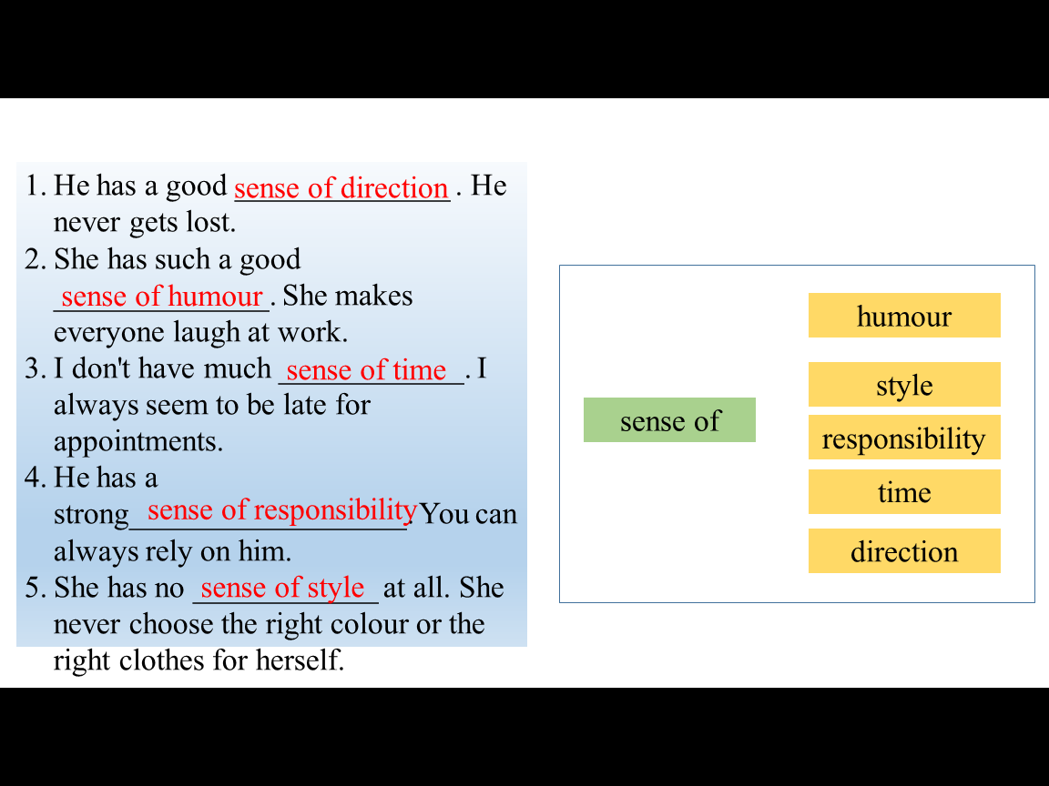
Activity 2: Teaching pronunciation ( 10 minutes)
*Aims: Help SS know the rising or falling tones in agreement and disagreement sentences and say the sentences correctly  * Process:  Ex5. Listen carefully and tick the correct box. Then listen agin and repeat.  Have Ss listen to the recording and tick the correct column for each question. Then let them listen again and hav them repeat the sentences with a focus on the tones  Ex6. Mark Mike’s sentences with falling (agreeing) or rising (disagreeing) arrows. Then listen and check.  Have Ss work individually. Ask them to read the conversation carefully and refer to the REMEMBER! box as they do the exercise. Then play the recording. Ss listen, check, and say the sentences. Call on some Ss to say the sentences individually  *Conclusion:  Almost all the students can know the rising or falling tones in agreement and disagreement sentences and say the sentences correctly. |  | II. Pronunciation  Agreeing or disagreeing tones.  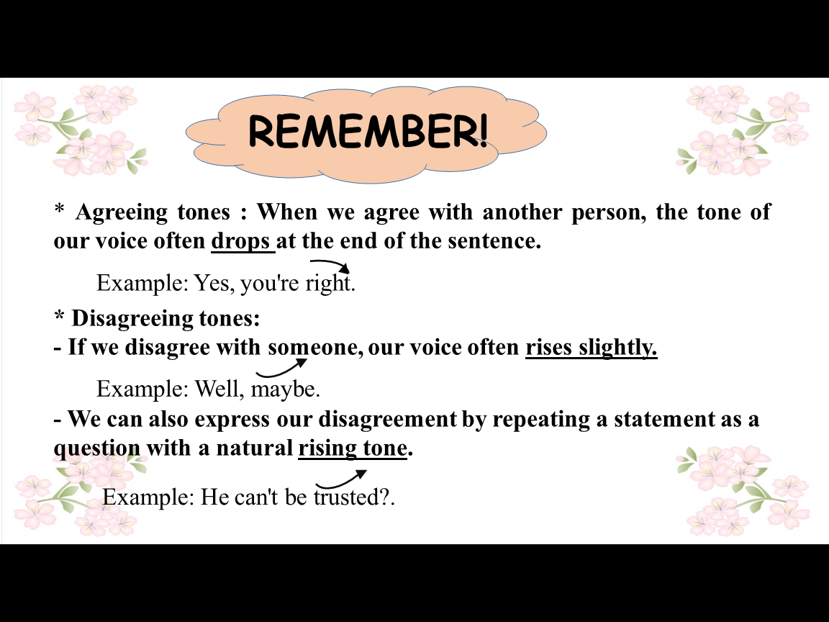  Ex5. Listen carefully and tick the correct box. Then listen agin and repeat.  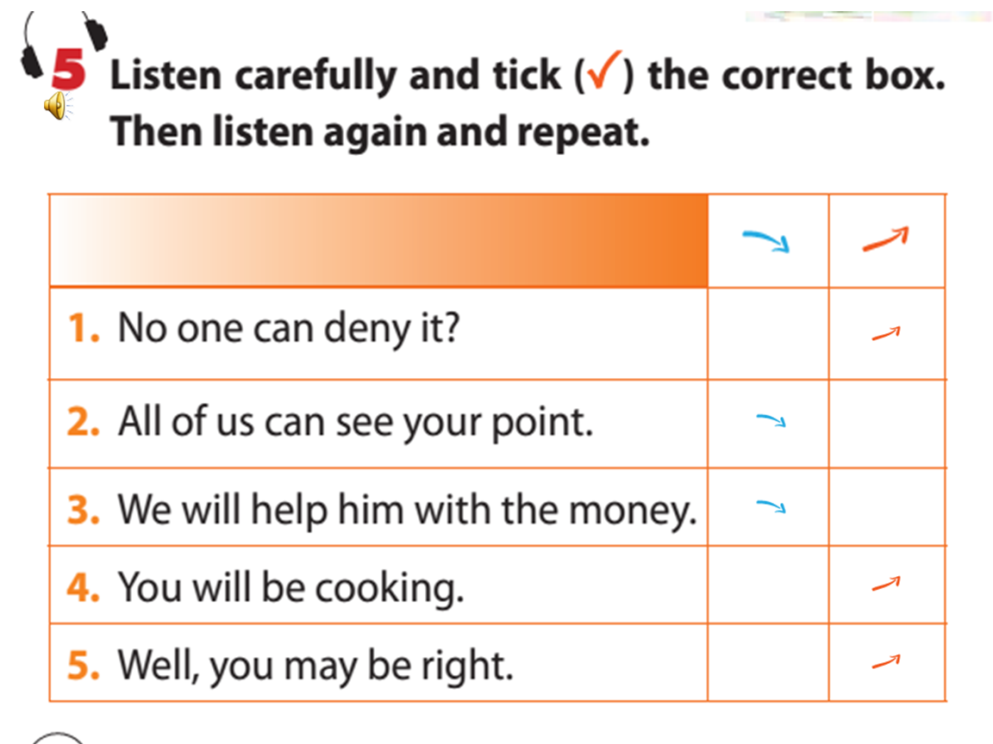  Ex6. Mark Mike’s sentences with falling (agreeing) or rising (disagreeing) arrows. Then listen and check.  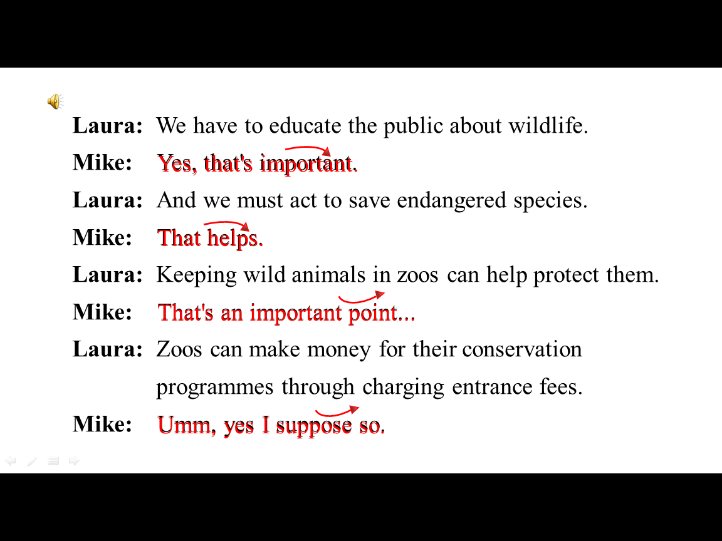
III. WRAPPING UP:3’
- T sums up the main points of the lesson.
IV. HOME ASSIGNMENTS :2’  -T explains how to do exercises |  | IV. HOME ASSIGNMENTS :2’  - Make sentences with new words  - Do ex A1, B1,2 (P40-41) - workbook

V. FEEDBACK:
.................................................................................................................................................................................................................................................................................................................................................................................................................................................................

