**UNIT 6: OUR TET HOLIDAY**

**Lesson 2: A closer look 1**

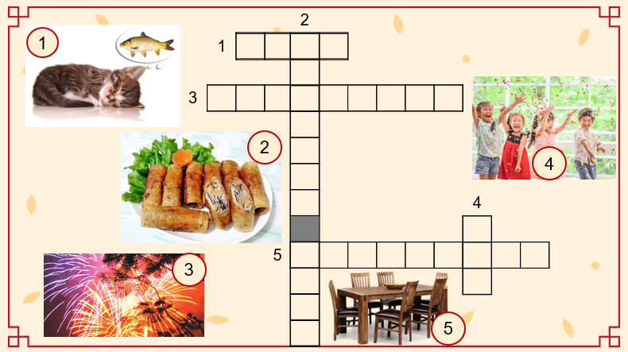

……………………………………………………………………………………………………………..

**UNIT 6: OUR TET HOLIDAY**

**Lesson 2: A closer look 1**