UBND HUYỆN CÁT HẢI  TRƯỜNG TH NGUYỄN VĂN TRỖI | ĐỀ KIỂM TRA CUỐI HỌC KÌ II  Năm học: 2022 - 2023  Môn: Tiếng Anh 5 Thời gian: 35 phút
Giám khảo 1  …………………….......... | Giám khảo 2  ................................ | Số phách  ..........................

 | Listening, reading and writing | Speaking | Total
Mark
Comments

I. LISTENING
Task 1. Listen and Tick . There is one example.
 |  | 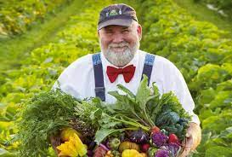
1.A.  | B. | C.
 |  | 
2.A. | B. | C.
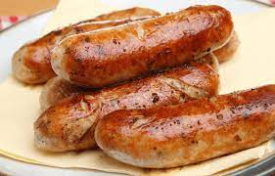 |  | 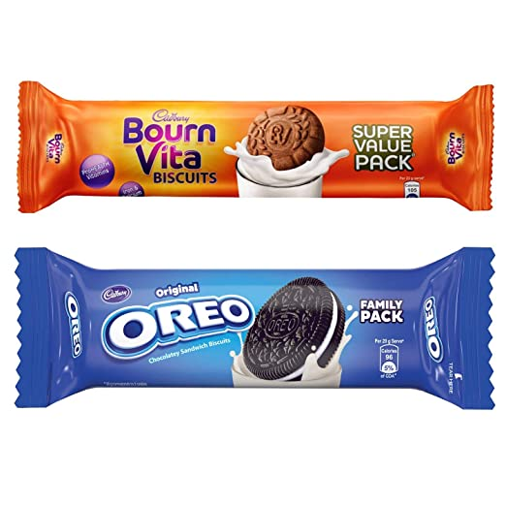
3.A. | B. | C.
Task 2. Listen and number . 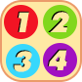
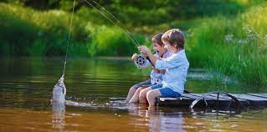 | 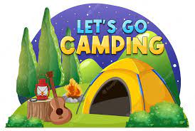 | 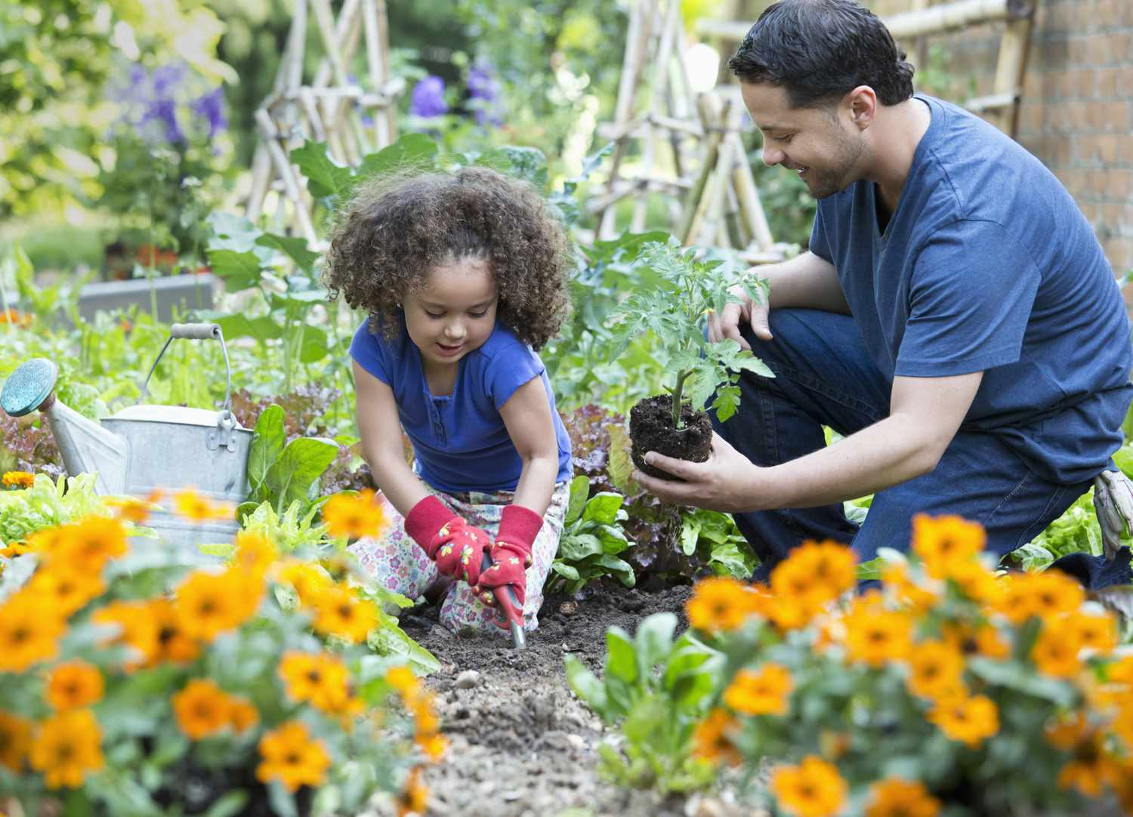 | 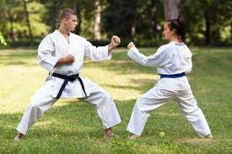
A. | B. | C. | D.
II. READING AND WRITING
Task 1. Choose the correct answer. There is one example (0)
0. What’s the matter __________you? - I have a sore throat.
A
A. with B. on C. from
1. How _________ milk do you drink every day?
- I drink two glasses.
A. often B. many C. much
2. What would you like to _________? - I’d like a glass of apple juice, please.
A. eat and drink B. drink C. eat
Task 2. Read and complete. There is one example (0)
stories | fly | writer | pilot | future
A: What would you like to be in the (0) future ?
B: I’d like to be a (1) ______________ .
A: Why?
B: Because I’d like to write (2) ____________ for children.
A: What about your brother? What would he like to be in the future?
B: He’d like to be a (3) ___________ .
A: Why?
B: Because he’d like to (4)_______________ a plane.
A. That’s great!
Task 3: Read and match. There is one example.
0. Where’s the post office? | 0.c | a. Because you may cut yourself.
1. How can I get to Ho Chi Minh City? | 1.___ | b. Ok, I won’t.
2. Why shouldn’t I play with the knife? | 2.___ | c. It’s next to the stadium.
3. Don’t run down the stairs! | 3.___ | d. It’s more beautiful than he expected.
4. What does he think of Cat Ba island? | 4.___ | e. You can go by plane.
Task 4. Look and write. There is one example.
0. What do you do in your free time?  I often swim in the sea. | 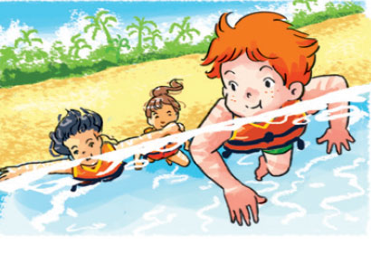
1. What do they do in their free time?  They often _____________________________ . | 
2. What does your sister do at weekends?  She usually _____________________________. | 
Task 5. Put the words in order to make sentences. There is one example.
0. | like / the / will / weather / What / be / tomorrow/?
→ | What will the weather be like tomorrow?
1. | hot/and/will/It// be/ sunny/.
→ | _________________________________________________________________
2 | summer/ What’s/ country/ like/ in/ your/ ?
→ | _________________________________________________________________
3. | he / summer /his/ because/ friends / likes/ can/ with/ for/ go/ a/ picnic/ Peter/.
→ | _________________________________________________________________

